JONIK NDOVU FARM
Conceptual Site & Design Brief
VERSION 3.0 | INVESTOR WORKING DRAFT | OCTOBER 2026

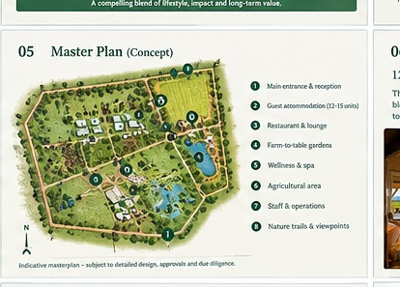
The image above is an AI-generated visual-direction crop only. It is not a surveyed plan and does not show verified boundaries, scale, setbacks, access, utilities, ecological constraints or buildable area.

Design intent
Create a low-density, landscape-led destination that feels rooted in Laikipia while remaining operationally efficient. Use local climate and material research, passive cooling/shading, water-sensitive landscape design, robust maintenance choices and clear separation of guest, service and staff circulation.

Functional zones to test
- Arrival, reception and discreet parking/drop-off.
- 12–15 accommodation units arranged for privacy, views and service access.
- Restaurant/lounge and outdoor dining linked to kitchen, stores and deliveries.
- Farm/garden areas supporting guest experiences and realistic food production.
- Shared experience spaces, wellness/quiet areas and trails where safe and permitted.
- Staff facilities, stores, laundry, plant, waste and maintenance areas.
- Water storage, wastewater treatment, fire access, backup power and other essential infrastructure.
- Landscape buffers, drainage routes, conservation/setback areas and future expansion capacity.

Required professional inputs
- Registered surveyor: title boundaries, levels, access and constraints.
- Architect and engineers: concept/site plan, code compliance and buildable area.
- Quantity surveyor: elemental cost plan, inflation, preliminaries, exclusions and contingency.
- Environmental specialist: screening and required assessment; biodiversity and water considerations.
- Operator/market specialist: unit mix, service model, operational adjacencies and guest journey.

Decision gates
- Gate 1: title/access and acquisition economics are acceptable.
- Gate 2: planning and environmental pathway is viable.
- Gate 3: 12-unit base case fits the US$2.4m funding envelope with contingency and working capital.
- Gate 4: 15-unit alternative and phased option compared on risk-adjusted cash flow.
- Gate 5: design freeze and contractor procurement only after funding and approvals are sufficiently secure.

