JONIK NDOVU FARM
Investor Brief — 5-Minute Overview
VERSION 3.0 | INVESTOR WORKING DRAFT | OCTOBER 2026

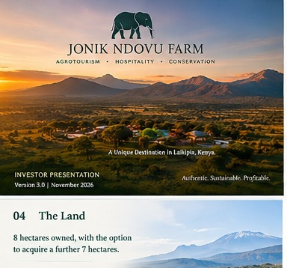

The proposition
Jonik Ndovu Farm is being developed as a hospitality-led agro-tourism destination in Segera, Laikipia County, Kenya. The ambition is to create a small, memorable place to stay where thoughtful accommodation, farm-to-table dining, agricultural experiences and the natural setting work together.

The verified project brief for Version 3.0
Project: Jonik Ndovu Farm — hospitality-led agro-tourism destination
Location: Segera, Laikipia County, Kenya (site-specific access, setting and claims to be verified)
Existing land: 8 hectares owned, subject to title/legal due diligence
Potential expansion: Up to approximately 7 additional hectares to acquire; subject to price, title, access and diligence
Indicative ultimate land area: Approximately 15 hectares if expansion is completed
Accommodation: 12–15 units, subject to final design, approvals, market testing and cost plan
Total capital requirement: US$2.4 million including acquisition of the additional land
Current stage: Concept and investor materials prepared; no investor discussions/commitments reported
Commercial positioning: Boutique hospitality as the principal commercial engine; agriculture integrated into guest experience, food and landscape

What makes the concept distinct
- Hospitality-led economics: accommodation, food and beverage, experiences and related guest spend are the intended core revenue drivers.
- Farm-integrated guest experience: productive gardens, food sourcing, guided activities and landscape design support the destination identity.
- Boutique scale: 12–15 units is the current developer-surveyed range, subject to final planning, design and feasibility.
- Land strategy: the existing 8 hectares provide the starting point; acquisition of up to approximately 7 additional hectares is included within the total US$2.4m capital target.

Capital requirement and use of funds
The stated total capital requirement is US$2.4 million inclusive of the potential additional land acquisition. A detailed allocation is not yet represented as final. The next step is to obtain written land terms, a quantity-surveyor cost plan, infrastructure scope, professional fees, pre-opening budget and a contingency-supported sources-and-uses schedule.

Investment approach
The preferred fundraising path is to identify a credible lead investor or strategic partner, then build a small aligned syndicate around a single diligence process. Both a phased build and a full build should be tested against the same demand, capex, staffing, infrastructure and cash-flow assumptions before recommending one.

What investors should expect next
- Land title and acquisition diligence; access, utilities, water and planning confirmation.
- Market and competitor assessment, target guest definition and channel strategy.
- Design brief, site survey, concept plan, approvals pathway and QS cost plan.
- Integrated 10-year model with transparent assumptions, downside cases and funding needs.
- Proposed legal structure, governance, operator strategy and indicative investment terms.

Important qualification
This is an introductory working brief, not an offer to sell securities or a representation of forecast performance. No investor discussions or commitments have been reported. All financial projections, returns and site-specific claims require independent validation.

