Payobook Architecture and Database Specification
  - Integrated payroll and workforce operations with secure data management
Payobook connects payroll, workforce administration, employee self-service, approvals and reporting through a modular application platform. Its user experience, business application, shared service, AI and intelligence, application foundation, and data and infrastructure layers provide consistent business rules, secure processing and controlled access to operational data.

Payobook platform system architecture
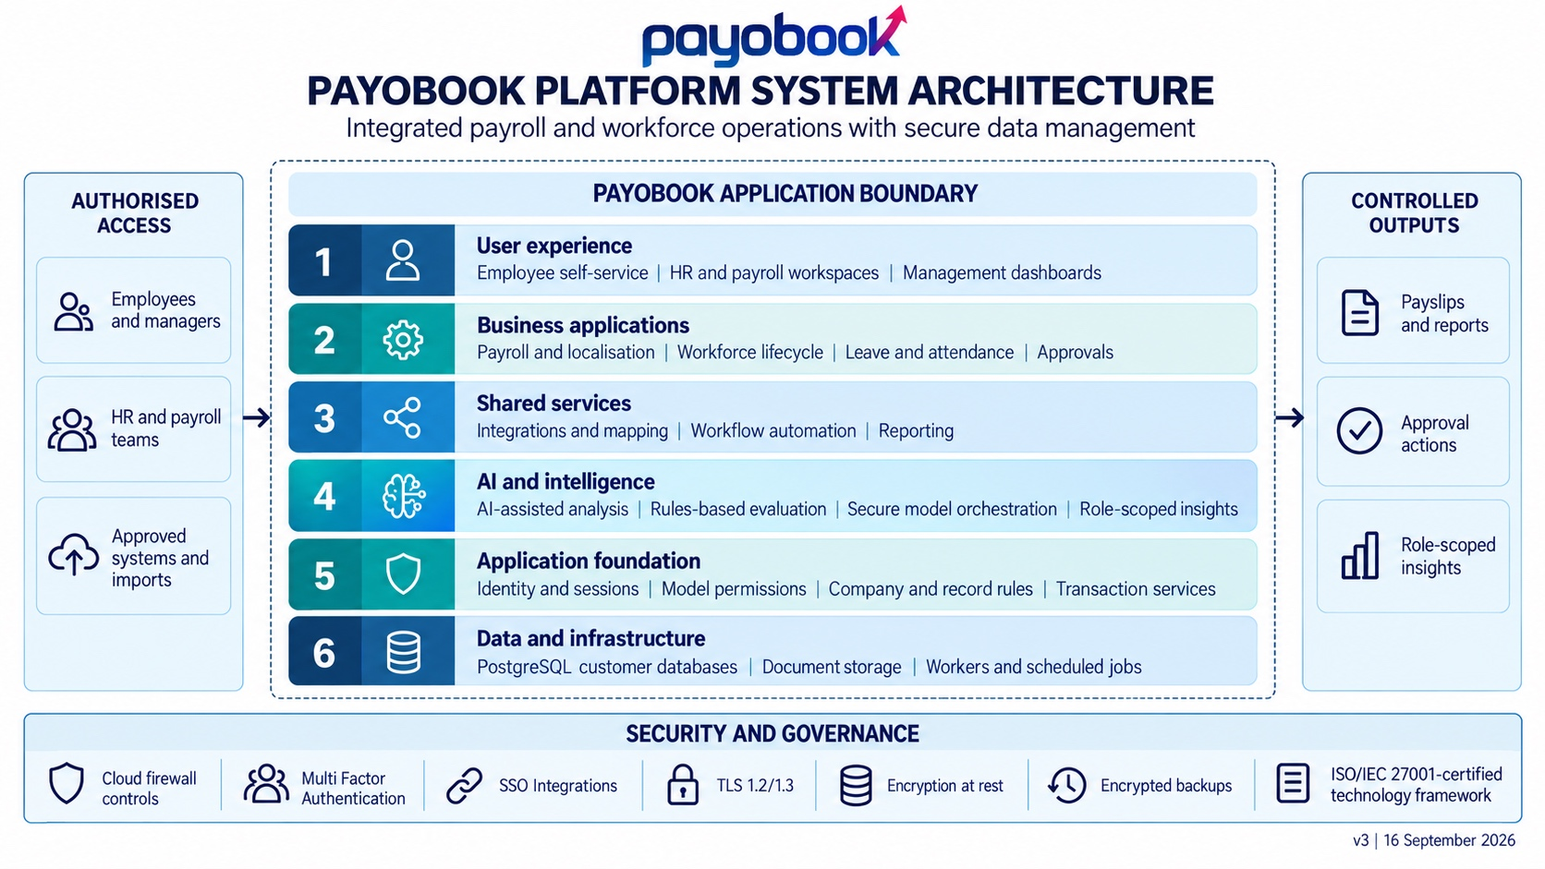
Figure 1 Six-layer architecture, security controls and controlled information flows

Layered platform architecture
Payobook operates as six integrated logical layers. They share controlled transaction services and customer-scoped data. Cloud firewall controls, multi-factor authentication, approved single sign-on integrations, TLS 1.2/1.3, encryption at rest and encrypted backups protect the platform across every layer.
Layer | Responsibilities
1 User experience | Employee self-service; HR and payroll workspaces; management dashboards.
2 Business applications | Payroll and localisation; workforce lifecycle; leave and attendance; approvals.
3 Shared services | Integrations and mapping; workflow automation; reporting.
4 AI and intelligence | AI-assisted analysis; rules-based evaluation; secure model orchestration; role-scoped insights.
5 Application foundation | Identity and sessions; model permissions; company and record rules; transaction services.
6 Data and infrastructure | PostgreSQL customer databases; document storage; workers and scheduled jobs.

Controlled inputs and outputs
Employees and business teams access the platform through authenticated interfaces. Approved connectors and imports map external information into business records. Password protected payslips, reports, approval actions and role-scoped insights are produced through the same application services.

Operational value with accountable decisions
Country-specific payroll logic, validation and approvals support consistent execution. Reporting and AI-assisted analysis help authorised users investigate trends and variances; established business workflows retain control of consequential decisions.

Database structure and processing
PostgreSQL is the transactional system of record. The documented tenancy model uses separate customer databases, with company and record-level permissions within each database. Logical separation does not imply dedicated servers or dedicated encryption keys.
Data domain | Principal records | Relationships and controls
Organisation and identity | Companies, employees, users, groups and employment records | Company membership and user roles determine permitted operations and record visibility.
Workforce and payroll | Contracts, attendance, leave, salary rules, pay runs and payslips | Employee and employment records link workforce inputs to payroll calculations and outputs.
Workflow and integrations | Approval proposals, decisions, connectors, mappings and import records | Business actions follow validation and approval rules; connectors map approved source data.
Documents and evidence | Employee documents, attachments and configured audit entries | Document metadata links files to business records; access rules govern retrieval and maintenance.
Reporting and assistance | Dashboards, report definitions, conversations and provider settings | Queries use authorised business context; enabled assistance services follow deployment policy.
Expanded workforce modules | Expanded workforce modules covering recruitment, onboarding, learning, performance, expenses, assets and offboarding. | Integrated lifecycle workflows connect authorised workforce records, approvals and operational actions across the employee journey.
Advanced reporting and insights | Advanced dashboards, scheduled reporting, controlled data exports and role-scoped management insights. | Role permissions and approved export controls ensure that dashboards, reports and management insights use authorised business context.

Transaction processing
A request is authenticated, checked against model and record permissions, validated against business rules and then persisted. Reports and approved exports use the application data model. Scheduled jobs handle recurring processing; a dedicated event-stream or analytical database is not a required baseline component.

Documents and data lifecycle
Document storage is included in encrypted backup and tested restoration procedures. Payobook applies defined retention, authorised export, deletion and customer offboarding controls to each data category. Payobook securely stores employee bank account details required for payroll. Role-based permissions restrict access, authorised workflows control their use, and protected storage and encrypted backups safeguard the records.

Private processing option
Local model inference and document OCR are supported. Payobook supports a private-processing configuration in which prompts, documents and business data remain within the approved hosting environment during AI processing. The configuration blocks external providers, transcription routes and fallback paths. Customer-authorised business integrations have a separate transfer scope.

Security governance and service resilience

Access and tenant separation
Separate customer databases establish the tenant boundary. Security groups, model permissions and company-scoped record rules govern access within a database. Employee document rules distinguish own-record reading, HR maintenance and managerial permissions. Customer-controlled support access includes a reason, a time limit and a session record.

Secure transfer and storage protection
HTTPS endpoints and certificate monitoring are part of the documented operating model. The deployment security profile enforces TLS policy, certificate validation, protected service connections and encryption for database volumes, documents and backups. The selected hosting configuration records cipher choices, key ownership and rotation.

Audit and operational monitoring
Configured field changes record the acting user, timestamp and before-and-after values. Audit access and retention are controlled; privileged administration and retention processes remain distinct from ordinary users. Health, backup and certificate alerts support operational oversight. Immutable off-site logging is a separate deployment control.

Continuity and controlled releases
Payobook uses backup tooling, restore-based release rehearsal and health-checked rollout waves to manage change safely. The service schedule records backup retention, independent copies, recovery drills, recovery point objectives and recovery time objectives for the deployed topology.

Cybersecurity and certification
Payobook operates a security framework covering patching, vulnerability assessment, access reviews, incident response and supplier assurance. The technology framework is ISO/IEC 27001:2022 certified within the certificate scope, and Payobook reviews certificate validity and service coverage as part of supplier governance.
Payobook supports Single sign-on, multi-factor authentication, identity lifecycle automation and additional approved integrations

Deployment acceptance
Before production launch, Payobook and the client confirm data location and retention, validate role boundaries and integrations, verify encryption and private-processing controls, reconcile payroll outputs, complete recovery checks and record customer acceptance. The agreed implementation plan defines the rollout schedule and support commitments.

