Payobook Security FAQ and Vendor Assessment
  - Customer security questions and a control evidence checklist
Payobook combines payroll and workforce operations with controlled access, traceable workflows and operational monitoring. This document explains the application controls and identifies the hosting and service commitments to establish for each customer deployment. The assessment matrix distinguishes implemented capabilities from configuration and assurance evidence.

Payobook platform system architecture
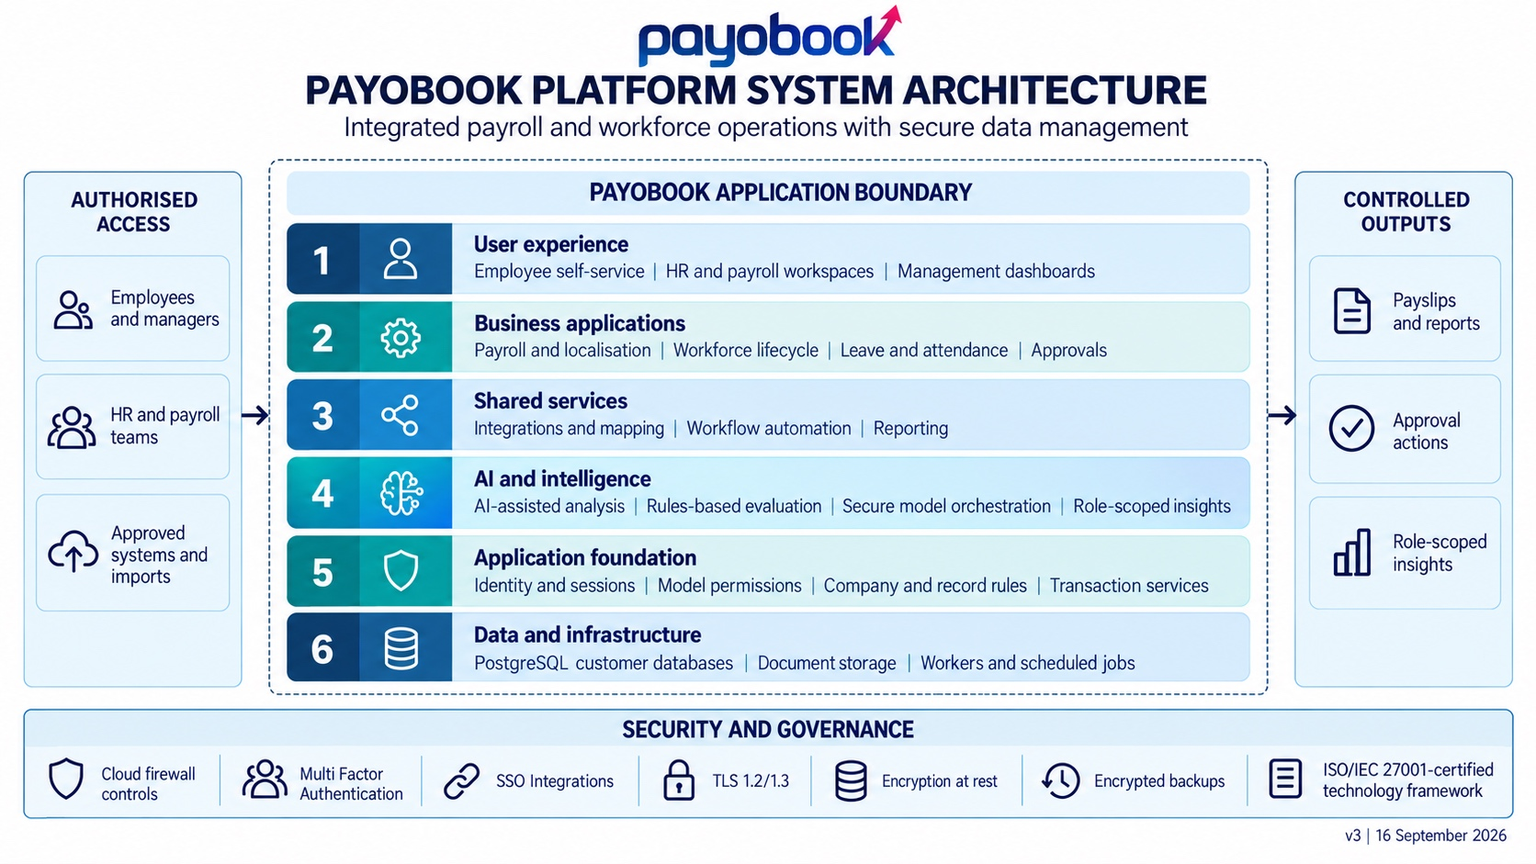
Figure 1 Revised six-layer architecture, security controls and controlled information flows

Platform and data protection

How is the platform structured?
Payobook uses six integrated logical layers: user experience, business applications, shared services, AI and intelligence, application foundation, and data and infrastructure. Payroll, workforce processes, approvals, integrations and reporting share a common transaction and permissions model.

Where is customer data hosted?
Payobook supports flexible hosting on Payobook-managed infrastructure or a client-recommended environment that satisfies the agreed technical, security, availability and support requirements. The customer service schedule records the selected provider, production region, backup locations and data-residency arrangements. Payobook validates the hosting design and applicable provider assurance before production use.

How is one customer separated from another?
The documented model uses separate customer databases. Within a database, security groups, model permissions and company/record rules control access. These application rules are distinct from database-native row-level security. Shared hosting does not itself provide dedicated hardware or customer-specific encryption keys.

How is data protected in transit and at rest?
The platform has HTTPS endpoints and certificate monitoring. The customer deployment profile defines minimum TLS versions, internal connection protection, storage encryption, backup encryption and key-management responsibilities. AES-256 or managed-key claims should be supported by configuration evidence for the actual services in use.

Does Payobook store financial information?
Payobook can hold employee bank details required for payroll and payment preparation. Payobook protects these records and exports with restricted role-based access, controlled workflows, protected storage and encrypted backups. Payment-card processing, tokenisation and payment-gateway certifications are separate integration matters and are confirmed for the selected payment route.

How are imports and integrations controlled?
Connectors use defined mappings and transformation rules to bring approved data into business workflows. Integration ledgers check access to records. The customer agrees the source, destination, authentication method, permitted fields and transfer purpose for each enabled connection.

Identity privacy and operational security

How are user and support privileges managed?
Application groups, model permissions and record rules govern business access. Employee document permissions distinguish self-service reading, HR maintenance and managerial actions. Support sessions require a reason and time limit, leave a customer-side record and can be refused by the customer.

Are single sign-on and multi-factor authentication available?
Payobook supports approved single sign-on integrations using secure standards such as OAuth 2.0 with PKCE and, where selected, SAML or OpenID Connect. The deployed identity route enforces account linking, multi-factor authentication for privileged access and an agreed session policy, with each route tested before production use.

How is information protected in AI-assisted features?
AI-assisted analysis and document processing are supporting platform services. Local inference and local OCR are supported. In the private-processing configuration, business content is processed within the approved hosting environment without transmission to external AI providers. Payobook blocks external provider, transcription and fallback routes; access checks and supported identifier redaction provide additional safeguards. Authorised users retain decision and approval responsibility.

Which activities are audited?
Configured changes to selected business fields record actor, timestamp and before/after values. Audit-reader permissions and retention control access and lifecycle. Coverage of record views, exports and IP addresses must be checked separately. Application audit records are not represented as immutable storage against privileged administrators.

How are availability and recovery managed?
Health, backup and certificate monitoring produce operational alerts. Backup tooling and restore-based rollout rehearsal are documented. The customer service schedule records off-site copies, disaster-recovery drills, retention, recovery point objectives and recovery time objectives, and Payobook retains the supporting recovery evidence for the deployed topology.

What cybersecurity and certification assurances apply?
Payobook operates a security framework covering patching, vulnerability management, incident response, personnel controls and supplier assurance. The technology framework is ISO/IEC 27001:2022 certified. Payobook verifies service coverage and documents notification timelines, support coverage and personnel controls in the agreed assurance pack.

Vendor assessment of application controls
This checklist records the controls and evidence for the customer environment. “Implemented capability” confirms Payobook platform functionality; customer-selected configuration items are verified during deployment and acceptance.
Control and owner | Assessment response | Status and evidence to retain
Architecture  Payobook | Six integrated logical layers share application permissions, secure AI orchestration and transaction services. | Implemented capability  Architecture diagram and module inventory.
Tenant separation  Payobook operations | Customer databases are separated; company and record rules govern access within each database. | Implemented capability  Database routing and cross-user/company access tests.
Business access  Payobook + customer | Groups, model permissions and record rules restrict business operations and sensitive records. | Implemented capability  Role matrix, joiner/leaver process and access-review results.
Support access  Payobook + customer | Reasoned, time-limited support sessions are logged; customers can refuse access. | Implemented capability  Support configuration and sampled session records.
Integration controls  Payobook + customer | Mappings, transformation rules and ledger access checks support controlled exchange. | Implemented capability  Approved destinations, credentials scope and integration tests.
Audit trail  Payobook | Selected field changes capture actor, time and before/after values; reader and retention controls apply. | Implemented capability  Audited-model inventory, sample records and retention settings.
Private processing  Payobook operations | Local inference and OCR are supported; the private-processing profile applies endpoint, outbound and fallback controls to prevent external AI transfer. | Configuration required  Provider settings, network policy and egress/fallback test results.
Authentication  Payobook + customer | Approved standards-based single sign-on is supported; the deployed route enforces privileged MFA and the agreed session policy. | Configuration required  Identity flow tests, privileged MFA and session policy.
AI and intelligence / Payobook | AI-assisted analysis, rules-based evaluation, secure model orchestration, local inference and OCR operate with role-scoped access and private-processing controls. | Implemented capability / Model inventory, access tests, provider settings and egress/fallback test results.

The customer controls user authorisation and approved data exchange. Payobook configures the application and operating environment. Hosting-provider controls should be assessed against the exact services and regions used.

Vendor assessment of infrastructure and assurance
Assurance status categories: Implemented and evidenced; Implemented—deployment evidence to be supplied; Design supported—operational control to be established; Verified external assurance.
Control and owner | Assessment response | Assurance status and evidence action
Hosting assurance  Hosting provider + Payobook | Payobook deploys on approved Payobook-managed or client-recommended hosting that meets the agreed security, availability, data-residency and support requirements. | Implemented—deployment evidence to be supplied / Approved hosting design, region, data-residency record and provider assurance.
Transport protection  Payobook operations | Payobook enforces HTTPS and approved TLS, monitors certificates, validates security headers and protects internal connections. | Implemented—deployment evidence to be supplied / TLS scans, certificate settings and network configuration.
Encryption and keys  Payobook operations | Payobook encrypts databases, attachments and backups, restricts key access, and governs key ownership, rotation and recovery. | Design supported—operational control to be established / Encryption settings, key-management records and recovery procedure.
Perimeter protection  Payobook operations | Payobook applies firewall rules, network restrictions, controlled administrative entry points and relevant rate-limiting and WAF controls. | Design supported—operational control to be established / Firewall and WAF rules, endpoint inventory and perimeter test results.
Recovery and logging  Payobook operations | Payobook monitors services, protects operational logs and recovery copies, and tests restoration against agreed recovery objectives. | Implemented—deployment evidence to be supplied / Retention settings, off-site recovery copies, drill results and agreed RPO/RTO records.
Security maintenance  Payobook operations | Payobook uses controlled releases, vulnerability scanning and managed patching, with findings prioritised and remediated. | Design supported—operational control to be established / Vulnerability scans, remediation records, release evidence and patch policy.
People and incidents  Payobook management | Payobook enforces personnel access obligations, security awareness and incident-response responsibilities, including agreed client notification. | Design supported—operational control to be established / Personnel policy, training records, access reviews, incident plan and notification commitments.
Certification  Supplier + Payobook | The Payobook technology framework is ISO/IEC 27001:2022 certified within its defined scope, with validity and service coverage reviewed through supplier assurance. | Verified external assurance / Current ISO/IEC 27001:2022 certificate, defined scope and supplier-assurance review.

