

VIETTEL MILITARY TELECOMMUNICATION GROUP

DOCUMENT DESCRIPTION OF WEBSERVICE
ELECTRONIC BILL

Hanoi, May 2023
CHANGE RECORDING SHEET

Version | Day | Detail
0.1 | 09/2017 | Initialized version
0.2 | March 2018 | Added sections 2.1.11, 2.1.12, 2.1.13
0.3 | September 2018 | Added 2.1.14, 2.1.15
1.0 | September 2018 | Add more details to the newsletter specification, reorganize the document
1.1 | April 2019 | Add item 7 mapping information fields and invoice templates
2.4 | 05/2022 | Add description of fields of TT78 warehouse note in section 6.9 Metadata, example json file in section 7.2
2.5 | 06/2022 | - Add the reason for the cancellation of the invoice in section 7.6  - Added error reason field for replacement adjustment invoice in section 6.2 generaIInvoiceInfo, json file in section 7.2 and section 7.15  - Addition of negative quantity/unit price transmission in item 6.6 itemInfo  - Add an Invoice Adjustment field that doesn't exist via the API in 6.2 generaIInvoiceInfo, The json file in 7.2 and 7.15
2.6 | 09/2022 | - Added new 6.12 QRcode  - Added new 7.22 Secret code level  - Add new 7.25 Update invoice printing status  - Newly added 7.26 Number of QRcode scans of invoices
2.7 | 09/2022 | - Added an information field that allows searching invoices by issuance date in section 7.7  - Add additional payment methods in section 6.5  - Add new 7.27. Api statistics invoices by user
2.8 | September 2022 | - Supplement the transmission of the Secret Code that has been granted to MST in section 6.2 generaIInvoiceInfo  - Added Sync notes/ for itemNote transfer in section 6.6 itemInfo
2.9 | November 2022 | - API explains section 7.26
2.10 | November 2022 | - Add content of sections 7.2 and 7.15: add in generalInvoiceInfo 2 tags: originalInvoiceType and originalTemplateCode  - Add new section 7.26: get list of sample and invoice symbols according to tax code
2.11 | 12/2022 | - Added content to change the way data is saved when making invoices for goods with Note properties in section 6.7  - Added content allowing to adjust itemInfo product information in section 6.6  - Add the content of the link to look up the invoice and email it to the buyer in section 7.14
2.12 | 12/2022 | - Add new content: API to issue invoices with secret codes 7.28 and 7.29
2.13 | 1/2023 | - Added a description of the rules for transmitting invoice symbols in generalInvoiceInfo section 6.2
2.14 | March 2023 | - Add new API to get sample list and invoice symbol according to tax code in the whole system section 7.30
2.15 | March 2023 | - Added description of invoice date check rule section 7.2, 7.9, 7.15 and 7.28
2.16 | March 2023 | - Add connection security standards: Encrypted connection API using https protocol with Basic Auth authentication section 5.5  - Add test account information item 5.6  - Add field adjustAmount20, invoiceNote item 6.2  - Update field description buyerNotGetInvoice item 6.4  - Change maxlength batchNo from 50 to 300, itemNote from 100 to 300 items 6.6  - Correctly update information on selection field item 6.6  - Change the maxlength of stringValue from 13 to 300 items 6.9  - Supplementing non-tariff sales slip section 6.9  - Updated format of strIssueDate, additionalReferenceDate from 4.1 to 5.1 item 7.5, 7.10, 7.18, 7.19, 7.26
2.17 | March 30, 2023 | - Update and rename configuration "Signed date as current time" to " Allow invoice date other than current date" section 7.2, 7.9, 7.15, 7.28
2.18 | April 13, 2023 | - Increase the secret code to 30,000 items 7.22  - Upgrade connection to BCCS section 7.31
2.19 | April 18, 2023 | - Add information transmitted when creating and viewing draft invoices to adjust/replace paper invoices (outside the system) Sections 7.8, 7.20
2.20 | May 5, 2023 | - Removed content Upgrade connection with BCCS section 7.31
2.21 | May 26, 2023 | - Additional information Note section 7.3, 7.4, 7.5 – Upgrade file download from API  - Add new 7.31 – Release/replace/modify for CLOUD CA (Step 1: Get hash string)  - Add new 7.32 – Issue/replace/adjust for CLOUD CA (Step 2: Cloud CA signing and invoice generation)  - New addition 7.33 – Issuing invoices with secret codes for CLOUD CA  - Additional information Note sections 7.2, 7.8, 7.9, 7.15, 7.16, 7.28 - For  Allows recording the total pre-tax value of goods when invoicing via API ( without recalculating) for customers who have unchecked data constraints.  - Additional information Note sections 7.2, 7.9. 7.16, 7.28 - Returns the CQT code in the codeOfTax field  - Additional information noted in sections 7.2, 7.9, 7.28 - Allows using USB CKS and  cloudCA issues cash register invoices using server api

TABLE OF CONTENTS
1. Terminology and abbreviations 7
2. Purpose and scope 7
3. Connection model 7
4. Some basic flows 8
5. Standards 9
5.1 Time standards 9
5.2 Data Standard 9
5.3 Special characters 10
5.4 Transaction sanitization mechanism 10
5.5 10 . connection security standard
6. Detailed specification of invoicing inputs 12
6.1 Overview 12
6.2 generalInvoiceInfo 13
6.3 sellerInfo 19
6.4 buyerInfo 21
6.5 payments 24
6.6 itemInfo 25
6.7 taxBreakdowns 33
6.8 summarizeInfo 35
6.9 metadata 39
6.10 meterReading 42
6.11 invoiceFile 43
6.12 qrcode 44
7. 45 . connection APIs
7.1 General concepts 45
7.2 Issuance/replacement/adjustment of invoices (For HSM CTS) 46
7.3 Get invoice file 49
7.4 Get the invoice file with the secret code 52
7.5 Get converted invoice file (pdf) 54
7.6 Cancel invoice 56
7.7 Invoice lookup 58
7.8 Get dynamic field information 62
7.9 Draft bill 70
7.10 Invoicing in batches 71
7.11 Update tax declaration 72
7.12 Provide invoice usage in 73 . range
7.13 Provide a list of invoices at 75 . intervals
7.14 Emailing customer invoices 77
7.15 Release/replace/modify for USB-TOKEN (Step 1: Get the hash string) 78
7.16 Issuing/replacing/adjusting USB-TOKEN (Step 2: Sign USB token and generate invoice) 81
7.17 Change font 83
7.18 Payment status update 84
7.19 Canceling payment status 86
7.20 Draft bill preview 88
7.21 Look up invoices using transactionUuid 89
7.22 Issue secret code 91
7.23 API to issue invoices with secret code (server signature) 92
7.24 Invoice issuance API with secret code ( USB-Token ) 93
7.25 Invoice printing status update 94
7.26 Number of QRcode scans of bills 95
8. System return error list 96
9. Mapping between information fields and invoice form 96
10. Test API using POSTMAN 97

Terms and abbreviations
STT | Acronyms | Full meaning
first | XML | e X tensible Markup L anguage - Extensible Markup Language
2 | VALVE | T axation V alue A dded N etwork
3 | ICC | I nvoice C ertification C enter
4 | PSD | P ortable S ecurity D evice
5 | SGML | S tantard G eneralized M arkup L anguage
6 | W3C | World Wide Web C onsortium , abbreviated W3C , sets standards for the Internet, especially for the World Wide Web
7 | SInvoice | Viettel's electronic invoice service/system
8 | HTTH | Accounting software system, business administration integrated with SInvoice system to issue invoices.

Purpose and scope
Detailed description of connection standards so that systems can connect to Viettel's mass electronic invoice service to ensure correct information is issued.

Connection model
SInvoice system plays the role of receiving invoice data from external systems (integrated systems) and issuing invoices according to the form the business has chosen. The APIs of the SInvoice system are provided according to the Restful Webservice standard.
Initially, businesses perform invoice declaration operations on the website of the SInvoice system including:
- Declare the name of the invoice template
- Select invoice template
- Declare invoice range
- Prepare release announcement
- Register digital certificate information
Detailed instructions can be found at: https://sinvoice.viettel.vn/ho-tro/huong-dan-su-dung/mo-ta-tong-the-cac-buoc-dang-ky- va-su-dung-dich-vu-hoa-don-dien-tu

Some basic streams
After the invoice form declaration information has been completed on SInvoice, businesses can use external systems to call APIs to perform the transaction.
- Simple flow
- Issuance/Replacement/modification of invoices ( Corresponding API section: 7.2 for HSM digital certificate or 7.15 and 7.16 for USB-TOKEN digital certificate type )
- Cancel invoice ( Corresponding API section: 7.6 )
- Download invoice file ( corresponding to API section: 7.3 )
- Look up invoices ( corresponding to API section: 7.7 )
- Create draft invoices ( corresponding to API section: 7.9 )
- The invoice stream has additional information fields (Information in addition to the standard declarations in section 5. For example: Electricity, water, hospital, sea, import and export, etc.)
- Get a list of dynamic fields declared in the invoice template ( corresponding to API section: 7.8 and section 7.9 )
- Issuing/Replacing/adjusting invoices ( Corresponding API section: 7.2 for HSM digital certificate type or 7.15 and 7.16 for USB-TOKEN digital certificate type )
- Cancel invoice ( Corresponding API section: 7.6 )
- Download invoice file ( corresponding to API section: 7.3 )
- Look up invoices ( corresponding to API section: 7.7 )
- Create draft invoices ( corresponding to API section: 7.9 )

Note 1: Invoicing using HSM digital signature and USB token using different functions. HSM uses a unique function, the interaction with the signature is handled by the Electronic Invoice system. USB uses 2 different functions, the interaction with the signature is taken care of by the built-in software. Customers need to be consulted before use.
Note 2: A business can have multiple tax identification numbers (businesses, branches), invoice templates, and invoice symbols. Therefore, integrated systems must allow enterprises to configure a lot of information to send to the SInvoice system.

Standards

Standard time
All specified data fields use this 5.1 standard, datetime type (full hours, minutes, seconds. Currently, the system only records seconds, not milliseconds) input and The output of these 20 APIs according to this standard is converted to longTime.
Example: 1587797116000. How to calculate DATE as shown in the image:
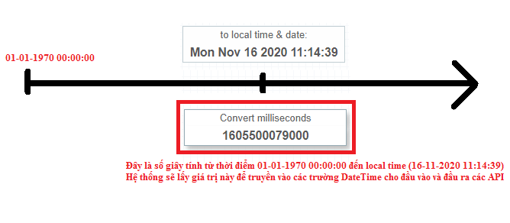
Reference website: https://currentmillis.com/

Data standards
- The SInvoice system supports Unicode standard data (UTF-8)
- For the data sent, the SInvoice system will leave the data format intact for display. Except for digital data (related to money, quantity, unit price, tax rate), bank name, bank account. The digital data sent is always in the format [0-9.]+. For example 100000.1234. SInvoice's template will automatically format the display. For data such as bank name and account name, multiple entries can be entered, separated by ";".

Special characters
Special characters to note and how to handle them according to json standards (marker characters are needed to identify special characters)
In json need to add the marker \ before special characters.

VD:
- Json: Want to transfer data is: Nguyen Van A "B"
Then need to pass in json as follows: "buyerName": "Nguyen Van A \"B\""

Transaction sterilization mechanism
- The integrated software and SInvoice communicate over the network environment, so it is very likely that during the transaction, there will be a transmission error (network error, high system load, etc.). To avoid a transaction being created into 2 invoices, for each invoice request sent in invoicing operations, the integrated system automatically generates a transactionUuid that is unique for that invoice and included in the invoicing request. . For details see section 5.2 on the transactionUuid data format.
- After the request is made, you need to wait for the request to respond to see if the result is correct or incorrect, or the request does not respond after a timeout period (minimum 90 seconds). Only then can another request be sent with the same transactionUuid. Sending 2 requests at the same time with the same transactionUuid will not be controlled by the processing system and will create 2 different invoices.
- In case no response has been received. You can proactively look up invoice information based on transactionUuid to know whether an invoice has been generated or not. For details, see section 6.21 Invoice lookup using transactionUuid

Connection security standards
There are 2 ways to authenticate:
Method 1:
- The API connection is encrypted using the https protocol with Basic Auth authentication.
- To ensure security, by default the system will not allow accounts to connect via API. To connect the API for accounts, users will have to log in to the Viettel website and configure the IP allowed for access. For details, see Step 1 in the user configuration guide (Link attached):

VD:
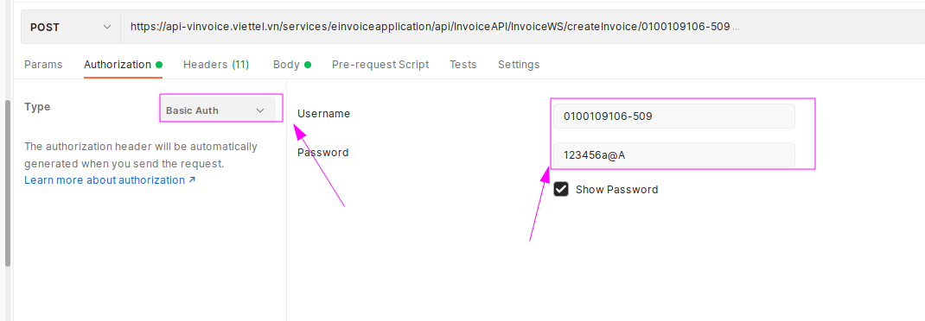
Method 2:
- The connection API is encrypted using the https protocol with Token authentication.
- Get Token information
  - Call API
API: /auth/login
Method: POST
Content-Type: application/json
Body: {"username":"0100109106-712","password":"12345678aA@"}

  - Getting the access_token value generated from the above API to use in API calls is equivalent to authentication:
    - Pass in the Header of the API access_token information
      - Key: Cookies
      - Value: access_token=abc…def
Example of how to use tokens with Postman
- Authorization:
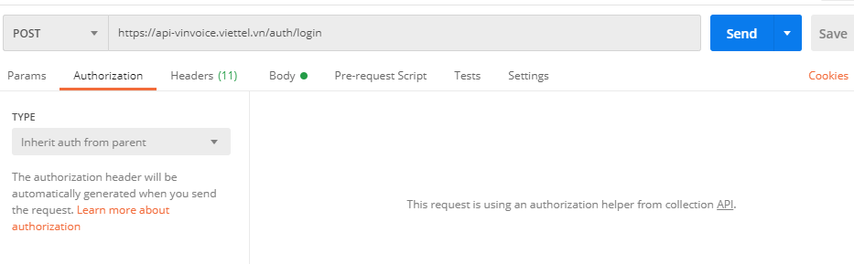
- Headers:
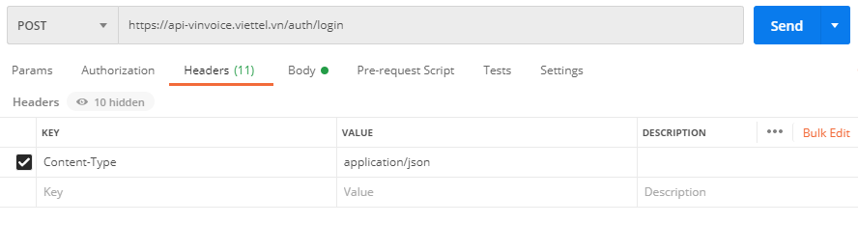
- Body:
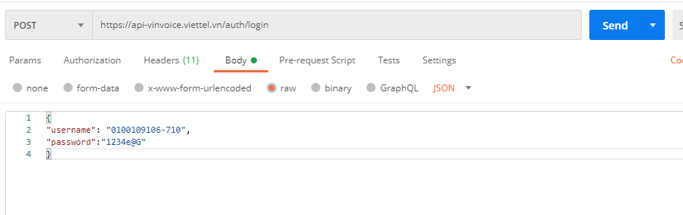
Result:
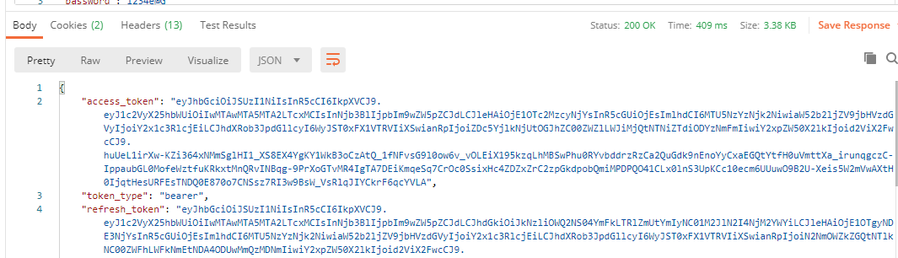

Then use access_token at Headers
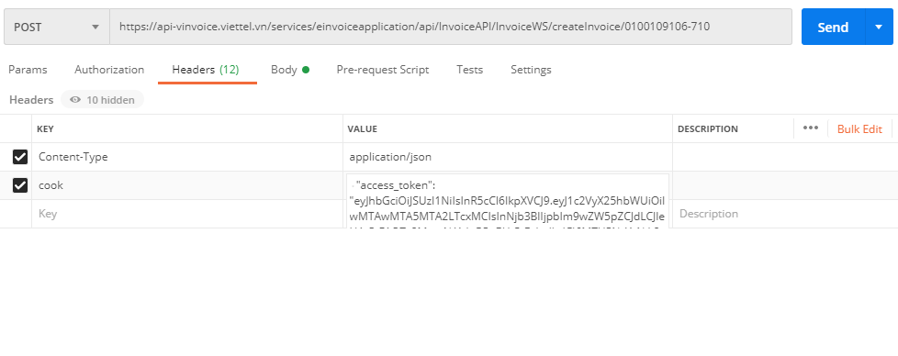

Test account
Units use the following account to test connection to the software
{
"username":"0100109106-509",
"password":"123456a@A"
}

Invoice input detail specification

overview
For the APIs for invoicing, adjusting invoices, replacing invoices, creating draft invoices, creating usb token invoices, and previewing draft invoices, the input data fields will have the same general form.
{
"generalInvoiceInfo":{ //General information of the invoice
},
"buyerInfo":{ //buyer information
},
"sellerInfo":{ //seller info
},
"payments":[ //payment information
],
"itemInfo":[ //goods information
],
"metadata":[ //dynamic field information
],
" meterReading": //special information for utility bills
],
"summarizeInfo":{ //invoice summarize information
},
"taxBreakdowns":[ //information for grouping invoices according to tax rate
]
}
Describe:
School's name | Describe
generalInvoiceInfo | This is general information for issuing invoices, including invoice template symbol, invoice symbol, invoice type, date of issue, etc.
sellerInfo | Information about the seller on the invoice. In case the integrator sends the MST, the system will take all the data sent by the integrator, if not, the system will get the information configured on the system.
buyerInfo | Information about the buyer on the invoice
extAttribute | Expanded data field, for further customization on the invoice template.
payments | Payment method name of the invoice.
itemInfo | Detailed goods information of the invoice.
taxBreakdowns | Summarize invoice tax rate information by tax rate, for example -2, -1, 0, 5, 10
summarizeInfo | Summarize the cost of the entire invoice
metadata | Invoice dynamic field information
meterReading | Special information, for electricity/water bills.

generalInvoiceInfo
Contains basic information of the invoice,
School's name | Datatypes | Describe
invoiceType | Required: false  DataType: String  Minlength:  Maxlength:  Format: | The Invoice Type Code accepts only the following values:  Circular 32 : 01GTKT, 02GTTT, 07KPTQ, 03XKNB, 04HGDL, 01BLP. Comply with the regulations on invoice type symbols of the Circular guiding the implementation of Decree No. 51/2010/ND-CP. For details, see PL1 Circular 39/2014/TT-BTC.  Circular 78: 1, 2, 3, 4. Comply with Circular 78/2021/TT-BTC  Note: at a time, businesses can use many types of invoices.
templateCode | Required: true  DataType: String  Minlength: N/A  Maxlength: 20  Format: | Invoice sample symbol, complying with the regulations on invoice template symbol of the Circular guiding the implementation  Circular 32: Decree No. 51/2010/ND-CP  Example 01GTKT0/001, where  01GTKT: invoice type symbol  0: contact number, for e-invoices is always 0  001: sequential number increases according to the number of enterprise samples registered with the tax authority  For details, see PL1 Circular 39/2014/TT-BTC  Circular 78: For example: 1/001 in there  1: Invoice type symbol  001: In ascending order according to the number of enterprise samples registered with the tax authority  Details in Clause 1, Article 3 of Circular 78 /2019/TT-BTC  Note: a business can have multiple invoice templates at a time.
invoiceSeries. invoiceSeries | Required : true  DataType: String  Minlength : NA  Maxlength : 7  Format : ^[a-zA-Z0-9/]*$ | Is "invoice symbol" in compliance with the rules of creating invoice symbols of the Circular guiding the implementation  Circular 32: Decree No. 51/2010/ND-CP.  For example AA/20E.  For details, see PL1 Circular 39/2014/TT-BTC  Circular 7 8: Example: K20TYY  Details in Clause 1, Article 3 of Circular 78 /2019/TT-BTC  Note: A business can have multiple invoice symbols at a time.  For invoices according to TT78, users are not required to transmit exactly two digits in the symbol according to the year of invoice issuance. In case the user transmits the wrong one (past or future year), the system still stores the symbol by year  For example : A user creates an invoice with symbol K18TAA, with an issuance date in 2023. If the value K50TAA is transmitted, the system will still save the invoice symbol after creation as K23TAA.
invoiceIssuedDate | Required: false  DataType: Datetime  Minlength: N/A  Maxlength: 50  Format: Section 4.1 | Invoice date, following the principle of ensuring chronological order in an invoice symbol of an invoice template with a specific tax code: the following invoice number must be issued with a time greater than or equal to advance invoice.  Note:  - The time is accurate to the hour, minute, second  - In case of not sending the set up date, the system will automatically get the current time on the system with GMT+7 time zone.  - The data transmitted is the time in milliseconds of long type in section 5.1  The system records seconds. The calculation formula can be found at: https://currentmillis.com/
currencyCode | Required: true  DataType: String  Minlength: 3  Maxlength: 3  Format: [AZ]+ | Currency code used for invoices is 3 characters long according to regulations of the State Bank of Vietnam. For example: USD, VND, EUR…
adjustmentType | Required: false  DataType: String  Minlength:  Maxlength: 1  Format: | Invoice adjustment status:  1: Original invoice  3: Substitute Invoice  5: Adjusted invoice  7: Invoice deleted  No transmission will default to 1
adjustedNote | Required: false  DataType: String  Minlength: N/A  Maxlength: 255  Format: | Reason for error  Allows you to enter a maximum character string of 255 characters.  Transmission is not required.  Set in generalInvoiceInfo
adjustmentInvoiceType | Required: false  DataType: String  Minlength:  Maxlength: 1  Format: | Adjustment type for adjustment invoice  1: Money adjustment invoice  2: Information adjustment invoice  Required if adjustmentType = 5
originalInvoiceId | Required: false  DataType: String  Minlength: 7  Maxlength: 15  Format: ^[a-zA-Z0-9]*$ | The invoice number of the original invoice in case of invoicing is:  Replacement invoice  Adjustment invoice  The invoice number is in the form AA20E00000001, where  AA20E: invoice symbol  00000001: ascending order number  For details, see PL1 Circular 39/2014/TT-BTC
originalInvoiceIssueDate | Required: false  DataType: Date  Minlength: N/A  Maxlength: 50  Format: yyyy-MM-dd | Original invoice time, required in case of replacement invoice and adjustment invoice. Used to search for original invoices of replacement or adjusted invoices
additionalReferenceDesc | Required : false  DataType: String  Minlength :  Maxlength : 225  Format : | Reference information, if any, attached to the invoice: written agreement between the buyer and the seller on replacing or adjusting the invoice. Required when invoicing replacement, adjustment invoices.
additionalReferenceDate | Required: false  DataType: Date  Minlength: N/A  Maxlength: 50  Format: Section 4.1 | Time for a written agreement between the buyer and the seller to arise, required when making a replacement invoice or adjustment invoice.  - The input data is the long time in millisecond format in section 5.1
paymentStatus | Required: true  DataType: Boolean  Minlength:  Maxlength: 1  Format: | Payment status of the invoice  True: Paid  False: Not yet paid
cusGetInvoiceRight | Required: false  DataType: Boolean  Minlength:  Maxlength: 1  Format: | Allows users to look up invoices or not.  Default true.  If the value is false, the invoice will not be able to be viewed
exchangeRate | Required: false  DataType: BigDecimal  Minlength:  Maxlength: 13  Format: | Currency exchange rate at the time of invoice conversion to VND  Note: The integer part can be entered up to 11 digits, the maximum decimal part is 2 digits
transactionUuid | Required: false  DataType: String  Minlength: 10  Maxlength: 36  Format: | Note : This data is not required in the json string but the software should have to control duplicate data for invoices .  The ID to verify the invoicing transaction, generated from the counterparty's system, is unique to each invoice. In case of sending transactionUuid, the partner system will self-manage to ensure the uniqueness of transactionUuid. For each transactionUuid, once a transactionUuid with an invoice A has been submitted, every request to invoice with the same transactionUuid will return invoice A and not another invoice. The validity period of transactionUuid is 3 days.  Recommendation: use UUID V4 to avoid duplicate numbers.  Reference: https://en.wikipedia.org/wiki/Universally_unique_identifier
certificateSerial | Required: false  DataType: String  Minlength:  Maxlength: 100  Format: | Used when invoicing using USB Token.  Serial Number of the business's digital certificate, this digital certificate has been pushed onto the system by the business when registering to use USB Token.  Hex format.  For example: 5404FFFEB7033FB316D672201B7BA4FE
originalInvoiceType | Required: false  DataType: String  Minlength: N/A  Maxlength:  Format: | Original invoice type  Pass a numeric value with the following meaning  0- Not paper invoices/invoices that don't exist on the system  1-Invoice TT78  2-Invoice according to Decision 1209  3-Electronic/Paper Invoice TT32  4-Paper invoice TT 78  If not transmitting, the default will be 0
originalTemplateCode | Required:  DataType: String  Minlength: N/A  Maxlength: 20  Format: | Casting is required if originalInvoiceType is 1, 2 , 3 or 4  For example, sample TT32: 01GTKT0/001  For example, the pattern TT78: 1/0224 will transmit as 1  2/001 will be transmitted as 2.... similar to other types of invoices (for TT78 will be transmitted according to invoiceType)
reservationCode | Required: true  DataType: String  Minlength:  Maxlength: 100  Format: | - Secret code has been issued for MST  - This request implements a new API to issue invoices with secret codes using server signatures  - The output information is similar to the createInvoice/{supplierTaxCode} API, in which the reservationCode in the response is the reservationCode in the Input.  - In case the system encounters an error/slowness and cannot return results immediately, return results after 10 seconds.
adjustAmount20 | Required: false  DataType: Number | 20% discount on sales invoices : The field receives the value "Percentage based on revenue".  The input value belongs to one of the values "1, 2, 3, 5".  For example: “adjustAmount20”: “2”
invoiceNote | Required: false  DataType: String  Minlength: N/A  Maxlength:  Format: | Used as a note line below the list of goods, when making adjustments, the system will automatically generate the line "Adjustment / replacement for invoice ... date .... ". When adjusting on the web, it will be generated automatically and the api must be transmitted  Note: Not autogenerated if the input data check is omitted
Sample data
Regular invoice
"generalInvoiceInfo": {
"transactionUuid": "859f390a-1e59-4a05-9663-1e9ec7afdb8f",
"invoiceType": "01GTKT",
"templateCode": "01GTKT0/001",
"invoiceSeries": "AB/20E",
"invoiceIssuedDate": 1605027600000,
"currencyCode": "VND",
"adjustmentType": "1",
"paymentStatus": true,
"cusGetInvoiceRight": true,
"reservationCode": "681DDYKLMOEFD"
}
Money Adjustment Invoice
"generalInvoiceInfo": {
"transactionUuid": "859f390a-1e59-4a05-9663-1e9ec7afdb8f",
"invoiceType": "01GTKT",
"templateCode": "01GTKT0/001",
"invoiceSeries": "AB/20E",
"invoiceIssuedDate": 1605027600000,
"currencyCode": "VND",
"adjustmentType": "5",
"adjustmentInvoiceType": "1",
"originalInvoiceId": "AB/20E0000036",
"originalInvoiceIssueDate": 1605027600000,
"additionalReferenceDesc": "Text",
"additionalReferenceDate": 1605027600000,
"paymentStatus": true,
"cusGetInvoiceRight": true
}
Invoice for adjustment of information
"generalInvoiceInfo": {
"transactionUuid": "859f390a-1e59-4a05-9663-1e9ec7afdb8f",
"invoiceType": "01GTKT",
"templateCode": "01GTKT0/001",
"invoiceSeries": "AB/20E",
"invoiceIssuedDate": 1605027600000,
"currencyCode": "VND",
"adjustmentType": "5",
"adjustedNote": "",
"adjustmentInvoiceType": "2",
"originalInvoiceId": "AB/20E0000036",
"originalInvoiceIssueDate": 1605027600000,
"additionalReferenceDesc": "Text",
"additionalReferenceDate": 1605027600000,
"originalInvoiceType": "1",
"originalTemolateCode": "1/0224",
"paymentStatus": true,
"cusGetInvoiceRight": true
}
Replacement invoice
"generalInvoiceInfo": {
"transactionUuid": "859f390a-1e59-4a05-9663-1e9ec7afdb8f",
"invoiceType": "01GTKT",
"templateCode": "01GTKT0/001",
"invoiceSeries": "AB/20E",
"invoiceIssuedDate": 1605027600000,
"currencyCode": "VND",
"adjustmentType": "3",
"adjustedNote": "",
"originalInvoiceId": "AB/20E0000037",
"originalInvoiceIssueDate": 1605027600000,
"additionalReferenceDesc": "Text",
"additionalReferenceDate": 1605027600000,
"originalInvoiceType": "1",
"originalTemolateCode": "1/0224",
"paymentStatus": true,
"cusGetInvoiceRight": true
}

sellerInfo
Seller information on the invoice, can be transferred or retrieved automatically on the e-invoice system. In case the sellerTaxCode is NOT transferred, the data will be taken from the e-invoice system.
Note 1 : The data fields are required = true when the sellerTaxCode is passed, if the sellerTaxCode is not passed, the other fields are taken from the HDDT system, not from the input information.
Note 2 : sellerTaxCode must match the taxCode of the logged in user
School's name | Datatypes | Describe
sellerLegalName | Required: true  DataType: String  Minlength:  Maxlength: 255  Format: N/A | Name (registered business in case of an enterprise) of the seller
sellerTaxCode | Required: true  DataType: String  Minlength:  Maxlength: 20  Format: | The seller tax code is issued by TCT Vietnam. Model 1: 0312770607  Form 2: 0312770607-001  This code is used to check whether the data will come from the SInvoice system or be transmitted by the integrated software. If there is data, all seller information will be retrieved from the integrated software. If not, the information configured on SInvoice will be retrieved. This code cannot be used to issue invoices.
sellerAddressLine | Required: true  DataType: String  Minlength:  Maxlength: 255  Format: N/A | The seller's address is shown on the invoice.
sellerPhoneNumber | Required: false  DataType: String  Minlength:  Maxlength: 50  Format: \s*[0-9]*\s* | Seller phone number
sellerFaxNumber | Required: false  DataType: String  Minlength:  Maxlength: 50  Format: \s*[0-9]*\s* | Seller fax number
sellerEmail | Required: false  DataType: String  Minlength:  Maxlength: 50  Format: \s{0,}(([a-zA-Z0-9][a-zA-Z0-9_*$&+,:;=?#|'<>.^*()%!-] {2,}@[a-zA-Z0-9]{2,}(\.[a-zA-Z0-9]{2,}){1,})+)\s{0,} | Seller's email address
sellerBankName | Required: false  DataType: String  Minlength:  Maxlength: 400  Format: | The name of the bank where the seller opens the trading account
sellerBankAccount | Required: false  DataType: String  Minlength:  Maxlength: 200  Format: \s*[0-9]*\s* | Seller's bank account
sellerDistrictName | Required: false  DataType: String  Minlength:  Maxlength: 50  Format: | District Name
sellerCityName | Required: false  DataType: String  Minlength:  Maxlength: 600  Format: | Name of Province/City
sellerCountryCode | Required: false  DataType: String  Minlength:  Maxlength: 15  Format: | Country code
sellerWebsite | Required: false  DataType: String  Minlength:  Maxlength: 200  Format: | Seller's website
merchantCode | Required: true  DataType: String  Minlength:  Maxlength: 4  Format: | Catalog code of units that accept payment  Only numeric characters are allowed to be transmitted  Note: these fields serve to generate qrcode78, other forms are optional
merchantName.merchantName | Required: true  DataType: String  Minlength:  Maxlength: 25  Format: | Name of the unit accepting payment  Only 96 characters are allowed to be transmitted according to the EMV Book  Note: these fields are for qrcode78 generation, other forms are not required
merchantCity | Required: true  DataType: String  Minlength:  Maxlength: 15  Format: | City of payment acceptance unit  Only 96 characters are allowed to be transmitted according to the EMV Book  Note: these fields are for qrcode78 generation, other forms are not required
Sample data
"sellerInfo": {
"sellerLegalName": "Seller",
"sellerTaxCode": "0100109106",
"sellerAddressLine": "Hanoi City - Vietnam",
"sellerPhoneNumber": "0123456789",
"sellerFaxNumber": "0123456789",
"sellerEmail": "email@gmail.com",
"sellerBankName": "Bank",
"sellerBankAccount": "012345678901",
"sellerDistrictName": "",
"sellerCityName": "Hanoi City",
"sellerCountryCode": "84",
"sellerWebsite": "sinvoice.viettel.vn"
}

buyerInfo
Buyer information on invoice.
School's name | Datatypes | Describe
buyerName | Required: false  DataType: String  Minlength:  Maxlength: 800  Format: | Name of buyer in case of retail or individual buyer. Buyer name or unit name is required when buyerNotGetInvoice = 0
buyerCode | Required: false  DataType: String  Minlength:  Maxlength: 400  Format: | Customer code, only characters allowed
buyerLegalName | Required: false  DataType: String  Minlength:  Maxlength: 1200  Format: | The name of the unit (registered business in the case of an enterprise) of the buyer. Buyer name or unit name is required.
buyerTaxCode | Required: false  DataType: String  Minlength:  Maxlength: 20  Format: | Buyer tax code, can be Vietnamese tax code or foreign tax code  Model 1: 0312770607  Form 2: 0312770607-001  Required when buyerNotGetInvoice = 0
buyerAddressLine | Required: false  DataType: String  Minlength:  Maxlength: 1200  Format: | Buyer's billing address  Required when buyerNotGetInvoice = 0
buyerPhoneNumber | Required: false  DataType: String  Minlength:  Maxlength: 15  Format: \s*[0-9]*\s* | The buyer's phone number will be used to send messages in case the seller registers for the SMS Brandname service.
buyerFaxNumber | Required: false  DataType: String  Minlength:  Maxlength:  Format: | Buyer's fax number
buyerEmail | Required: false  DataType: String  Minlength:  Maxlength: 2000  Format: ^[_A-Za-z0-9-\+]+(\.[_A-Za-z0-9-]+)*@[A-Za-z0-9-]+(\.[A- Za-z0-9]+)*(\.[A-Za-z]{2,})$ (applies to each individual email) | Buyer email, used to send invoice to buyer  If there are multiple emails, separate them by semicolons (;). When the seller's email account is configured on the system, the system automatically sends if there is a buyer's email. For email configuration details, see here: https://sinvoice.viettel.vn/ho-tro/huong-dan-su-dung/5-huong-dan-cau-hinh-doanh-nghiep--cau-hinh- shared
buyerBankName | Required: false  DataType: String  Minlength:  Maxlength: 200  Format: | The name of the head office of the bank where the buyer opens a trading account.
buyerBankAccount | Required: false  DataType: String  Minlength:  Maxlength: 100  Format: | Buyer's bank account.
buyerDistrictName | Required: false  DataType: String  Minlength:  Maxlength:  Format: | District Name
buyerCityName | Required: false  DataType: String  Minlength:  Maxlength:  Format: | Name of Province/City
buyerCountryCode | Required: false  DataType: String  Minlength:  Maxlength:  Format: | Buyer country code
buyerIdType | Required: false  DataType: String  Minlength:  Maxlength:  Format: [123]* | Buyer's document type,  - 1: ID card number  - 2: Passport  - 3: Business license
buyerIdNo | Required: false  DataType: String  Minlength:  Maxlength: 200  Format: [a-zA-Z0-9-_ ]* | Note : When buyerIdType has a value, buyerIdNo is required to have a value.  Buyer's document number, can be identity card, business license, passport
buyerBirthDay | Required: false  DataType: Date  Minlength:  Maxlength:  Format: | Buyer's date of birth
buyerNotGetInvoice | Required: false  DataType: Integer  Minlength: 0  Maxlength: 1  Format: | Buyer does not receive invoice  0-Buyer got the invoice  1-Buyer does not receive invoice  If no transmission, default is 0
Sample data
"buyerInfo": {
"buyerName": "Customer Name",
"buyerLegalName": "Unit name",
"buyerTaxCode": "0100109106",
"buyerAddressLine": "An Khanh Hoai Duc Hanoi",
"buyerPostalCode": "2342324323",
"buyerDistrictName": "No. 9, Street 11, VSIP Bac Ninh, Tu Son Town, Province",
"buyerCityName": "Hanoi City",
"buyerCountryCode": "84",
"buyerPhoneNumber": "987999999",
"buyerFaxNumber": "0458954",
"buyerEmail": "minhltt@viettel.com.vn",
"buyerBankName": "MB Military Bank",
"buyerBankAccount": "01578987871236547",
"buyerIdType": "3",
"buyerIdNo": "8888899999",
"buyerCode": "832472343b_b",
"buyerBirthDay": ""
}

payments

School's name | Datatypes | Describe
paymentMethod | Required: false  DataType: String  Minlength:  Maxlength: 50  Format: | Payments. There may be no need to pass a value, just pass paymentMethodName  - Includes the following values:  1: when the payment method is TM  2: when the payment method is CK  3: when the payment method is TM/CK  4: when the payment method is DTCN  5: when the payment method is KHAC  6: When the form of payment is Cash  7: When the form of payment is Bank Transfer  8: When the payment method is Cash/Bank Transfer  - No data transmission will be interpreted as 5
paymentMethodName | Required: true  DataType: String  Minlength:  Maxlength: 50  Format: | The detailed payment method must be mapped according to paymentMethod.  - Includes the following values:  TM  CK  Trade/Security  DTCCN  KHAC  Cash  Transfer  Cash, bank transfer  - If data is not transmitted, an error message is returned  - Enter free text when paymentMethod = 5, understood as another form of payment
Sample data
"payments": [
{
"paymentMethod": "2",
"paymentMethodName": "CK"
}
]

Or

"payments": [
{
"paymentMethodName": "Pass the desired value directly here"
}
]

itemInfo
Is a list of goods/services displayed on the invoice

School's name | Datatypes | Describe
lineNumber | Required: false  DataType: Integer  Minlength:  Maxlength:  Format: | Invoice line order, starting from 1  No need to enter, the system automatically generates
selection | Required: false  DataType: Integer  Min: 1  Max: 6  Format: | Mark the type of goods/services  For Circular 32:  Null or 1- Goods ( Birth No, you must enter quantity and unit price)  2: Note (Do not generate STT and do not add money to the total payment)  3: Discount (No STT generated, no need to enter quantity, unit price and add isIncreaseItem = false to determine discount)  4: List (Generate STT, no need to enter quantity or unit price, just enter amount)  5: Other fees (Set number, required to enter quantity, unit price)  For Circular 78:  Null or 1- Goods (Generate STT, must enter quantity and unit price)  2 : Note (Do not generate STT and do not add money to total payment)  3: Discount (No STT, no need to enter quantity, unit price and add isIncreaseItem = false to determine the discount)  4 : Other fees (Set number, required to enter quantity, unit price)  5 : Promotion (Generate STT, must enter number quantity, unit price)
itemCode | Required: false  DataType: String  Minlength:  Maxlength: 50  Format: | Code of goods and services
itemName | Required: false  DataType: String  Minlength:  Maxlength: 500  Format: | Name of goods and services  Mandatory entry with the nature of goods as Goods, Promotions and Other Fees  For adjusted invoices, the system will rely on the value of isIncreaseItem to determine the increase or decrease to automatically generate a description:  "Adjustment to increase/decrease prices of goods and taxes of goods and services" + itemName
unitCode | Required: false  DataType: String  Minlength:  Maxlength: 100  Format: | Unit code
unitName | Required: false  DataType: String  Minlength:  Maxlength: 300  Format: | Name of the unit for which goods and services are calculated
unitPrice | Required: false  DataType: BigDecimal  Minlength:  Maxlength:  Format: [0-9.]+ | Unit price of goods, no negative numbers.  Required to enter with the nature of goods as Goods, Promotions and Other Fees  Added permission to pass negative values
quantity | Required: false  DataType: BigDecimal  Minlength:  Maxlength:  Format: [0-9.]+ | The quantity of the goods is always a positive number  Required to enter with the nature of goods as Goods, Promotions and Other Fees  Added permission to pass negative values
itemTotalAmountWithoutTax | Required: true  DataType: BigDecimal  Minlength:  Maxlength: 13  Format: [0-9.]+ | Is the total amount excluding VAT of goods/services. The total amount does not have a negative number. itemTotalAmountWithoutTax = quantity * unitPrice  The system will check the received data on the left side with the calculated data on the right side to check the accuracy of the data.  Regular invoice: Is the total amount of goods and services without VAT.  Adjusted invoice: Is the total adjusted amount of goods and services excluding VAT  Note: Allow an error of 5 units
taxPercentage | Required: false  DataType: BigDecimal  Minlength:  Maxlength:  Format: [0-9.]+ | In case of total tax/sales invoice (according to standard authentication invoices are required)  - Total tax: to follow the general figure  - Sales invoice/tax-free invoice: -2  Tax rates of goods and services. Tax rates include the following types:  -2: no tax  -1: do not declare/pay tax This place is a bit different from the invoice with the authentication code of TCT  0: 0%  5: 5%  10: 10%
taxAmount | Required: false  DataType: BigDecimal  Minlength:  Maxlength  Format: [0-9.]+ | In case of total tax/sales invoice: (according to the standard authentic invoice, it is required)  - Total tax: total goods price * general tax  - Sales invoice/tax-free invoice: 0  Total tax  If not transmitted, interpreted as = 0
isIncreaseItem | Required: false  DataType: Boolean  Minlength:  Maxlength:  Format: | Normal invoice: has value of null.  Modified Invoice:  - false: the flow of goods/services is reduced  - true: the flow of goods/services is adjusted
itemNote | Required: false  DataType: String  Minlength:  Maxlength: 300  Format: | - Notes for each line of goods  - To synchronize the note content of each line of goods read automatically on the web and the note content from the integrated API when making payment adjustment invoices, users of the integrated API transmit detailed note content for each line goods into the itemNote field in itemInfo. The system will automatically read the information "of goods and services" and pair it with the name of goods and services  For example: The system automatically generates notes: Adjustment to increase quantity, decrease unit price of goods and services: Computer
batchNo | Required: false  DataType: String  Minlength:  Maxlength: 300  Format: | Batch numbers, often used for medicinal goods, can be used to display additional information if necessary.
expDate | Required: false  DataType: String  Minlength:  Maxlength: 50  Format: | Expiration date of goods, often used for medicinal goods, can be used to display additional information if necessary.
discount | Required: false  DataType: BigDecimal  Minlength:  Maxlength:  Format: [0-9.]+ | % discount on product line, calculated on the unit price of the product. In case of none, transmit 0
discount2 | Required: false  DataType: BigDecimal  Minlength:  Maxlength:  Format: [0-9.]+ | 2nd % discount on the product line, calculated on the unit price of the product. In case it is not present, transmit 0.
itemDiscount | Required: false  DataType: BigDecimal  Minlength:  Maxlength:  Format: [0-9.]+ | Discount value on product line, after multiplying by quantity and discount %.  The system calculates itself, no need to transmit data
itemTotalAmountAfterDiscount | Required: false  DataType: BigDecimal  Minlength:  Maxlength:  Format: [0-9.]+ | Is the total amount after deducting discounts and rebates .  The system calculates itself, no need to transmit data
itemTotalAmountWithTax | Required: false  DataType: BigDecimal  Minlength:  Maxlength:  Format: [0-9.]+ | Is the total amount including VAT of goods/services.  The system calculates itself, no need to transmit data
Note 1 : For each line of goods, in case information fields such as quantity, unitPrice, itemTotalAmountWithoutTax, taxPercentage, taxAmount, discount, itemDiscount, itemTotalAmountWithTax have data (non-null data), the system will calculate and Check the data
The system compares quantity x unitPrice by no more than 5 VND compared to itemTotalAmountWithoutTax
The system compares itemTotalAmountWithoutTax and when the deviation is too large, the system reports an error.
Note line for the adjusted invoice, replace the aggregate system will automatically add .
For example, adjusting to increase the price of goods and taxes of goods and services: Goods 01, the system will automatically synthesize and generate an item of selection =2 with the following summary content, the software system does not need to add, avoid duplication:
Invoice for adjustment of goods price and tax for electronic invoice form No. 01GTKT0/002, symbol AA/20E, invoice number AA/20E0000162, date of creation09:22:25 November 19, 2020: amount: 165,495 VND
Replacement invoice for electronic invoice form number 01GTKT0/002, symbol AA/20E, invoice number AA/20E0000156, date of creation 14:01:00 November 18, 2020

- In case the user transmits any information in itemInfo, it must be saved according to the value the user transmitted.
- Note 2: allows users to adjust goods information when making invoices to adjust information via integrated API:
+ In case the goods in itemInfo only transmit selection or lineNumber information, this goods data will not be saved
+ In case the goods have at least one other information ( in addition to lineNumber or selection including: itemCode, itemName, unitCode, unitName, batchNo, itemNote, expDate ), then save the goods according to the value the user passes into list_product in the invoice. Any information field that is not transmitted/empty will be stored as null.
+ Other information fields lineNumber, selection , itemCode, itemName, unitCode, unitName, batchNo, itemNote, expDate, whether transmitted or not transmitted, are stored as NULL
Sample data
"itemInfo": [
{goods_1}, {goods_1}
]
General cargo
"itemInfo": [
{
"lineNumber": 1,
"itemCode": "PCDELLV3653_i56400_R4H10DVDRW",
"itemName": "DELL VOSTRO 3653 Desktop Core i5-6400 upto3.30Ghz/ 4GB/ 1TB HDD/DVDRW/NVIDIA Geforce 705 2Gb/ Wireless-Bluetooth/ K/ M/1Yr Pro",
"unitName": "The",
"itemNote": "",
"unitPrice": 10300000,
"quantity": 1,
"itemTotalAmountWithoutTax": 10300000,
"itemTotalAmountWithTax": 11330000,
"itemTotalAmountAfterDiscount": 10300000,
"taxPercentage": 10,
"taxAmount": 1030000,
"customTaxAmount": "0",
"discount": 0,
"itemDiscount": 0,
"batchNo": "",
"expDate": ""
}
]
Goods with notes:
"itemInfo": [
{
"lineNumber": 2,
"selection": 2,
"itemName": "Notes for invoice",
}
]
Merchandise has discounts across the product line
"itemInfo": [
{
"lineNumber": 1,
"itemCode": "LCDLI2215S_LNV",
"itemName": "LENOVO LCD computer monitor LI2215S 21.5\" Led (65CCAACC6VN)",
"unitName": "The",
"itemNote": "",
"unitPrice": 1750000,
"quantity": 2,
"itemTotalAmountWithoutTax": 3500000,
"itemTotalAmountWithTax": 3696000,
"itemTotalAmountAfterDiscount": 3360000,
"taxPercentage": 10,
"taxAmount": 336000,
"customTaxAmount": "0",
"discount": 4,
"itemDiscount": 140000,
"batchNo": "",
"expDate": ""
}
]
Goods with a discount line
"itemInfo": [
{
"lineNumber": 2,
"itemCode": "chieu_khau_hang_hoa",
"selection": 3,
"itemName": "Discount of goods",
"unitName": "",
"itemNote": "",
"itemTotalAmountWithoutTax": 50000,
"itemTotalAmountWithTax": 50000,
"itemTotalAmountAfterDiscount": 50000,
"taxPercentage": 0,
"taxAmount": 0,
"customTaxAmount": "0",
"discount": 0,
"itemDiscount": 0,
"isIncreaseItem": false,
"batchNo": "",
"expDate": ""
}
]
Listed goods
"itemInfo": [
{
"lineNumber": 1,
"itemCode": "bang_ke_hang_hoa",
"selection": 4,
"itemName": "List of goods",
"unitName": "",
"itemNote": "",
"itemTotalAmountWithoutTax": 97770000,
"itemTotalAmountWithTax": 107547000,
"itemTotalAmountAfterDiscount": 97770000,
"taxPercentage": 10,
"taxAmount": 9777000,
"customTaxAmount": "0",
"discount": 0,
"itemDiscount": 0,
"batchNo": "",
"expDate": ""
}
]
Goods come with other fees
"itemInfo": [
{
"lineNumber": 2,
"itemCode": "phi_bao_tri",
"selection": 5,
"itemName": "Maintenance Fee",
"unitName": "",
"itemNote": "",
"unitPrice": 20000,
"quantity": 1,
"itemTotalAmountWithoutTax": 20000,
"itemTotalAmountWithTax": 20000,
"itemTotalAmountAfterDiscount": 20000,
"taxPercentage": 0,
"taxAmount": 0,
"customTaxAmount": "0",
"discount": 0,
"itemDiscount": 0,
"batchNo": "",
"expDate": ""
}
]
Commodity is adjusted down
"itemInfo": [
{
"lineNumber": 1,
"itemCode": "DELL_LJ2350D",
"itemName": "Dell LJ 2350D 1Y Wty Printer",
"unitName": "The",
"itemNote": "",
"unitPrice": 6281000,
"quantity": 3,
"itemTotalAmountWithoutTax": 18843000,
"itemTotalAmountWithTax": 20727300,
"itemTotalAmountAfterDiscount": 18843000,
"taxPercentage": 10,
"taxAmount": 1884300,
"customTaxAmount": "0",
"adjustmentTaxAmount": 1,
"discount": 0,
"itemDiscount": 0,
"isIncreaseItem": false,
"batchNo": "",
"expDate": ""
}
}
]
Commodities are adjusted upward
"itemInfo": [
{
"lineNumber": 1,
"itemCode": "DELL_LJ2350D",
"itemName": "Dell LJ 2350D 1Y Wty Printer",
"unitName": "The",
"itemNote": "",
"unitPrice": 6281000,
"quantity": 5,
"itemTotalAmountWithoutTax": 31405000,
"itemTotalAmountWithTax": 34545500,
"itemTotalAmountAfterDiscount": 31405000,
"taxPercentage": 10,
"taxAmount": 3140500,
"customTaxAmount": "0",
"adjustmentTaxAmount": 1,
"discount": 0,
"itemDiscount": 0,
"isIncreaseItem": true,
"batchNo": "",
"expDate": ""
}
]
Notes of invoices for payment adjustments, information adjustments, and replacement invoices will be transferred to invoiceNote in generalInvoiceInfo
Commodity transmission itemNote
For example, an invoice to increase the quantity or decrease the unit price of goods is a Computer
{
"lineNumber": 1,
"itemCode": "",
"itemName": "Computer",
"unitName": "Unit",
"unitPrice": 1500000,
"quantity": 20,
"selection": 1,
"itemTotalAmountWithoutTax": 30000000,
"taxPercentage": 10,
"taxAmount": 3000000,
"discount": null,
"discount2": null,
"itemDiscount": 0,
"itemNote": "Adjust to increase quantity, decrease unit price",
"batchNo": null,
"expDate": null,
"isIncreaseItem": true
}
The system automatically generates notes: Adjusting the quantity to increase or decrease the unit price of goods and services: Computer

taxBreakdowns
Used to summarize tax rates by level for invoices.

School's name | Datatypes | Describe
taxPercentage | Required: false  DataType: BigDecimal  Minlength:  Maxlength:  Format: [0-9.]+ | Tax rate: declare the value as follows  -2: no tax  -1: not declaring/paying tax  0: 0%  5: 5%  10: 10%  Note : Each tax value appears only once (save the aggregate value of goods of the same tax type)  Required to enter with tax code Total  In case the user does not transmit information, store the null value in list_product in the invoice table.  Note that in the case of total tax invoices, goods with note properties do not transmit the value of vatPercentage, then the tax rate value of the goods is stored as NULL, not according to vatPercentage in taxBreakDowns as it is now )
taxableAmount | Required: false  DataType: BigDecimal  Minlength:  Maxlength:  Format: [0-9.]+ | Total taxable amount of the corresponding tax level, total taxable amount does not have a negative number. Equals the sum of itemTotalAmountWithoutTax of all itemInfo items with the same tax rate as the aggregate tax rate. In case the product line is discounted, subtract it.  No need to enter data, the system automatically calculates based on itemsTotalAmountWithoutTax
taxAmount | Required: false  DataType: BigDecimal  Minlength:  Maxlength:  Format: [0-9.]+ | The total tax amount of the corresponding tax level, the total tax amount does not have a negative number. Equals the sum of the taxAmount of all itemInfo items that have the same tax rate as the aggregate tax rate. In case the product line is discounted, subtract it.  No need to enter data, if no data is transmitted, the system will automatically calculate based on taxPercentag and itemsTotalAmountWithoutTax.  If you enter data, a difference of 20,000 is allowed compared to the value the system automatically calculates
taxableAmountPos | Required: false  DataType: Boolean  Minlength:  Maxlength:  Format: | Used to indicate whether the total taxable amount of the tax rate is negative or positive.  - null/true: Total positive tax. Used for common goods.  - false: Negative total tax amount, used with reduced adjustment invoices or invoices with discounted goods where the total amount of goods and tax discount is negative.
taxAmountPos | Required: false  DataType: Boolean  Minlength:  Maxlength: 20  Format: | Used to indicate whether the total tax amount of the tax rate is negative or positive. The value of taxAmountPos is always the same as the value of taxableAmountPos.  - null/true: Total positive tax  - false: Total tax is negative
taxExemptionReason | Required: false  DataType: String  Minlength:  Maxlength: 255  Format: | Reasons for tax exemption
Note: The system compares the sum of itemTotalAmountWithoutTax of all itemInfo in the same tax rate with the taxableAmount in taxBreakDowns. In case of deviation, the system will report an error.
The system compares the sum of the taxAmount of all itemInfo in the same tax rate with taxAmount in taxBreakDowns. In case of deviation, the system will report an error.
Allow a tax difference of 20,000 compared to the calculated value
Sample data
Tax has %
"taxBreakdowns": [
{
"taxPercentage": 5,
"taxableAmount": 40000,
"taxAmount": 20000
},
{
"taxPercentage": 10,
"taxableAmount": 400000,
"taxAmount": 40000
}
]
No tax
"taxBreakdowns": [
{
"taxPercentage": -2,
"taxableAmount": 40000,
"taxAmount": 0
}
]
No tax declaration/payment
"taxBreakdowns": [
{
"taxPercentage": -1,
"taxableAmount": 40000,
"taxAmount": 0
}
]
Invoice with negative tax
"taxBreakdowns": [
{
"taxPercentage": 10,
"taxableAmount": 100000, //negative total amount 100000
"taxAmount": 10000, //negative tax 10000
"taxableAmountPos": false,
"taxAmountPos": false
}
]

summarizeInfo
Used to sum up the total amount for the entire invoice., Do not use, the system automatically calculates the total invoice amount
School's name | Datatypes | Describe
sumOfTotalLineAmountWithoutTax | Required: false  DataType: BigDecimal  Minlength:  Maxlength: 13  Format: [0-9.]+ | ItemTotalAmountWithoutTax total amount of all invoice lines excluding VAT. Total amount does not have a negative number.  - Regular bills: Total HHDV on the lines of contracts.  - Adjusted invoice: Total adjusted amount of the contract lines.
totalAmountWithoutTax | Required: true  DataType: BigDecimal  Minlength:  Maxlength: 15  Format: [0-9.]+ | Total invoice amount does not include VAT (includes discounted goods (if any)). The total bill amount does not have a negative number.  - Regular invoice: Total HHDV on the lines of contracts and other increases/decreases on the whole contract.  - Adjustment invoice: Total adjustment amount of contract lines and other increases/decreases throughout the contract.
totalTaxAmount | Required: false  DataType: BigDecimal  Minlength:  Maxlength: 13  Format: [0-9.]+ | Total tax on entire invoice. The total tax amount does not have a negative number.  - Regular invoice: Total VAT on the lines of the contract and other taxes on the whole contract.  - Adjusted invoice: Total adjusted VAT of the contract lines and other VAT increases/decreases on the whole contract.
totalAmountWithTax | Required: false  DataType: BigDecimal  Minlength:  Maxlength: 13  Format: [0-9.]+ | Total amount on invoice includes VAT. Total after-tax does not have a negative number.  - Regular invoice: Total service charge on contract lines and other increases/decreases throughout the contract including VAT.  - Adjustment invoice: Total adjustment amount of the contract lines and other increases/decreases on the whole contract including VAT
totalAmountWithTaxFrn | Required: false  DataType: BigDecimal  Minlength:  Maxlength: 13  Format: [0-9.]+ | The total currency of the invoice is inclusive of VAT. Used in case the invoice currency is not selected as VND  - Regular invoice: Total service charge on contract lines and other increases/decreases throughout the contract including VAT.  - Adjustment invoice: Total adjustment amount of contract lines and other increases/decreases throughout the contract including VAT
totalAmountWithTaxInWords | Required: false  DataType: String  Minlength:  Maxlength: 255  Format: | The invoice amount includes VAT in words. The electronic invoice system will automatically regenerate this data to ensure the correct system data.
isTotalAmountPos | Required: false  DataType: Boolean  Minlength:  Maxlength: 20  Format: | To mark the total amount after tax as negative or positive  - null/True: Total amount is a positive number, used for regular bills or invoices with a discount but the total tax is still positive after deducting the discount.  - False: Total negative, used for reduced or discounted invoices where the discount is larger than the normal amount.
isTotalTaxAmountPos | Required: false  DataType: Boolean  Minlength:  Maxlength: 20  Format: | To mark the total tax amount as negative or positive  - null/true: total tax is positive  - false: total tax is negative
isTotalAmtWithoutTaxPos | Required: false  DataType: Boolean  Minlength:  Maxlength: 20  Format: | To mark the pre-tax total as negative or positive  - null/true: total amount before tax is positive  - false: total pre-tax amount is negative
discountAmount | Required: true  DataType: BigDecimal  Minlength:  Maxlength: 13  Format: [0-9.]+ | Total commercial discount on the entire invoice before calculating tax. Note: When calculating the discount, only one tax rate is used for the entire invoice.  Note: For total tax invoice, pre-tax discount has 2 ways. Tax country has 2 ways to input data  - Enter the discount percentage and discount amount on each product line (itemInfo.discount, itemInfo.itemDiscount)  - Enter 1 more discounted product (selection = 3)  In case of entering both ways, discountAmount is equal to the sum of the two values
settlementDiscountAmount | Required: false  DataType: BigDecimal  Minlength:  Maxlength: 13  Format: [0-9.]+ | Total discount paid on the entire invoice after tax calculation. Note: When calculating the discount, only one tax rate is used for the entire invoice.
isDiscountAmtPos | Required: false  DataType: Boolean  Minlength:  Maxlength: 20  Format: | Field that identifies whether the total discount amount is positive or negative  - null/true: total discount amount is positive  - false: total discount is negative

Sample data
Regular invoice
"summarizeInfo": {
"sumOfTotalLineAmountWithoutTax": 100000,
"totalAmountWithoutTax": 100000,
"totalTaxAmount": 10000,
"totalAmountWithTax": 110000,
"totalAmountAfterDiscount": 0,
"totalAmountWithTaxInWords": "One hundred and ten thousand dong",
"discountAmount": 0,
"taxPercentage": 10
}
The invoice has a negative total
"summarizeInfo": {
"sumOfTotalLineAmountWithoutTax": 100000,
"totalAmountWithoutTax": 100000,
"totalTaxAmount": 10000,
"totalAmountWithTax": 110000,
"totalAmountAfterDiscount": 0,
"totalAmountWithTaxInWords": "One hundred and ten thousand dong",
"discountAmount": 0,
"taxPercentage": 10,
"isTotalAmountPos": false,
"isTotalTaxAmountPos": false,
"isTotalAmtWithoutTaxPos": false
}

metadata
Dynamic field information data (Additional field information), in addition to the information fields described in this section 6. If the information field does not exist in item 5, it will have to be added. This dynamic field will be assigned to each invoice form for each customer. The list of dynamic fields of a particular pattern will be obtained using the 6.8 . function
School's name | Datatypes | Describe
keyTag | Required: false  DataType: String  Minlength:  Maxlength:  Format: | Data name  Text:  Number:  Date: Duedate
valueType | Required: false  DataType: String  Minlength:  Maxlength:  Format: | Data types include: text, number, date
dateValue | Required: false  DataType: Date  Minlength:  Maxlength:  Format: | Data value when type is date.
stringValue | Required: false  DataType: String  Minlength:  Maxlength: 300  Format: | Data value when type is text
numberValue | Required: false  DataType: Integer  Minlength:  Maxlength: 6  Format: | Data value when type is number
keyLabel | Required: false  DataType: String  Minlength:  Maxlength: 50  Format: | Display label of data
isRequired | Required: false  DataType: Boolean  Minlength:  Maxlength:  Format: | Whether the value is required or not
isSeller | Required: false  DataType: Boolean  Minlength:  Maxlength:  Format: | The value of the seller or buyer  False: Buyer  True: Seller
Sample data
"metadata": [
{
"keyTag": "dueDate",
"valueType": "date",
"dateValue": 1544115600000,
"keyLabel": "Payment term",
"isRequired": false,
"isSeller": false
},
{
"keyTag": "contractNo",
"stringValue": "555",
"valueType": "text",
"keyLabel": "Number combination",
"isRequired": false,
"isSeller": false
}
]

Some special metadata (used as standard fields of XML Circular 78)
School's name | Datatypes | Describe
WAREHOUSE RECORD AND INTERNAL TRANSPORTATION
economicContractNo | Required: true  DataType: String  Minlength:  Maxlength:  Format: | - Internal dispatch orders  - XML tag name: “LDDNBo”  - Tag location in XML:  “DLHDon/NDHDon/NBan/LDDNBo”
transformer | Required: false  DataType: String  Minlength:  Maxlength:  Format: | - Name of carrier  - Tag name in XML: “TNVChuyen”  - Tag location in XML:  “DLHDon/NDHDon/NBan/TNVChuyen”
vehicle. vehicle | Required: true  DataType: String  Minlength:  Maxlength:  Format: | - Transportation  - Tag name in XML: “PTVchuyen”  - Tag location in XML:  “DLHDon/NDHDon/NBan/PTTVchuyen”
contractNo | Required: false  DataType: String  Minlength:  Maxlength:  Format: | - Contract no  - Tag name in XML: “HDSo”  - Tag location in XML:  “DLHDon/NDHDon/NBan/HDSo”
HVTNXHang | Required: false  DataType: String  Minlength:  Maxlength:  Format: | - Full name of the consignor  - Tag name in XML: “HVTNXHang”  - Tag position in XML:  “DLHDon/NDHDon/NBan/HVTNXHang”

Some special metadata (used as standard fields of Circular 78 XML)
School's name | Datatypes | Describe
EXCHANGE COLLECTION FOR AGENTS
economicContractNo | Required: true  DataType: String  Minlength:  Maxlength:  Format: | - Digital economic contract  - Tag name in XML: “HDKTSo”  - Tag location in XML:  “DLHDon/NDHDon/NBan/HDKTSo”
commandDate | Required: true  DataType: String  Minlength:  Maxlength:  Format: | - Daily economic contract  - Tag name in XML: “HDKTngay”  - Tag location in XML:  “DLHDon/NDHDon/NBan/HDKTDay”
transformer | Required: true  DataType: String  Minlength:  Maxlength:  Format: | - Name of carrier  - Tag name in XML: “TNVChuyen”  - Tag location in XML:  “DLHDon/NDHDon/NBan/TNVChuyen”
vehicle. vehicle | Required: true  DataType: String  Minlength:  Maxlength:  Format: | - Transportation  - Tag name in XML: “PTVchuyen”  - Tag location in XML:  “DLHDon/NDHDon/NBan/PTTVchuyen”
contractNo | Required: false  DataType: String  Minlength:  Maxlength:  Format: | - Contract No. (Transportation Contract)  - Tag name in XML: “HDSo”  - Tag location in XML:  - “DLHDon/NDHDon/NBan/HDSo”
HVTNXHang | Required: false  DataType: String  Minlength:  Maxlength:  Format: | - Full name of the consignor  - Tag name in XML: “HVTNXHang”  - Tag location in XML:  “DLHDon/NDHDon/NBan/HVTNXHang”

Some special metadata (used as standard fields of XML Circular 78)
School's name | Datatypes | Describe
NON TARIFF SALES SCHEDULE
KPTQuan | Required: true  DataType: String  Minlength:  Maxlength:  Format: | - represents the non-tariff pattern  - pass a value of 1 to display the non-tariff form on the tax side  - Note that the format must be text and cannot be declared as a number or date.

meterReading
Specific data for electricity/water bills.
School's name | Datatypes | Describe
meterName | Required: false  DataType: String  Minlength:  Maxlength: 50  Format: | Index name
previousIndex | Required: false  DataType: String  Minlength:  Maxlength:  Format: | Old indicator of utility bills.
currentIndex | Required: false  DataType: String  Minlength:  Maxlength:  Format: | New index of electricity and water bills.
factor | Required: false  DataType: String  Minlength:  Maxlength:  Format: | Multiplier of utility bills. For example, domestic water will have a different multiplier than business water. This content will be regulated and displayed by the electricity / water company.
amount | Required: false  DataType: String  Minlength:  Maxlength:  Format: | Total of invoice  The system does not validate the formula to calculate the value
Sample data
"meterReading": [{
"previousIndex": "110",
"currentIndex": "150",
"factor": "1",
"amount": "40"
},
{
"previousIndex": "44",
"currentIndex": "50",
"factor": "1",
"amount": "6"
}]

invoiceFile
Attached files when making invoices
School's name | Datatypes | Describe
fileContent | Required: false  DataType: String | File content as base64 string
fileType | Required: false  DataType: Double | File type  - 1: manifest (Allow xlsx format)  - 2: minutes of agreement (Allow .doc, .docx, .pdf, .png, .jpg formats)
fileExtension | Required: false  DataType: String | File format according to each corresponding fileType
Sample data
"invoiceFile": {
"fileType": 1,
"fileExtension": "xlsx",
"fileType": "RmlsZSBi4bqjbmcga8OqIMSRxrDhu6NjIGFkZCBsw6puIHThuqFpIHBo4bqnbiBs4bqtcCBow7NhIMSRxqFu"
}

qrcode
- API allows system users to integrate electronic invoices on the electronic invoice system using server signatures.
- General description: Adds additional information about QRCODE when invoicing with integrated API using server signature.
- Input :
- Add 05 additional information fields in the input parameters placed in qrCodeInfo as follows:
School's name | Datatypes | Describe
totalQrcode | Required: false  DataType: int(3)  Minlength:  Maxlength:  Format: | Total number of times scanned QRCODE
remainQrcode | Required: false  DataType: int(3)  Minlength:  Maxlength:  Format: | Number of QRCODE scans remaining
startDateQrcode | Required: false  DataType: timestamp  Minlength:  Maxlength:  Format: | Effective start time of QRCODE
endDateQrcode | Required: false  DataType: timestamp  Minlength:  Maxlength:  Format: | Validity end time of QRCODE

- Connectivity APIs

General concepts
Explanation 1 request includes
- Action: Method and function to execute (Example: “ /InvoiceAPI/InvoiceWS ” POST method).
- Content-Type: Type of request information
- Data: input data format.
- Webservice output: The Response object describes the error status the Webservice returned and the data object the Webservice returned
- Test system information ( Perform the connection test on the test system, not test the connection on the real system)
- Integrated system information
Web link : https://vinvoice.viettel.vn
API link : https://api-vinvoice.viettel.vn/services/einvoiceapplication/api/
- Authentication header: Authentication header is sent with each request during use. Authenticate with the token generated after making the login API call in section 4.5. Header needs to transmit additional information Cookie has access_token of the form access_token=abc_def (See Example in 4.5. Connection security standards)
C#:
WebRequest request = WebRequest.Create(pzUrl);
request.Headers.Add("Cookie","access_token=abc_def");
Java:
String path = "url";
HttpPost post = new HttpPost(path);
post. setHeader ("Cookie", "access_token=abc_def");
- Header data format: Data sent to the Web service can be JSON, FormParam or QueryParam
  - With JSON: Add header: Content-Type: application/json
  - With FormParam: Add header: Content-Type: application/x-www-form-urlencoded
  - With QueryParam: No header needed, parameters passed via URL
- The data returned from the Web service is JSON
  - To get JSON: Add header: Accept: application/json
Note: Due to the need for connection time and request processing time, the returned results may have to wait for a period of time (recommended to leave the timeout time when sending a request about 60-90 seconds).

Issue/replace/adjust invoices for CTS SERVER
* Invoice date check rule:
SInvoice V2 electronic invoice system, the General configuration section related to invoice date has 2 checkboxes: Allow invoice date to be different from the current date , Automatically set the value for invoice date equal to the most recent date.
When issuing invoices via API, the invoice date will be affected when the user selects these checkboxes. There are 4 cases as described below:
TH1: Don't accumulate both
- Date created (invoiceIssuedDate) null: get the current date and time (sysdate)
- Date made < date of the last invoice: invalid date
- Date of creation >= date of last invoice and <= current date: invalid date
- Date created > current date: get the date passed (do not check the time)
TH2: Check “ Configure signing date is current time”
- Date created (invoiceIssuedDate) null: get the current date and time (sysdate)
- Date made < date of the last invoice: get the date of the most recent invoice
- Date made >= the date of the last invoice and <= current date: get the date of transmission
- Created date > current date: invalid creation date
TH3: Check “ Automatically set the invoice date to the most recent date”
- Date created (invoiceIssuedDate) null: get the current date and time (sysdate)
- Date made < date of the last invoice: invalid date
- Date made >= the date of the last invoice and <= current date: get the date of transmission
- Created date > current date: invalid creation date
TH4: Product of both
- InvoiceIssuedDate null: get the current date and time (sysdate)
- Date of creation < date of most recent invoice: get the date of the most recent invoice
- Creation date >= creation date of the most recent invoice and <= current date: get the transmitted date
- Creation date > current date: invalid creation date
- Input:
Webservice is commonly used in cases of original invoices, money adjustment invoices, information adjustment invoices, and replacement invoices.
- Action (POST): InvoiceAPI/InvoiceWS/createInvoice/{supplierTaxCode}
- Headers:
+ Cookie: access_token value or Authorization: username/pass like logging in on the web or Authorization: username/pass like logging in on the web
+ Content-Type : application/json

School's name | Data types, constraints | Describe
supplierTaxCode | Required: true  DataType: String  Minlength:  Maxlength: 20  Format : | Tax identification number of the invoice-issuing business/branch. A business can have multiple tax codes  Model 1: 0312770607  Model 2: 0312770607-001  The system will use this information field to check and get information about the tax identification number of the branch/enterprise.  https://en.wikipedia.org/wiki/Thu%E1%BA%BF_Vi%E1%BB%87t_Nam  During the integration process, if the unit uses multiple accounts of multiple departments to issue invoices at the same time, each department should separate 1 invoice symbol for use.  Example:  + The accounting department uses the symbol: C22TKT  + The general department uses the symbol: C22TTH  In addition, it is possible to apply invoice symbol separation according to user use  Example:  + Account A uses the symbol C22TAA  + Account B uses the symbol C22TBB
originalInvoiceType | Required: True  DataType: String  Minlength: N/A  Maxlength:  Format: | Original invoice type  Pass a numeric value with the following meaning  0- Not paper invoices/invoices that don't exist on the system  1-Invoice TT78  2-Invoice according to Decision 1209  3-Electronic/Paper Invoice TT32  4-Paper invoice TT 78  Note : In case the originalInvoiceType tag is not transmitted or the empty value/0 is transmitted, the originalTemplateCode tag is not required to be transmitted. The system validates the information when making an invoice as is.  -In case the originalInvoiceType tag transmits the value 1, 2, 3 or 4, then  +The originalTemplateCode tag must be passed, the validation rules for this tag are the same as the current templateCode tag.  +When making an invoice, the system does not check the existence of the original invoice on the system, other authentication rules remain the same
originalTemplateCode | Required:  DataType: String  Minlength: N/A  Maxlength: 20  Format: | Casting is required if originalInvoiceType is 1, 2, 3 or 4  Example TT32: 01GTKT0/001  Example TT78: 1/0224
- Data: Invoicing sample data ( Details of objects see each subsection in section 5 )
{
"generalInvoiceInfo":{ //General information of the invoice
},
"buyerInfo":{ //seller info
},
"sellerInfo":{ //buyer info
},
"payments":[ //payment information
],
"itemInfo":[ //commodity information
],
"metadata":[ //dynamic field information
],
" meterReading": //special information for utility bills
],
"summarizeInfo":{ //invoice summarize information
},
"taxBreakdowns":[ //invoice grouping information by tax rate
]
}

Note:
- These data include all possible data fields when invoicing. Not all information fields are required, users can remove them to suit customer needs. Details of required or optional fields can be found in section 5.
- In case the enterprise removes the data constraint, add totalAmountAfterDiscount to summarizeInfo and save this value (if it is empty or null or not transmitted, then recalculate). In case the enterprise does not remove the data binding, this field will not be processed (whether transmitted or not).
- If it is a cash register invoice, the response will return information including the CQT code issued: "codeOfTax", if it is not a cash register invoice, return codeOfTax = null
Example output sample
{
"errorCode": null,
"description": null,
"result": {
"supplierTaxCode": "0100109106-710",
"invoiceNo": "C23MHY3",
"transactionID": "168378907853232661",
"reservationCode": "2QTBFEMAXFWZO5B",
"codeOfTax": "M1-23-34567-0000000201"
}
}
- If the No Invoice Signing configuration has an initialization code from the cash register and the invoice is of the cash register type, it allows businesses to use USB Token signature and CloudCA to issue invoices using API Server .

Sample data | JSON | Note
Original bill
Substitute Invoice
Invoice for adjustment of information |  | Do not record values in itemInfo
Money Adjustment Invoice |  | Do not record values in buyerInfo
Internal warehouse release slip |  | economicContractNo values , vehicle are required to be transmitted with circular 78
Dealer delivery note |  | Note the 4 values economicContractNo , vehicle, commandDate, transformer is required to transmit with circular 78

- Output:
The Response object describes the error status returned by the Webservice and the returned Webservice data object:
    - Data about information about issued invoices
{
"errorCode" : "" ,
"description" : "" ,
"result" : {
"supplierTaxCode" : 1258694363 ,
"invoiceNo" : AA / 20E0000001 ,
"transactionID" : 12523522245 ,
"reservationCode" : AXHBNK8I0H
}
}

Example response in case originalInvoiceType . is passed incorrectly
{
"code": 400,
"message": "BAD_REQUEST_ORIGINAL_INVOICE_TYPE_INVALID",
"data": "BAD_REQUEST_ORIGINAL_INVOICE_TYPE_INVALID"
}

Describe
School's name | Describe
errorCode | Error code (value is null if invoiced successfully)
description | Error Description (value is null if invoiced successfully)
supplierTaxCode | Seller tax code (invoice-issuing business)
invoiceNo | Invoice number Example: AA/20E0000001
transactionID | Id of the transaction
reservationCode | Secret codes used by customers to look up
- Example:
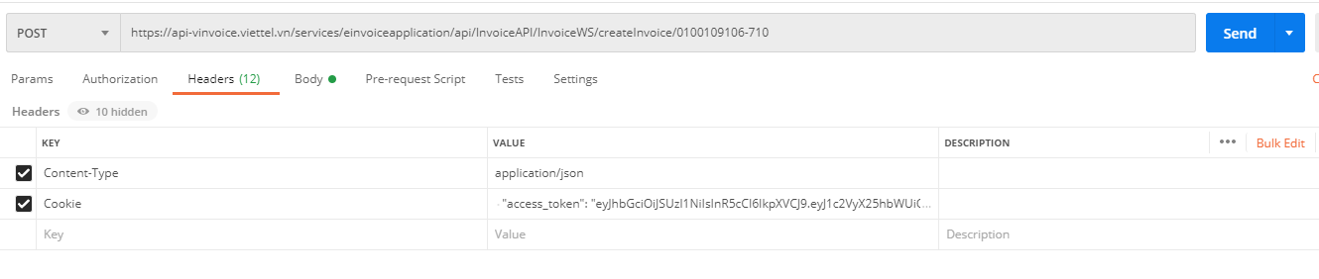

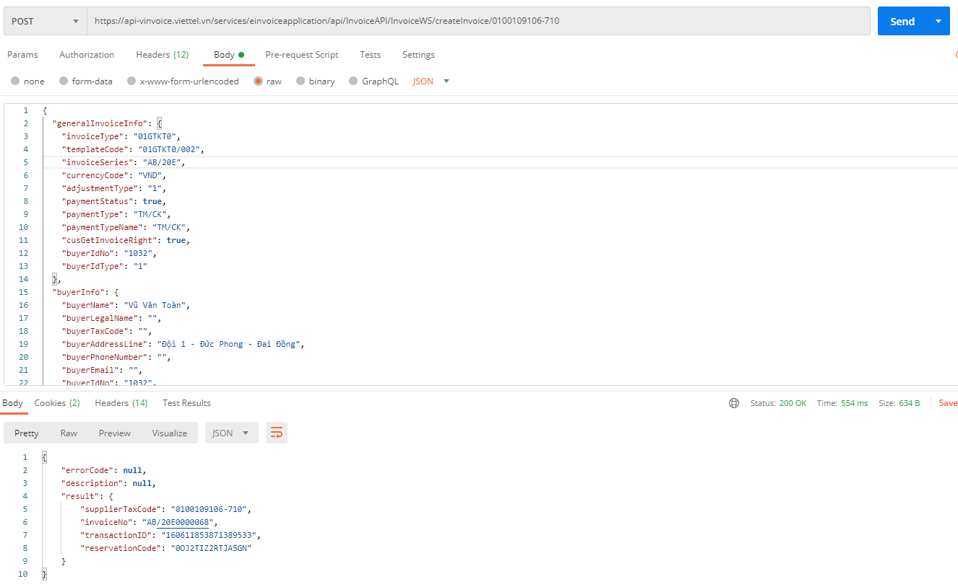

Get the invoice file
Webservice used for system integration can get invoice files after successfully issued.
Note:
- The electronic invoice system runs on an asynchronous mechanism, so the system pushes invoices to the database after receiving a request to issue an invoice about 1 second. Therefore, when integrating, the request to get the invoice file should be made 2-5 seconds after the invoice is issued.
- The system only retrieves invoices with available status (state = 1).
- Input:
- Action (POST): /InvoiceAPI/ InvoiceUtilsWS/getInvoiceRepresentationFile
- Headers:
+ Cookie: access_token value or Authorization: username/pass like logging in on the web or Authorization: username/pass like logging in on the web
+ Content-Type : application/json
Parameters of the CommonDataInput . object
Parameter name | Data types, constraints | Describe
supplierTaxCode | Required: true  DataType: String  Minlength:  Maxlength: 20  Format : [0-9-]+ | Tax identification number of the invoice-issuing business/branch. A business can have multiple tax codes  Model 1: 0312770607  Model 2: 0312770607-001  https://en.wikipedia.org/wiki/Thu%E1%BA%BF_Vi%E1%BB%87t_Nam
invoiceNo | Required : true  DataType: String  Minlength: 7  Maxlength: 15  Format : [a-zA-Z0-9]*$ | Invoice number, including invoice number and invoice number
templateCode | Required : true  DataType: String  Minlength :  Maxlength : 20  Format : | Invoice sample code  VD:  01GTKT0/001  1/001
transactionUuid | Required : false  DataType: String  Minlength : 10  Maxlength : 36  Format : N/A | The data check string (fkey) is passed in when invoicing. For details see section 6.2
fileType | Required : false  DataType: String  Minlength : 3  Maxlength : 3  Format : N/A | File type you want to download, allowed formats  ZIP, PDF
paid | Required : false  DataType: boolean  Minlength :  Maxlength :  Format : N/A | true – Paid  false – Unpaid

Sample example and data fields:
- JSON:
{
"supplierTaxCode":"0100109106-712",
"invoiceNo":"AA/20E0000166",
"templateCode":"01GTKT0/002",
"transactionUuid":"testuuid9999999",
"fileType":"ZIP"
}
- Output:
Response object with HTTPSstatus and output Entity.
School's name | Describe
errorCode | Error code (value is null, no error occurs)
description | Error description (value is null, no error occurs)
fileName | Download file name
fileToBytes | File content is converted to bytes  Invoice file bytes array, converting this bytes array to a file will yield a file containing invoice information. For example, a .zip file includes .xml, .xsl files, logo image, watermark, qrcode  Code converted to Java file  FileUtils.writeByteArrayToFile(newFile("D:/viettel/fileName.zip"), output.getFileToBytes());

Get the invoice file with the secret code
Allows to get the successfully issued invoice file with secret code check.
Note:
- The electronic invoice system runs on an asynchronous mechanism, so the system pushes invoices to the database after receiving a request to issue an invoice about 1 second. Therefore, when integrating, the request to get the invoice file should be made 2-5 seconds after the invoice is issued.
- The system only retrieves invoices with available status (state = 1).
- Input:
- Action (POST): InvoiceAPI/InvoiceUtilsWS/getInvoiceFilePortal
- Headers:
+ Cookie: access_token value or Authorization: username/pass like logging in on the web or Authorization: username/pass like logging in on the web
+ Content-Type : application/x-www-form-urlencoded

School's name | Data types, constraints | Describe
supplierTaxCode | Required: true  DataType: String  Minlength:  Maxlength: 20  Format: [0-9-]+ | Tax identification number of the invoice-issuing business/branch. A business can have multiple tax codes  Model 1: 0312770607  Form 2: 0312770607-001
templateCode | Required : true  DataType: String  Minlength :  Maxlength : 20  Format : | Invoice sample code  VD:  01GTKT0/001  1/001
invoiceNo | Required: true  DataType: String  Minlength: 7  Maxlength: 15  Format: [a-zA-Z0-9]*$ | Is invoice number = invoice symbol + invoice number eg : AA/20E0000001, according to tax department standards
buyerIdNo | Required: false  DataType: String  Minlength:  Maxlength: 100  Format: | Buyer's document number
reservationCode | Required: true  DataType: String  Minlength:  Maxlength: 100  Format: | Secret number
fileType | Required: true  DataType: String  Minlength:  Maxlength: 100  Format: | File type: zip
strIssueDate | Required: true  DataType:  Minlength:  Maxlength:  Format : Standard 5.1 | Invoice issue date
VD:
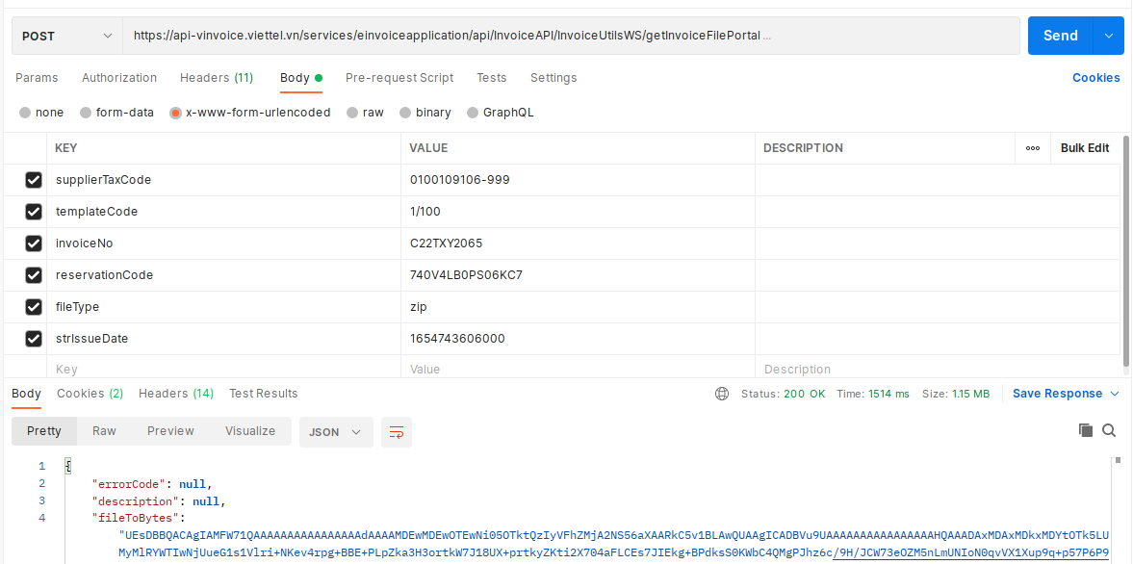Output:
The Response object describes the error status returned by the Webservice and the returned Webservice data object:
- For example : the result returned in the form of FormParam
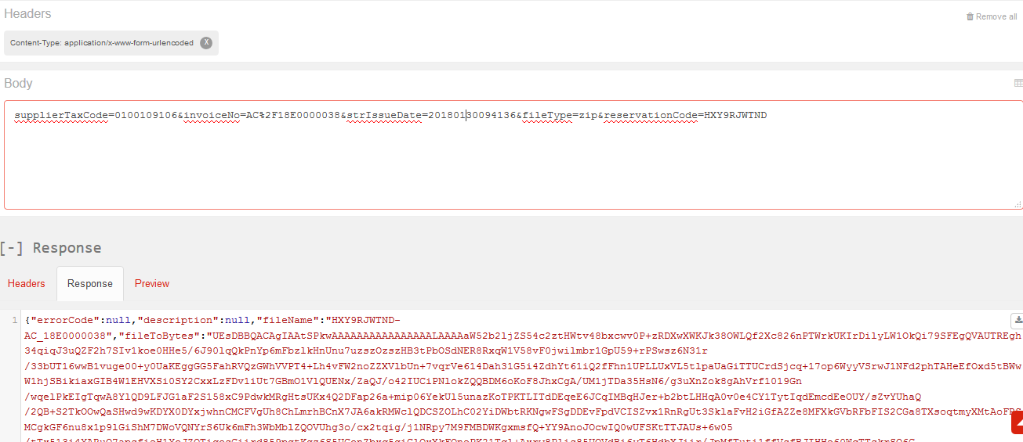
Describe
School's name | Describe
errorCode | Error code (value is null if receipt is successful)
description | Error description (value is null if invoice is successfully retrieved)
fileToBytes | Invoice file bytes array, converting this bytes array to a file will yield a file containing invoice information. For example, a .zip file includes .xml, .xsl files, logo image, watermark, qrcode  Code converted to Java file  FileUtils.writeByteArrayToFile(newFile("D:/viettel/fileName.zip"), output.getFileToBytes());
paymentStatus | Payment Status
fileName | Filename

Get the converted invoice file (pdf)
Allow the integrated system to get the converted invoice file of the electronic invoice. In case the invoice has been converted before, SInvoice will re-download the old file without creating a new file (Condition must be the same exchangeUser as the first conversion).
Note:
- The electronic invoice system runs on an asynchronous mechanism, so the system pushes invoices to the database after receiving a request to issue an invoice about 1 second. Therefore, when integrating, the request to get the invoice file should be made 2-5 seconds after the invoice is issued.
- The system only retrieves invoices with available status (state = 1).
- Input:
- Action (POST): InvoiceAPI/InvoiceWS/createExchangeInvoiceFile
- Headers:
+ Cookie: access_token value or Authorization: username/pass like logging in on the web or Authorization: username/pass like logging in on the web
+ Content-Type : application/x-www-form-urlencoded

School's name | Data types, constraints | Describe
supplierTaxCode | Required : true  DataType: String  Minlength :  Maxlength : 20  Format : [0-9-]+ | Seller's tax code  Invoice sample code, complying with the regulations on invoice sample symbols of the Circular guiding the implementation of Decree No. 51/2010/ND-CP
invoiceNo | Required : true  DataType: String  Minlength : 7  Maxlength : 15  Format : [a-zA-Z0-9]*$ | Is invoice symbol + invoice number eg: AA/20E0000001
strIssueDate | Required : true  DataType:  Minlength :  Maxlength :  Format: Standard 5.1 | Invoice date.
exchangeUser | Required : true  DataType: String  Minlength :  Maxlength : 100 | Converter Name (Need to do value encode: Reference: https://www.urlencoder.org/ )

- Data: FormParam format of the parameters passed.
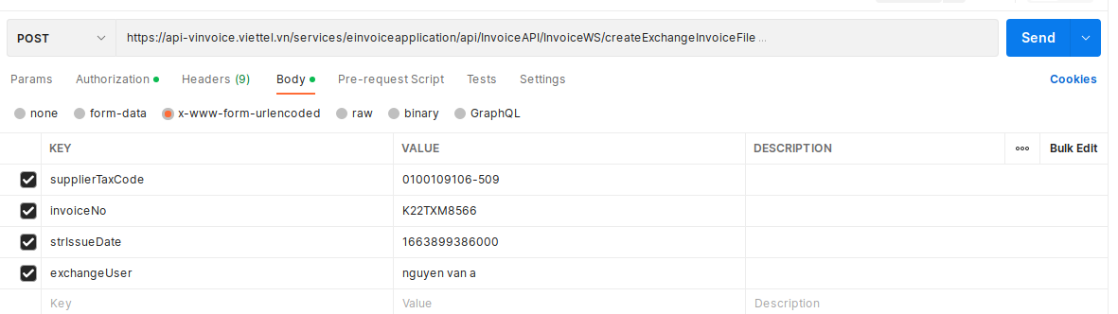
- Output:
The Response object describes the error status returned by the Webservice and the returned Webservice data object:
Describe
School's name | Describe
errorCode | Error code (value is null if receipt is successful)
description | Error description (value is null if invoice is successfully retrieved)
fileToBytes | Invoice byte file array, convert this byte array to a file that will be converted by invoice pdf file  Code converted to Java file  FileUtils.writeByteArrayToFile(newFile("D:/viettel/fileName.pdf"), output.getFileToBytes());
fileName | Name of invoice file

Response returned image
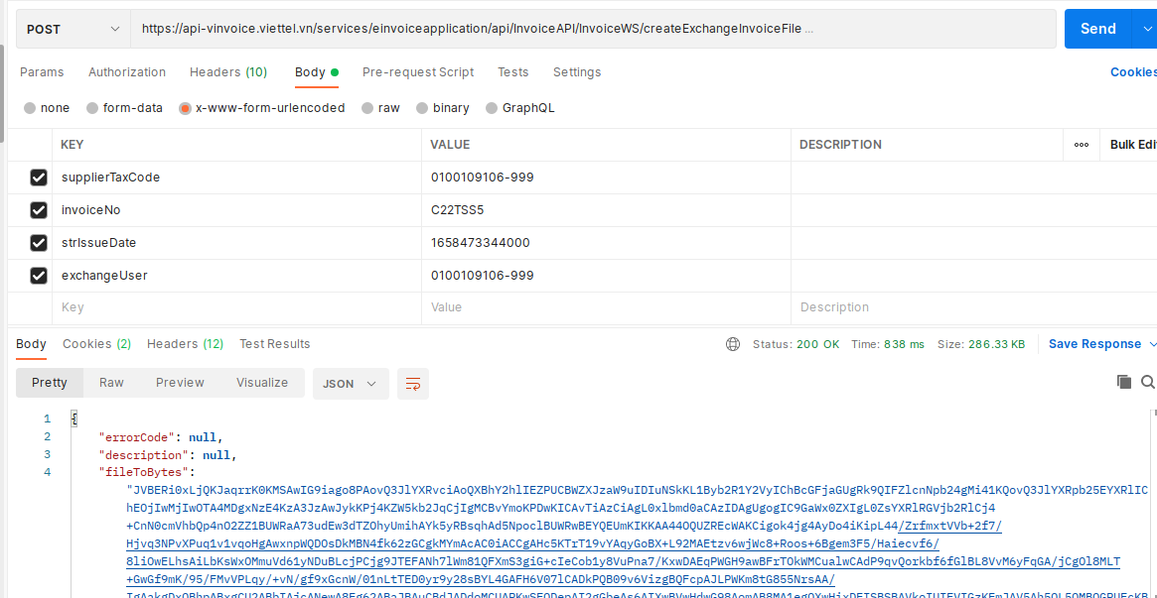

Look up invoices
In case a business has a web portal to look up invoices, it can connect to Viettel's Electronic Invoice web service to look up invoices according to the conditions.
For example, your customers can look up their invoices by time period.
- Input:
- Action (POST): InvoiceAPI/InvoiceUtilsWS/getInvoices/{supplierTaxCode}
- Headers:
+ Cookie: access_token value or Authorization: username/pass like logging in on the web or Authorization: username/pass like logging in on the web
+ Content-Type : application/json
School's name | Data types, constraints | Describe
supplierTaxCode | Required : true  DataType: String  Minlength :  Maxlength : 20  Format : [0-9-]+ | Tax identification number of the invoice-issuing business/branch. A business can have multiple tax codes  Model 1: 0312770607  Form 2: 0312770607-001
GetInvoiceInput | Object | The object consists of parameter data fields
- Data: JSON
  - Parameters of the GetInvoiceInput . object
Parameter name | Data types, constraints | Describe
invoiceNo | Required : false  DataType: String  Minlength : 7  Maxlength : 15  Format : [a-zA-Z0-9]*$ | Is invoice symbol + invoice number eg: AA/20E0000001
startDate | Required : true  DataType: Date  Minlength :  Maxlength : 50  Format : | Since  Format "2019-05-12"
endDate | Required : true  DataType: Date  Minlength :  Maxlength : 50  Format : | To date  Format "2019-05-12"
invoiceType | Required : false  DataType: String  Minlength :  Maxlength :  Format : | Invoice type, as one of the values  Circular 32: 01GTKT, 02GTTT, 03XKNB, 04HGDL, 07KPTQ  Circular 78 : 1, 2, 3, 4
rowPerPage | Required : true  DataType: Number  Min : 1  Max: | Number of lines per page
pageNum | Required : true  DataType: Number  Min : 0  Max | Page index
buyerTaxCode | Required : false  DataType: String  Minlength :  Maxlength : 20 | Customer's tax code
buyerIdNo | Required : false  DataType: String | Customer's document number
templateCode | Required : false  DataType: String  Minlength :  Maxlength : | Invoice sample code.
invoiceSeri | Required : false  DataType: String  Minlength :  Maxlength : 7  Format : [a-zA-Z0-9]*$ | Invoice series
getAll | Required : false  DataType: Boolean  Minlength:  Maxlength:  Format : true/false | Allows to look up invoice information of the whole enterprise for users of the parent company.  Values are true/false
issueStartDate | Required: false  DataType: Date  Minlength:  Maxlength: 50  Format: | Release date from date  Format "2019-05-12"
issueEndDate | Required: false  DataType: Date  Minlength:  Maxlength: 50  Format: | Release date to date  Format "2019-05-12"
Example of sending data with JSON:
{
"startDate" : " 2020-05-12 " ,
"endDate" : " 2020-05-12 ",
"invoiceType" : "02GTTT",
"rowPerPage" : 20,
"pageNum" : 1,
"templateCode" : null
}
- Output:
{
"errorCode": null,
"description": null,
"totalRow": 286,
"invoices": [
{
"invoiceId": 213469,
"invoiceType": "02GTTT",
"adjustmentType": "1",
"templateCode": "02GTTT0/089",
"invoiceSeri": "QT/17E",
"invoiceNumber": "0000003",
"invoiceNo": "QT/17E0000003",
"currency": "VND",
"total": 38000000,
"issueDate": 1587797116843 ,
"issueDateStr": null,
"state": null,
"requestDate": null,
"description": null,
"buyerIdNo": null,
"stateCode": null,
"subscriberNumber": null,
"paymentStatus": 1,
"viewStatus": 1,
"downloadStatus": null,
"exchangeStatus": null,
"numOfExchange": null,
"createTime": 1587797116843 ,
"contractId": null,
"contractNo": null,
"supplierTaxCode": "0100109106",
"buyerTaxCode": "6200000230",
"totalBeforeTax": 3800000,
"taxAmount": 0,
"taxRate": null,
"paymentMethod": null,
"paymentTime": null,
"customerId": null,
"buyerName": "Tran Trung Dung",
"no": null,
"paymentStatusName": null
}
}
Response object with HTTPSstatus and output Entity.
School's name | Describe
errorCode | Error code (value is null get invoice successfully)
description | Description of error (value is null get invoice successfully)
List<InvoiceBean> | List of invoice records that meet the condition

Get dynamic field information
For each invoice template, there can be different dynamic field information (information fields in addition to the static fields described in section 6). SInvoice allows integrated systems to retrieve dynamic field information for a specific invoice template used by a customer.
- Input:
- Action (GET): /InvoiceAPI/InvoiceWS/getCustomFields?taxCode=&templateCode =
- Headers:
+ Cookie: access_token value or Authorization: username/pass like logging in on the web or Authorization: username/pass like logging in on the web
Example: /InvoiceAPI/InvoiceWS/getCustomFields?taxCode=0100109106&templateCode=01GTKT0%2f001
- Data: the data passed in the form of Query Param includes the following parameters:
School's name | Data types, constraints | Describe
taxCode | Required : true  DataType: String  Minlength :  Maxlength : 20  Format : [0-9-]+ | Tax code
templateCode | Required : false  DataType: String  Minlength :  Maxlength : 20  Format : [a-zA-Z0-9/]+ | Invoice sample code, complying with the regulations on invoice sample symbols of the Circular guiding the implementation of Decree No. 51/2010/ND-CP  Note: Invoice templates with at least 1 release notice in draft status can get a dynamic field list via API
- Output:
The Response object is a dynamic field list that corresponds to the business invoice template :
- Example:
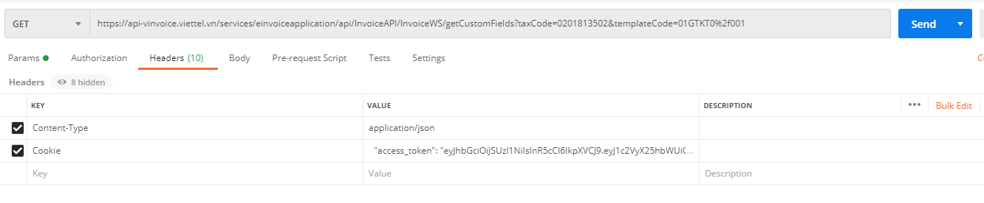
Result:
"errorCode": null,
"description": null,
"customFields": [
{
"id": null,
"invoiceTemplatePrototypeId": 2503,
"keyTag": "commandDes",
"valueType": "text",
"keyLabel": "about",
"isRequired": false,
"isSeller": false
},
{
"id": null,
"invoiceTemplatePrototypeId": 2503,
"keyTag": "contractNo",
"valueType": "text",
"keyLabel": "Contract number",
"isRequired": false,
"isSeller": false
},
{
"id": null,
"invoiceTemplatePrototypeId": 2503,
"keyTag": "vehicle",
"valueType": "text",
"keyLabel": "Transport vehicle",
"isRequired": false,
"isSeller": false
},
{
"id": null,
"invoiceTemplatePrototypeId": 2503,
"keyTag": "exportAt",
"valueType": "text",
"keyLabel": "Export at the warehouse",
"isRequired": false,
"isSeller": false
},
{
"id": null,
"invoiceTemplatePrototypeId": 2503,
"keyTag": "exportAtNo",
"valueType": "text",
"keyLabel": "Repository code",
"isRequired": false,
"isSeller": false
},
{
"id": null,
"invoiceTemplatePrototypeId": 2503,
"keyTag": "importAt",
"valueType": "text",
"keyLabel": "Input at the warehouse",
"isRequired": false,
"isSeller": false
},
{
"id": null,
"invoiceTemplatePrototypeId": 2503,
"keyTag": "importAtNo",
"valueType": "text",
"keyLabel": "Repository code",
"isRequired": false,
"isSeller": false
},
{
"id": null,
"invoiceTemplatePrototypeId": 2503,
"keyTag": "vehicleNo",
"valueType": "text",
"keyLabel": "Vehicle number",
"isRequired": false,
"isSeller": false
},
{
"id": null,
"invoiceTemplatePrototypeId": 2503,
"keyTag": "economicContractNo",
"valueType": "text",
"keyLabel": "Based on digital economic contract",
"isRequired": false,
"isSeller": false
},
{
"id": null,
"invoiceTemplatePrototypeId": 2503,
"keyTag": "commandDate",
"valueType": "date",
"keyLabel": "Mobilization date",
"isRequired": false,
"isSeller": false
},
{
"id": null,
"invoiceTemplatePrototypeId": 2503,
"keyTag": "commandOf",
"valueType": "text",
"keyLabel": "of",
"isRequired": false,
"isSeller": false
}
]
}

School's name | Data types, constraints | Describe
id | DataType: Number | Dynamic field ID
keyLabel | DataType: String | Dynamic field display name,  Displayed on input interface when invoicing
keyTag | DataType: String | Name of dynamic field when saving to data
valueType | DataType: String | The data type of the dynamic field. Include only values: “text”, “date”, “number”
isRequired | DataType: Boolean | Is the field mandatory?
isSeller | DataType: Boolean | isSeller = true: The data field belongs to the seller  isSeller = false: The data field belongs to the buyer
Sending invoicing data with dynamic fields: Add a metadata array, each element includes values mapped based on customFields received from response as follows
Inner field  (customFields) | Field name  (metadata) | Data types, constraints | Describe
id | invoiceCustomFieldId | Required : false  DataType: Number  Minlength :  Maxlength : 10  Format : | Dynamic field ID
keyTag | keyTag | Required : true  DataType: String | The name of the dynamic field when saving to data
valueType | valueType | Required : true  DataType: String | Data type of dynamic field. Include only values: “text”, “date”, “number”
keyLabel | keyLabel | Required : true  DataType: String | Display name of the dynamic field,  Displayed on input interface when invoicing
valueType = date | dateValue | Required : false  DataType: Date | The value of the data field in the case valueType = date
valueType = number | numberValue | Required : false  DataType: Number | The value of the data field in the case valueType = number
valueType = text | stringValue | Required : false  DataType: String | The value of the data field in the case valueType = text

{
"generalInvoiceInfo": {
"invoiceType": "03XKNB",
"templateCode": "03XKNB0/003",
"invoiceSeries": "AA/20E",
"currencyCode": "VND",
"adjustmentType": "1",
"paymentStatus": true,
"cusGetInvoiceRight": true
},
"sellerInfo": {
"sellerLegalName": "Seller",
"sellerTaxCode": "0100109106-712",
"sellerAddressLine": "Hanoi City - Vietnam",
"sellerPhoneNumber": "0123456789",
"sellerFaxNumber": "0123456789",
"sellerEmail": "email@gmail.com",
"sellerBankName": "Bank",
"sellerBankAccount": "012345678901",
"sellerDistrictName": "",
"sellerCityName": "Hanoi City",
"sellerCountryCode": "84",
"sellerWebsite": "sinvoice.viettel.vn"
},
"buyerInfo": {
"buyerName": "Customer Name",
"buyerLegalName": "Unit Name",
"buyerTaxCode": "0100109106",
"buyerAddressLine": "An Khanh Hoai Duc Hanoi",
"buyerPostalCode": "2342324323",
"buyerDistrictName": "No. 9, Street 11, VSIP Bac Ninh, Tu Son Town, Province",
"buyerCityName": "Hanoi City",
"buyerCountryCode": "84",
"buyerPhoneNumber": "987999999",
"buyerFaxNumber": "0458954",
"buyerEmail": "abc@gmail.com",
"buyerBankName": "MB Military Bank",
"buyerBankAccount": "01578987871236547",
"buyerIdType": "3",
"buyerIdNo": "8888899999",
"buyerCode": "832472343b_b",
"buyerBirthDay": ""
},
"payments": [
{
"paymentMethodName": "Pass the desired value here directly"
}
],
"taxBreakdowns": [
{
"taxPercentage": -1,
"taxableAmount": 27286150,
"taxAmount": 0
}
],
"itemInfo": [
{
"lineNumber": 1,
"itemCode": "HH0001",
"itemName": "Commodity 01",
"unitCode": null,
"unitName": "Unit",
"unitPrice": 150450,
"quantity": 100,
"selection": 1,
"itemTotalAmountWithoutTax": 15045000,
"taxPercentage": -1,
"taxAmount": 0,
"discount": null,
"discount2": null,
"itemDiscount": 0,
"itemNote": null,
"batchNo": null,
"expDate": null,
"isIncreaseItem": null
},
{
"lineNumber": 2,
"itemCode": "HH00002",
"itemName": "Commodity 02",
"unitCode": null,
"unitName": "The",
"unitPrice": 244823,
"quantity": 50,
"selection": 1,
"itemTotalAmountWithoutTax": 12241150,
"taxPercentage": -1,
"taxAmount": 0,
"discount": null,
"discount2": null,
"itemDiscount": 0,
"itemNote": null,
"batchNo": null,
"expDate": null,
"isIncreaseItem": null
}
],
"metadata": [
{
"keyTag": "commandDes",
"keyLabel": "about",
"dateValue": null,
"stringValue": "internal conversion",
"numberValue": null,
"valueType": "text",
"isRequired": false,
"isSeller": false,
"required": false
},
{
"keyTag": "contractNo",
"keyLabel": "Number contract",
"dateValue": null,
"stringValue": "Number contract",
"numberValue": null,
"valueType": "text",
"isRequired": false,
"isSeller": false,
"required": false
},
{
"keyTag": "vehicle",
"keyLabel": "Transportation vehicle",
"dateValue": null,
"stringValue": "truck",
"numberValue": null,
"valueType": "text",
"isRequired": false,
"isSeller": false,
"required": false
},
{
"keyTag": "exportAt",
"keyLabel": "Export at the warehouse",
"dateValue": null,
"stringValue": "Volume 1",
"numberValue": null,
"valueType": "text",
"isRequired": false,
"isSeller": false,
"required": false
},
{
"keyTag": "importAtNo",
"keyLabel": "Repository code",
"dateValue": null,
"stringValue": "KH2",
"numberValue": null,
"valueType": "text",
"isRequired": false,
"isSeller": false,
"required": false
},
{
"keyTag": "importAt",
"keyLabel": "Imported at warehouse",
"dateValue": null,
"stringValue": "Warehouse 2",
"numberValue": null,
"valueType": "text",
"isRequired": false,
"isSeller": false,
"required": false
},
{
"keyTag": "importAtNo",
"keyLabel": "Repository code",
"dateValue": null,
"stringValue": "KH0",
"numberValue": null,
"valueType": "text",
"isRequired": false,
"isSeller": false,
"required": false
},
{
"keyTag": "vehicleNo",
"keyLabel": "Vehicle number",
"dateValue": null,
"stringValue": "1524-jhh",
"numberValue": null,
"valueType": "text",
"isRequired": false,
"isSeller": false,
"required": false
},
{
"keyTag": "economicContractNo",
"keyLabel": "Based on digital economic contract",
"dateValue": null,
"stringValue": "123456",
"numberValue": null,
"valueType": "text",
"isRequired": false,
"isSeller": false,
"required": false
},
{
"keyTag": "commandDate",
"keyLabel": "Date of Maneuver",
"dateValue": "1605752798000",
"stringValue": null,
"numberValue": null,
"valueType": "date",
"isRequired": false,
"isSeller": false,
"required": false
},
{
"keyTag": "commandOf",
"keyLabel": "of",
"dateValue": null,
"stringValue": "ABC Company",
"numberValue": null,
"valueType": "text",
"isRequired": false,
"isSeller": false,
"required": false
}
]
}

Create draft invoices
- Input:
Webservice used to save draft invoice data to SInvoice system. These draft invoices have no invoice number or digital signature, can only be viewed/issued on SInvoice's website. When issued, the invoice numbers will not be updated to the integrated software.
- Action (POST): InvoiceAPI/InvoiceWS/createOrUpdateInvoiceDraft/{supplierTaxCode}
- Headers:
+ Cookie: access_token value or Authorization: username/pass like logging in on the web or Authorization: username/pass like logging in on the web
+ Content-Type : application/json
School's name | Data types, constraints | Describe
supplierTaxCode | Required: true  DataType: String  Minlength:  Maxlength: 20  Format: [0-9-]+ | Tax identification number of the invoice-issuing business/branch. A business can have multiple tax codes  Model 1: 0312770607  Model 2: 0312770607-001
- Data: JSON format
- The input data parameters are similar to the Invoicing section. Refer to json in section 6.2
Note:
In case of preparing an adjustment/replacement invoice for a paper invoice, add two tags in generalInvoiceInfo as follows:
School's name | Datatypes | Describe
originalInvoiceType | Required: false  DataType: String  Minlength: N/A  Maxlength:  Format: | Original invoice type  Pass a numeric value with the following meaning  0- Not paper invoices/invoices that don't exist on the system  1-Invoice TT78  2-Invoice according to Decision 1209  3-Electronic/Paper Invoice TT32  4-Paper invoice TT 78
originalTemplateCode | Required:  DataType: String  Minlength: N/A  Maxlength: 20  Format: | Casting is required if originalInvoiceType is 1, 2, 3 or 4  For example, sample TT32: 01GTKT0/001  Example TT78: 1/0224
When invoicing, the system does not check the existence of the original invoice on the system, other validation rules keep the status quo.
- Output:
The Response object describes the error status the Webservice returns and the data object the Webservice returns:
    - Data on information about draft invoices created successfully
{
"errorCode" : "" ,
"description" : "" ,
"result" : {
}
}
Describe
School's name | Describe
errorCode | Error code (value is null if invoiced successfully)
description | Error Description (value is null if invoiced successfully)

Note: In case the enterprise removes the data constraint, then add totalAmountAfterDiscount to summarizeInfo and save it according to this value (passing empty or null or not transmitting, recalculating). In case the enterprise does not remove the data binding, this field will not be processed (whether transmitted or not).

Invoicing in batches
*Rules for checking invoice date:
SInvoice V2 electronic invoice system, the General configuration section related to invoice date has 2 checkboxes: Allow invoice date to be different from the current date , Automatically set the value for invoice date equal to the most recent date.
When issuing invoices via API, the invoice date will be affected when the user selects these checkboxes. There are 4 cases as described below:
TH1: Don't tick both
- InvoiceIssuedDate null: get the current date and time (sysdate)
- Date of creation < date of creation of most recent invoice: date of creation is invalid
- Date of creation >= date of creation of the most recent invoice and <= current date: date of creation is invalid
- Establishment date > current date: get the transmitted date (do not check the time)
Case 2: Tick " Configure the signing date as the current time"
- InvoiceIssuedDate null: get the current date and time (sysdate)
- Date of creation < date of most recent invoice: get the date of the most recent invoice
- Creation date >= creation date of the most recent invoice and <= current date: get the transmitted date
- Creation date > current date: invalid creation date
Case 3: Tick " Automatically set the value for the invoice date to the most recent invoice date"
- InvoiceIssuedDate null: get the current date and time (sysdate)
- Date of creation < date of creation of most recent invoice: date of creation is invalid
- Creation date >= creation date of the most recent invoice and <= current date: get the transmitted date
- Creation date > current date: invalid creation date
TH4: Product of both
- InvoiceIssuedDate null: get the current date and time (sysdate)
- Date of creation < date of most recent invoice: get the date of the most recent invoice
- Date made >= the date of the last invoice and <= current date: get the date of transmission
- Created date > current date: invalid creation date
- In case customers want to invoice in batches, they will use the following function. Note that it is only used for HSM . digital certificates
Note:
- The system is allowing a maximum of 50 invoices / 1 lot due to the long processing time for each invoice, if you leave too many batches, there may be timeout. In case the data from the system is more integrated, it is possible to automatically split the number of invoices and send them over.
- Make only original invoices in batches
- In case the enterprise has removed the data constraint, then add totalAmountAfterDiscount to summarizeInfo and save it according to this value (passing empty or null or not transmitting, recalculating). In case the enterprise does not remove the data binding, this field will not be processed (whether transmitted or not).
- If it is a cash register invoice, the response will include the information CQT code issued: "codeOfTax", if not a cash register invoice, return codeOfTax = null
Example output sample
{
"errorCode": null,
"description": null,
"result": {
"supplierTaxCode": "0100109106-710",
"invoiceNo": "C23MHY3",
"transactionID": "168378907853232661",
"reservationCode": "2QTBFEMAXFWZO5B",
"codeOfTax": "M1-23-34567-0000000201"
}
}
- If the No-Billing configuration has an initialization code from the cash register and the invoice is of cash register type, it allows businesses using USB Token and CloudCA signatures to bill in batches using the API Server.
- Input:
- Action (POST): InvoiceAPI/InvoiceWS/createBatchInvoice/{supplierTaxCode}
- Headers:
+ Cookie: value of access_token or Authorization: username/pass like login on web or Authorization: username/pass like login on web
+ Content-Type : application/json
School's name | Data types, constraints | Describe
supplierTaxCode | Required: true  DataType: String  Minlength:  Maxlength: 20  Format: [0-9-]+ | Tax identification number of the invoice-issuing business/branch. A business can have multiple tax codes  Model 1: 0312770607  Form 2: 0312770607-001

- Data: Batch invoicing sample data
JSON
Invoicing in batches
The results of successful batch invoicing will return results according to the transactionUuid to determine which invoices are successful and which invoice numbers are generated.
- Output:
School's name | Describe
createInvoiceOutputs | Results returned when the invoice is made successfully (pay the invoice number)
lstMapError | Description of the error ( the errors encountered by the invoice ds )
totalSuccess | Total number of successful invoice creation lines
totalFail | Total number of defective invoices that have not been issued successfully

Example of returned results:
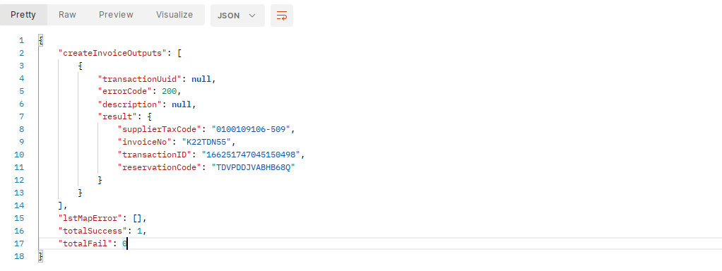

Error about wrong, missing information
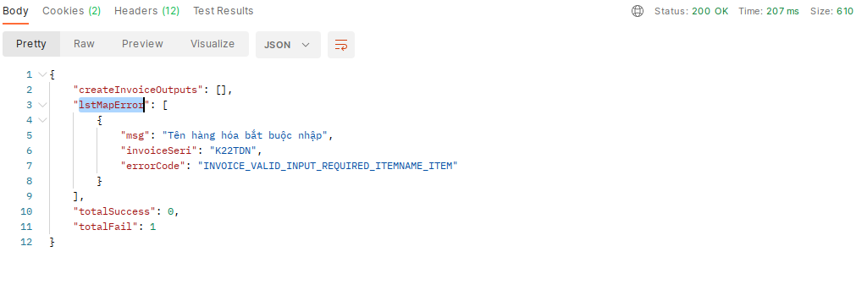
The json and token format errors will be returned in the format
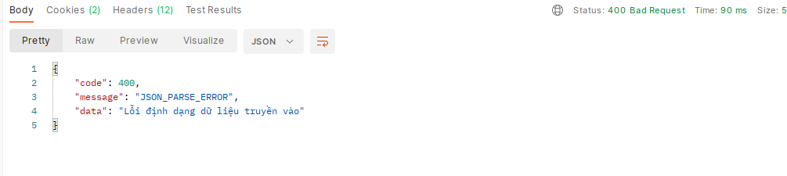

Cancelling invoice
Allows invoice deletion (move invoice to delete state) from the integrated system.
- Input:
- Action (POST): InvoiceAPI/InvoiceWS/cancelTransactionInvoice
- Headers:
+ Cookie: value access_token or Authorization: username/pass like login on web or Authorization: username/pass like login on web
+ Content-Type : application/x-www-form-urlencoded

School's name | Data types, constraints | Describe
supplierTaxCode | Required : true  DataType: String  Minlength :  Maxlength : 20  Format : [0-9-]+ | Tax identification number of the invoice-issuing business/branch. A business can have multiple tax codes  Model 1: 0312770607  Form 2: 0312770607-001
templateCode | Required : false  DataType: String  Minlength :  Maxlength : 20  Format : | Invoice sample code  VD:  01GTKT0/001  1/001
invoiceNo | Required : true  DataType: String  Minlength : 7  Maxlength : 15  Format : [a-zA-Z0-9/]+ | Is invoice number = invoice symbol + invoice number .  eg: AA/20E0000001
strIssueDate | Required : true  DataType :  Minlength :  Maxlength :  Format: Standard 5.1 | Invoice date (do not exceed current date)
additionalReferenceDesc | Required : true  DataType: String  Minlength : 1  Maxlength : 400 | Name of invoice cancellation agreement document
additionalReferenceDate | Required : true  DataType:  Minlength :  Maxlength :  Format: Standard 5.1 | Agreement date (do not exceed current date)
reasonDelete | Required: False  DataType: String  Minlength: N/A  Maxlength: 255  Format: | Reason for canceling invoice  Allows you to enter up to 255 characters

Form Data Example:
- Output:
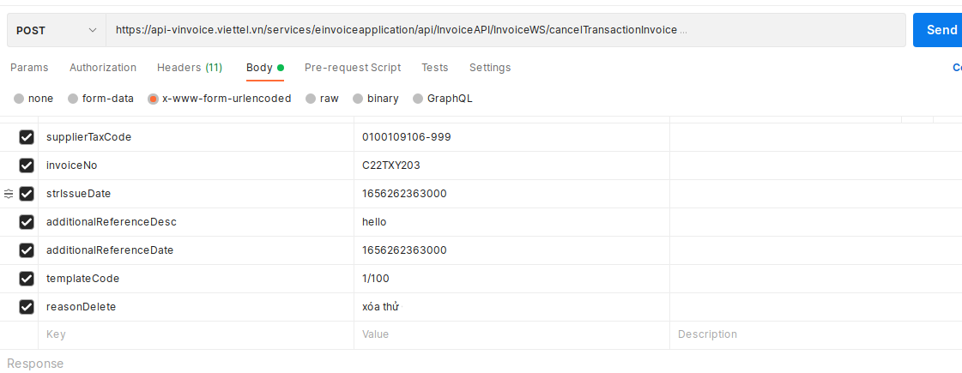
The Response object describes the error status returned by the Webservice and the returned Webservice data object:
Successful return example:
{
"errorCode": null,
"description": "CANCEL TRANSACTION INVOICE SUCCESS"
}
    - Error code table:
Describe
School's name | Describe
errorCode | Error code (value is null if receipt is successful)
description | Description of the error (value is null if receipt is successful),  Check if invoices are original invoices, undeclared, paid status, not adjusted invoices, replacement invoices and not and canceled adjusted invoices or not? If you have to return invalid invoice information

Update tax declaration
Allowing the integrated system to send updated tax declaration information to, to prevent customers from making mistakes during use (actually declared invoices can still be deleted or replaced).
- Input:
- Action (POST): InvoiceAPI/InvoiceUtilsWS/updateTaxDeclaration/
- Headers:
+ Cookie: value access_token or Authorization: username/pass like login on web or Authorization: username/pass like login on web
+ Content-Type: application/json
includes parameters:
School's name | Data types, constraints | Data/description
supplierTaxCode | Required: true  DataType: String  Minlength:  Maxlength: 20  Format: [0-9-]+ | Tax identification number of the invoice-issuing business/branch. A business can have multiple tax codes  Model 1: 0312770607  Form 2: 0312770607-001
strIssueDate | Required: true  DataType: String  Minlength:  Maxlength:  Format: dd/mm/yyyy | Invoice date

- Example with json format:
{
"supplierTaxCode":"0100109106",
"strIssueDate":"March 14, 2018"
}

- Output:
Image Response returned successfully
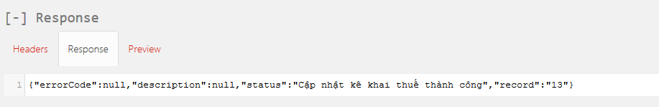

Provide usage status of invoices by strip
Returns detailed information on the number of invoices used, the remaining amount of an invoice range so that the integration partner can proactively warn the customer in the event of insufficient invoices.
- Input:
- Action (POST): /InvoiceAPI/ InvoiceUtilsWS/getProvidesStatusUsingInvoice
- Headers:
+ Cookie: value of access_token or Authorization: username/pass like login on web or Authorization: username/pass like login on web
+ Content-Type : application/json
Parameters of the CommonDataInput . object
Parameter name | Data types, constraints | Describe
supplierTaxCode | Required : true  DataType: String  Minlength :  Maxlength : 20  Format : [0-9-]+ | Tax identification number of the invoice-issuing business/branch. A business can have multiple tax codes  Model 1: 0312770607  Form 2: 0312770607-001
templateCode | Required : true  DataType: String  Minlength :  Maxlength : 20  Format : | Invoice sample code  Invoice sample code, complying with the regulations on invoice form symbols of the Circular guiding the implementation of Decree No. 51/2010/ND-CP  For details, see PL1 Circular 39/2014/TT-BTC
serial | Required : true  DataType: String  Minlength :  Maxlength : 7  Format : [a-zA-Z0-9]*$ | Invoice series

Sample example and data fields:
- JSON:
{
"supplierTaxCode":"0100109106-712",
"templateCode":"01GTKT0/003",
"serial":"AA/20E"
}
- Output:
Response object with HTTPSstatus and output Entity.
School's name | Describe
errorCode | Error code (value is null, no error occurs)
description | Error description (value is null, no error occurs)
statuses | Status (value is 200 get successful invoice usage information)
numOfpublishInv | Total number of invoices issued
totalInv | Total number of invoices that can be made with invoice template + input strip

Provide a list of invoices by time period
Returns detailed information of invoices so that the invoice can be verified for a period of time.
- Input:
- Action (POST): /InvoiceAPI/ InvoiceUtilsWS/getListInvoiceDataControl
- Headers:
+ Cookie: access_token value or Authorization: username/pass like logging in on the web or Authorization: username/pass like logging in on the web
+ Content-Type : application/json
Parameters of the CommonDataInput . object
Parameter name | Data types, constraints | Describe
supplierTaxCode | Required : true  DataType: String  Minlength :  Maxlength : 20  Format : [0-9-]+ | Tax identification number of the invoice-issuing business/branch. A business can have multiple tax codes  Model 1: 0312770607  Form 2: 0312770607-001
fromDate | Required : true  DataType: String  Format: dd/MM/yyyy | Start date you want to search
toDate | Required : true  DataType: String  Format: dd/MM/yyyy | The end date you want to search for
Sample example and data fields:
- JSON:
{ "supplierTaxCode":"0100109106",
"fromDate":"March 10, 2018",
"toDate":"March 16, 2018"
}
- Output:
Response object with HTTPSstatus and output Entity.
School's name | Describe
errorCode | Error code (value is null, no error occurs)
description | Error description (value is null, no error occurs)
lstInvoiceBO | List of invoices generated by the time passed in
Note the adjustmentType of the returned invoice:
School's name | Describe
adjustmentType | Invoice type :  1: Original invoice  3: Replacement invoice  Information adjustment invoice  7: Invoice deleted  9 : Money adjustment invoice
{
"errorCode": null,
"description": null,
"totalRows": 8162,
"invoices": [
{
"invoiceId": 16376495,
"invoiceType": "1",
"adjustmentType": "1",
"templateCode": "1/011",
"invoiceSeri": "K22TXK",
"invoiceNumber": "0037294",
"invoiceNo": "K22TXK37294",
"currency": "VND",
"total": 13627273.000000000,
"issueDate": 1663204962000,
"issueDateStr": null,
"state": 1,
"requestDate": null,
"description": null,
"buyerIdNo": "",
"stateCode": 1,
"subscriberNumber": null,
"paymentStatus": 1,
"viewStatus": null,
"downloadStatus": null,
"exchangeStatus": 0,
"numOfExchange": null,
"createTime": 1663204962000,
"contractId": null,
"contractNo": null,
"supplierTaxCode": "0100109106-509",
"buyerTaxCode": "",
"totalBeforeTax": 13627273.000000000,
"taxAmount": 0E-9,
"taxRate": null,
"paymentMethod": "5",
"paymentTime": null,
"customerId": null,
"no": null,
"paymentStatusName": "Paid",
"buyerName": "Nguyen Van A",
"transactionUuid": "E8AE136CEF1272AAE05324011E0A9838"
}
]
}

Email invoices to customers
- In case the customer has configured an email server and an email form on the SInvoice system, the system will automatically send an email to the buyer when there is an email in the invoice information. This API allows the software to actively integrate the sending of emails to the customer, in case the email's configuration is not working or wants to resend the email to the customer when required.
- Attention:
+ Add a link to look up invoices by secret code in the invoice email sent to the buyer.
+ In case the data is valid, the system emails the invoice to the buyer according to the configured form, replacing the information in {} marks with the current invoice/seller information, adding an additional line. link lookup invoice by secret code at parameter {link-invoice-search}.
- Input:
- Action (POST): /InvoiceAPI/ InvoiceUtilsWS/sendHtmlMailProcess
- Headers:
+ Cookie: access_token value or Authorization: username/pass like logging in on the web or Authorization: username/pass like logging in on the web
+ Content-Type : application/json
- sendHtmlMailProcess parameters
Parameter name | Data types, constraints | Describe
supplierTaxCode | Required : true  DataType: String  Minlength :  Maxlength : 20  Format : [0-9-]+ | Tax identification number of the invoice-issuing business/branch. A business can have multiple tax codes  Model 1: 0312770607  Form 2: 0312770607-001
lstTransactionUuid | Required : true  DataType: String | List of key requests, each transactionUuid corresponds to 1 invoice (Validate transactionUuid length is between 10 - 36 characters). The transactionsUuid are separated by ","

Sample example and data fields:
- JSON:
{
"supplierTaxCode":"0100109106-712s",
"lstTransactionUuid":"idtest9999999999,testuuid8888888,transactionUuid123"
}

- Output:
Response object with HTTPStatus and output Entity.
School's name | Describe
errorCode | Error code (value is null no error occurs)
description | Error description (value is null no error occurs)

Issue/replace/adjust to USB-TOKEN (Step 1: Get hash string)
*Rules for checking invoice date:
SInvoice V2 electronic invoice system, the General configuration section related to invoice date has 2 checkboxes: Allow invoice date other than the current date , Automatically set the value for invoice date equal to the most recent date.
When issuing invoices via API, the invoice date will be affected when the user selects these checkboxes. There are 4 cases as described below:
TH1: Don't tick both
- Date created (invoiceIssuedDate) null: get the current date and time (sysdate)
- Date made < date of the last invoice: invalid date
- Date of creation >= date of last invoice and <= current date: invalid date
- Establishment date > current date: get the transmitted date (do not check the time)
Case 2: Tick " Configure the signing date as the current time"
- InvoiceIssuedDate null: get the current date and time (sysdate)
- Date of creation < date of most recent invoice: get the date of the most recent invoice
- Creation date >= creation date of the most recent invoice and <= current date: get the transmitted date
- Creation date > current date: invalid creation date
Case 3: Tick " Automatically set the value for the invoice date to the most recent invoice date"
- InvoiceIssuedDate null: get the current date and time (sysdate)
- Date made < date of the last invoice: invalid date
- Date made >= the date of the last invoice and <= current date: get the date of transmission
- Created date > current date: invalid creation date

TH4: Product of both
- Date created (invoiceIssuedDate) null: get the current date and time (sysdate)
- Date made < date of the last invoice: get the date of the most recent invoice
- Date made >= the date of the last invoice and <= current date: get the date of transmission
- Created date > current date: invalid creation date
- Generate xml file and hash string of XML file of invoice signed by USB Token.
- Input:
- Action (POST): InvoiceAPI/InvoiceWS/createInvoiceUsbTokenGetHash/{supplierTaxCode}
- Headers:
+ Cookie: access_token value or Authorization: username/pass like logging in on the web or Authorization: username/pass like logging in on the web
+ Content-Type : application/json
Similar inputs such as invoicing, adding attached deed information.
Added Invoice Error Reason field. Adjustment to allow transmission of negative signs of quantity/unit price
Parameter name | Data types, constraints | Describe
certificateSerial | Required : true  DataType: String  Minlength :  Maxlength : 100  Format : | Serial Number of the business's digital certificate, this digital certificate has been pushed onto the system by the business when registering to use USB Token.  Hex format.  Example: 5404FFFEB7033FB316D672201B7BA4FE
adjustedNote | Required: False  DataType: String  Minlength: N/A  Maxlength: 255  Format: | Reason for error  Allows you to enter a maximum character string of 255 characters.  Transmission is not required.  Set in generalInvoiceInfo
unitPrice | Required: false  DataType: BigDecimal  Minlength:  Maxlength:  Format: [0-9.]+ - | Unit price of the goods.  Constraint rules keep the status quo.  Added permission to pass negative values
quantity | Required: false  DataType: BigDecimal  Minlength:  Maxlength:  Format: [0-9.]+ - | Quantity of goods  Constraint rules keep the status quo.  Added permission to pass negative values
originalInvoiceType | Required: True  DataType: String  Minlength: N/A  Maxlength:  Format: | Original invoice type  Pass a numeric value with the following meaning  0- Not paper invoices/invoices that don't exist on the system  1-Invoice TT78  2-Invoice according to Decision 1209  3-Electronic/Paper Invoice TT32  4-Paper invoice TT 78  Attention :  - In case the originalInvoiceType tag is not transmitted or the empty value/0 is transmitted, the originalTemplateCode tag is not required to be transmitted, the system validates the information when making an invoice as is.  - In case the originalInvoiceType tag transmits the value 1, 2, 3 or 4, then  + The originalTemplateCode tag must be passed, the validation rules for this tag are similar to the current templateCode tag.  + When making an invoice, the system does not check the existence of the original invoice on the system, other authentication rules remain the same
originalTemplateCode | Required:  DataType: String  Minlength: N/A  Maxlength: 20  Format: | Casting is required if originalInvoiceType is 1, 2, 3 or 4  For example, sample TT32: 01GTKT0/001  For example, model TT78: 1/0224

{
"generalInvoiceInfo":{
"invoiceType":"01GTKT",
"templateCode":"01GTKT0/170",
"invoiceSeries":"AA/17E",
"transactionUuid": "123e4567-e89b-12d3-a456-42665540000",
"invoiceIssuedDate": 1587797116843 ,
"currencyCode":"VND",
"adjustmentType":"1",
"adjustedNote":"",
"originalInvoiceType": "1",
"originalTemolateCode": "1/0224",
"paymentStatus":true,
"paymentType":"TM",
"paymentTypeName":"TM",
"cusGetInvoiceRight":true,
"userName":"user1",
“certificateSerial”:”5404FFFEB7033FB316D672201B7BA4FE”
},
"buyerInfo":{
"buyerName":"Dang Thi Thanh Tam",
"buyerLegalName":"",
"buyerTaxCode":"",
"buyerAddressLine":"HN VN",
"buyerPhoneNumber":"11111",
"buyerEmail":"",
"buyerIdNo":"123456789",
"buyerIdType":"1"
},
"sellerInfo":{
"sellerLegalName":"Dang Thi Thanh Tam",
"sellerTaxCode":"0100109106-501",
"sellerAddressLine":"test",
"sellerPhoneNumber":"0123456789",
"sellerEmail":"PerformanceTest1@viettel.com.vn",
"sellerBankName":"vtbank",
"sellerBankAccount":"23423424"
},
"extAttribute":[

],
"payments":[
{
"paymentMethodName":"TM"
}
],
"deliveryInfo":{

},
"itemInfo":[
{
"lineNumber":1,
"itemCode":"ENGLISH_COURSE",
"itemName":"English course",
"unitName":"course",
"unitPrice":"-3500000.0",
"quantity":"-10.0",
"itemTotalAmountWithoutTax":35000000,
"taxPercentage":10.0,
"taxAmount":0.0,
"discount":0.0,
"itemDiscount":150000.0
}
],
"discountItemInfo":[

],
"metadata":[

],

" meterReading": [{
"previousIndex": "5454",
"currentIndex": "244",
"factor": "22",
"amount": "2"
},
{
"previousIndex": "44",
"currentIndex": "44",
"factor": "33",
"amount": "3"
}],
"summarizeInfo":{
"sumOfTotalLineAmountWithoutTax":35000000,
"totalAmountWithoutTax":35000000,
"totalTaxAmount":3500000.0,
"totalAmountWithTax":38500000,
"totalAmountWithTaxInWords":"Thirty eight million five hundred thousand even",
"discountAmount":0.0,
"settlementDiscountAmount":0.0,
"taxPercentage":10.0
},
"taxBreakdowns":[
{
"taxPercentage":10.0,
"taxableAmount":35000000,
"taxAmount":3500000.0
}
]
}
    - Hash string data returned
{
"errorCode" : "" ,
"description" : "" ,
"result" : {
"hashString" : 0HFm34vX525V3Syg5EwdTnfO21s= , }
}
Example response in case originalInvoiceType . is passed incorrectly
{
"code": 400,
"message": "BAD_REQUEST_ORIGINAL_INVOICE_TYPE_INVALID",
"data": "BAD_REQUEST_ORIGINAL_INVOICE_TYPE_INVALID"
}
Note:
- The original invoice data is stored in the instance_file_name column in the invoice table as follows:
Invoice Type | Invoice Form | Invoice symbol | Some bills
in there:
- Invoice type is card value originalInvoiceType
- Invoice template is the originalTemplateCode . tag value
- In case the enterprise removes the data constraint, add totalAmountAfterDiscount to summarizeInfo and save this value (if it is empty or null or not transmitted, then recalculate). In case the enterprise does not remove the data binding, this field will not be processed (whether transmitted or not).
Output :
School's name | Data types, constraints | Describe
errorCode | DataType: String | Error code if any, if there is no error, return null
description | DataType: String | Detailed error description
hashString | DataType: String | Return Hash String of Invoice, Base64

Issuance/replacement/modification for USB-TOKEN (Step 2: Sign USB token and generate invoice)
- Use USB-TOKEN to sign the hashString received from the API in step 6.15. Get the signature string to generate an invoice.
- Input:
- Action (POST): InvoiceAPI/InvoiceWS/createInvoiceUsbTokenInsertSignature
- Headers:
+ Cookie: access_token value or Authorization: username/pass like logging in on the web or Authorization: username/pass like logging in on the web
+ Content-Type : application/json
Parameter name | Data types, constraints | Describe
supplierTaxCode | Required : true  DataType: String  Minlength :  Maxlength : 20  Format : [0-9-]+ | Tax identification number of the invoice-issuing business/branch. A business can have multiple tax codes  Model 1: 0312770607  Form 2: 0312770607-001
templateCode | Required : true  DataType: String  Minlength :  Maxlength : 20 | Invoice sample code.
hashString | Required : true  DataType: String | The Hash string that the data returned is in the getHash request above  = out put of API : 7.15 USB Token Signing Billing (Step 1: Get the hash string)
signature. signature | Required : true  DataType: String | Signature after hashString has been signed by USB token. Base64 format
Json example
{
"supplierTaxCode": "0100109106-712",
"templateCode": "01GTKT0/002",
"hashString": "0HFm34vX525V3Syg5EwdTnfO21s=",
"signature": "U0WpJk2Q/rDsnZDz8hiWKvs6QEf5DHTG8JyXjjNMtggZ/MIDP0hn9Mutc2uPZEOxqk2YnMjuRSxU8ST/T+C5i46Vb/0+7uIfzKpPm2yrsOSivCdzr6FrY6nJPkfkOWEdEs/hqDzcf 4Vn8ZCVkNfovYR4prPGc7kNpO21sNb9BAI="
}
Results returned
    - Data on information about issued invoices0
{
"errorCode" : "" ,
"description" : "" ,
"result" : {
"supplierTaxCode" : 0100109106-712 ,
"invoiceNo" : AA / 20E0000018 ,
"transactionID" : 12523522245 ,
"reservationCode" : AXHBNK8I0H
}
}

School's name | Describe
errorCode | Error code (value is null if invoiced successfully)
description | Error Description (value is null if invoiced successfully)
supplierTaxCode | Seller tax code (invoice-issuing business)
invoiceNo | Invoice number eg: AA\20E0000001
transactionID | Id of the transaction
reservationCode | Secret codes used by customers to look up
More information at https://sinvoice.viettel.vn/download/soft/signhash.rar
Note: If it is a cash register invoice, the response will return information including the CQT code issued: "codeOfTax", if it is not a cash register invoice, return codeOfTax = null
Example output sample
{
"errorCode": null,
"description": null,
"result": {
"supplierTaxCode": "0100109106-710",
"invoiceNo": "C23MHY3",
"transactionID": "168378907853232661",
"reservationCode": "2QTBFEMAXFWZO5B",
"codeOfTax": "M1-23-34567-00000000201"
}
}

Switch fonts
Support converting from fonts to unicode (Customers use this API) combined with the invoice creation API to convert data
- Input:
- Action (POST): InvoiceAPI/InvoiceUtilsWS/convertFont
- Headers:
+ Cookie: access_token value or Authorization: username/pass like logging in on the web or Authorization: username/pass like logging in on the web
+ Content-Type : application/json
Parameter name | Data types, constraints | Describe
font | Required : true  DataType: String | Font data, supporting data include:  VNI  TCVN3  TCVN1
data | Required : true  DataType: String | Data to be transferred
json example:
{
"font": "TCVN3",
"data": "Data is not Unicode-ready to convert"
}
Results returned
{
"errorCode": null,
"description": null,
"result": "Unicode standard data to convert"
}

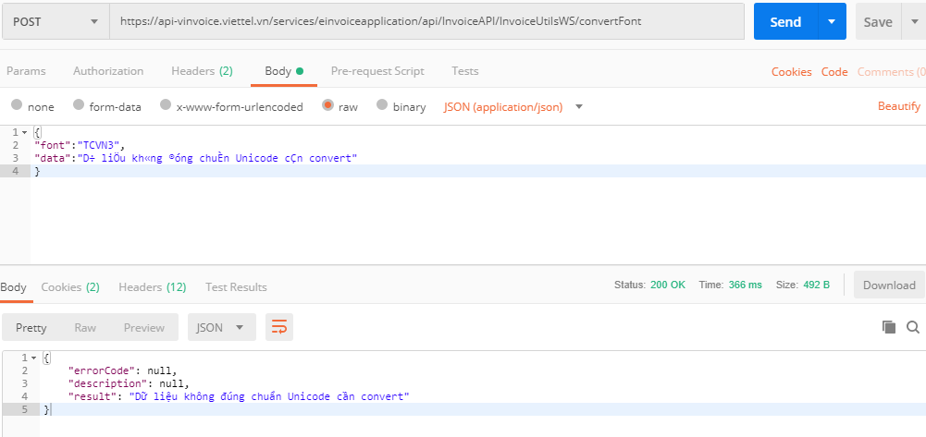

School's name | Describe
errorCode | Error code (value is null if font conversion is successful)
description | Error description (value is null if font conversion is successful)
result. result | Data after being converted to Unicode standard

Update payment status
Allows the integrated system to update the billing status of the invoice to paid.
- Input:
- Action (POST): InvoiceAPI/InvoiceWS/updatePaymentStatus
- Headers:
+ Cookie: access_token value or Authorization: username/pass like logging in on the web or Authorization: username/pass like logging in on the web
+ Content-Type : application/x-www-form-urlencoded
- Data: data passed in the form of Form Param includes the following parameters:
School's name | Data types, constraints | Data/Description
supplierTaxCode | Required: true  DataType: String  Minlength:  Maxlength: 20  Format: [0-9-]+ | Tax identification number of the invoice-issuing business/branch. A business can have multiple tax codes  Model 1: 0312770607  Form 2: 0312770607-001
templateCode | Required: true  DataType: String  Minlength:  Maxlength: 20  Format: | Sample invoice number
invoiceNo | Required: true  DataType: String  Minlength: 7  Maxlength: 15  Format: [a-zA-Z0-9]*$ | Is the invoice symbol + invoice number eg: AA/20E0000001
buyerEmailAddress | Required: false  DataType: String  Minlength:  Maxlength: 2000  Format: ^[_A-Za-z0-9-\+]+(\.[_A-Za-z0-9-]+)*@[A-Za-z0-9-]+(\.[A-) Za-z0-9]+)*(\.[A-Za-z]{2,})$ | Buyer's Email
strIssueDate | Required: false  DataType :  Minlength:  Maxlength:  Format: Standard 5.1 | Invoice date
paymentType | Required: false  DataType: String  Minlength:  Maxlength:  Format: | Type of payment method
paymentTypeName | Required: false  DataType: String  Minlength:  Maxlength:  Format: | Payment method name
cusGetInvoiceRight | Required: false  DataType: Boolean  Minlength:  Maxlength:  Format: true/false | Show customers invoices in Manage invoices
    - FormParam format example
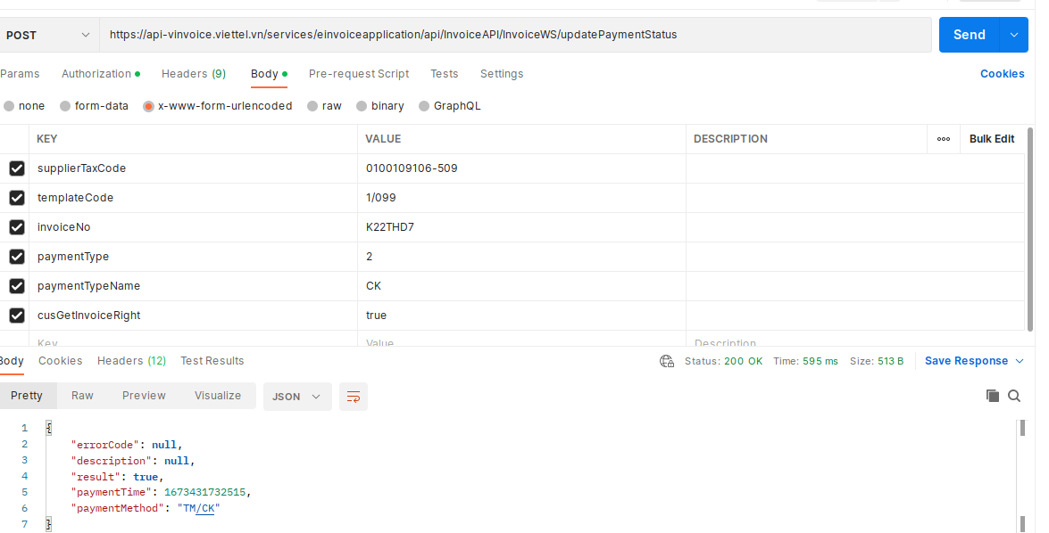
Returned data
{"errorCode":null,"description":null,"result":true,"paymentTime":null,"paymentMethod":null}
Describe
School's name | Describe
errorCode | Error code (value is null if payment status update was successful)
description | Error description (value is null if payment status update was successful)
result. result | Payment status update results  Success: true  Failed: false
paymentTime | Payment status update time
paymentMethod | Payment methods

Cancel payment status
Allows you to change the payment status of an invoice to unpaid.
- Input:
- Action (POST): InvoiceAPI/InvoiceWS/cancelPaymentStatus
- Headers:
+ Cookie: access_token value or Authorization: username/pass like logging in on the web or Authorization: username/pass like logging in on the web
+ Content-Type : application/x-www-form-urlencoded

School's name | Data types, constraints | Data/Description
supplierTaxCode | Required : true  DataType: String  Minlength :  Maxlength : 20  Format : [0-9-]+ | Tax identification number of the invoice-issuing business/branch. A business can have multiple tax codes  Model 1: 0312770607  Form 2: 0312770607-001
invoiceNo | Required : true  DataType: String  Minlength : 7  Maxlength : 15  Format : [a-zA-Z0-9]*$ | Is invoice symbol + invoice number eg: AA/20E0000001
strIssueDate | Required : true  DataType:  Minlength :  Maxlength :  Format: Standard 5.1 | Invoice date
    - FormParam . format example
supplierTaxCode=0100109106-712&invoiceNo=AA%2F20E0000002&strIssueDate=1600154781000
    - Returned data
{
"errorCode": null,
"description": "Success"
}

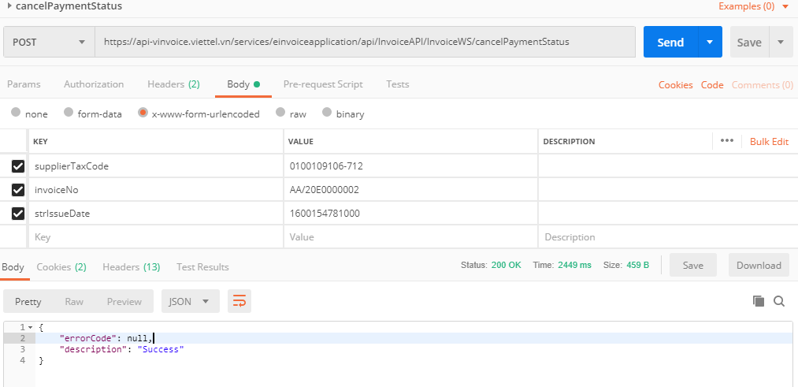

Preview draft invoices
- Input:
Webservice used to get PDF files of data to view. The integrated system pushes the invoicing data and SInvoice returns a PDF file of that data, the data will not be saved in SInvoice.
- Action (POST): InvoiceAPI/InvoiceUtilsWS/createInvoiceDraftPreview/{supplierTaxCode}
- Headers:
+ Cookie: access_token value or Authorization: username/pass like logging in on the web or Authorization: username/pass like logging in on the web
+ Content-Type : application/json
School's name | Data types, constraints | Describe
supplierTaxCode | Required: true  DataType: String  Minlength:  Maxlength: 20  Format: [0-9-]+ | Tax identification number of the invoice-issuing business/branch. A business can have multiple tax codes  Model 1: 0312770607  Form 2: 0312770607-001

- Data: JSON format
- The input data parameters are similar to the Invoicing section. Refer to json in section 6.2
Note:
In case of preparing an adjustment/replacement invoice for a paper invoice, add two tags in generalInvoiceInfo as follows:
School's name | Datatypes | Describe
originalInvoiceType | Required: false  DataType: String  Minlength: N/A  Maxlength:  Format: | Original invoice type  Pass a numeric value with the following meaning  0- Not paper invoices/invoices that don't exist on the system  1-Invoice TT78  2-Invoice according to Decision 1209  3-Electronic/Paper Invoice TT32  4-Paper invoice TT 78
originalTemplateCode | Required:  DataType: String  Minlength: N/A  Maxlength: 20  Format: | Casting is required if originalInvoiceType is 1, 2, 3 or 4  For example, sample TT32: 01GTKT0/001  Example TT78: 1/0224
When creating an invoice, the system does not check the existence of the original invoice on the system, other authentication rules remain the same.
- Output:
- Response object with HTTPSstatus and output Entity.
School's name | Describe
errorCode | Error code (value is null, no error occurs)
description | Error description (value is null, no error occurs)
fileName | Download file name
fileToBytes | File content is converted to byte type, base64 . format

Invoice lookup using transactionUuid
Allows the integrated system to look up successfully issued invoices based on transactionUuid (Data that uniquely identifies an invoice generated and controlled by the integrated software)
Often use this API when it is necessary to reconcile data between 2 HDDT systems and integrated software.
- Input:
- Action (POST): InvoiceAPI/InvoiceWS/searchInvoiceByTransactionUuid
- Headers:
+ Cookie: access_token value or Authorization: username/pass like logging in on the web or Authorization: username/pass like logging in on the web
+ Content-Type : application/x-www-form-urlencoded
School's name | Data types, constraints | Data/description
supplierTaxCode | Required: true  DataType: String  Minlength:  Maxlength: 20  Format: [0-9-]+ | Tax identification number of the invoice-issuing business/branch. A business can have multiple tax codes  Model 1: 0312770607  Form 2: 0312770607-001
transactionUuid | Required: true  DataType: String  Minlength: 10  Maxlength: 36  Format: | The transactionUuid value assigned to the invoice when sending invoicing data.

Example with formParam format:
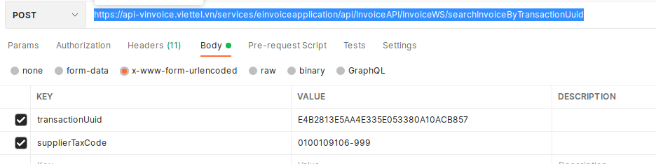Image Response returned successfully
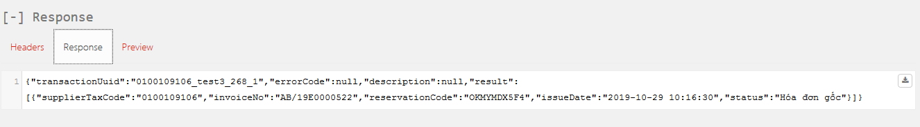
Details Response
{
"transactionUuid": "0100109106_test3_268_1",
"errorCode": null,
"description": null,
"result": [
{
"supplierTaxCode": "0100109106",
"invoiceNo": "AB/19E0000522",
"reservationCode": "OKMYMDX5F4",
"issueDate": 1587797116843
"status": "Original invoice"
}
]
}
For invoices according to Circular 78 that have been issued a code by the tax authority, there will be additional information about the tax authority code as follows.
STT | Name card | Meaning
 | exchangeStatus | Describe the transmission and reception status of the Contract with the CQT
 | exchangeDes | Description of transmission error
 | codeOfTax | Code issued by CQT
{
"errorCode": null,
"description": null,
"transactionUuid": "4543Gfd565h",
"result": [
{
"supplierTaxCode": "0100109106-710",
"invoiceNo": "K21DTT4",
"reservationCode": "UFODH7MN7LT0GW5",
"issueDate": 1638852198000,
"status": "Money adjustment invoice",
"exchangeStatus": " CQT issued code: 00BDD6525B75646655B654665B65466565",
"exchangeDes": null,
"codeOfTax": "00BDD6525B75646655B654665B65466565"
}
]
}

7.22 Issuing secret codes
- Allow API to issue secret codes to businesses according to MST.
- API path: InvoiceAPI/BotWS/getReservationCode/{taxCode}
- Method: POST
Input :
School's name | Data types, constraints | Describe
transactionUuid | Required: false  DataType: String  Minlength: 10  Maxlength: 36  Format: | ID to verify transactions.  Recommendation: use UUID v4.
requestCode | Required: true  DataType: BigDecimal  Minlength:  Maxlength:  Format: | Number of codes required  Maxlength = 30,000 – Number of unused codes
expiredDate | Required: false  DataType: Date  Minlength:  Maxlength:  Format: | Code expiration date  Format according to Standard 5.1 , to hours, minutes, seconds  For example: 1587797116000

For example:
{
"transactionUuid": "56432347787",
"expiredDate": 1587797116000,
"requestCode": 50
}
Output :
School's name | Describe
transactionUuid | transactionUuid passed in Input
expiredDate | Expiration date of code passed in Input
reservationCode | List of secret codes for MST

For example:
{
"transactionUuid": "56432347787",
"expiredDate": 1587797116000
"result":
{
"reservationCode": ["479765676", "867547567"]
}
}

Update invoice printing status
- General description: Add a new API to update the printing status of issued invoices.
- API path: InvoiceAPI/InvoiceUtilsWS/updateInvoicePrintStatus
- Method: PUT
- Scope: NA

Input :
School's name | Datatypes | Describe
taxCode | Required: true  DataType: String  Minlength:  Maxlength: 20  Format: [0-9-]+ | Tax identification number of the invoice-issuing business/branch.  For example:  Model 1: 0312770607  Form 2: 0312770607-001
templateCode | Required: true  DataType: String  Minlength:  Maxlength: 20  Format: | Invoice sample code  For example:  Invoice TT32: 01GTKT0/001  Invoice TT78: 1/001
invoiceNo | Required: true  DataType: String  Minlength: 7  Maxlength: 15  Format: [a-zA-Z0-9]*$ | Is invoice symbol + invoice number  For example :  Invoice TT32: AA/20E0000001  Invoice TT78: K22THY12
printStatus | Required: true  DataType: int(3)  Minlength:  Maxlength: 1  Format: | Print status of invoice  1-in  0-not printed yet
Output :
Successful case example:
{
"code": 200,
"message": "SUCCESS_UPDATE_PRINT_STATUS",
"data": "Print status update successful"
}

Error case example:
{
"code": 400,
"message": "INVOICE_NOT_FOUND",
"data": "Invoice does not exist"
}

7.24 Number of QRcode scans of invoice
- General description: Add new API to update the number of QRCODE scans of issued invoices.
- API path: InvoiceAPI/InvoiceUtilsWS/updateInvoiceScanQrcode
- Method: PUT
- Range: NA
Input :
School's name | Datatypes | Describe
taxCode | Required: true  DataType: String  Minlength:  Maxlength: 20  Format: [0-9-]+ | Tax identification number of the invoice-issuing business/branch.  For example:  Model 1: 0312770607  Form 2: 0312770607-001
templateCode | Required: true  DataType: String  Minlength:  Maxlength: 20  Format: | Invoice sample code  For example:  Invoice TT32: 01GTKT0/001  Invoice TT78: 1/001
invoiceNo | Required: true  DataType: String  Minlength: 7  Maxlength: 15  Format: [a-zA-Z0-9]*$ | Is invoice symbol + Invoice number  For example :  Invoice TT32: AA/20E0000001  Invoice TT78: K22THY12

Output :
Successful case example:
{
"code": 200,
"message": "SUCCESS_UPDATE_SCAN_QRCODE",
"data": "QRCODE scan update successful",
"remainScan": 5
}
Error case example:
{
"code": 400,
"message": "INVOICE_NOT_FOUND",
"data": "Invoice does not exist"
}

7.25 Billing statistics by user
- General description: This request adds a new invoice statistics API.
- API Path: Action (GET): InvoiceAPI/InvoiceWS/getInvoiceUsage
- Scope: All types of invoices
- Headers:
+ Cookie: access_token value or Authorization: username/pass like logging in on the web or Authorization: username/pass like logging in on the web
+ Content-Type: application/json
Input :
Parameter name | Data types, constraints | Describe
supplierTaxCode | Required: true  DataType: String  Minlength:  Maxlength:  Format: | Tax identification number of the invoice-issuing business/branch.
issueDateFrom | Required: true  DataType: DateTime  Minlength:  Maxlength:  Format: | Invoice issuance time from date  Format milliseconds
issueDateTo | Required: true  DataType: DateTime  Minlength:  Maxlength:  Format: | Invoice issuance time to date  Format milliseconds
createUser | Required: true  DataType: String  Minlength:  Maxlength:  Format: | Invoice creator  (Transmit username)
deletedStatus | Required: false  DataType: Integer  Minlength:  Maxlength:  Format: | Cancellation status of the invoice, including:  0-Not canceled yet  1-Cancelled
templateCode | Required: false  DataType: String  Minlength:  Maxlength:  Format: | Invoice sample code  Example with TT32: 01GTKT0/001  Example with TT78: 1/0234
invoiceSeri | Required: false  DataType: String  Minlength:  Maxlength:  Format: | Invoice symbol  Example: K22THY, AB/22E
itemName | Required: false  DataType: String  Minlength:  Maxlength:  Format: | Name of goods and services
itemCode | Required: false  DataType: String  Minlength:  Maxlength:  Format: | Code of goods and services
totalAmountWithVat | Required: false  DataType: BigDecimal  Minlength:  Maxlength:  Format: | Total after-tax amount of the invoice
scanStatus | Required: false  DataType: Integer  Minlength:  Maxlength:  Format: | Status of scanning QrCode of invoice, including:  1-Not scanned yet  2-Scanned  3-Turn ends  4-There are still turns

Output :
Successful case example
{
"errorCode" : "" ,
"description" : "" ,
"result" : {
"totalDeletedInvoice" : 5 ,
"totalNotDeletedInvoice" : 50 ,
"totalScanInvoice" : 10 ,
"totalNotScanInvoice" : 5,
"totalOutOfScanInvoice" : 5 ,
"totalRemainScanInvoice" : 20 ,
"totalAmountDeleted" : 5000000 ,
"totalAmountNotDeleted" : 700000000
}
}
Error case example
{
"code" : 400 ,
"message" : "FROM_BIGGER_DAY_TO_DAY" ,
"data" : "From date cannot be greater than date"
}

7.26 Explanation
- General description: This request implements a new API that allows users to explain information for issued invoices.
- Method: PUT
- API path: InvoiceWS/update-explanation
- Scope: Only applicable to invoices according to TT78, invoices with a status other than Canceled.
Input :
School's name | Data types, constraints | Describe
supplierTaxCode | Required: true  DataType: String  Minlength:  Maxlength: 20  Format | Tax identification number of the invoice-issuing business/branch.
templateCode | Required: true  DataType: String  Minlength:  Maxlength: 20  Format: | Invoice sample code  VD:  01GTKT0/001  1/001
invoiceNo | Required: true  DataType: String  Minlength:  Maxlength: 15  Format: | Is the invoice symbol combined with the invoice number  Example: AA/20E0000001 or K22THY112
strIssueDate | Required: true  DataType: Long  Minlength:  Maxlength:  Format: Standard 5.1 | Invoice date
reason. reason | Required: False  DataType: String  Minlength:  Maxlength: 255  Format: | Explanatory content of the invoice  Allows input of up to 255 characters
For example:
{
"supplierTaxCode": "0100109106-710",
"templateCode": "5/036",
"invoiceNo": "C22MTY1",
"strIssueDate": 1666084951000,
"reason": "ok"
}
Output :
School's name | Describe
errorCode | NULL in case of successful exposition
description | Notification in case of successful explanation
code | Error code (in case of error)
message | Error code (in case of error)
data | Error description (in case of error)
Successful case example:
{
"errorCode": null,
"description": "SUCCESSFUL INVOICE EXPLANATION!"
}
Error case example:
{
"code": 400,
"message": "INVOICE_STATUS_INVALID",
"data": "Invalid invoice status"
}

7.27 Get a list of sample and invoice symbols according to tax code (POS machine)
- This request implements a new API that allows users of the integrated system to get a list of samples and invoice symbols of a given tax code on the POS machine.
- API path: /InvoiceAPI/InvoiceUtilsWS/getInvoiceTemplates
Input :
School's name | Datatypes | Describe
taxCode | Required: True  DataType: String  Minlength: N/A  Maxlength:  Format: | Corporate tax code  Validate rules as the current system status
invoiceType | Required: True  DataType: String  Minlength: N/A  Maxlength:  Format: | Bills  Includes the values 1, 2, 3, 4, 5, 6
For example:
{
"taxCode": "0100109106-710",
"invoiceType": "5"
}
Output :
STT | School's name | Describe
 | errorcode | Error code
 | description | Error description
 | totalRows | Total number of result lines found
 | template | NA
 | templateCode | Invoice form
 | invoiceSeri | Invoice symbol
 | originalTemplateCode | Original invoice form

7.28 Issue an invoice with a secret code to CTS SERVER
* Invoice date check rule:
SInvoice V2 electronic invoice system, the General configuration section related to invoice date has 2 checkboxes: Allow invoice date to be different from the current date , Automatically set the value for invoice date equal to the most recent date.
When issuing invoices via API, the invoice date will be affected when the user selects these checkboxes. There are 4 cases as described below:
TH1: Don't tick both
- Date created (invoiceIssuedDate) null: get the current date and time (sysdate)
- Date made < date of the last invoice: invalid date
- Date of creation >= date of last invoice and <= current date: invalid date
- Date created > current date: get the date passed (do not check the time)
Case 2: Tick " Configure the signing date as the current time"
- Date created (invoiceIssuedDate) null: get the current date and time (sysdate)
- Date of creation < date of most recent invoice: get the date of the most recent invoice
- Creation date >= creation date of the most recent invoice and <= current date: get the transmitted date
- Creation date > current date: invalid creation date
Case 3: Tick " Automatically set the value for the invoice date to the most recent invoice date"
- Date created (invoiceIssuedDate) null: get the current date and time (sysdate)
- Date made < date of the last invoice: invalid date
- Date made >= the date of the last invoice and <= current date: get the date of transmission
- Created date > current date: invalid creation date
TH4: Product of both
- Date created (invoiceIssuedDate) null: get the current date and time (sysdate)
- Date made < date of the last invoice: get the date of the most recent invoice
- Date made >= the date of the last invoice and <= current date: get the date of transmission
- Created date > current date: invalid creation date
- General description: This request implements a new API that allows users to create invoices with secret codes
- API path: InvoiceAPI/BotWS/createInvoiceWithCode/ {taxCode}
- Similar inputs such as invoicing and additional information:
+ add reservationCode in input generalInvoiceInfo (required)
+ Valid conditions: code is issued with correct MST, code has not been used for any invoice, code has not expired
+ reservationCode in input is reservationCode in output

reservationCode | Required: true  DataType: String  Minlength:  Maxlength: 100  Format: | Secret number

For example:
Input generalInvoiceInfo:
generalInvoiceInfo": {
"invoiceType": "13",
"templateCode": "2/035",
"invoiceSeries": "C22DVH",
"currencyCode": "VND",
"adjustmentType": "1",
"paymentStatus": true,
"cusGetInvoiceRight": true,
"invoiceIssuedDate": null,
"reservationCode": " 0RS5LCM7P2ODPB4"
}
Output:

{
"errorCode": null,
"description": null,
"result": {
"supplierTaxCode": "0100109106-710",
"invoiceNo": "C22DVH26",
"transactionID": "167238328041929055",
"reservationCode": "0RS5LCM7P2ODPB4"
}
}
Error case example:
{
"code": 400,
"message": "reservation.code.used",
"data": "BAD_REQUEST_RESERVATION_CODE_USED"
}
Note:
- In case the enterprise removes the data constraint, then add totalAmountAfterDiscount to summarizeInfo and save it according to this value (passing empty or null or not transmitting, recalculating). In case the enterprise does not remove the data binding, this field will not be processed (whether transmitted or not).
- If it is a cash register invoice, the response will return information including the CQT code issued: "codeOfTax", if it is not a cash register invoice, return codeOfTax = null
Example output sample
{
"errorCode": null,
"description": null,
"result": {
"supplierTaxCode": "0100109106-710",
"invoiceNo": "C23MHY3",
"transactionID": "168378907853232661",
"reservationCode": "2QTBFEMAXFWZO5B",
"codeOfTax": "M1-23-34567-00000000201"
}
}
- If the No-Billing configuration has an initialization token from the cash register and the invoice is of the cash register type, it allows businesses using USB Token and CloudCA signatures to issue invoices with secret codes using the API Server.

7.29 Issuing an invoice with a secret code for USB- TOKEN
- General description: This request implements a new API that allows users to invoice with a secret code
- API path to get hash string : InvoiceAPI/InvoiceWS/createInvoiceUsbTokenGetHash/{supplierTaxCode}
- API link for signing and generating invoices :
InvoiceAPI/InvoiceWS/createInvoiceUsbTokenInsertSignature
- The content is similar to the bill of the server secret code section 7.28

7.30 Get a list of samples and invoice symbols by tax code throughout the system
- The API allows users of the integrated system to get a list of templates and invoice symbols khả dụngof a given tax code across the entire system.
- API path: /InvoiceAPI/InvoiceUtilsWS/getAllInvoiceTemplates
Input :
School's name | Datatypes | Describe
taxCode | Required: True  DataType: String  Minlength: N/A  Maxlength:  Format: | Corporate tax code  Validate rules as the current system status
invoiceType | Required: True  DataType: String  Minlength: N/A  Maxlength:  Format: | Ví dụ với TT32: 01GTKT  Ví dụ với TT78: 1

For example:
{
"taxCode": "0100109106-710",
"invoiceType": "all"
}
Output :
STT | School's name | Describe
first | errorcode | Error code
2 | description | Error description
3 | totalRows | Total number of lines of results found
4 | template | NA
5 | templateCode | Invoice template
6 | invoiceSeri | Invoice symbol
7 | originalTemplateCode | Original invoice form

For example:
{
"errorCode": null ,
"description": null ,
"totalRows": 10,
"template": [
{
"templateCode": "1/138",
"invoiceSeri": "K23TYH",
"originalTemplateCode": "1/0001"
},
{
"templateCode": "1/141",
"invoiceSeri": "K23TKH",
"originalTemplateCode": "1/0008"
},
{
"templateCode": "1/142",
"invoiceSeri": "K23TRW",
"originalTemplateCode": "1/0005"
},
{
"templateCode": "1/143",
"invoiceSeri": "K22TYT",
"originalTemplateCode": "1/0001"
},
{
"templateCode": "1/143",
"invoiceSeri": "K23TEF",
"originalTemplateCode": "1/0001"
},
{
"templateCode": "1/001",
"invoiceSeri": "C21TUH",
"originalTemplateCode": "1/0001"
},
{
"templateCode": "2/002",
"invoiceSeri": "K23MAA",
"originalTemplateCode": "2/0002"
},
{
"templateCode": "2/002",
"invoiceSeri": "K22MAB",
"originalTemplateCode": "2/0002"
},
{
"templateCode": "2/005",
"invoiceSeri": "C21MYH",
"originalTemplateCode": "2/0002"
},
{
"templateCode": "6/003",
"invoiceSeri": "K22NKL",
"originalTemplateCode": "6/0001"
}
]
}
  - Release/replace/adjust to CLOUD CA (Step 1: Get the hash string)
*Rules for checking invoice date:
SInvoice V2 electronic invoice system, the General configuration section related to invoice date has 2 checkboxes: Allow invoice date to be different from the current date , Automatically set the value for invoice date equal to the most recent date.
When issuing invoices via API, the invoice date will be affected when the user selects these checkboxes. There are 4 cases as described below:
Case 1: Don't tick both
- InvoiceIssuedDate null: get the current date and time (sysdate)
- Date made < date of the last invoice: invalid date
- Date of creation >= date of last invoice and <= current date: invalid date
- Establishment date > current date: get the transmitted date (do not check the time)
Case 2: Tick " Configure the signing date as the current time"
- InvoiceIssuedDate null: get the current date and time (sysdate)
- Date of creation < date of most recent invoice: get the date of the most recent invoice
- Creation date >= creation date of the most recent invoice and <= current date: get the transmitted date
- Creation date > current date: invalid creation date
Case 3: Tick " Automatically set the value for the invoice date to the most recent invoice date"
- InvoiceIssuedDate null: get the current date and time (sysdate)
- Date made < date of the last invoice: invalid date
- Creation date >= creation date of the most recent invoice and <= current date: get the transmitted date
- Creation date > current date: invalid creation date

Case 4: Accumulate both
- InvoiceIssuedDate null: get the current date and time (sysdate)
- Date of creation < date of most recent invoice: get the date of the most recent invoice
- Creation date >= creation date of the most recent invoice and <= current date: get the transmitted date
- Creation date > current date: invalid creation date
- Generate xml file and hash string of XML file of invoice signed by USB Token.
- Input:
- Action (POST): InvoiceAPI/InvoiceWS/createInvoiceUsbTokenGetHash/{supplierTaxCode}
- Headers:
+ Cookie: value of access_token or Authorization: username/pass like login on web or Authorization: username/pass like login on web
+ Content-Type : application/json
Similar inputs such as invoicing, adding attached deed information.
Added Invoice Error Reason field. Adjustment allows transmission of negative quantity/unit price
Parameter name | Data types, constraints | Describe
certificateSerial | Required : true  DataType: String  Minlength :  Maxlength : 100  Format : | Serial Number of the business's digital certificate, this digital certificate has been pushed onto the system by the business when registering to use USB Token.  Hex format.  Example: 5404FFFEB7033FB316D672201B7BA4FE
adjustedNote | Required: False  DataType: String  Minlength: N/A  Maxlength: 255  Format: | Reason for error  Allows you to enter a maximum character string of 255 characters.  Transmission is not required.  Set in generalInvoiceInfo
unitPrice | Required: false  DataType: BigDecimal  Minlength:  Maxlength:  Format: [0-9.]+ - | Unit price of the goods.  Constraint rules keep the status quo.  Added permission to pass negative values
quantity | Required: false  DataType: BigDecimal  Minlength:  Maxlength:  Format: [0-9.]+ - | Quantity of goods  Constraint rules keep the status quo.  Added permission to pass negative values
originalInvoiceType | Required: True  DataType: String  Minlength: N/A  Maxlength:  Format: | Original invoice type  Pass a numeric value with the following meaning  0- Not paper invoices/invoices that don't exist on the system  1-Invoice TT78  2-Invoice according to Decision 1209  3-Electronic/Paper Invoice TT32  4-Paper invoice TT 78  Attention :  - In case the originalInvoiceType tag is not transmitted or the empty value/0 is transmitted, the originalTemplateCode tag is not required to be transmitted, the system validates the information when making an invoice as is.  - In case the originalInvoiceType tag transmits the value 1, 2, 3 or 4  + Required to pass the originalTemplateCode tag, this tag's validation rules are similar to the current templateCode tag.  + When making an invoice, the system does not check the existence of the original invoice on the system, other authentication rules remain the same
originalTemplateCode | Required:  DataType: String  Minlength: N/A  Maxlength: 20  Format: | Casting is required if originalInvoiceType is 1, 2, 3 or 4  Example TT32: 01GTKT0/001  Example TT78: 1/0224

{
"generalInvoiceInfo":{
"invoiceType":"01GTKT",
"templateCode":"01GTKT0/170",
"invoiceSeries":"AA/17E",
"transactionUuid": "123e4567-e89b-12d3-a456-42665540000",
"invoiceIssuedDate": 1587797116843 ,
"currencyCode":"VND",
"adjustmentType":"1",
"adjustedNote":"",
"originalInvoiceType": "1",
"originalTemolateCode": "1/0224",
"paymentStatus":true,
"paymentType":"TM",
"paymentTypeName":"TM",
"cusGetInvoiceRight":true,
"userName":"user 1",
“certificateSerial”:”5404FFFEB7033FB316D672201B7BA4FE”
},
"buyerInfo":{
"buyerName":"Dang Thi Thanh Tam",
"buyerLegalName":"",
"buyerTaxCode":"",
"buyerAddressLine":"HN VN",
"buyerPhoneNumber":"11111",
"buyerEmail":"",
"buyerIdNo":"123456789",
"buyerIdType":"1"
},
"sellerInfo":{
"sellerLegalName":"Dang Thi Thanh Tam",
"sellerTaxCode":"0100109106-501",
"sellerAddressLine":"test",
"sellerPhoneNumber":"0123456789",
"sellerEmail":"PerformanceTest1@viettel.com.vn",
"sellerBankName":"vtbank",
"sellerBankAccount":"23423424"
},
"extAttribute":[

],
"payments":[
{
"paymentMethodName":"TM"
}
],
"deliveryInfo":{

},
"itemInfo":[
{
"lineNumber":1,
"itemCode":"ENGLISH_COURSE",
"itemName":"English course",
"unitName":"course",
"unitPrice":"-3500000.0",
"quantity":"-10.0",
"itemTotalAmountWithoutTax":35000000,
"taxPercentage":10.0,
"taxAmount":0.0,
"discount":0.0,
"itemDiscount":150000.0
}
],
"discountItemInfo":[

],
"metadata":[

],

" meterReading": [{
"previousIndex": "5454",
"currentIndex": "244",
"factor": "22",
"amount": "2"
},
{
"previousIndex": "44",
"currentIndex": "44",
"factor": "33",
"amount": "3"
}],
"summarizeInfo":{
"sumOfTotalLineAmountWithoutTax":35000000,
"totalAmountWithoutTax":35000000,
"totalTaxAmount":3500000.0,
"totalAmountWithTax":38500000,
"totalAmountWithTaxInWords":"Thirty eight million five hundred thousand even",
"discountAmount":0.0,
"settlementDiscountAmount":0.0,
"taxPercentage":10.0
},
"taxBreakdowns":[
{
"taxPercentage":10.0,
"taxableAmount":35000000,
"taxAmount":3500000.0
}
]
}
    - Hash string data returned
{
"errorCode" : "" ,
"description" : "" ,
"result" : {
"hashString" : 0HFm34vX525V3Syg5EwdTnfO21s= , }
}
Example response in case originalInvoiceType . is passed incorrectly
{
"code": 400,
"message": "BAD_REQUEST_ORIGINAL_INVOICE_TYPE_INVALID",
"data": "BAD_REQUEST_ORIGINAL_INVOICE_TYPE_INVALID"
}
Note: The original invoice data is stored in the instance_file_name column in the invoice table as follows:
Invoice Type | Invoice Form | Invoice symbol | Some bills
in there:
- Invoice type is the originalInvoiceType tag value
- Invoice template is the originalTemplateCode tag value
Output :
School's name | Data types, constraints | Describe
errorCode | DataType: String | If there is an error code, if there is no error, return null
description | DataType: String | Detailed description of the error
hashString | DataType: String | The returned Hash string of the invoice, in Base64 format

Note: In case the enterprise removes the data constraint, then add totalAmountAfterDiscount to summarizeInfo and save it according to this value (passing empty or null or not transmitting, recalculating). In case the enterprise does not remove the data binding, this field will not be processed (whether transmitted or not).
  - Release/replace/adjust to CLOUD CA (Step 2: Sign Cloud CA and generate invoice)
- Use CLOUD CA to sign the hashString string received from the API in step 7.31. Get the signed string to generate the invoice.
- Head enter:
- Action (POST): InvoiceAPI/InvoiceWS/createInvoiceUsbTokenInsertSignature
- Headers:
+ Cookie: access_token value or Authorization: username/pass like logging in on the web or Authorization: username/pass like logging in on the web
+ Content-Type: application/json
Parameter name | Data types, constraints | Describe
supplierTaxCode | Required : true  DataType: String  Minlength :  Maxlength : 20  Format : [0-9-]+ | Tax identification number of the invoice-issuing business/branch. A business can have multiple tax codes  Model 1: 0312770607  Model 2: 0312770607-001
templateCode | Required : true  DataType: String  Minlength :  Maxlength : 20 | Invoice sample code.
hashString | Required : true  DataType: String | The Hash string that the data returned is in the getHash request above  = out put of API : 7.15 USB Token Signing Billing (Step 1: Get the hash string)
signature. signature | Required : true  DataType: String | Signature after hashString has been signed by USB token. Base64 format
Json example
{
"supplierTaxCode": "0100109106-712",
"templateCode": "01GTKT0/002",
"hashString": "0HFm34vX525V3Syg5EwdTnfO21s=",
"signature": "U0WpJk2Q/rDsnZDz8hiWKvs6QEf5DHTG8JyXjjNMtggZ/MIDP0hn9Mutc2uPZEOxqk2YnMjuRSxU8ST/T+C5i46Vb/0+7uIfzKpPm2yrsOSivCdzr6FrY6nJPkfkOWEdEs/hqDzcf 4Vn8ZCVkNfovYR4prPGc7kNpO21sNb9BAI="
}
Results returned
    - Data on information about issued invoices0
{
"errorCode" : "" ,
"description" : "" ,
"result" : {
"supplierTaxCode" : 0100109106-712 ,
"invoiceNo" : AA / 20E0000018 ,
"transactionID" : 12523522245 ,
"reservationCode" : AXHBNK8I0H
}
}

School's name | Describe
errorCode | Error code (value is null if invoiced successfully)
description | Error Description (value is null if invoiced successfully)
supplierTaxCode | Seller tax code (invoice-issuing business)
invoiceNo | Invoice number eg: AA\20E0000001
transactionID | Id of the transaction
reservationCode | Secret codes used by customers to look up
More information at https://sinvoice.viettel.vn/download/soft/signhash.rar
Note: If it is a cash register invoicing, the response will include the CQT code provided: "codeOfTax", if it is not a cash register invoice, return codeOfTax = null

7.33 Issuing an invoice with a secret code for CLOUD CA
- General description: This request implements a new API that allows users to invoice with a secret code
- API path to get hash string : InvoiceAPI/InvoiceWS/createInvoiceUsbTokenGetHash/{supplierTaxCode}
- API path for signing and generating invoices :
InvoiceAPI/InvoiceWS/createInvoiceUsbTokenInsertSignature
- The content is similar to the bill of the server secret code section 7.28
- List of errors returned by the system
The Response object describes the error status the Webservice returns and the data object the Webservice returns. Includes error code and error description.
Note: When an error occurs, first check the error code in the error list to understand the reason for the error and how to fix it.
- Mapping between information fields and invoice templates
The information fields will be mapped onto the invoice form depending on the detailed design of that invoice form. Basically, invoice templates will have fields mapped as follows:
Note: in case the information field is not displayed correctly, the cause may be due to incorrect data sent or the design invoice template does not display the correct information. Check that the data in the original invoice file (xml) downloaded is correct.
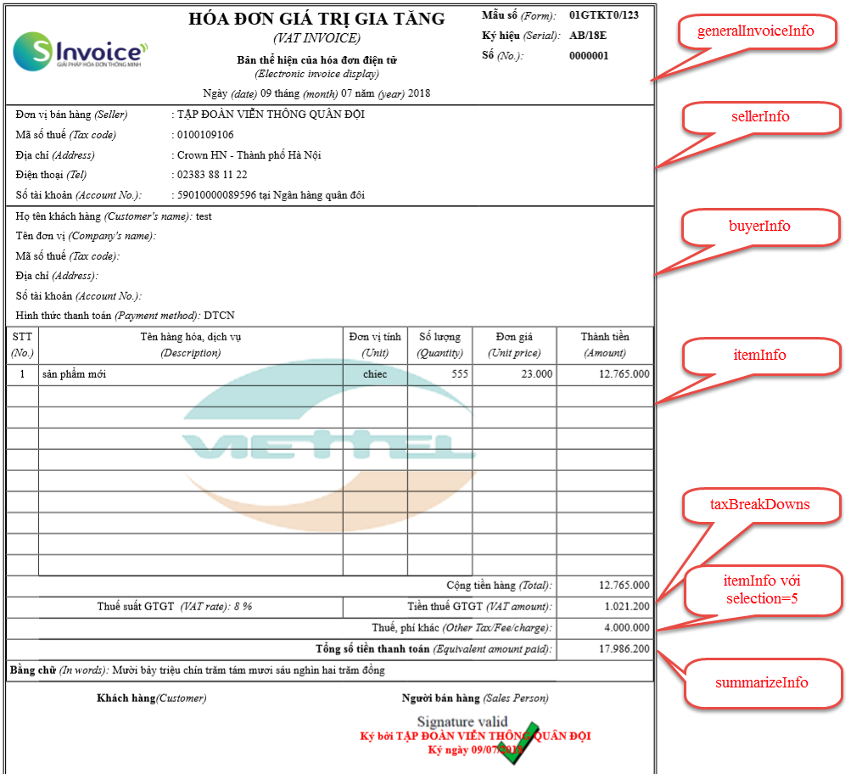
- Test API with POSTMAN
Before programming, the integrated software should pre-check the APIs with POSTMAN to understand the data that needs to be passed in/returned by the system. After running the test, the code will be faster.
See details at:
https://sinvoice.viettel.vn/ho-tro/huong-dan-su-dung/35-huong-dan-su-dung-postman-goi-api-webservice-hoa-don-dien-tu

