Technical Specification (TS) – CRM & Invoicing System

1. Scope & Boundaries
- CRM Scope: Contact → Booking (Service Order creation)→ Draft Invoice →Assignment → Service Delivery → Completion → Confirmed Invoicing.
- Invoicing Scope: Starts at service completion and ends with posting to MISA Accounting.
- Website Platform: Proprietary (not Odoo website) for SEO advantages. CRM integration via dedicated API provided by proprietary website
- API Out of Scope: No EasyHRR link required.

2. Workflows

2.1 CRM Workflow
- Contact Creation → Booking (Service Order creation) → Draft Invoice → Assignment → Notification → Service Event → Confirmed Invoice Submission.
- Status updates are event-driven (e.g., booking assigned, nurse notified, service started, service completed).
- Zalo integration used for assignment notifications (push + nurse acceptance).

2.2 Service & Invoicing Workflow
- Nurses issue confirmed invoice only once at service completion (only draft invoice mid-process).
- System checks compliance with Tax Department (red invoice submission in real time, deferred only if connectivity issue).
- Edge Case: Part-time nurses/doctors do not issue invoices; system allows Office Manager (OM) to issue on their behalf.

2.3 Payment Scenarios
- Case 1 – Payment on completion of service:
Nurse finalizes invoice → submission to Tax Dept → AR entry → sync to MISA.
- Case 2 – Prepaid services:
Prepayment invoice issued by OM/Sales → CRM tracks prepaid sessions → auto-applied at service completion.
- Case 3 – Payment after service delivery:
Nurse finalizes invoice → AR shows outstanding balance → OM records payment later → sync to MISA.

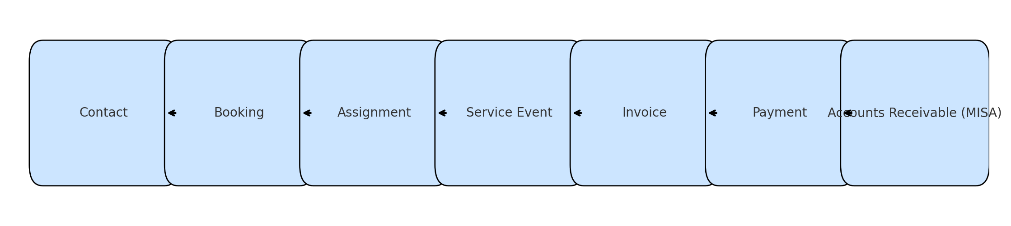3. Forms to be Developed
- Contact Form – capture new inquiries, lead source, client details
- Service Order– booking details, provider assignment, draft invoice attached, schedule date and time, Zalo notification trigger.
- Service Order– logs service start & end times, triggers final invoicing.
- Invoice Form – single final invoice, linked to booking (service order), Red invoice generation
- Invoice Form – capture cash, card, transfer payments, including photo receipts.
- Service Follow-up Form – client feedback & complaints.

4. Required Fields (Mapped to Odoo CRM/Invoice/AR)
- Keep existing Odoo fields where possible (relabeled for business terminology).
- Additional fields required:
  - Contact: unique_contact_ID, record_status, booking_status.
  - Client Master: kinship title, caregiver links, payer/referrer info, GPS coordinates, client deceased flag.
  - Booking/Assignment: province_code, access notes, estimated travel time, notification timestamps.
  - Service Event: start_time_actual, end_time_actual, adjusted submission time (audit compliance).
  - InvoiceHeader: tax_submission_id, tax_submission_time, prepaid balances, compliance fields for VAT invoice.
  - InvoiceLine: service_item_code, discount, line_total automation.
  - Payment: evidence_uri, cash_in_transit, om_received_at.
  - PrepaymentBatch: prepaid balances, committed/consumed counts.
  - AssignmentNotificationLog: channel, template, status.

5. Integrations to be Developed

5.1 Accounting Integration – MISA
- Syncs AR balances, sales, payments, cash/bank movements.
- API Hook: Send AR entries (invoice_id, amount_total, payment_method, status).

5.2 Notifications – Zalo
- Push assignment details to nurse; nurse accepts by replying.
- API Endpoints:
  - POST /assignment/notify
  - POST /assignment/confirm

5.3 Website Integration
- Proprietary Website ↔ CRM sync.
- Endpoints:
  - POST /crm/contact
  - GET /crm/contact/:id

5.4 Social Media Integration – Meta
- Capture leads from Facebook/Instagram.
- Endpoints:
  - GET /meta/leads
  - POST /crm/contact

5.5 Optional/Future Integrations
- CloudDoctor (clinical notes & MOH reporting).
- MOH API (clinical record, prescriptions).
- Digital Signature Provider for e-invoices.

6. Edge Cases & Automation
- Part-time staff invoicing – OM creates invoice on behalf of nurse.
- No Internet – completion logged locally, submitted later with adjusted time stamp.
- Prepayment tracking – CRM reduces prepaid service count automatically.
- Invoice compliance – system auto-flags if nurse does not finalize invoice.
- Quality Assurance (future) – monitor accuracy of nurse-issued invoices.

7. Data Model & Field Mapping
- Odoo standard fields are used where possible.
- Custom models required: service_order, invoice, staff, calendar, availability, api, lookup tables, equipments, inventory, pricelist, location, mobile
- Extensions applied to crm.lead, res.partner, account.move, account.payment.

8. Lookup Tables & Codes
- Lookup tables must be provided in CSV/Excel
- Required lookups: Province Codes, Contact Reasons, Contact Outcomes, Booking Status, Invoice Status, Payment Methods, Relationship Codes, Feedback Types.

9. API Payload Schemas
Example – MISA Invoice:
{
"invoice_id": "INV-2025-00123",
"client_id": "C12345",
"date": "2025-08-19",
"amount_total": 1200000,
"currency": "VND",
"tax_rate": 0.1,
"tax_amount": 120000,
"payment_status": "unpaid",
"lines": [
{
"service_item_code": "SRV001",
"description": "Nursing visit",
"quantity": 1,
"unit_price": 1200000,
"line_total": 1200000
}
]
}
Similar schemas are defined for Payments (MISA), Zalo Notifications, Website Leads, and Meta Leads.

10. Role-Based Access Control (RBAC)
- Nurse/Doctor (Full-time): Create service events, finalize invoices, submit payments. Cannot modify client master.
- Nurse/Doctor (Part-time): Log service start/end only. Cannot finalize invoices.
- Office Manager (OM): Full permissions on bookings, invoices, payments, follow-ups. Can issue invoice for part-time staff.
- Sales/Admin: Create contacts, clients, bookings, prepayment batches. Cannot finalize invoices.
- System Admin: Full control including managing lookup tables, user roles, and audit logs.

11. Draft forms for Validation
- Developers should prepare draft forms for demo
- Clinic staff must review and sign off before finalisation.

12. Development Deliverables
- Custom Odoo modules
- API endpoints for MISA, Zalo, Website, Meta.
- Custom forms/views
- Workflow automation rules.
- Validation rules.
- Lookup table integration.
- RBAC permissions.

