VIET UC CMS
User Manual
Home Healthcare Operations Platform

Comprehensive guide to every menu and workflow — web + mobile
Version 1.0

Table of Contents
Note: This is an editable Word document. To refresh the page numbers below, select all (Ctrl+A / Cmd+A) and press F9, then choose "Update entire table". The PDF version already has them filled in.
Update this field (select all, press F9) to build the contents.

Getting Started
Welcome to the Viet UC CMS. This chapter explains what the system is for, how to sign in, and the handful of patterns that work the same way on every screen. Once you understand the ideas here, the rest of the manual will feel familiar.

What Viet UC CMS Is For
Viet UC CMS is the home-healthcare operations platform for the Viet Uc clinic. You use it to run the day-to-day work of caring for patients in their homes, all in one place. It manages:
- Contacts and leads — people who enquire about your services.
- Clients and patients — the people you care for.
- Bookings — home-visit appointments.
- Staff and assignments — who is going to which visit.
- Invoicing and payments — billing for the care you provide.
- A separate Nurse Mobile App — used by nurses out in the field.
NOTE What you can see and do depends on your assigned role. For example, a nurse sees only the bookings they are assigned to and only clients in their catchment area; Finance staff see the Finance screens; an admin or owner sees everything. See the Appendix for the full role and visibility summary.

Logging In
This is how you open the system and reach your starting screen.
How to use it:
- Open a web browser and go to care.biztinct.com.
- Enter your email and password.
- Sign in. After login you land on a dashboard — typically the Operations Center, depending on your role.
TIP The dashboard you see first is chosen for your role, so two different staff members may land on different screens. That is normal.

Finding Your Way Around
This section explains the two parts of the screen you will use constantly: the left sidebar (for navigation) and the main area (where each screen opens).
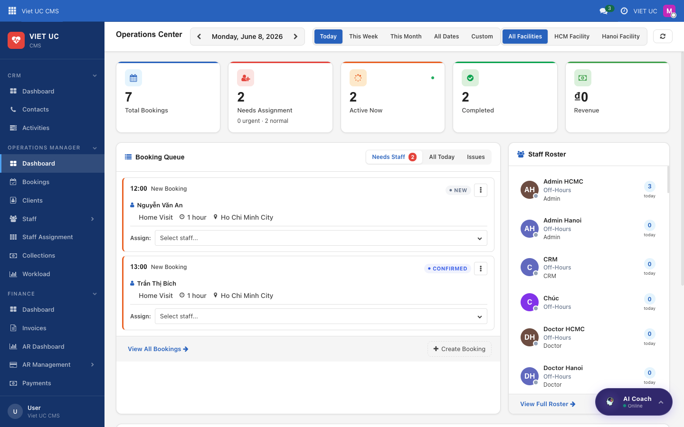
Figure: The Operations Center dashboard, showing the left sidebar, the period filter row, the KPI cards, and the green refresh button.

The Left Sidebar
The left sidebar is your main navigation. It stays available so you can move between screens at any time.
What you see on this screen:
- The Viet Uc logo / company at the top.
- Four collapsible sections: CRM, OPERATIONS MANAGER, FINANCE, and ADMIN.
- The individual menu items inside each section.
How to use it:
- Click a section heading (CRM, Operations Manager, Finance, or Admin) to expand or collapse it and reveal its items.
- Click any item to open that screen in the main area to the right.
NOTE You may not see every section. The sidebar shows only the areas your role gives you access to.

The Top Bar
The top bar runs across the top-right of every screen and gives you quick tools no matter where you are.
What you see on this screen:
- A search box.
- A chat / messages counter.
- An activities counter.
- The company name.
- Your user menu.

Patterns You Only Need to Learn Once
These behaviors work the same way everywhere in the system. Learn them here and you will recognise them on every screen.

The Period Filter
Every dashboard has a period filter row across the top. It controls the time range that all the numbers on the page are based on.
What you see on this screen:
- A row of choices: Today, This Week, This Month, All Dates, and Custom.
How to use it:
- Click a period (for example, This Week) to re-scope every figure on the page to that time range.
- Choose Custom to set your own date range.
NOTE Changing the period updates *every* figure on the page at once, not just one card.

KPI Cards and Drill-Down
KPI cards are the summary tiles on a dashboard, each showing a key number. They are not just for reading — they are clickable.
How to use it:
- Click a KPI card.
- The system opens the underlying filtered list — the records behind that number. This is called a drill-down.
TIP Drill-down is the fastest way to go from "how many" to "exactly which ones." If a number looks surprising, click it to see what is inside.

Lists and Forms
Most screens show a list of records, and each list opens into a detailed form.
How to use it:
- On a list, use the search box or the filter tabs to narrow down what you see.
- Click a row to open its detailed record (the form).
- To go back, use the breadcrumb at the top-left of the screen.

The Chatter on Forms
Every form includes a "chatter" panel that keeps a history of the record.
- It records a log of activity and history for that record.
- It lets you schedule follow-ups so nothing is forgotten.

The Refresh Button
When you want the latest figures, use the green refresh button.
How to use it:
- Click the green Refresh button.
- The current dashboard reloads its data.
TIP If you have just made a change elsewhere and want to confirm it shows up, click Refresh rather than reloading the whole browser.

The AI Coach
A floating AI Coach button sits in the bottom-right corner of the screen.
How to use it:
- Click the AI Coach button at any time.
- It offers in-app help to guide you while you work.
TIP If you get stuck on a screen, the AI Coach is the quickest place to ask for help without leaving what you are doing.

CRM — Contacts & Leads
The CRM section is where you manage enquiries — the people who call, message, or reach out to the clinic — and guide each one along their journey toward a confirmed booking. This chapter covers the three items in this section: the Dashboard, Contacts, and Activities.

Overview
Every enquiry becomes a contact. As you work with that person, their status moves through a simple lifecycle:
- Active (Initial Contact) — a new enquiry has just come in.
- Lead — you have marked them for future follow-up.
- Booking — a service has been booked for them.
- Lost Booking — a booking fell through.
- Spam — the enquiry is junk and is flagged to ignore.
The Dashboard gives you the big picture, Contacts is where you do the day-to-day work, and Activities is your shared follow-up to-do board.

Dashboard

CRM Dashboard
The CRM Dashboard is your at-a-glance command center. Use it at the start of your shift to see how many enquiries came in, what still needs follow-up, and how the team is doing on conversions.
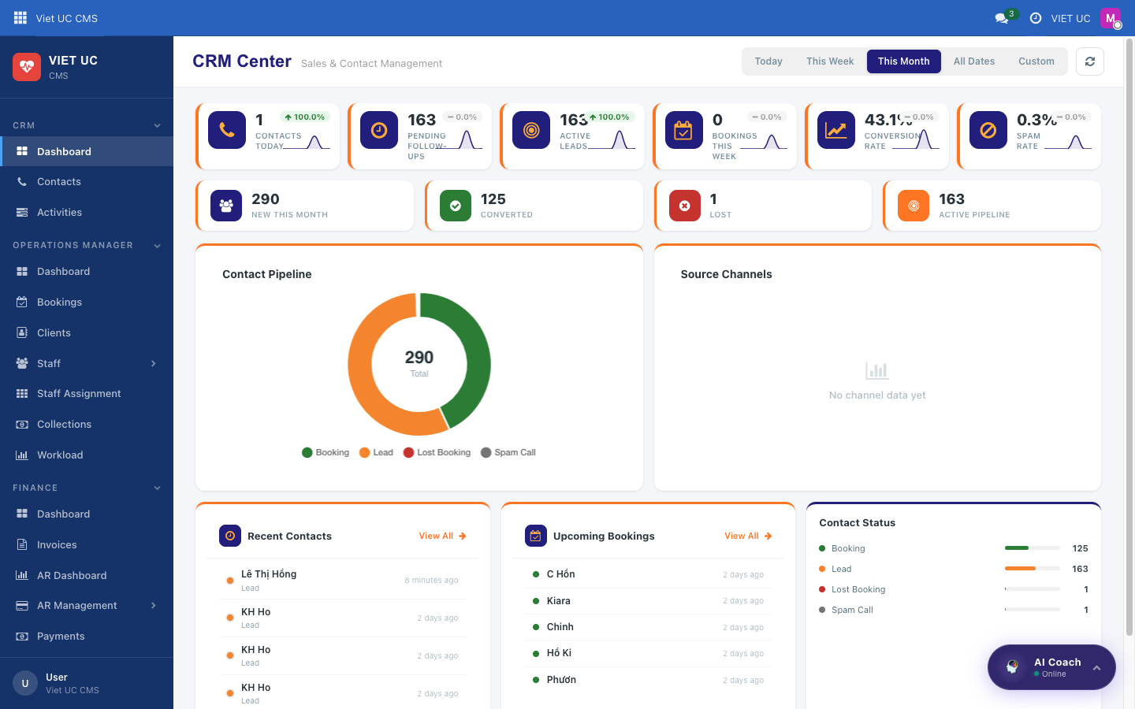
Figure: The CRM Center dashboard with KPI cards, charts, and activity feeds
What you see on this screen
- A header titled "CRM Center — Sales & Contact Management".
- A period filter at the top — choose Today, Week, Month, All, or Custom — plus a refresh button to reload the latest numbers.
- A row of KPI cards, each one clickable:
- Contacts Today — enquiries received today.
- Pending Follow-ups — leads that are waiting for you to follow up.
- Active Leads — leads currently in progress.
- Bookings This Week — bookings created this week.
- Conversion Rate — your conversion rate this month.
- Spam Rate — the share of enquiries marked as spam.
- A second strip of stats: New This Month, Converted, Lost, and Active Pipeline.
- A "Contact Pipeline" donut chart breaking contacts down by status (Booking / Lead / Lost Booking / Spam).
- A "Source Channels" bar chart showing where your contacts came from.
- Three feed panels:
- Recent Contacts — each entry shows a status dot, the name, the channel, and the time.
- Upcoming Bookings — the bookings coming up next.
- Contact Status — a bar per status with its count.
How to use it
- Choose a time range in the period filter (Today / Week / Month / All / Custom). The whole dashboard updates to that range.
- Click refresh at any time to pull the latest figures.
- Click any KPI card to drill straight into a filtered list of the matching contacts or bookings.
- In the Contact Pipeline donut, click a segment (for example, Lead) to open the contacts filtered to that status.
- In Recent Contacts, click a row to open that contact, or click View All to open the full contacts list.
- In Upcoming Bookings, click an entry to open that booking.
TIP Every KPI card and every chart segment is a shortcut. If a number looks surprising, click it to see exactly which contacts it represents.

Contacts

Contacts
Contacts is your working list of every enquiry. From here you can see each person's status, take quick action on them, and open their full record. This is where most of your day-to-day CRM work happens.
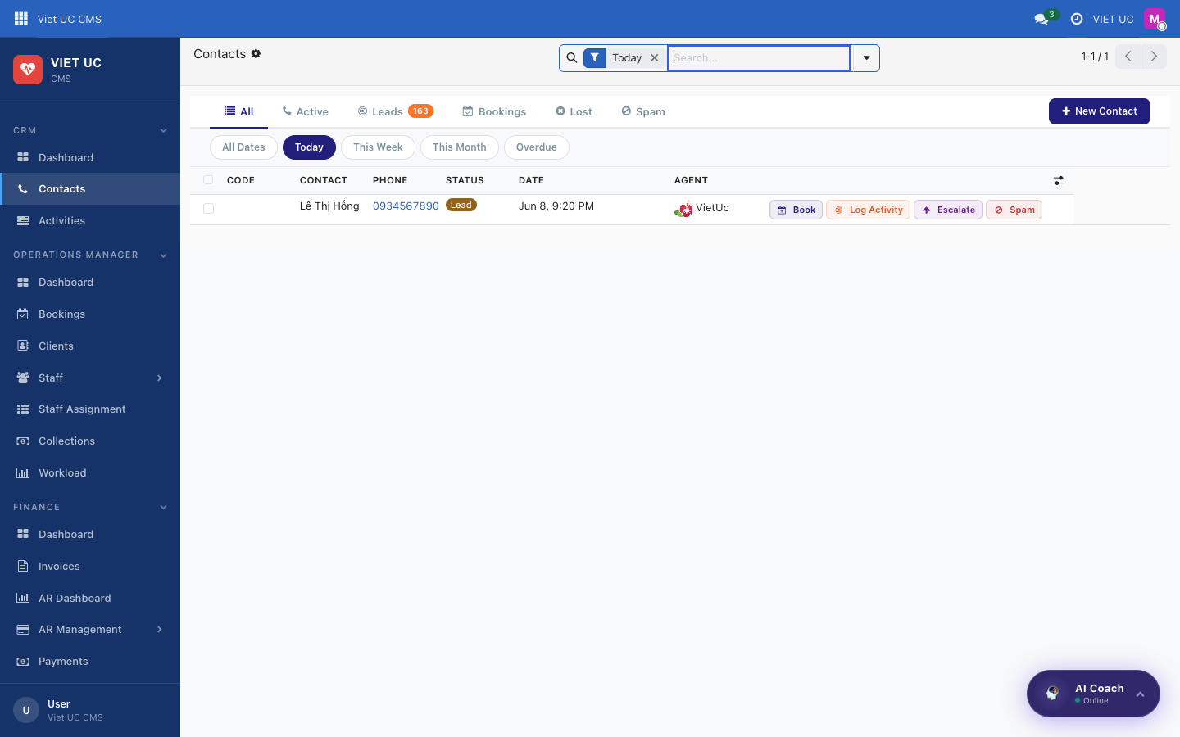
Figure: The Contacts list with status tabs and quick action buttons on each row
What you see on this screen
- Tabs to filter the list: All, Active, Leads, Bookings, Lost, and Spam.
- Date filters to narrow the list by when contacts came in.
- On each row, a set of quick action buttons: Book, Log Activity, Escalate, and Spam.
How to use it
- Click a tab (for example, Leads) to show only contacts with that status.
- Use the date filters to focus on a specific time period.
- On any row, use the quick action buttons to act without opening the contact (see the button reference below).
- Click a contact's row to open its full contact form.

Contact form
Opening a contact shows its full form, with all the key action buttons in the header. Use this when you want to work a single enquiry in detail — book them in, log a follow-up, escalate, or close them out.
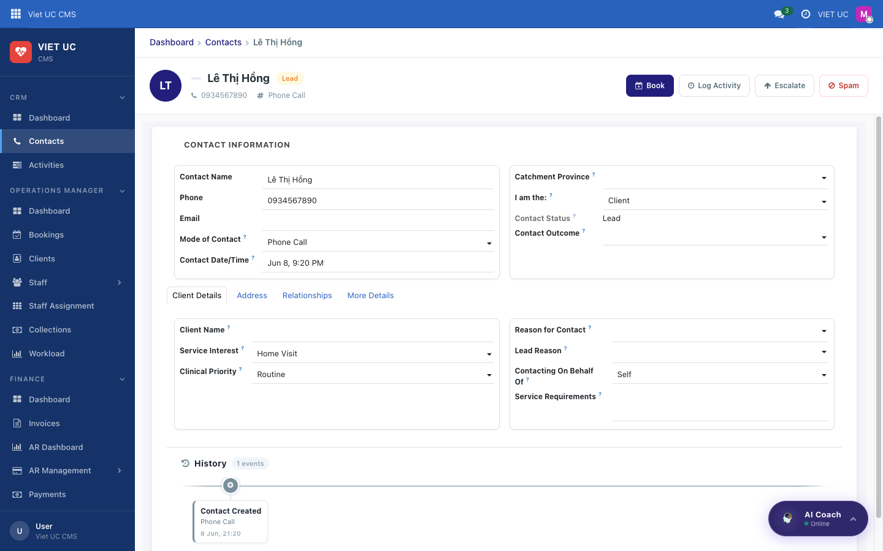
Figure: The contact form with action buttons in the header
What you see on this screen
- The contact's details.
- A header with the key action buttons: Book, Log Activity, Log as Lead, Escalate, Spam, and (when the contact is already a booking) Booking Lost.
How to use it
- To turn the enquiry into a booking, click Book. The Quick Booking wizard opens. It searches existing clients so you don't create a duplicate — confirm the matching client or create a new one, then fill in the service type, facility, date/time, and duration. Click Create Booking to create the booking; the contact's status changes to booking.
- To schedule a follow-up, click Log Activity and set up a call or meeting on the contact.
- To keep the enquiry for later, click Log as Lead. The status changes to lead.
- To hand the contact to a specialist, click Escalate. The contact is routed to the Head Nurse, OM, or Duty Doctor.
- If the enquiry is junk, click Spam. The contact is marked as spam and its phone number is flagged for the future.
- If a booking fell through, click Booking Lost (shown only when the status is booking) and record the lost-booking reason.
Button reference
Button | What it does | Resulting status
Book | Opens the Quick Booking wizard; find/confirm the client, fill service type, facility, date-time, duration, then Create Booking | booking
Log Activity | Schedules a follow-up activity (call/meeting) on the contact | (unchanged)
Log as Lead | Keeps the contact for future follow-up | lead
Escalate | Routes the contact to a specialist (Head Nurse / OM / Duty Doctor) | (unchanged)
Spam | Marks the contact as spam and flags the phone number | spam
Booking Lost | Records a lost-booking reason (only when status is booking) | lost_booking

NOTE The Book wizard checks for existing clients before creating a new one. Always confirm a suggested match when it appears, so you avoid duplicate client records.

TIP The quick action buttons on the list rows (Book, Log Activity, Escalate, Spam) do the same thing as the matching buttons on the contact form — use whichever is faster for what you're doing.

Activities

Activities
The Activities board is the team's shared follow-up to-do list. Every call, meeting, email, or task you schedule on a contact shows up here, so nothing slips through the cracks.
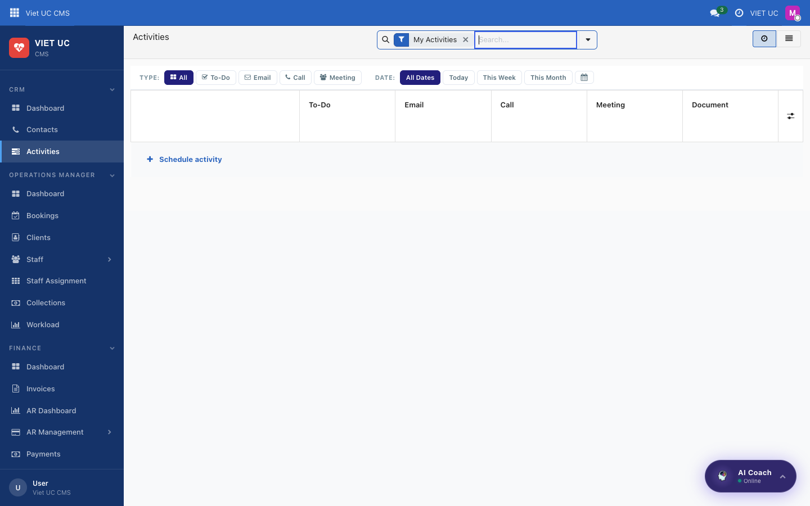
Figure: The Activities board grouped by activity type
What you see on this screen
- A board of scheduled activities grouped by type: To-Do, Email, Call, Meeting, and Document.
- A Type filter to show only one kind of activity.
- A Date filter: All Dates, Today, This Week, or This Month.
- A + Schedule activity button.
How to use it
- Use the Type filter to focus on a single activity type (for example, only Call).
- Use the Date filter to show activities due Today, This Week, This Month, or across All Dates.
- Click + Schedule activity to open the picker, choose the contact, and schedule the activity.
TIP Check this board regularly — it's how the whole team keeps track of who needs a follow-up and when.

Operations Manager — Bookings, Staff & the Service Workflow
The Operations Manager section is where you run day-to-day home-visit operations: seeing what is happening today, taking bookings from first request through to a closed, paid visit, managing your clients and staff, assigning nurses, and reconciling the cash they collect in the field.
This section contains: the Dashboard (Operations Center), Bookings, Clients, Staff (Roster / Schedules / Time Off), Staff Assignment, Collections, and Workload.

Dashboard (Operations Center)

Operations Center
The Operations Center is your live "command desk" for the day. Use it first thing in the morning and throughout the day to see every booking, spot the ones that still need a nurse, and assign staff in a single click.

Figure: The Operations Center dashboard with KPI cards, booking queue, staff roster, and timeline
What you see on this screen:
- Top controls: date navigation (previous / next arrows and the current date), a period filter (Today / Week / Month / All / Custom), a Facility filter (All Facilities or a single facility), and a refresh button.
- KPI cards: Total Bookings, Needs Assignment (with an urgent / normal breakdown), Active Now (visits in progress), Completed, and Revenue.
- Booking Queue panel with three tabs: "Needs Staff" (with a badge count), "All Today", and "Issues". Each booking card shows the time, the booking ID, an URGENT badge if it is high priority, a status chip, a 3-dot menu, the client name, and the service type, duration, and location. Unassigned cards also have an inline Assign: dropdown.
- Staff Roster panel: each staff member shown with an avatar, a status dot, their name, and today's booking count.
- Today's Timeline: a time grid from 7am to 6pm with a row per staff member and colored service blocks. A legend explains the colors: Home Visit, Clinic, Consult, Follow-up.
- Footer buttons: "View All Bookings" and "Create Booking".
How to use it:
- Set the period filter (Today / Week / Month / All / Custom) and the Facility filter to choose what you are looking at; the whole dashboard updates to match.
- Use the prev / next arrows to move the date backward or forward, and refresh to pull the latest data.
- Read the KPI cards to gauge the day at a glance; the Needs Assignment card tells you how many bookings (and how many urgent ones) still have no nurse.
- In the Booking Queue, click the Needs Staff tab to see only bookings waiting for a nurse, All Today for everything today, or Issues for problem bookings.
- To staff an unassigned booking fast, open its Assign: dropdown — it lists available staff together with their current workload — and pick one. The nurse is assigned in a single click.
- To do more with a booking, open its 3-dot menu: View Details, Assign Staff, Start Service, Collect Payment, or Cancel. Each opens the matching screen or action.
- In the Staff Roster, click any staff member to open their record.
- Use Create Booking to start a new booking, or View All Bookings to jump to the full Bookings list.
TIP The "Needs Staff" badge count and the "Needs Assignment" KPI are the two numbers to keep at zero — clear them and every client for the day has a nurse.

Bookings
A booking is one scheduled home visit, from the moment you create it to the moment it is closed and paid. This is the heart of your day, so the workflow below is described step by step.

Viewing bookings (List & Calendar)
You can view your bookings as a sortable list or as a calendar, whichever suits the task.
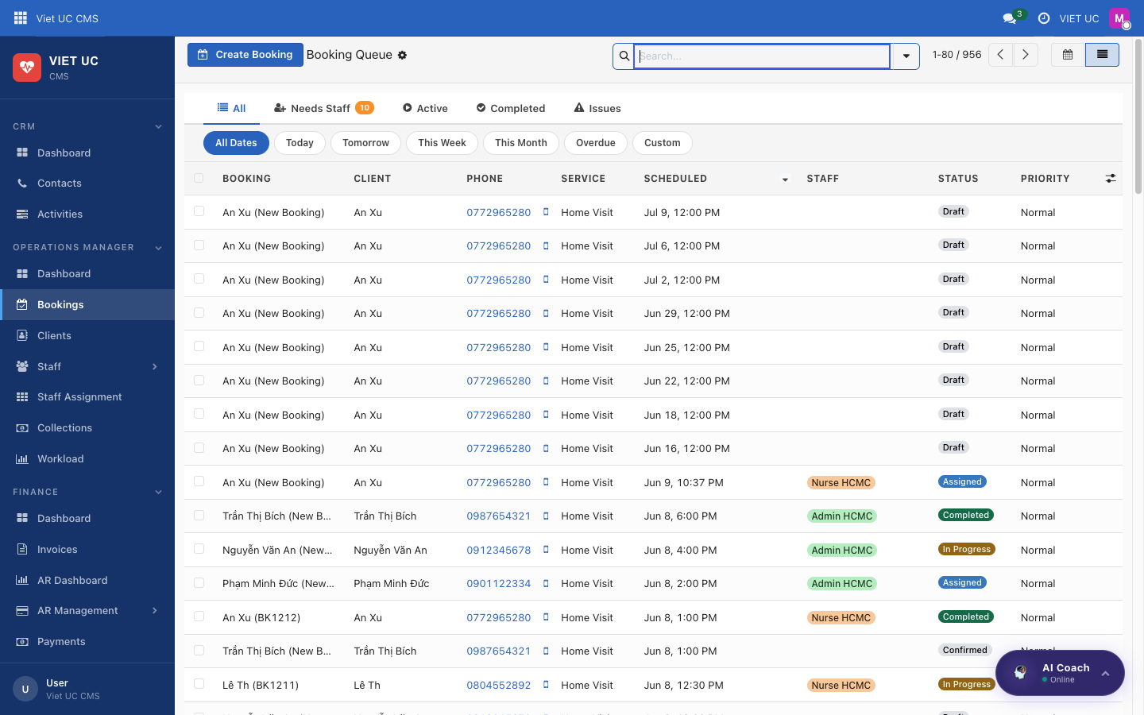
Figure: The Bookings list view
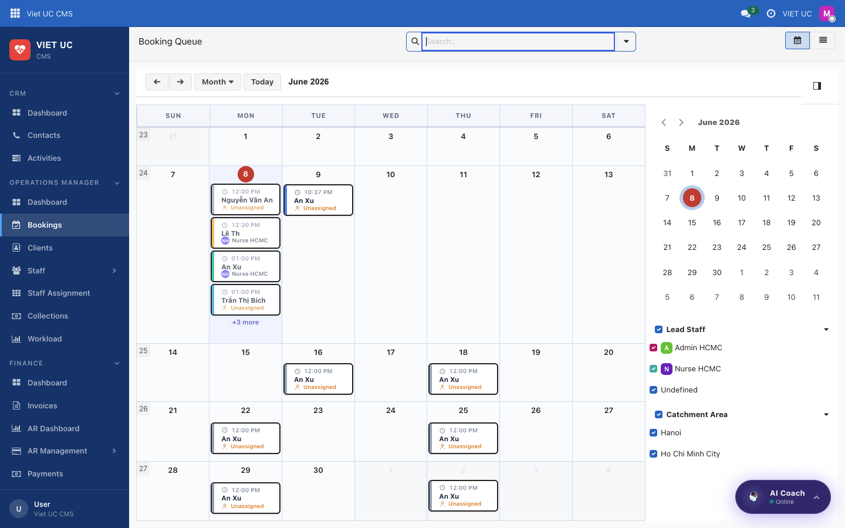
Figure: The Bookings calendar view
What you see on this screen:
- A list view of all bookings.
- A calendar view that can be switched between Day, Week, and Month.
How to use it:
- Use the list view to scan and sort many bookings at once.
- Switch to the calendar view and choose Day, Week, or Month to see bookings laid out by time.
- Click any booking to open its full record.

The booking record
Every booking opens to a single record that shows you exactly where it is in its life and what to do next.
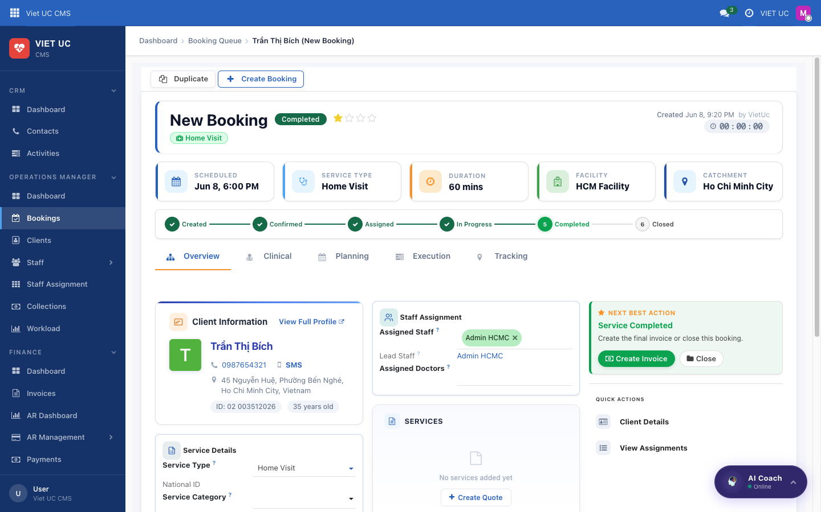
Figure: A completed booking detail with lifecycle bar, summary cards, and quick actions
What you see on this screen:
- A lifecycle progress bar: Created → Confirmed → Assigned → In Progress → Completed → Closed.
- Summary cards: Scheduled, Service Type, Duration, Facility, and Catchment.
- Client Information and Staff Assignment panels.
- A Next Best Action panel that tells you the single most useful thing to do next.
- Quick Actions: Client Details, View Quote, View Payments, and View Assignments.
How to use it:
- Read the lifecycle progress bar to see which stage the booking is at.
- Follow the Next Best Action panel — it surfaces the right button for the current stage.
- Use the Quick Actions to jump to the client, the quote, the payments, or the assignments without leaving the booking.

The full booking workflow
This is the complete journey of a booking. Each step lists the action you take, what it does, and what appears next.
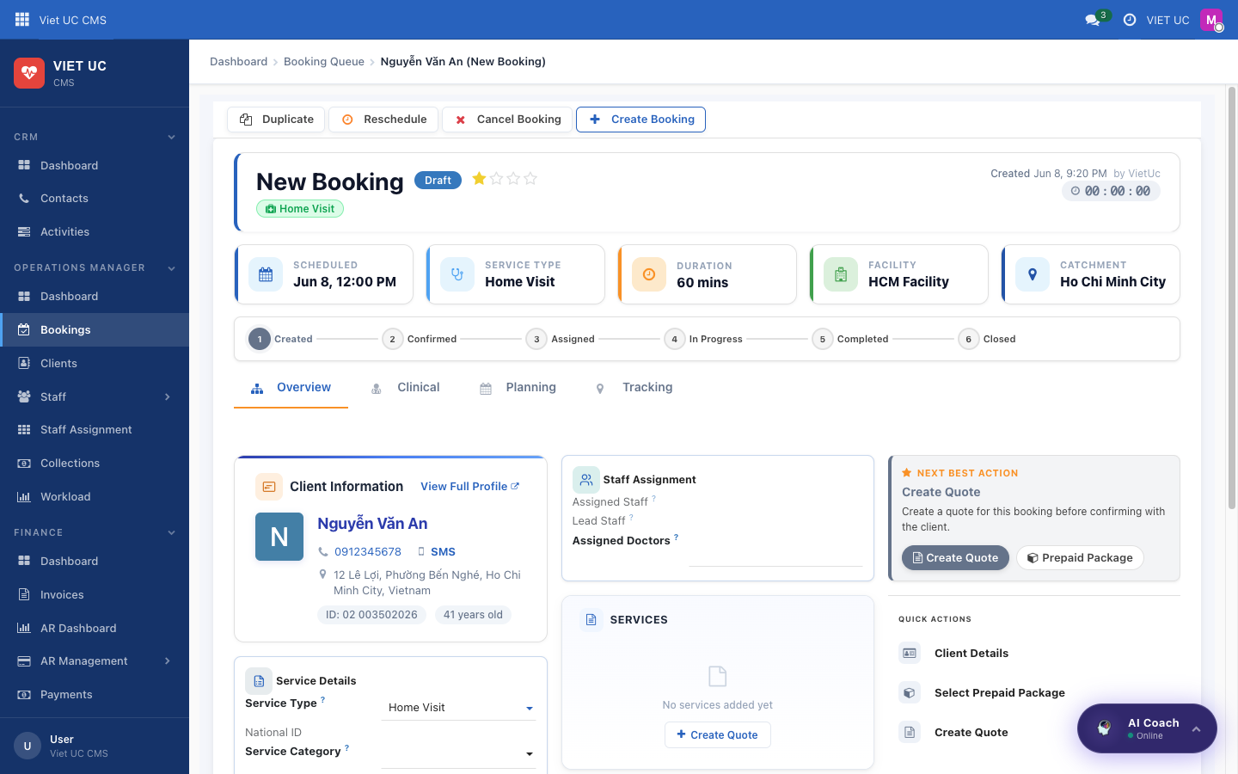
Figure: A draft booking showing the Create Quote next best action
- Create the booking (Draft). Click Create Booking (from the Operations Center or from a client profile). Fill in the client (the system de-duplicates so you do not create the same client twice), the service type, the facility, the date and time, and the duration. The booking saves as a Draft.
- Create the quote (still Draft). On a draft booking, the Next Best Action panel shows Create Quote. Click it to add priced service lines, then save. Pricing can automatically apply distance-based travel charges.
- Confirm the booking (→ Confirmed). Once a quote exists and the date is set, click Confirm Booking. This finalises the booking number and moves it to Confirmed — the client is now booked.
- Assign staff (→ Assigned). Click Assign Staff (or use the Assign dropdown in the Operations Center). This creates the staff assignment(s): the first nurse is the Lead and any others are Support. The assigned nurse(s) receive a push notification.
- Start the service (→ In Progress). Click Start Service. This stamps the actual start time and starts a timer; the booking now shows as Active Now.
- Add clinical notes. During the visit, add clinical notes on the Clinical tab. This is required before you can complete the booking.
- Complete the service (→ Completed). Click Complete Service. This stamps the end time. Bookings handled by full-time staff move to Completed; bookings handled by part-time staff move to Completed-Pending-Invoice, which means Operations must raise the invoice.
- Create the invoice. Click Create Invoice. This opens the quote for a final review and generates the invoice.
- Collect payment. Record the payment as cash or transfer.
- Close the booking (→ Closed). Click Close. This finalises the booking and locks it.
Alternatives at any time before completion:
- Cancel Booking (available before Completed) opens a cancel wizard where you enter a reason and notes; it cancels the assignments and notifies the staff.
- Reschedule changes the date and time and reassigns staff.
Button reference:
Button | What it does | State after
Create Booking | Creates a new booking from the client and visit details | Draft
Create Quote | Adds priced service lines (may include travel charges) | Draft
Confirm Booking | Finalises the booking number; client is booked | Confirmed
Assign Staff | Creates assignment(s); first = Lead, others = Support; notifies nurses | Assigned
Start Service | Stamps start time and starts the timer | In Progress
Complete Service | Stamps end time | Completed (or Completed-Pending-Invoice for part-time staff)
Create Invoice | Opens the quote for review and generates the invoice | Completed
Close | Finalises and locks the booking | Closed
Cancel Booking | Opens cancel wizard; cancels assignments and notifies staff | Cancelled
Reschedule | Changes date/time and reassigns | (date/time changed)

NOTE The difference between full-time and part-time staff matters at step 7. Part-time visits land in Completed-Pending-Invoice and will not finish on their own — you must raise the invoice for them.

WARNING Clinical notes are required before you complete a service (step 6). If they are missing, you will not be able to move the booking to Completed.

Clients

Clients list
The Clients list is your directory of patients. Use it to find a client and immediately act on them.
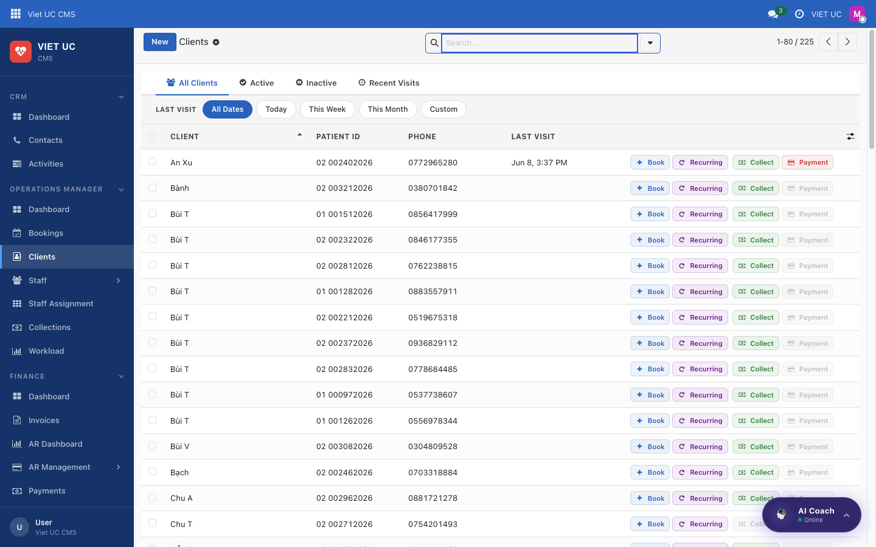
Figure: The Clients list with patient details and quick actions
What you see on this screen:
- Each client row shows the Patient ID, phone, and last visit.
- Quick actions on each row: Book, Recurring, Collect, and Payment.
How to use it:
- Find the client you need in the list.
- Use the row quick actions: Book to create a one-off booking, Recurring to set up a repeating booking, Collect to record collected cash, or Payment to take a payment.
- Click the client to open their full profile.

Client profile
The client profile is the complete picture of one patient — their history, their spend, where they live, and the route your nurse will drive.
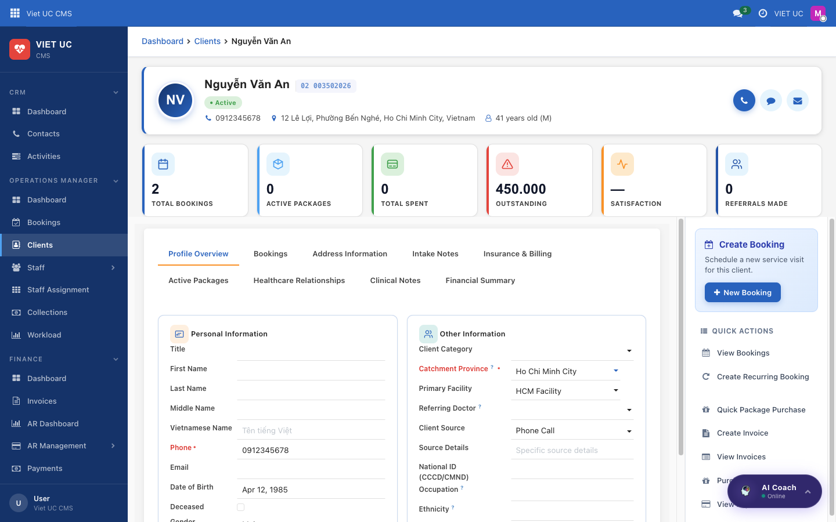
Figure: A client profile with KPI cards, address, map route, and quick actions
What you see on this screen:
- KPI cards: Total Bookings, Active Packages, Total Spent, Outstanding, Satisfaction, and Referrals.
- Address Details, including the driving distance to the clinic.
- A Map Location showing the route.
- A Create Booking button and a Quick Actions panel: View Bookings, Create Recurring Booking, Quick Package Purchase, Create Invoice, View Invoices, and Purchased Packages.
How to use it:
- Review the KPI cards to understand the client's history and any outstanding balance at a glance.
- Enter or edit the address — it auto-geocodes, and the route and distance appear on the map.
- Use Create Booking to start a booking for this client, or pick from Quick Actions to view bookings, set up recurring visits, purchase a package, create or view invoices, or see purchased packages.
NOTE The driving distance shown here feeds your pricing — it is what powers the distance-based travel charges that can appear on a quote.

Staff

Roster
The Roster shows who is on and how busy they are right now.
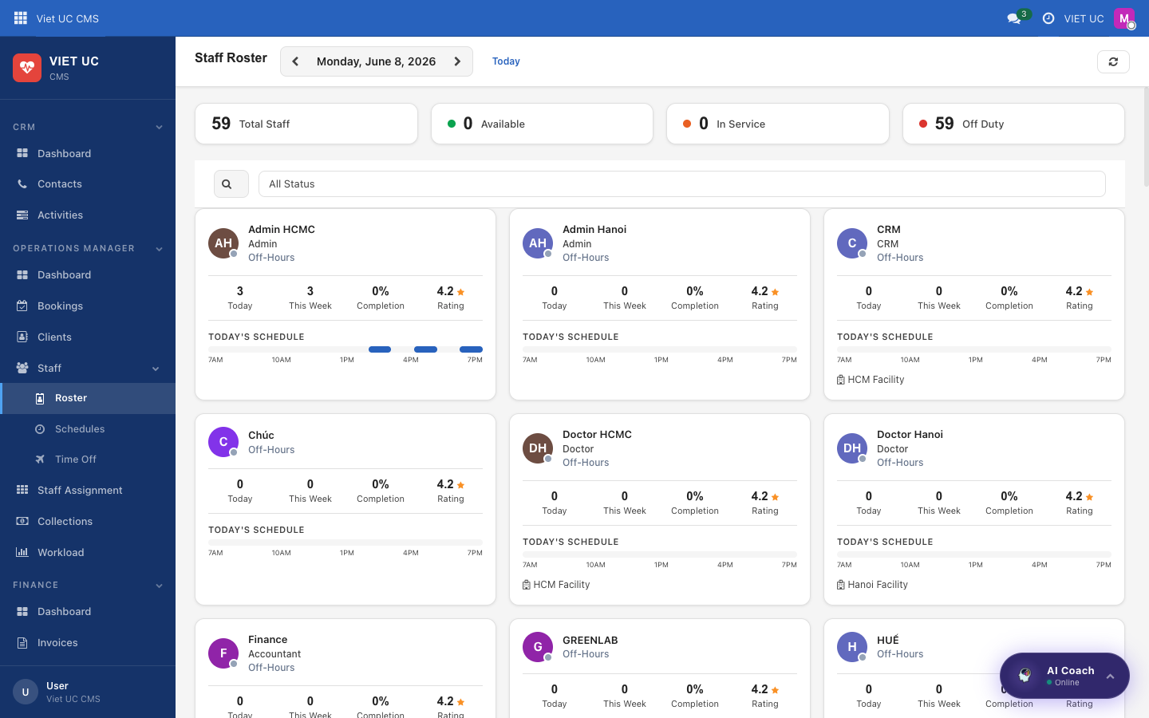
Figure: The staff roster showing availability and today's load
What you see on this screen:
- Each staff member's availability and today's load.
How to use it:
- Check the roster to see who is available before assigning work.
- Read each person's today's load to balance assignments fairly.

Schedules
Schedules show each staff member's regular working hours.
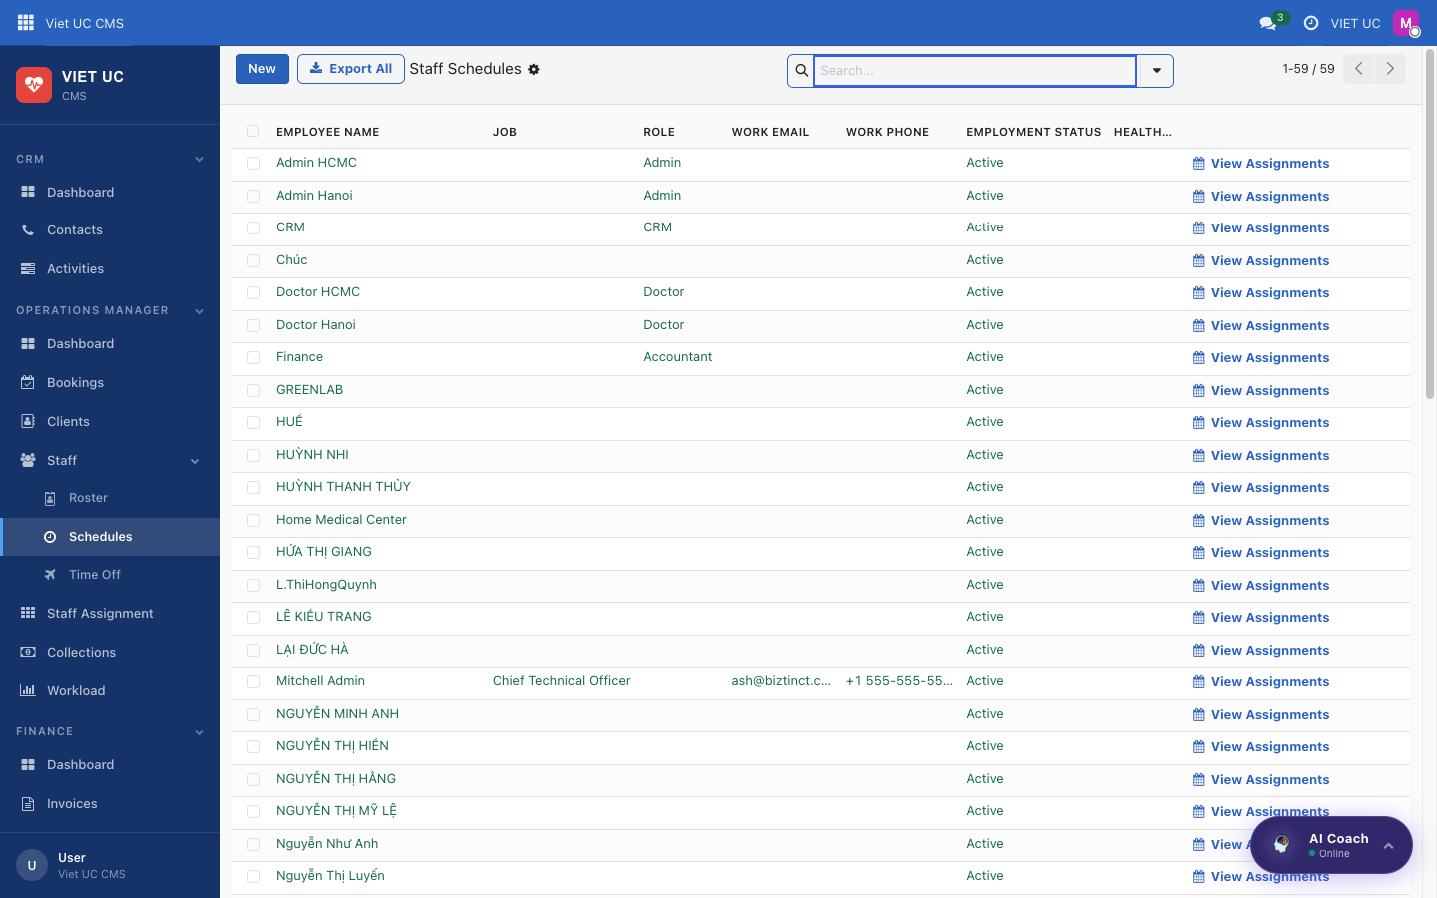
Figure: Staff working-hours schedules
What you see on this screen:
- Each staff member's working hours.
How to use it:
- Open Schedules to confirm a nurse's working hours before booking them into a visit.

Time Off
Time Off lists staff leave so you do not assign someone who is away.
What you see on this screen:
- A list of staff leave.
How to use it:
- Check Time Off before assigning a visit to make sure the nurse is not on leave.

Staff Assignment

Staff Assignment timeline
Staff Assignment is a timeline view of every assignment across all your staff and the day, so you can see who is doing what and when.
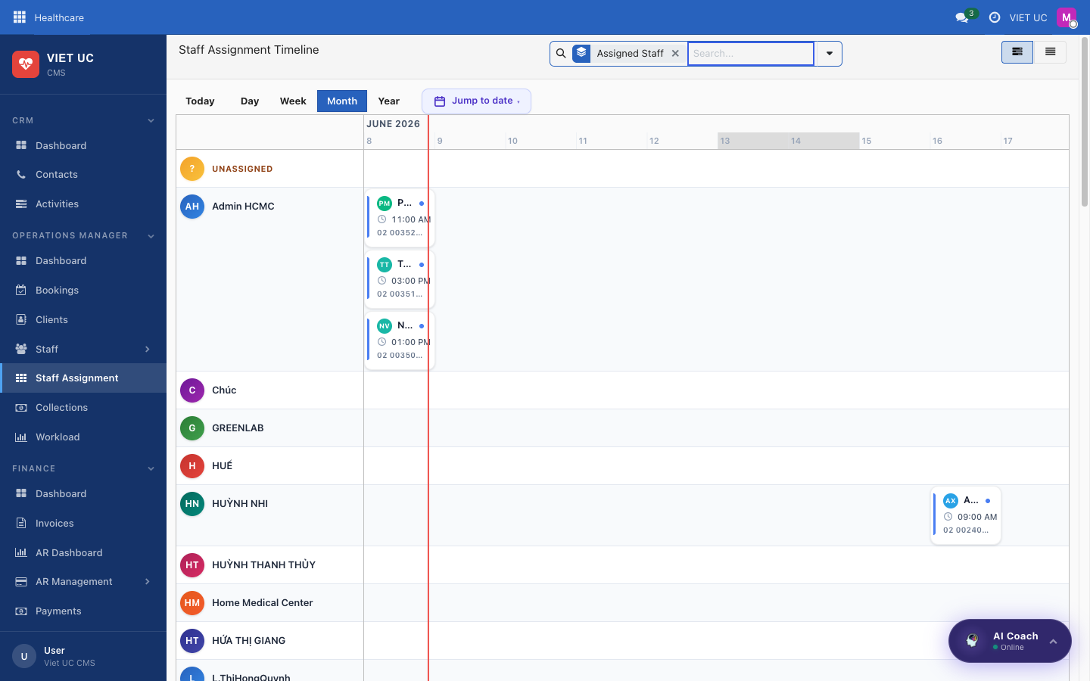
Figure: The staff assignment timeline across staff and time
What you see on this screen:
- A timeline of assignments laid out across staff and time.
How to use it:
- Read the timeline to see each nurse's assignments through the day.
- Track each assignment through its lifecycle: assigned → confirmed (the nurse accepts in the mobile app) → in_progress (the nurse starts) → completed.
NOTE Nurses accept, start, and complete their assignments from the mobile app. See the Mobile chapter for how the nurse side works.

Collections

Collections
Collections is where you reconcile the cash your nurses collect in the field. When a nurse takes cash on a visit, it is marked "pending delivery" to the office; here is where the office confirms it has arrived.
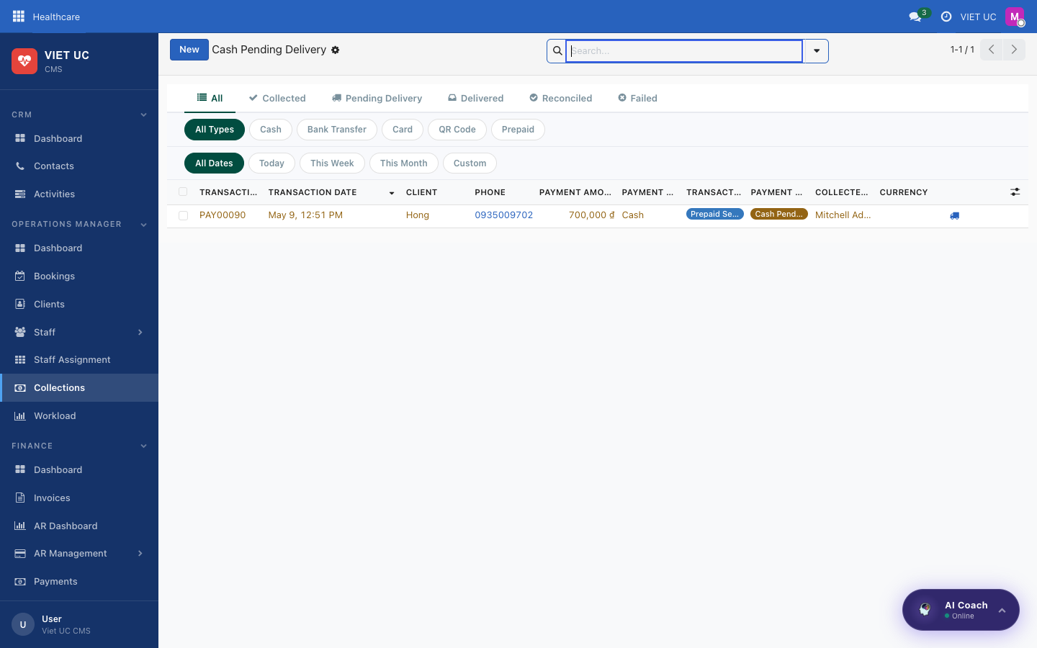
Figure: The collections screen for reconciling field cash
What you see on this screen:
- Cash collected by nurses in the field that is pending delivery to the office.
How to use it:
- Review the cash listed as pending delivery.
- Reconcile each amount as it is handed in to the office.
TIP Reconciling Collections regularly keeps your field cash and your office records in sync, so nothing collected on a visit goes unaccounted for.

Workload

Workload
Workload is a dashboard of how busy your staff are, so you can spread visits evenly and avoid overloading anyone.
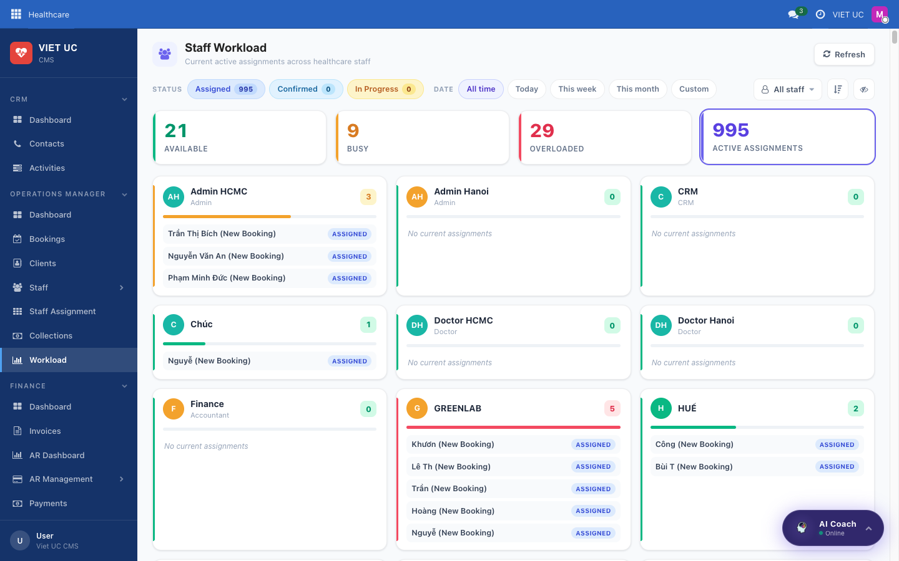
Figure: The workload dashboard of staff utilisation and assignment load
What you see on this screen:
- A dashboard of staff utilisation and assignment load.
How to use it:
- Review each staff member's utilisation and assignment load.
- Use what you see to rebalance work — move assignments away from overloaded staff toward those with spare capacity.

Finance — Invoicing, Payments & Receivables
The Finance section is where you handle everything to do with money: creating bills (invoices), collecting payments, and keeping track of who still owes you (accounts receivable, or "AR"). This chapter walks you through each screen, from the at-a-glance Dashboard down to the detailed receivables ledger.
The Finance menu contains these items:
- Dashboard — the Finance Center overview
- Invoices — create and manage bills
- AR Dashboard — see outstanding receivables and aging
- AR Management — Account Payment, Cash In Transit, Refund / Credit
- Payments — every payment transaction
- Overdue Clients — your collections worklist
- VAT Log — VAT / red-invoice tracking
- AR Transactions — the detailed receivables ledger

Dashboard (Finance Center)

Finance Center
This is your home base for finance. It gives you a single, live overview of revenue, money owed to you, cash collected, and recent activity, so you can spot what needs attention without digging through lists.
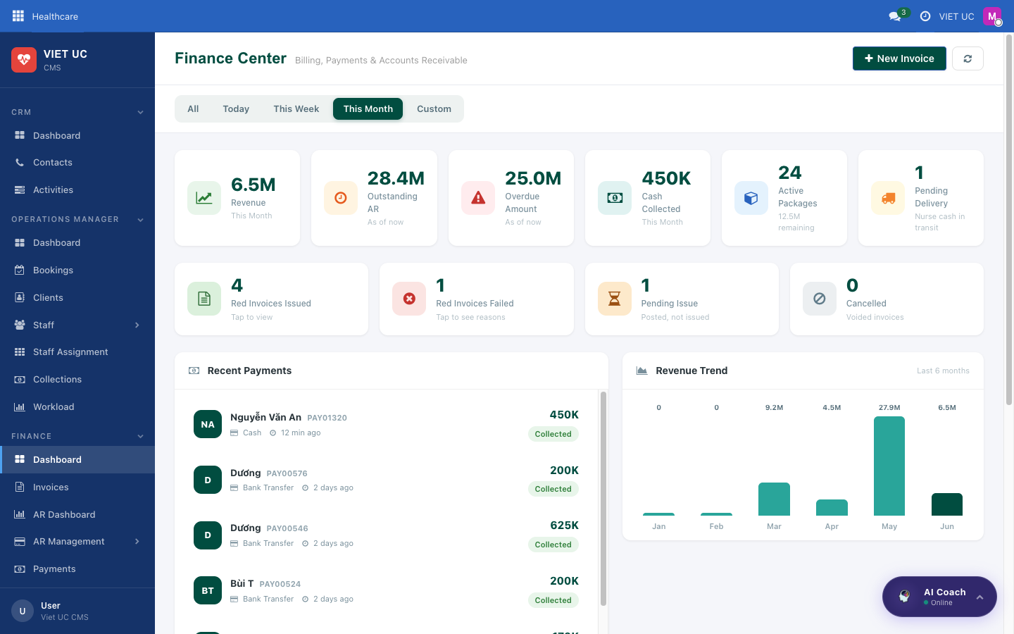
Figure: Finance Center dashboard with KPI cards, recent payments and revenue trend
What you see on this screen:
- Header — titled "Finance Center — Billing, Payments & Accounts Receivable", with a New Invoice button and a period filter to choose the time range you are looking at.
- KPI cards (each one is clickable and drills down to the underlying details):
- Revenue — income for this period, from posted invoices.
- Outstanding AR — amounts that are unpaid or only partially paid.
- Overdue Amount — money past its due date.
- Cash Collected — payments you have taken in.
- Active Packages — count of active packages plus their remaining value.
- Pending Delivery — nurse cash that is still in transit to the clinic.
- Red-Invoice status row (Vietnamese VAT e-invoices) — may show counts for Red Invoices Issued, Failed, Pending Issue, and Cancelled.
- Recent Payments — a list showing avatar, client, reference, method, amount, and a status badge (such as Collected, Pending Delivery, or Reconciled).
- Revenue Trend — a bar chart of the last 6 months.
- Quick Actions — shortcut buttons: New Invoice, Payments, AR Dashboard, VAT Log.
- Invoice Status breakdown — totals by status: Draft, Posted, Paid, Partial, Overdue, Cancelled.
How to use it:
- Use the period filter in the header to set the date range. All KPI cards update to match the period you choose.
- Click any KPI card (for example, Outstanding AR) to drill down into the list of records behind that number.
- Click a row in Recent Payments to open that individual payment and view its full details.
- Click a Quick Action button to jump straight to that screen: New Invoice starts a new bill, Payments opens the payment list, AR Dashboard opens receivables, and VAT Log opens VAT tracking.
- Read the Invoice Status breakdown to see how many invoices are still Draft, Posted, Overdue, and so on.
TIP The KPI cards are the fastest way to investigate a number that looks off — if Overdue Amount seems high, click it to see exactly which invoices are late.

Invoices

Invoices
This is where bills live. Use it to create new invoices, review existing ones, confirm them so they count as revenue, and track whether they have been paid.
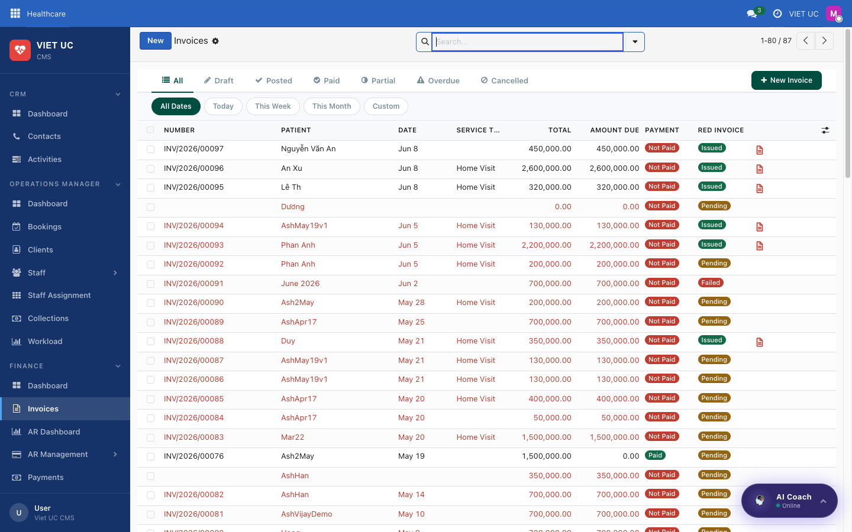
Figure: Invoices list with status tabs and date filters
What you see on this screen:
- Status tabs — to filter invoices by their stage.
- Date filters — to narrow the list to a chosen time range.
- A row per invoice, showing the client and key details.
When you open a single invoice, the form looks like this:
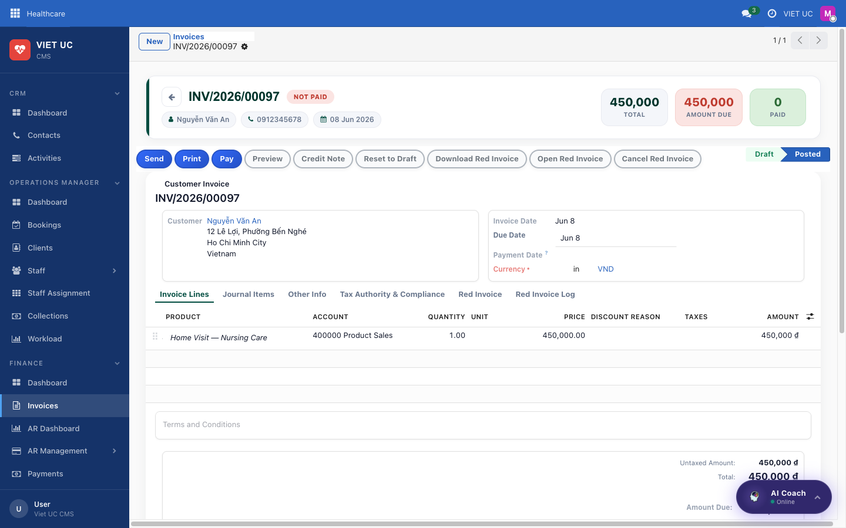
Figure: Invoice form showing client, line items, totals and payment status
- Client — who the invoice is billed to.
- Line items — the services or products being charged.
- Totals — the overall amount due.
- Payment status — whether the invoice is Draft, Posted, Paid, and so on.
How to use it — the invoice-to-payment workflow:
- An invoice is created from a completed booking, or by clicking New Invoice.
- The invoice starts as Draft. While it is Draft, you can still edit it.
- Click Confirm / Post to post the invoice. Once posted, it counts as revenue and as outstanding AR.
- Register a payment against the invoice (cash or bank transfer).
- When the invoice is fully paid, its status automatically becomes Paid.
NOTE Vietnamese "red" / VAT invoices can additionally be issued for a posted invoice. When that happens, the invoice appears in the VAT Log.

Invoice statuses at a glance:
Status | What it means
Draft | Newly created and still editable; not yet counted as revenue.
Posted | Confirmed; now counts as revenue and outstanding AR.
Partial | Some payment received, but a balance remains.
Paid | Fully paid.
Overdue | Posted and unpaid past the due date.
Cancelled | Voided; no longer owed.

WARNING Only edit an invoice while it is in Draft. Once you post it, it counts toward revenue and receivables, so changes should be made carefully.

Accounts Receivable

AR Dashboard
The AR Dashboard shows everything still owed to you (your outstanding receivables). Use it to answer "who owes us, how much, and how late is it?" — including aging.
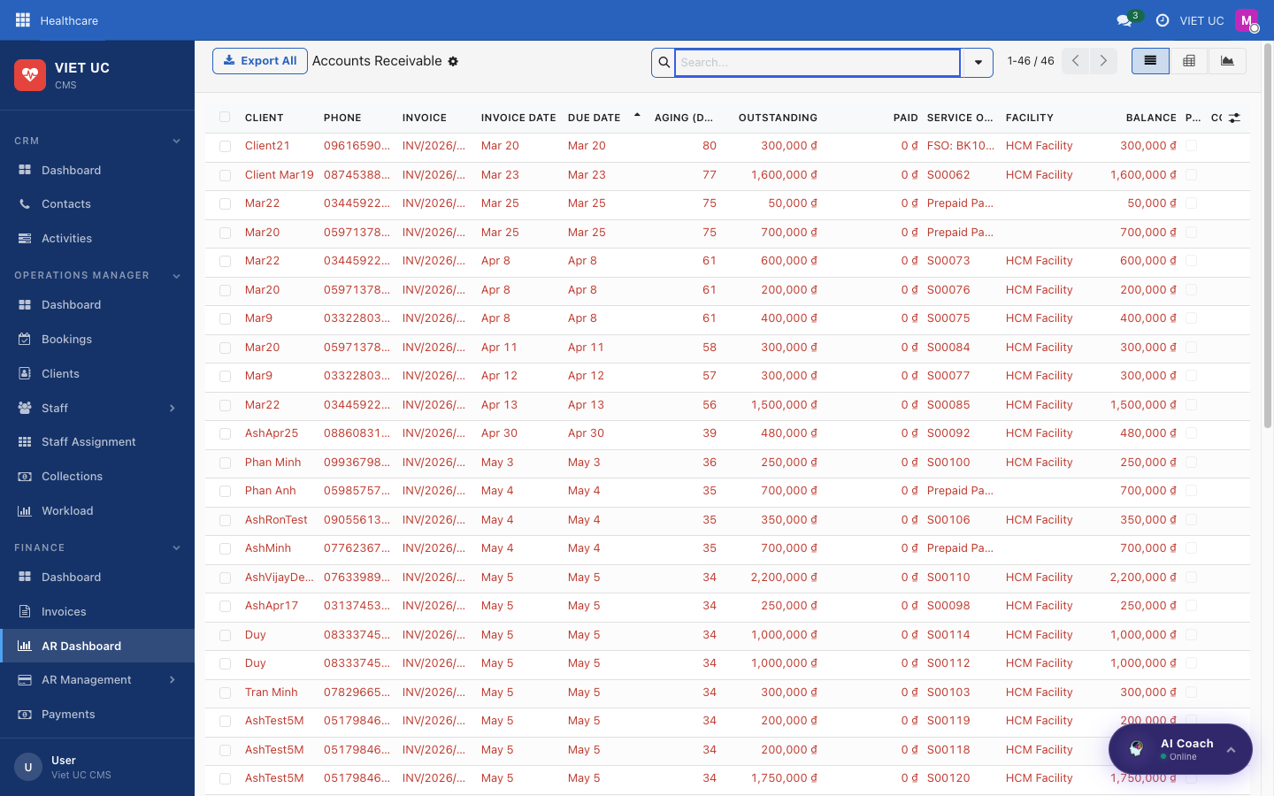
Figure: AR Dashboard showing outstanding receivables as list, pivot and graph
What you see on this screen:
- Outstanding receivables presented as a list, a pivot, and a graph.
How to use it:
- Use the list view to scan individual outstanding amounts by client.
- Switch to the pivot view to summarize and group the receivables (for example, by client or period).
- Switch to the graph view to see the totals and aging visually.
TIP Use this screen to understand aging — how long invoices have been outstanding — so you know which clients to follow up with first.

AR Management
AR Management is a sub-menu with three tools for working with receivables: recording payments, tracking nurse cash, and issuing credits.
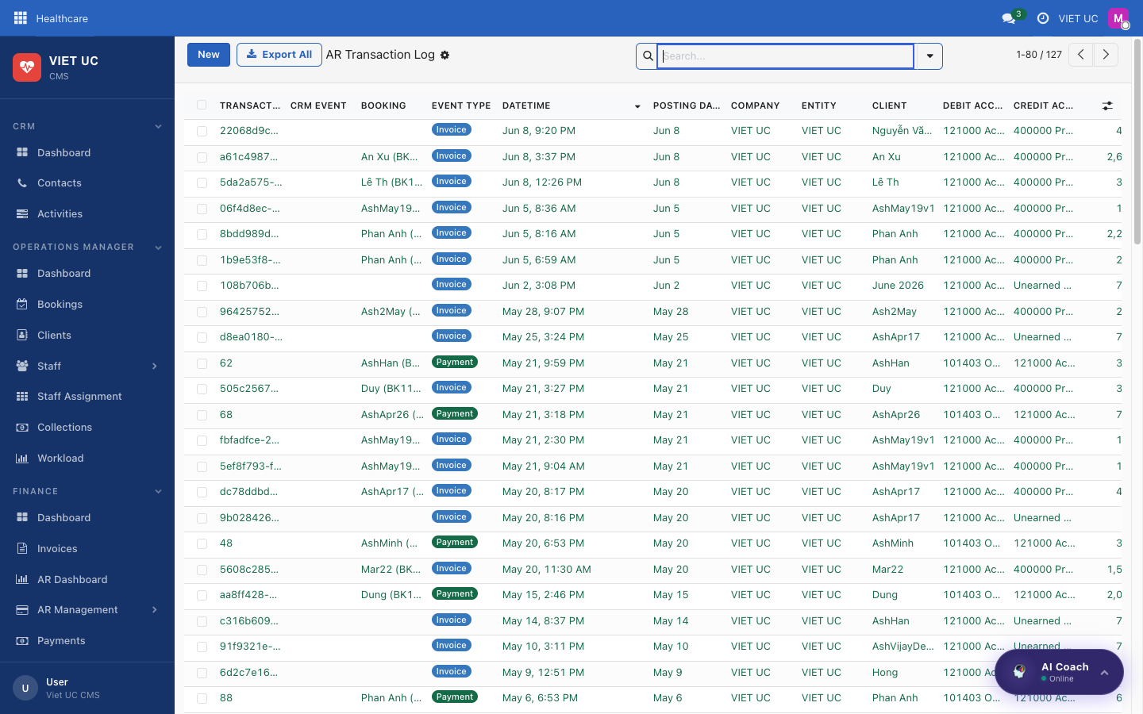
Figure: Accounts receivable transactions ledger
What you see in this sub-menu:
- Account Payment — opens a payment-collection wizard so you can record a payment against a client or invoice.
- Cash In Transit — nurse cash that is pending delivery to the clinic (this is the same as Pending Delivery on the Dashboard).
- Refund / Credit — customer credit notes.
How to use it:
- Choose Account Payment when a client pays you. The payment-collection wizard opens; record the payment against the relevant client or invoice.
- Choose Cash In Transit to see cash a nurse has collected that has not yet been delivered and reconciled at the clinic.
- Choose Refund / Credit to issue a customer credit note.
NOTE "Cash In Transit" and the Dashboard's "Pending Delivery" KPI refer to the same thing — nurse cash that has not yet reached the clinic.

Payments & Collections

Payments
This screen lists every payment transaction. Use it to confirm a specific payment, check its method and amount, or see whether the money has been reconciled.
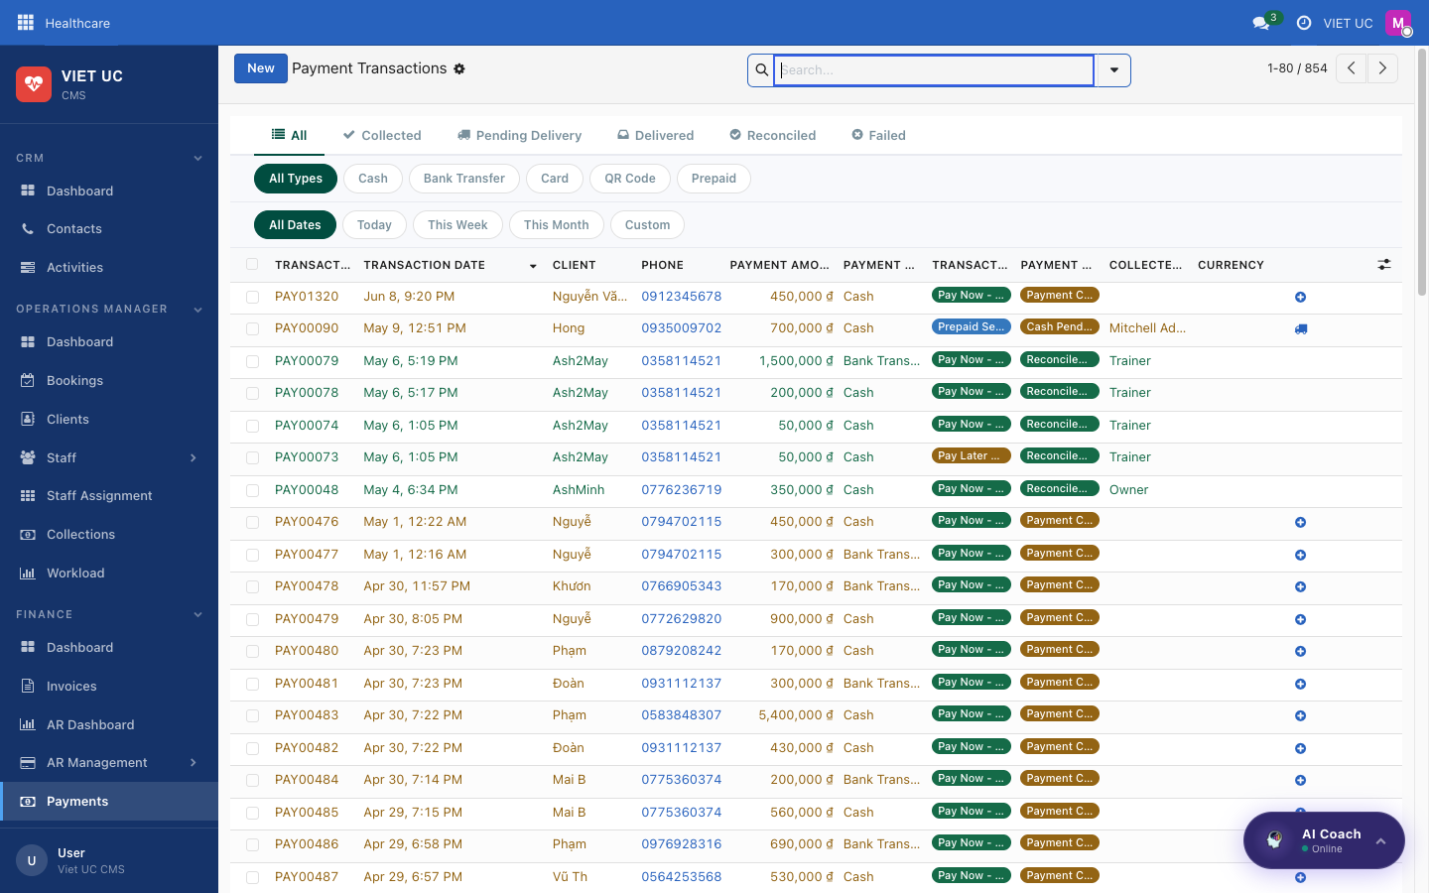
Figure: Payments list with method, amount, date and status
What you see on this screen:
- One row per payment, showing the method, amount, date, and status.
Payment statuses:
Status | What it means
Collected | The payment has been taken.
Pending Delivery | Nurse cash that has not yet been delivered to the clinic.
Delivered | The cash has been delivered.
Reconciled | The payment has been matched and confirmed in the books.

How to use it:
- Scan the list to find the payment you need by client, date, or amount.
- Click a payment row to open it and view its full details.
- Check the status column to know where each payment is in its lifecycle, from Collected through to Reconciled.

Overdue Clients
This is your collections worklist: posted invoices that are unpaid and past their due date. Use it to know exactly who to chase for payment.
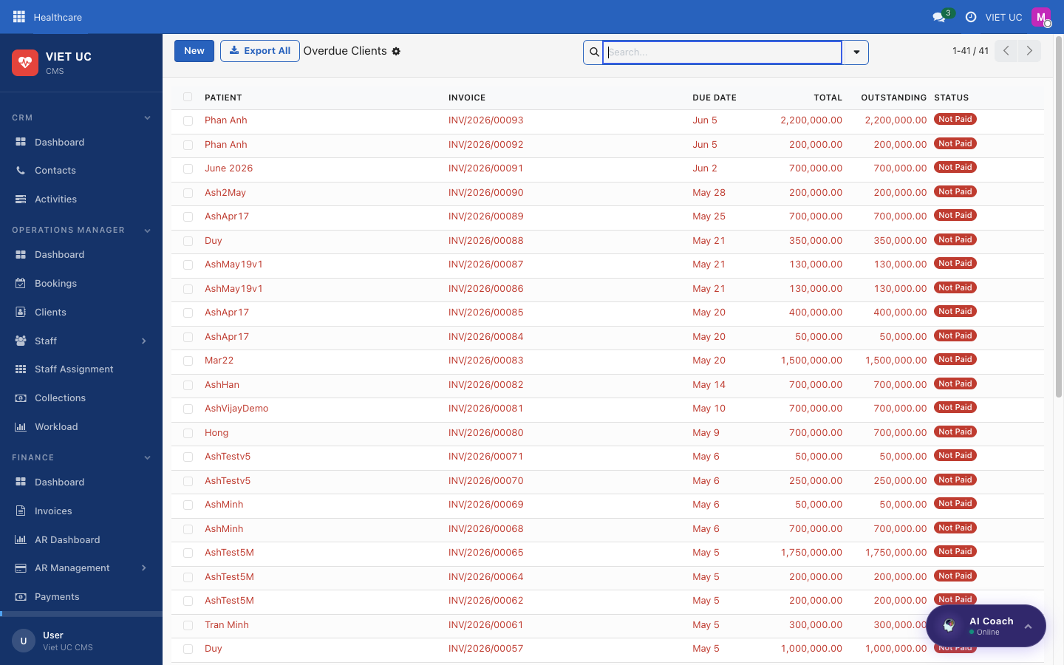
Figure: Overdue clients list of posted, unpaid, past-due invoices
What you see on this screen:
- A list of posted, unpaid invoices that are past their due date.
How to use it:
- Open this screen to get your list of overdue accounts.
- Work through the clients, following up with each one to collect payment.
- As payments come in and invoices are settled, they drop off this list.
TIP Check Overdue Clients regularly — it is the most direct way to keep receivables under control.

Tax & Ledger

VAT Log
The VAT Log tracks posted customer invoices for VAT and red-invoice purposes. Use it when you need to review or follow up on Vietnamese VAT e-invoices.
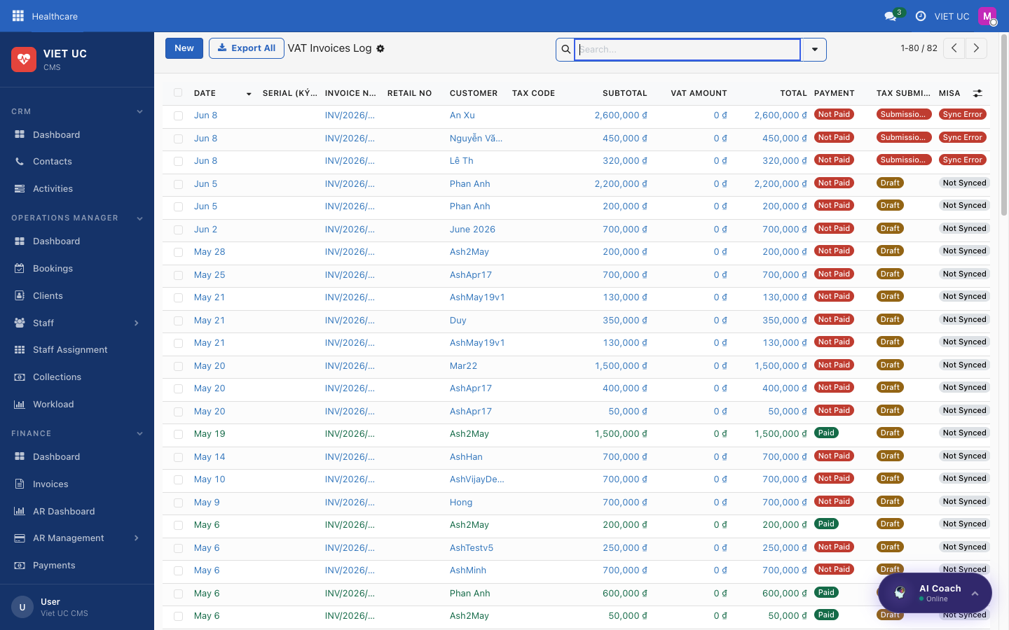
Figure: VAT Log of posted customer invoices for VAT and red-invoice tracking
What you see on this screen:
- A list of posted customer invoices tracked for VAT / red-invoice purposes.
How to use it:
- Open the VAT Log to review the posted invoices relevant to VAT.
- Cross-check against the Dashboard's Red-Invoice status row (Issued, Failed, Pending Issue, Cancelled) to confirm which red invoices still need attention.
NOTE A Vietnamese "red" / VAT invoice can be issued for a posted invoice; once issued, it is tracked here.

AR Transactions
AR Transactions is the detailed receivables ledger. Use it when you need the full, line-by-line history of receivables rather than a summary.

Figure: AR Transactions detailed receivables ledger
What you see on this screen:
- The detailed receivables ledger — every receivable transaction in full detail.
How to use it:
- Open AR Transactions when you need to trace a receivable in depth.
- Review the individual entries to reconcile balances or investigate a specific client's account.
TIP Use the AR Dashboard for the big picture and aging, then come to AR Transactions when you need the detailed, transaction-level record.

Admin — Users, Master Data, Pricing & Settings
The Admin section is where you set up and configure the whole system: the people who can log in, the reference lists every other screen relies on, how prices are calculated, and your company-wide options. Most day-to-day staff will only visit a few of these screens, but everything that powers the bookings, quotes, and scheduling lives here.

Getting your bearings

Admin Dashboard
The Admin Dashboard is your starting point. It gives you a one-glance health check of the system and fast shortcuts to the things you set up most often.
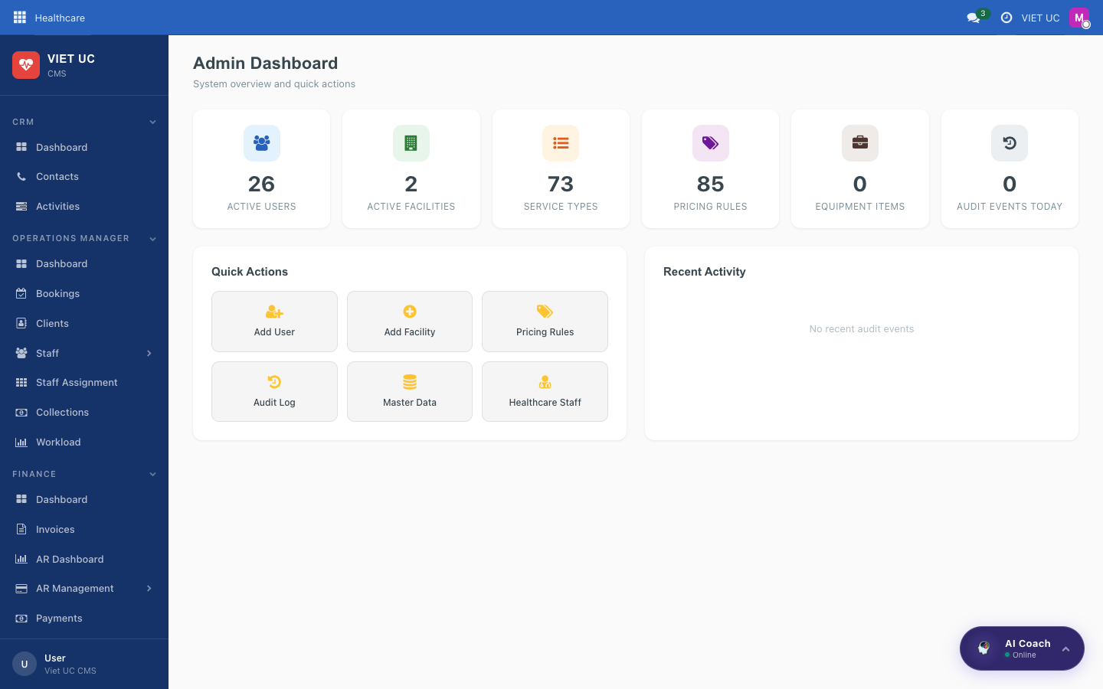
Figure: The Admin Dashboard with KPI cards, Quick Actions, and Recent Activity
What you see on this screen
- KPI cards (each one is clickable and opens the matching list):
- Active Users
- Active Facilities
- Service Types
- Pricing Rules
- Equipment Items
- Audit Events Today
- Quick Actions grid with one-click buttons: Add User, Add Facility, Pricing Rules, Audit Log, Master Data, Healthcare Staff.
- Recent Activity feed showing the most recent audited changes in the system.
How to use it
- Read the KPI cards at the top to see current totals at a glance.
- Click any KPI card to jump straight into that list (for example, click *Active Users* to open the user list).
- Use a Quick Action button to start a common task immediately — for example, *Add User* opens the new-user wizard, or *Add Facility* opens a new facility form.
- Scan the Recent Activity feed to see what was changed recently and by whom.
TIP When you are not sure where to start, the Quick Actions grid covers the most common admin jobs, so you rarely need to hunt through menus.

People & access

Users & Roles
This is the list of internal user accounts — the people who can log in to the system. Crucially, this is also where you control what each person is allowed to see and do, by assigning them a role.
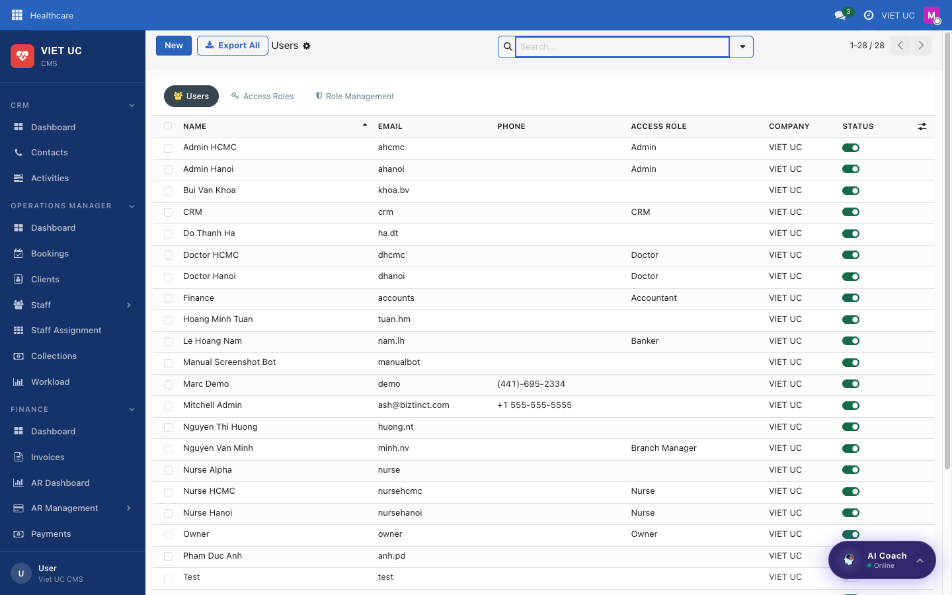
Figure: The Users & Roles list of internal accounts
What you see on this screen
- A list of all internal user accounts.
- A button/option to create a new user, which opens a user wizard.
How roles control access
A role bundles together the permissions (groups) that decide which menus and records a person can see. Some examples:
Role | What they can see
Nurse | Only their assigned bookings and the clients in their catchment
Operations Manager | All bookings in their catchment
Finance | Finance-related records
Owner / Admin | Everything

How to use it
- Open Users & Roles to view the list of accounts.
- To add a person, start a new user — this opens the user wizard.
- In the wizard, enter the person's name, their login / email, and assign a role. The role automatically applies the right permissions and groups.
- Save the user. They can now log in and will only see the menus and records their role allows.
- To change what an existing person can access, open their account and change their role / groups here.
NOTE Visibility is driven entirely by the assigned role. If someone says they "can't see" a booking or client, the fix is almost always to review and adjust their role on this screen.

Reference data the whole app uses

Master Data
Master Data is a tabbed navigator over all the reference (lookup) tables that the rest of the app draws from. Anything that appears in a dropdown elsewhere — service types, symptoms, insurance providers, and so on — is defined and maintained here.
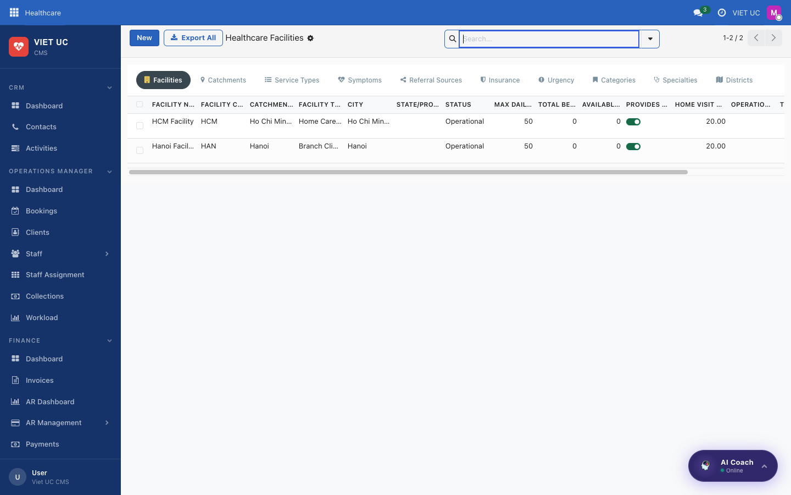
Figure: The Master Data tabbed navigator over reference tables
What you see on this screen
A set of tabs, each one a simple list-plus-form for a single reference table:
- Facilities — clinics / home-care centres
- Catchments — geographic service areas (these drive client and staff matching)
- Service Types
- Symptoms
- Referral Sources
- Insurance providers
- Urgency levels
- Patient Categories
- Medical Specialties
- Districts
How to use it
- Open Master Data and choose the tab for the list you want to manage (for example, *Service Types*).
- To add an entry, create a new record in that tab's list and fill in the form.
- To change an entry, open it from the list and edit it.
- Save. The new or updated entry now appears in the matching dropdowns across the app.
TIP Keep Catchments accurate — they drive which clients and staff get matched together, so an out-of-date catchment can affect who gets assigned to bookings.

Pricing
Pricing holds the rules that the quote engine uses to calculate charges automatically. When a booking is quoted, these rules add the right amounts without anyone keying them in by hand.
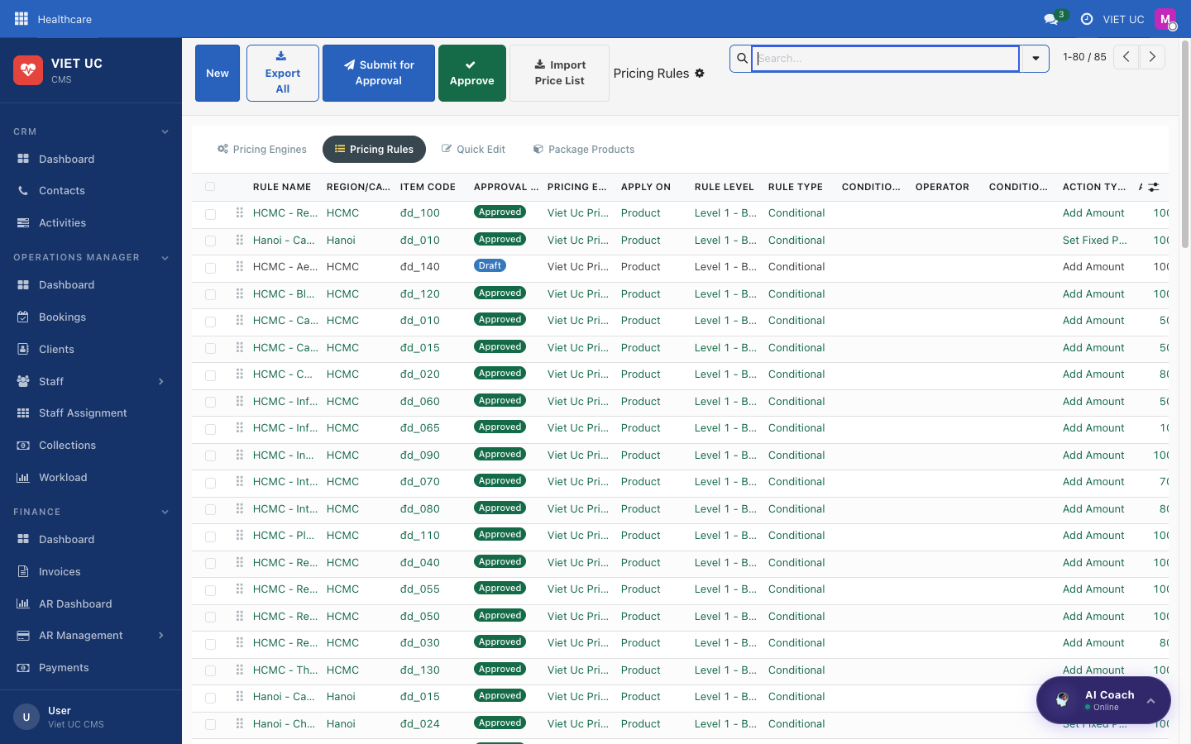
Figure: The Pricing rules used by the quote engine
What you see on this screen
- Pricing rules, which can depend on factors such as:
- Distance (distance bands / per-km)
- Zone
- Service type
- Time
- Urgency
- Pricing engines
- Healthcare packages
How to use it
- Open Pricing to see the existing rules.
- To add a charge, create a new pricing rule and choose what it depends on (for example, a distance band, a zone, a service type, a time, or an urgency level) and the amount it adds.
- Save the rule. From then on, the quote engine applies it automatically when a matching booking is quoted.
- Manage your pricing engines and healthcare packages from the same screen as needed.
NOTE The driving distance calculated on a booking feeds the distance-based rules here, so travel charges are applied automatically — you do not need to add them by hand.

Staff, equipment & scheduling

Healthcare Staff
This is the master list of your healthcare staff (nurses and doctors). What you record here decides who can be assigned to bookings.
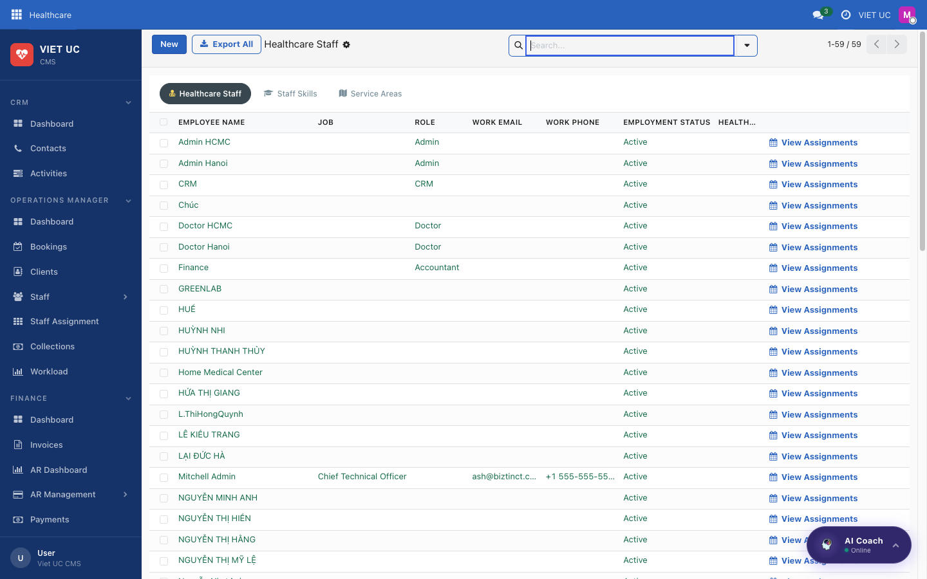
Figure: The Healthcare Staff master list
What you see on this screen
- A list of all healthcare staff.
- For each person, their profile, role, facility / catchment, skills, and service areas.
How to use it
- Open Healthcare Staff to view the list.
- To add someone, create a new staff record and fill in their profile, role, facility / catchment, skills, and service areas.
- To update someone, open their record and edit these details.
- Save. These details drive who can be assigned to bookings — for example, matching staff skills and service areas to a booking's needs.
TIP Keep each person's catchment, skills, and service areas current so the system suggests the right people when bookings are assigned.

Equipment
Equipment is your inventory of portable equipment that can be attached to bookings.
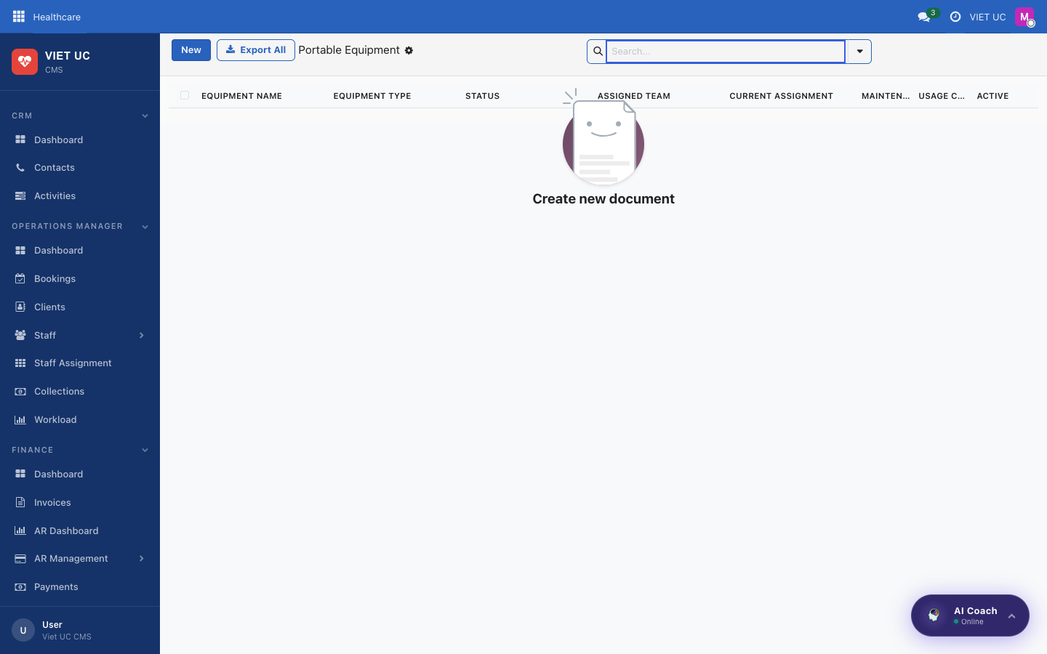
Figure: The Equipment inventory
What you see on this screen
- A list of portable equipment items.
How to use it
- Open Equipment to view the inventory.
- To add an item, create a new equipment record and save it.
- The item is then available to be attached to bookings.

Public Holidays
A calendar of public holidays that affect scheduling and pricing. Add the dates here so the system knows which days are holidays when it schedules visits and calculates quotes.
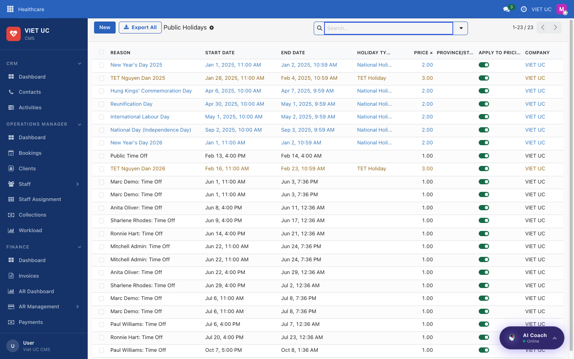
Figure: The Public Holidays calendar

Compliance & configuration

Audit Log
A read-only record of who changed what and when, kept for compliance. You cannot edit it — you use it to look back and confirm what happened. The Recent Activity feed on the dashboard is a quick window into the same information.
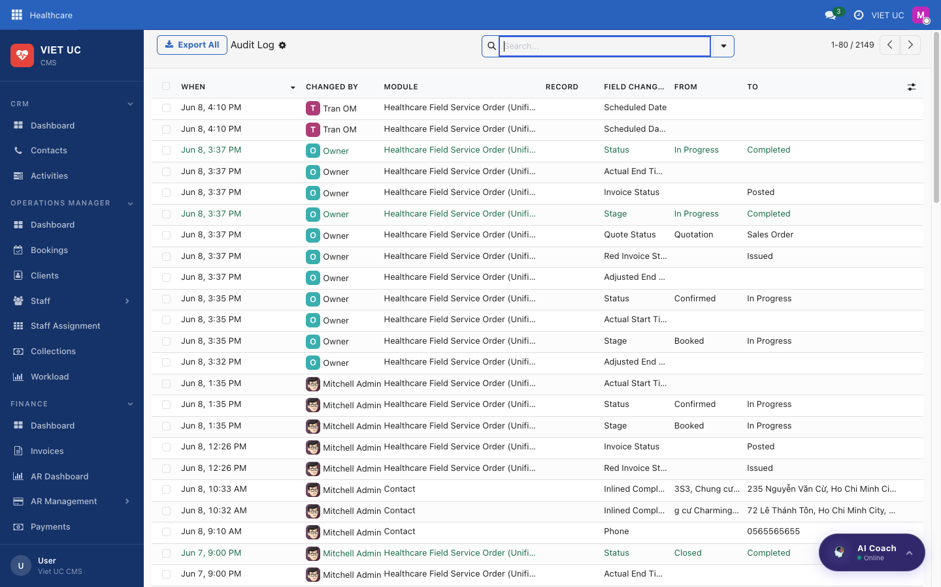
Figure: The Audit Log of changes

Field Requirements
This is where you configure which form fields are mandatory. Use it to make sure staff fill in the information you consider essential before they can save a record.
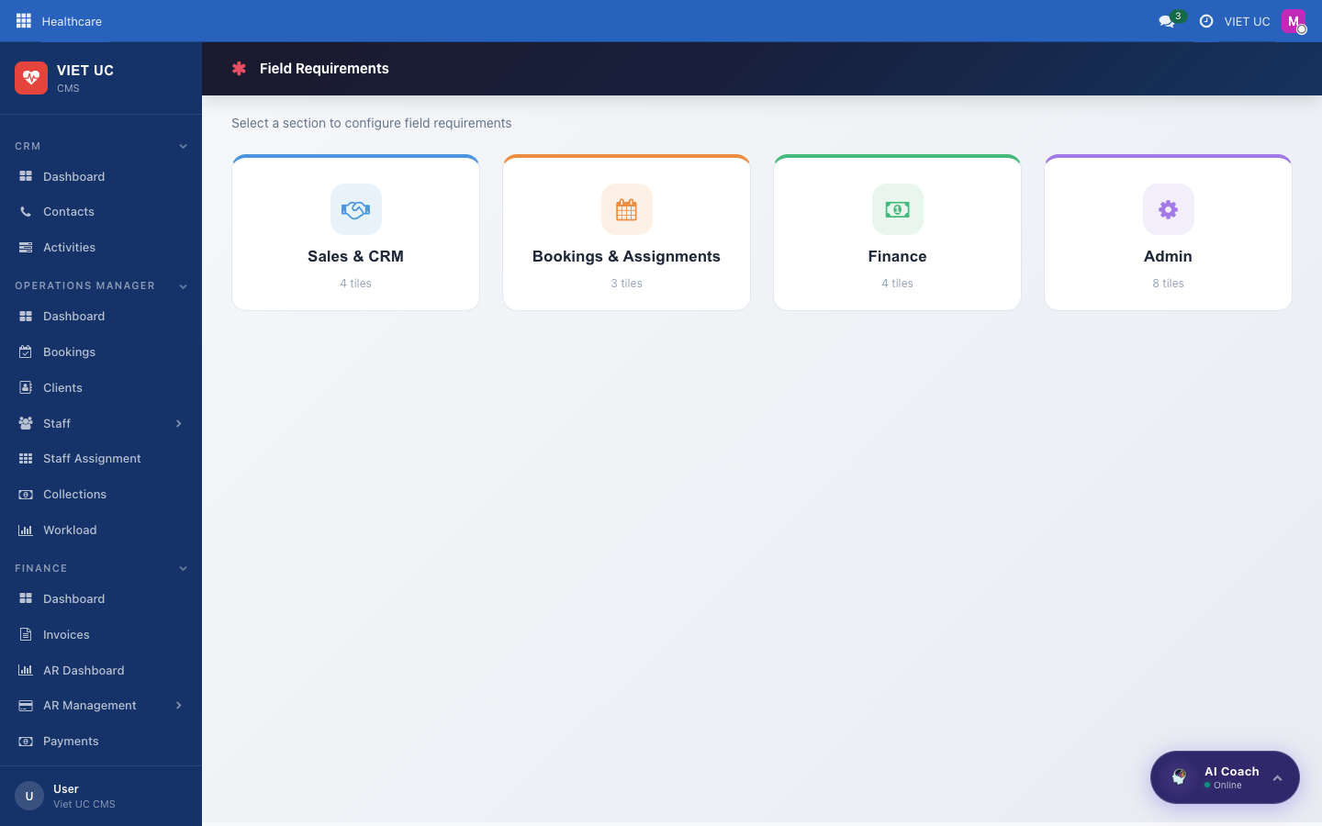
Figure: The Field Requirements configuration

CMS Sidebar Config
An advanced screen that defines the left-hand menu itself — the sections and the items inside them. Changing it reshapes the navigation everyone sees, so it is normally only touched during setup.
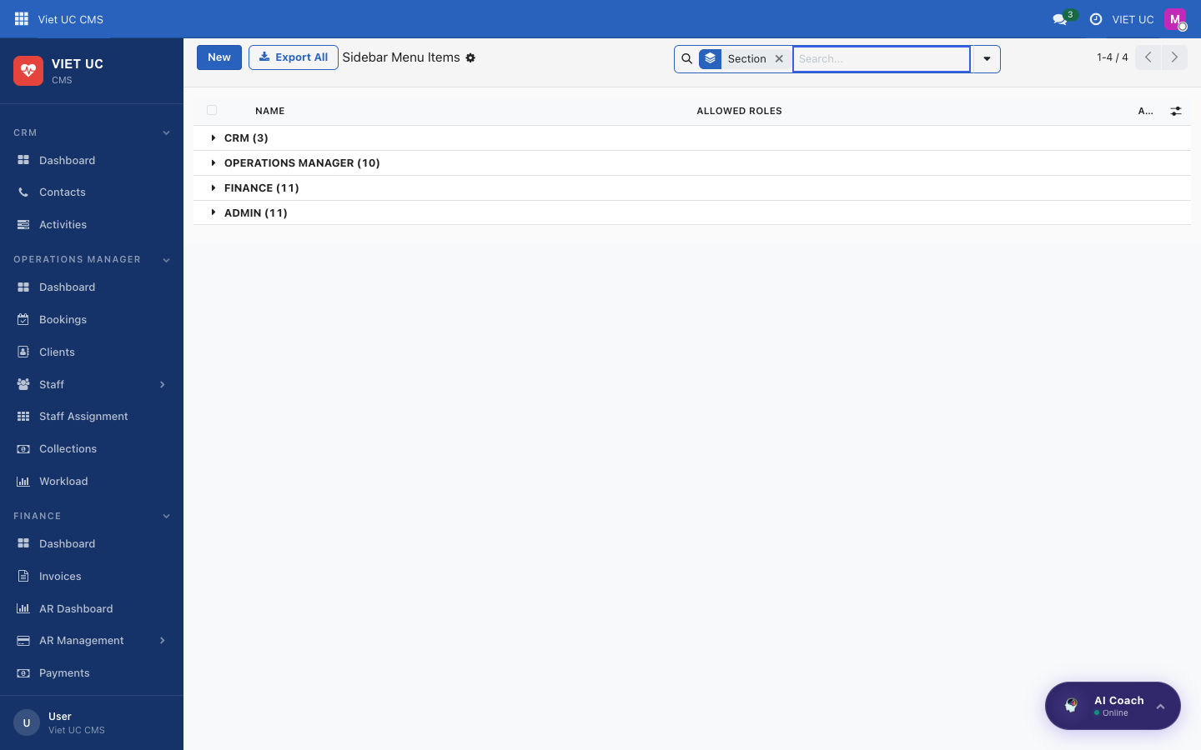
Figure: The CMS Sidebar configuration
WARNING Because the CMS Sidebar Config controls the menus for all users, only change it when you are confident about the effect — a wrong edit can hide menus people rely on.

Settings
Settings is the home for system-wide configuration — the company-wide options that apply to everyone.
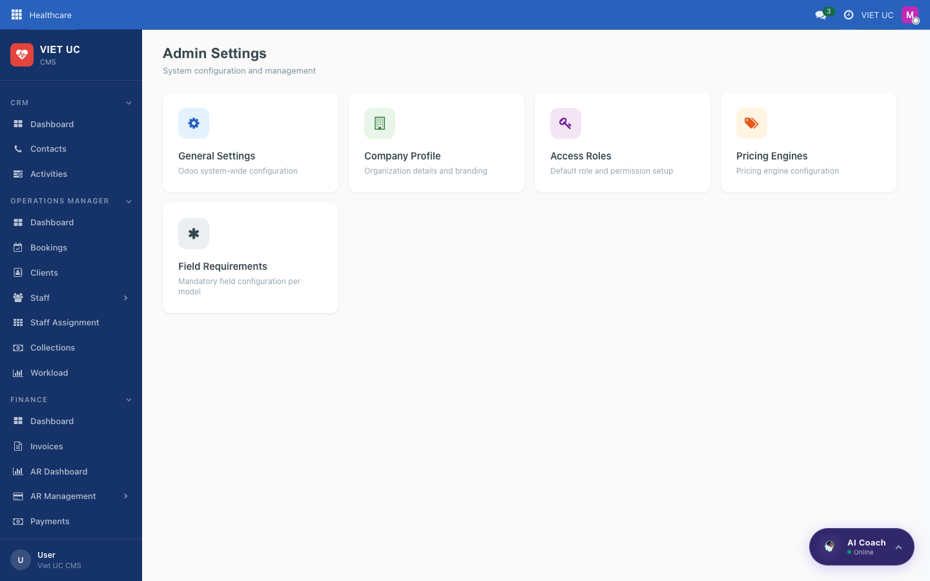
Figure: The system Settings screen
What you set here
- Map provider / API key
- Invoicing options
- Integrations
How to use it
- Open Settings.
- Find the option you need (for example, the map provider / API key, invoicing, or an integration).
- Enter or update the value and save. The change applies across the whole company.
NOTE These are company-wide options, so a change here affects every user — set them once during setup and revisit only when something like an API key or integration needs updating.

Mobile Nurse App
The Mobile Nurse App is what field nurses use on their phone to see their visits, open patient details, start and complete services, and stay in sync with the office. It is a Progressive Web App (PWA), which means it runs in your phone's web browser but can behave just like a regular app.

Getting Started

Opening and Installing the App
This is the very first thing you do on your phone before any visit. You open the app in your browser, log in once, and (optionally) add it to your Home Screen so it opens like a normal app from then on.
How to use it:
- Open your phone's web browser and go to care.biztinct.com/health_pwa.
- Log in with your nurse account (the same username and password the office gave you).
- To make it behave like a real app, use your browser's Add to Home Screen option. An app icon appears on your phone, and tapping it opens the Nurse App directly.
TIP Adding it to your Home Screen means you no longer have to type the web address each time. Just tap the icon.

NOTE The app caches (saves) data on your phone so it keeps working even with poor signal. Your changes sync back automatically once you are online again.

The Bottom Navigation and Top Header
Wherever you are in the app, the same bottom navigation and top header are always available, so you can move around quickly.
- Bottom navigation (four tabs): Booking, Patients, Call, Profile. Tap a tab to switch to that screen.
- Top header language switch (VI/EN): tap to switch the app between Vietnamese and English.
- Notifications bell: shows a count of new notifications; tap it to view them.
NOTE When a new version of the app is available, a banner appears. Tap Update Now to refresh to the latest version.

Booking Tab
The Booking tab is your home base for the day. It shows your assigned visits and lets you view them by Day, Week, or Month.

Booking — Day View
Use the Day view to see everything scheduled for a single day, one visit per card. This is the view you will use most while out on visits.
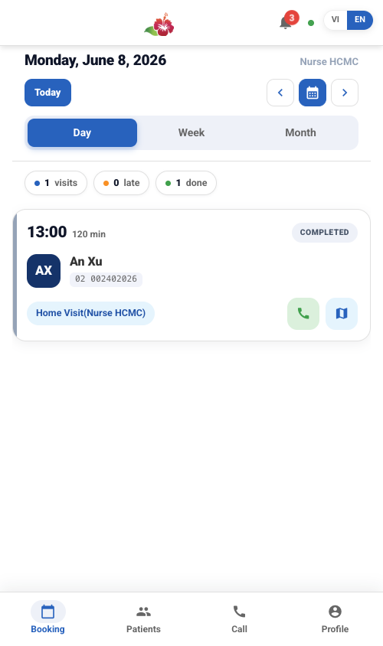
Figure: Day view listing each visit as a card with time, status, and quick actions
What you see on this screen:
- A header with the current date, a Today button, previous/next arrows, and a calendar picker to jump to any date.
- A Day / Week / Month switcher to change how visits are displayed.
- A visit card for each appointment, showing:
- The time and duration of the visit.
- The status (for example, Completed or Assigned).
- The client name and ID.
- The service type.
- Quick Call and Map buttons.
How to use it:
- Tap Today to jump back to the current day's visits at any time.
- Tap the previous/next arrows to move one day at a time, or tap the calendar picker to jump straight to a specific date.
- On a visit card, tap Call to phone the client, or tap Map to get directions to the visit location.
- Tap anywhere else on the visit card to open its detail sheet (see *Opening a Booking* below).
TIP The status on each card updates in real time, so you can always see at a glance which visits are done and which are still ahead of you.

Booking — Week View
Use the Week view when you want to see how your visits are spread across the whole week.
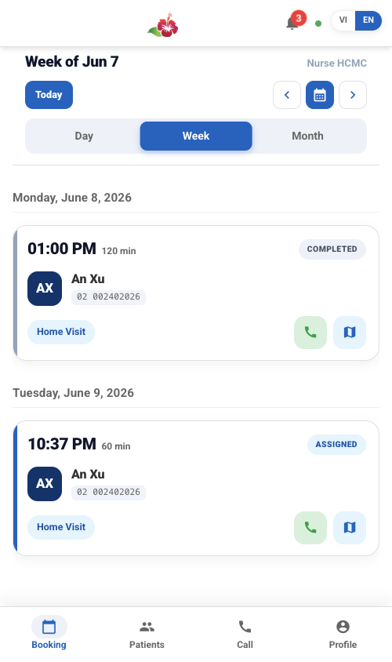
Figure: Week view grouping visits by day
What you see on this screen:
- The same date header and Day / Week / Month switcher.
- Your visits grouped by day across the week.
How to use it:
- Tap Week in the switcher to open this view.
- Use the previous/next arrows or the calendar picker to move between weeks.
- Tap any visit to open its detail sheet.

Booking — Month View
Use the Month view to get a big-picture overview of which days have visits scheduled.
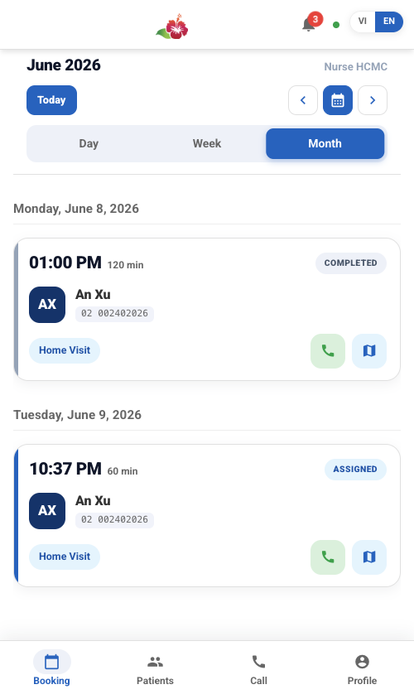
Figure: Month view as a calendar with dots on days that have visits
What you see on this screen:
- A full calendar for the month.
- Dots on the days that have visits scheduled.
How to use it:
- Tap Month in the switcher to open this view.
- Look for the dots to spot which days have visits.
- Tap a day to see its visits.

Opening a Booking and the Nurse Service Flow
Tapping a visit opens its detail sheet, where you carry out the visit step by step using the service action buttons. This is the core of your daily work in the app.
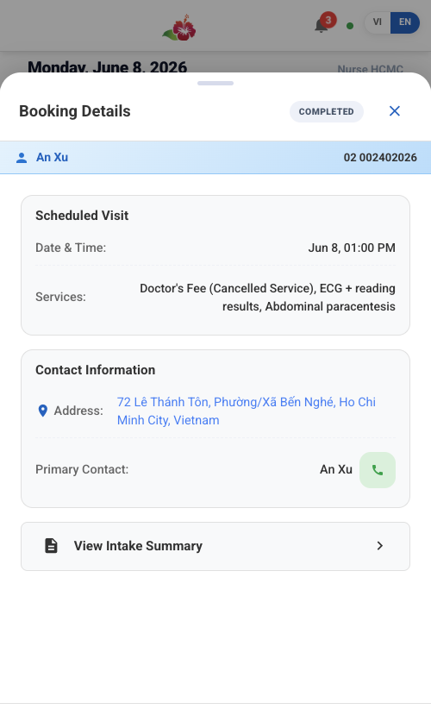
Figure: Booking detail sheet with the service action buttons
What you see on this screen:
- The visit's details.
- The service action buttons that walk you through the visit (Accept, Start Service, Complete).
How to use it (the nurse service flow):
- Accept the assignment to confirm it. This tells the office you have taken on the visit.
- On arrival, tap Start Service to start the visit timer.
- Record your clinical notes during the visit.
- When you are finished, tap Complete to close out the service.
Button | What it does
Accept | Confirms the assignment
Start Service | Starts the visit timer (tap on arrival)
Complete | Marks the service finished

NOTE As you move through these steps, the booking status updates in real time and syncs back to the office, so the team always sees your current progress.

Patients Tab

Patients List
The Patients tab lets you look up the people in your care so you can review their details before or during a visit.
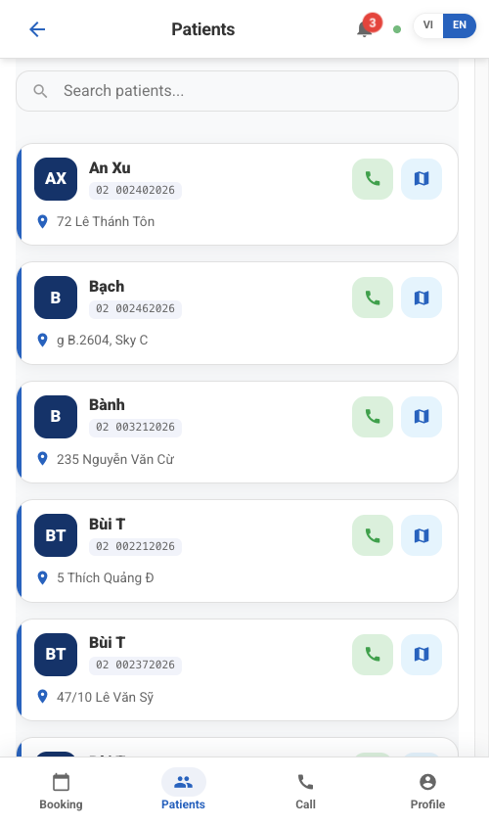
Figure: Patients tab with searchable patient list and details
What you see on this screen:
- A search box to find a patient.
- The patient list and patient details, limited to the patients within your catchment (your assigned area).
How to use it:
- Type a name in the search box to find a patient.
- Tap a patient to view their details.
NOTE You only see patients within your catchment area.

Call Tab

One-Tap Clinic Call
The Call tab is a quick shortcut to phone the clinic whenever you need to reach the office.
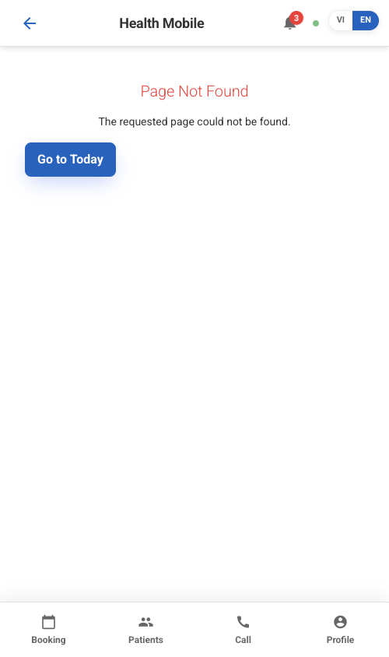
Figure: Call tab with one-tap dial to the clinic's phone number
How to use it:
- Tap the Call tab.
- Tap to dial the clinic's phone number in one tap.

Profile Tab

Your Profile, Sync, and Log Out
The Profile tab shows who you are signed in as and gives you the controls to sync your data and log out securely.
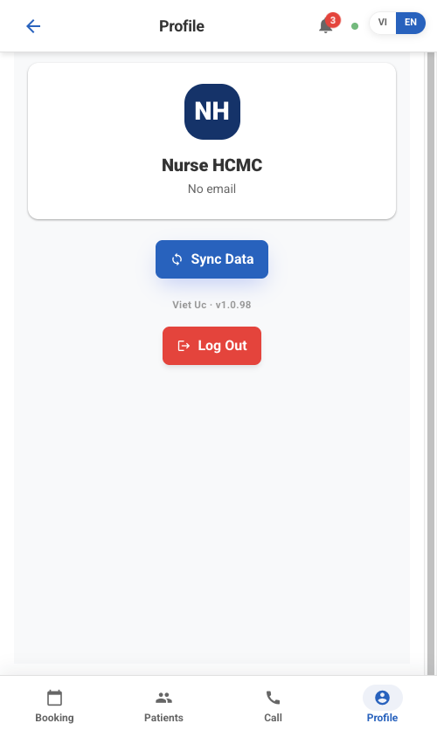
Figure: Profile tab showing name and email, Sync Data, and Log Out
What you see on this screen:
- Your name and email.
- A Sync Data button.
- A red Log Out button.
How to use it:
- Tap Sync Data to pull the latest data from the office and push up any changes you made while offline.
- Tap Log Out when you are done using the app.
Button | What it does
Sync Data | Pulls the latest data and pushes your offline changes
Log Out | Signs you out and clears cached patient data from the device

WARNING Logging out clears the cached patient data stored on the device for privacy. Only log out when you intend to fully sign off, and make sure you have synced any offline changes first.

TIP If something looks out of date, tap Sync Data to refresh. This is also how your offline changes reach the office once you have signal again.

Appendix — Glossary, Statuses & Roles
This appendix is your quick-reference guide. Whenever you see a status label, a colour, or a role name in the CMS and you are not sure what it means, come back here. Keep it open in a second tab while you learn the system.

Statuses at a Glance
These are the labels you will see most often on records throughout the CMS. Each one tells you where a record is in its journey.

Booking States
A booking moves through these states from the moment it is created until it is finalised. The state controls what you can do with the booking next.
What you see on this screen:
State | Meaning
Draft | Created, but not yet confirmed
Confirmed / Booked | Client confirmed, and the booking has a quote
Assigned | A staff member has been assigned to the booking
In Progress | The service is currently running
Completed | The service is done
Completed-Pending-Invoice | Done by part-time staff; the office still needs to invoice it
Cancelled | The booking was cancelled
Closed | Finalised and locked

NOTE "Completed-Pending-Invoice" is not the same as "Completed." It means the service is finished but billing is still outstanding, so the office must raise the invoice before the booking can be closed.

Contact Statuses
A contact status tells you what kind of relationship you have with a person or lead, so you know who needs follow-up and who has already booked.
What you see on this screen:
Status | Meaning
Active / Initial Contact | A new or active contact
Lead | A contact to follow up with
Booking | This contact has booked a service
Lost Booking | A booking opportunity that did not convert
Spam | Junk or unwanted contact

Assignment Statuses
An assignment status follows a single staff member's progress on a job, from the moment they are assigned to the moment they finish.
What you see on this screen:
Status | Meaning
Assigned | The nurse has been assigned to the job
Confirmed | The nurse has accepted the job
In Progress | The nurse has started the job
Completed | The nurse has finished the job
Cancelled | The assignment was cancelled

NOTE An assignment normally flows Assigned → Confirmed → In Progress → Completed. It can be Cancelled at any point.

Payment Statuses
A payment status tells you where the money is, which is especially important when nurses collect cash in the field.
What you see on this screen:
Status | Meaning
Collected | Payment has been taken
Pending Delivery | Cash is with the nurse, not yet handed in at the office
Delivered / Reconciled | Cash has reached the office and the books match
Failed / Refunded | The payment failed or was refunded

WARNING A status of "Pending Delivery" means real cash is still out with a nurse. It is not money in the office until it shows as "Delivered / Reconciled."

Roles & Visibility
Your role decides which screens and records you can see. This keeps each person focused on the records that belong to them.

Who Sees What
What you see on this screen:
Role | What they see
Nurse | Only the bookings they are assigned to, plus clients in their own catchment area
Operations Manager | All bookings and clients in their catchment
Finance | The Finance screens
Owner / Administrator | Everything

NOTE A user can be given more than one role. Their access is the combination of all their roles, so someone who is both Finance and Operations Manager sees both sets of screens.

Handy Tips for New Users
These small habits will make day-to-day work in the CMS much faster.
- Change every figure at once: use the period filter on a dashboard to update all the figures on that dashboard together.
- See the records behind a number: click any KPI card to open the list of records that make up that number.
- Go back a step: use the breadcrumb in the top-left corner to return to the previous screen.
- Check a record's history: the chatter on a record logs its full history, so you can see what happened and when.
- Ask for help: the AI Coach in the bottom-right corner can answer your questions.
TIP When a number on a dashboard looks surprising, click the KPI card to drill into the actual records behind it before raising a concern. The detail almost always explains the figure.

