VIET UC HEALTHCARE PLATFORM
User Manual
Version 1.0 — May 2026

Confidential — For Internal Use Only

Table of Contents
1. Introduction & Dashboard Overview
2. Sales & CRM Module
2.1 Contacts — Initial Contact Wizard
2.2 Follow-up Activities
2.3 All Contacts & All Clients
2.4 Healthcare Relationships
2.5 CRM Pipeline (Opportunities)
2.6 Reporting & Configuration
3. Bookings Module
3.1 Creating a New Booking
3.2 Booking Lifecycle & Stages
3.3 Staff Assignment
3.4 Healthcare Quotes & Pricing
3.5 Service Completion & Clinical Notes
3.6 Communications
4. Finance Module
4.1 Service Billing
4.2 Invoices
4.3 Accounts Receivable (AR Dashboard)
4.4 Cash Collections
4.5 Payment Transactions
4.6 Service Packages
5. Admin Module
5.1 User Management
5.2 Access Roles
5.3 Configuration & Lookups
5.4 Pricing Engine & Rules
5.5 Audit Log
6. Glossary & Quick Reference

1. Introduction & Dashboard Overview
Welcome to the Viet Uc Healthcare Platform — your all-in-one system for managing healthcare services from first contact to final invoice. This manual will guide you through every feature, step by step.

1.1 The Dashboard — Your Home Screen
When you log in, you'll see the main dashboard with module cards arranged around a central "CLIENTS" hub. Each card represents a major area of the platform. Simply click any card to dive into that module.
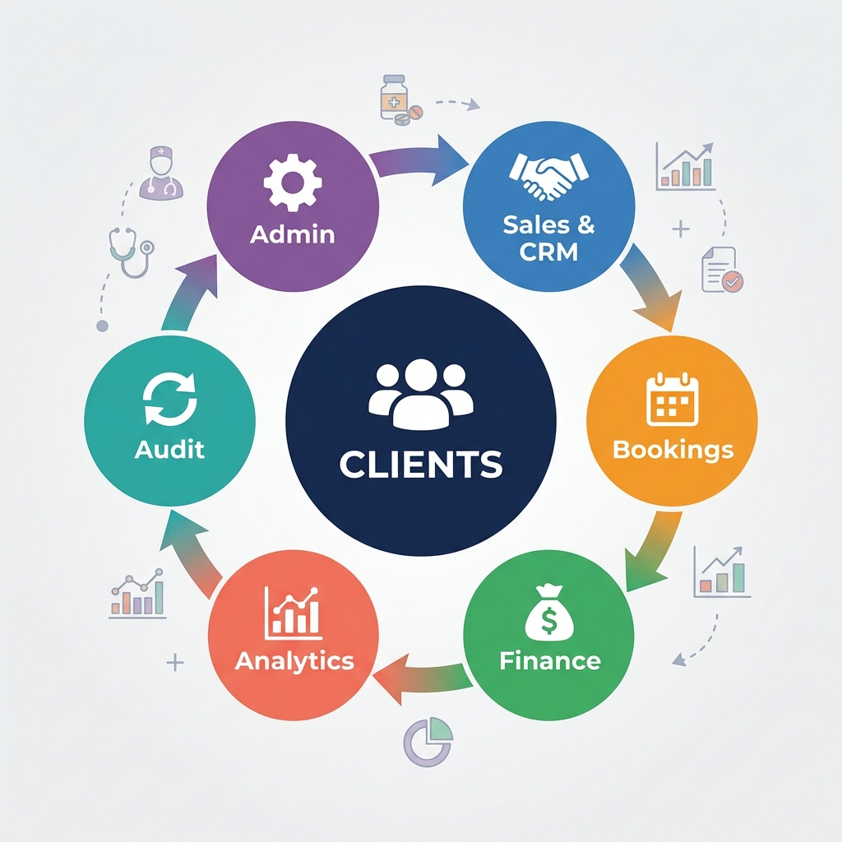
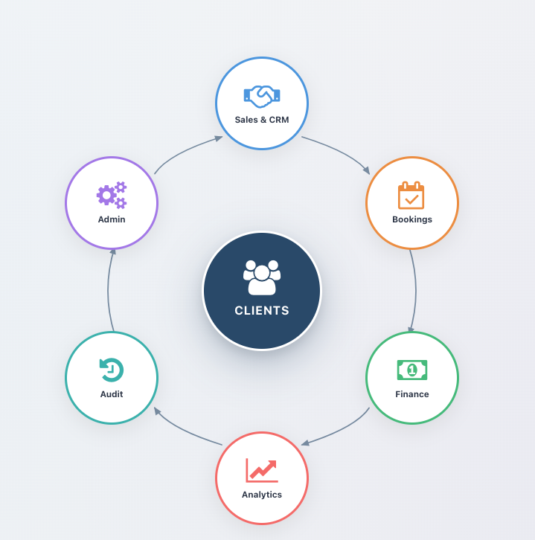

Dashboard Modules at a Glance
Feature | Description
CRM | Manages Initial contacts , Leads and Clients
Client | View and manage all client records
Booking | Create and manage healthcare service bookings
Staff | Schedule staff, manage workload
Accounts | Billing, invoices, payments, and AR management
Configuration | System settings, pricing rules, and lookups
Audit Log | Track all changes made in the system
💡 Tip: Use the search bar (Ctrl+K / Cmd+K) on the dashboard to quickly find any module or submenu.

2. Sales & CRM Module
The Sales & CRM module is your starting point for acquiring new clients. It helps you track every interaction — from the very first phone call to converting a contact into a paying client.
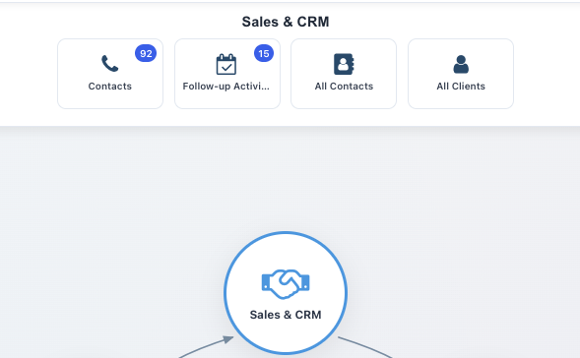

2.1 Contacts — Initial Contact Wizard
The Initial Contact Wizard is designed for your sales team to quickly log a new enquiry. It captures essential information in a guided, step-by-step form.

How to Log a New Contact
- Step 1: Click "CRM" on the dashboard, or navigate to Healthcare → Sales & CRM → Contacts.
- Step 2: The Initial Contact Wizard opens automatically.
- Step 3: Fill in the contact's name, phone number, and email.
- Step 4: Select the Contact Reason (e.g., "Enquiry about Home Visit Services").
- Step 5: Add any notes about the conversation.
- Step 6: Click "Save" to create the contact record and a CRM lead.
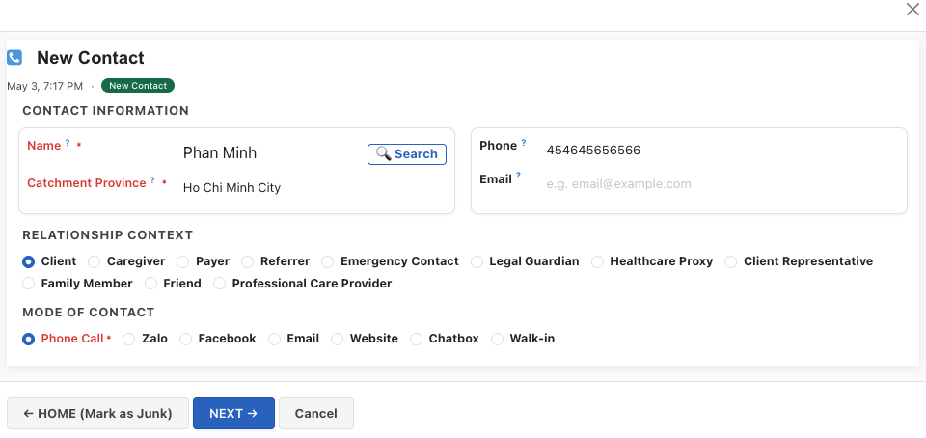

2.2 Follow-up Activities
After the initial contact, follow-up activities help your team stay on top of every contact. Schedule calls, meetings, or send information.

How to Schedule a Follow-up
- Step 1: Navigate to Sales & CRM → Follow-up Activities.
- Step 2: The Follow-up Wizard shows all pending activities.
- Step 3: Select a contact and choose the activity type (Call, Meeting, Email, etc.).
- Step 4: Set the date and add notes.
- Step 5: Click "Schedule" to create the follow-up reminder.

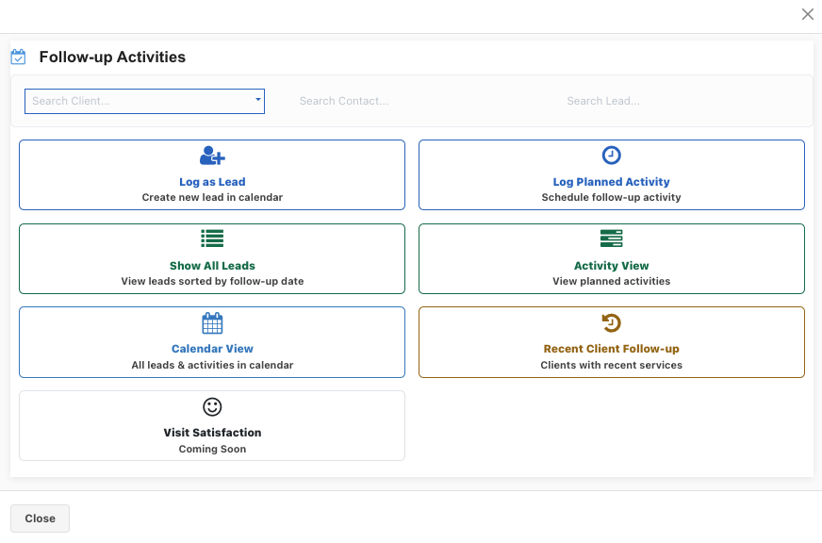2.3 All Contacts & All Clients
These two views give you a bird's-eye view of your contact database:
Feature | Description
All Contacts | Every person who has ever contacted your organisation, grouped by contact status  Initial Contact->Lead-> Booking (Client created)
All Clients | Only confirmed clients/patients, sorted by creation date.
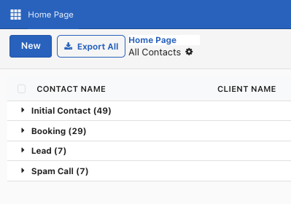

2.3 Dashboard (Contact)
- Once you click on any of the contact, it opens up the dashboard
- Clicking the center circle with the name of the client , it opens up the details for the contact
- You can also fill up the details for the contact by clicking on the outer circles eg Map, Led Info , Relations etc
Buttons | Description
Mark Spam | Mark the contact as Spam
Booking | Create a booking
Consultation | Select a person from whom consultation is required
Escalate | Escalate the contact to be referred to a particular Duty Doctor / Head Nurse/ Operations Manager
Send Message | Send message to a particular person
Log Activity | To-do / Email / Call / Meeting / Attach Document

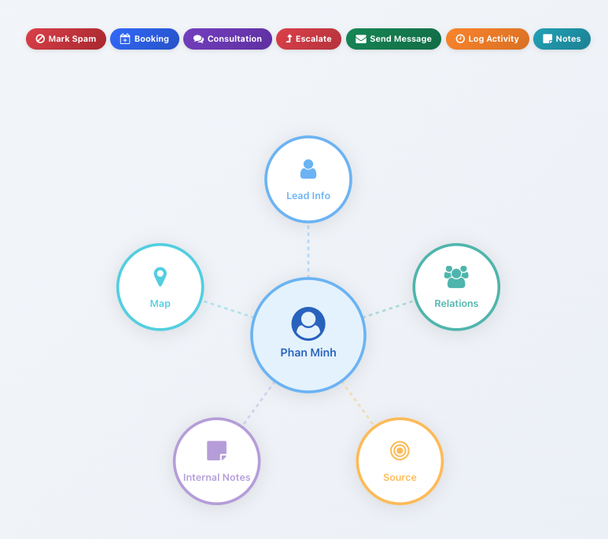

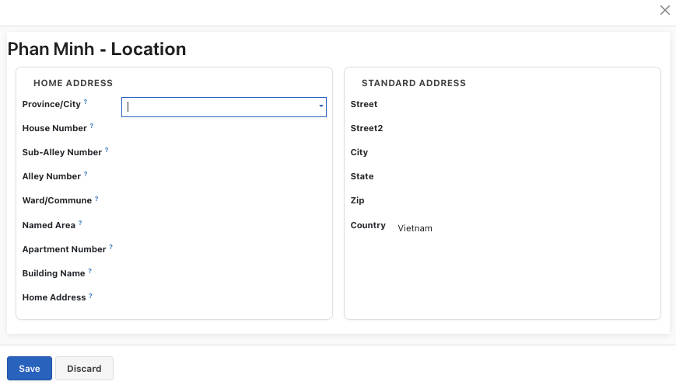

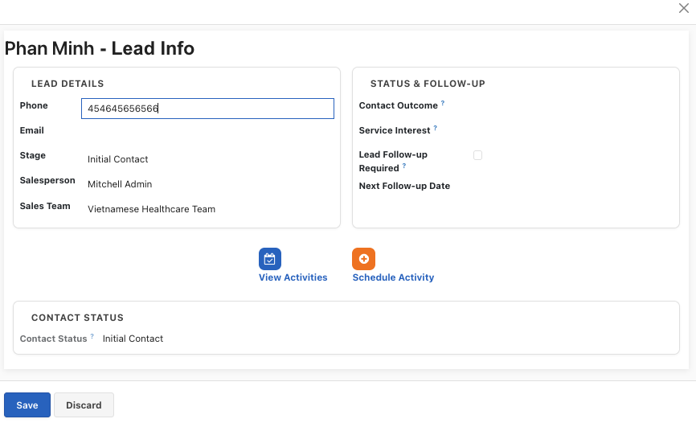

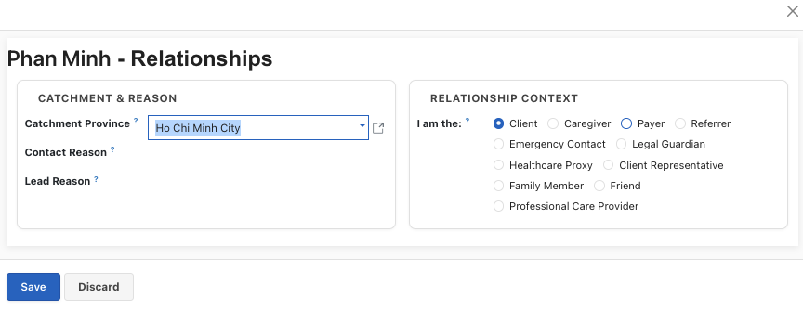

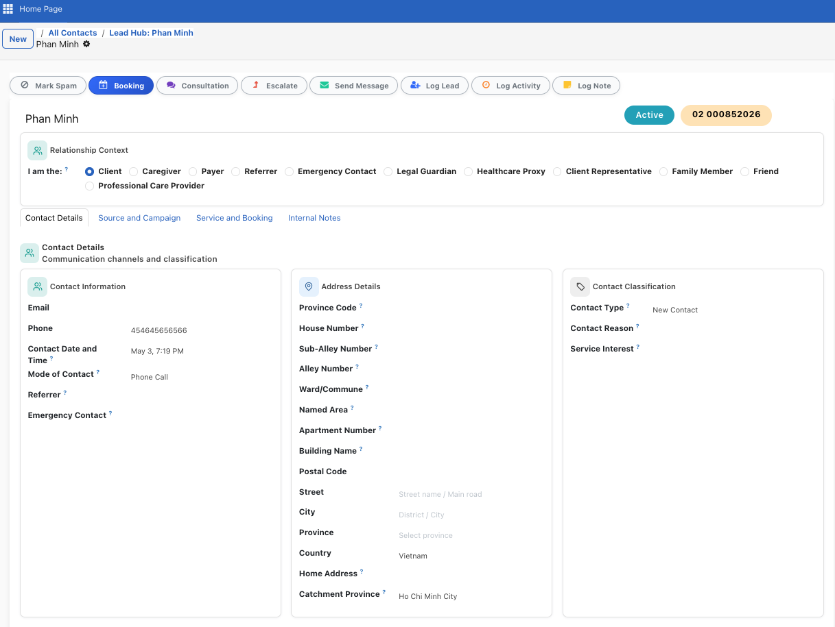

3. Bookings Module
The Bookings module is the heart of the platform. It manages the entire lifecycle of a healthcare service — from scheduling an appointment to completing the visit and generating an invoice.
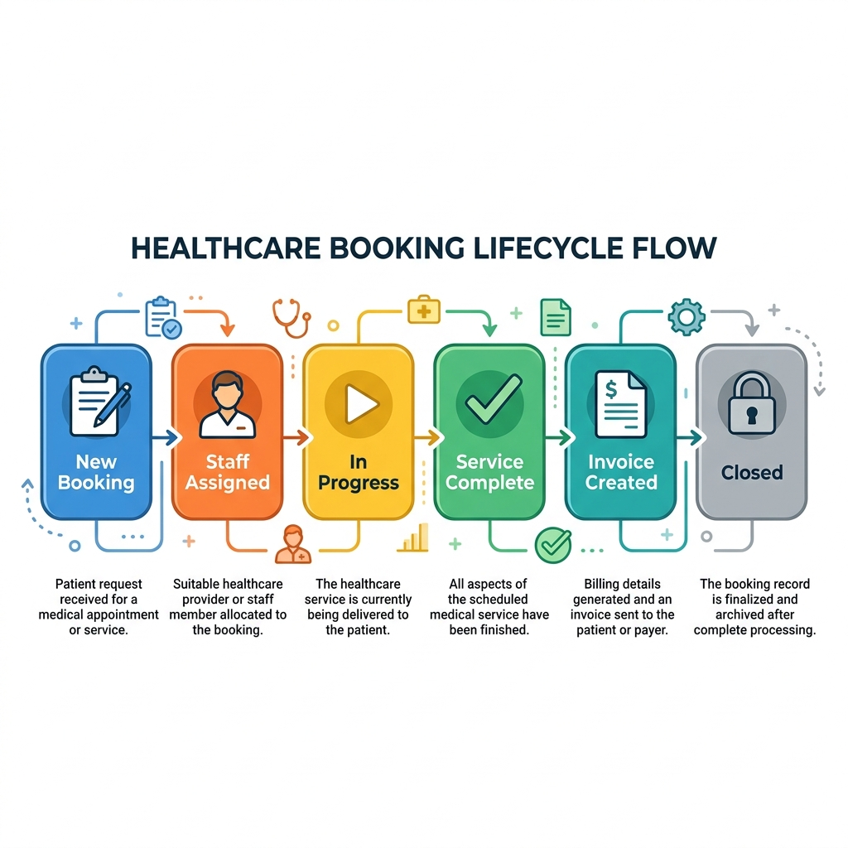

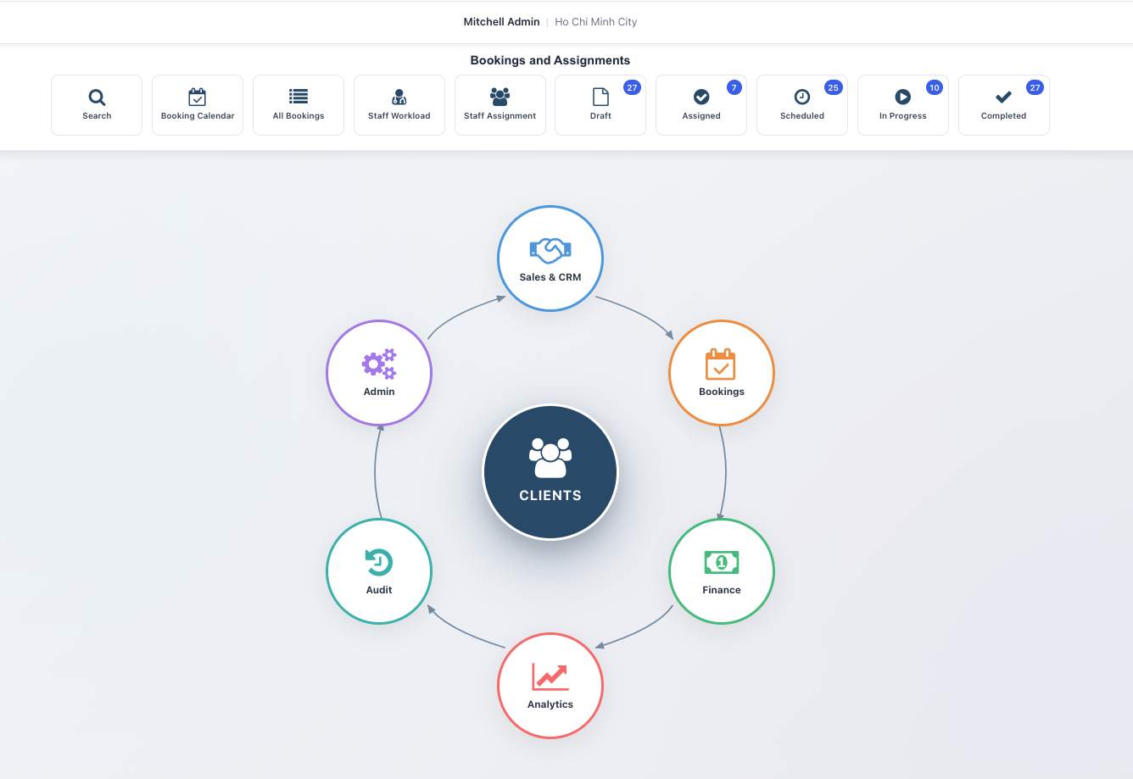

3.1 Creating a New Booking
A booking represents a single healthcare service visit. You can create bookings from the dashboard or from within a client's record.

Booking from Dashboard
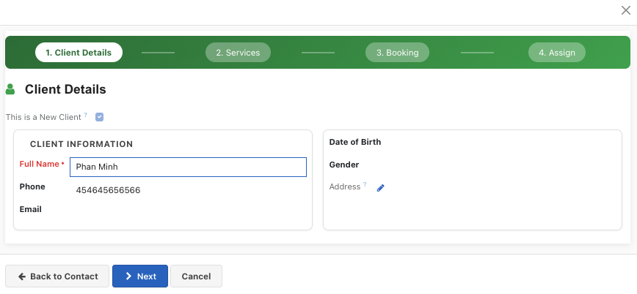
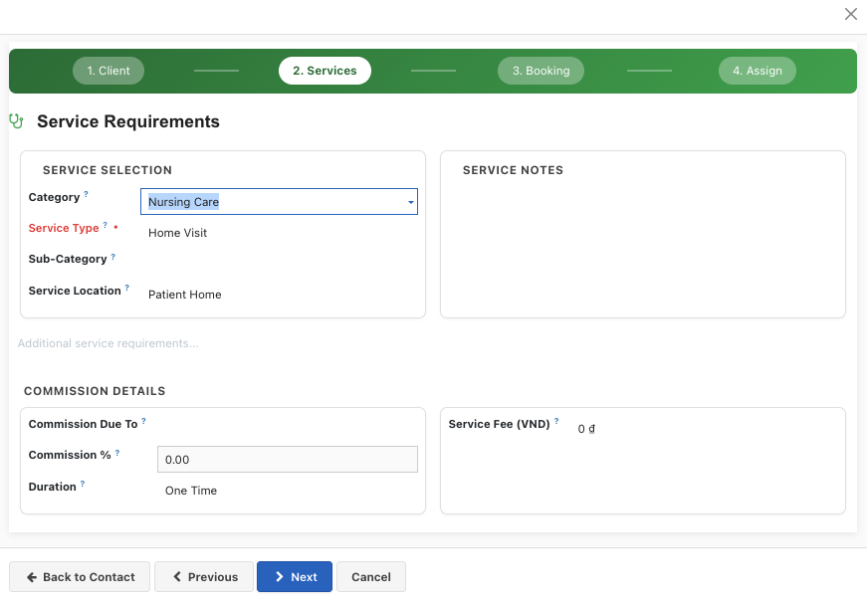

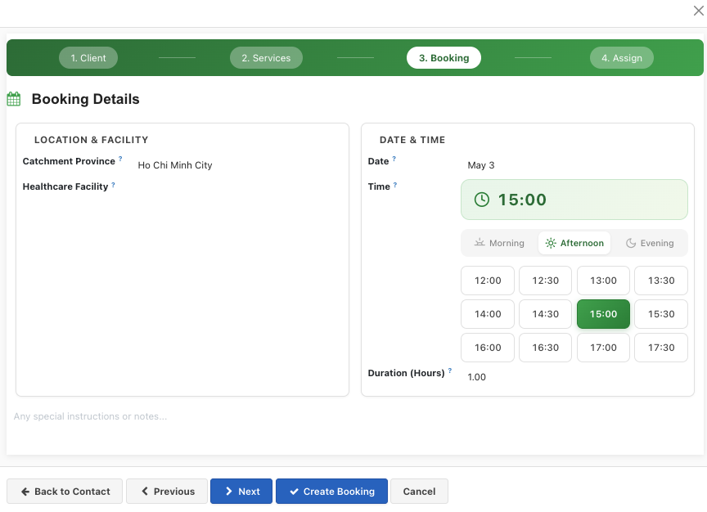
Booking from Client center
- Clicking on the center circle will allow user to fill in all details in one form

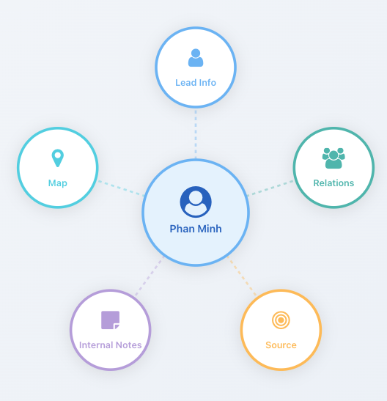
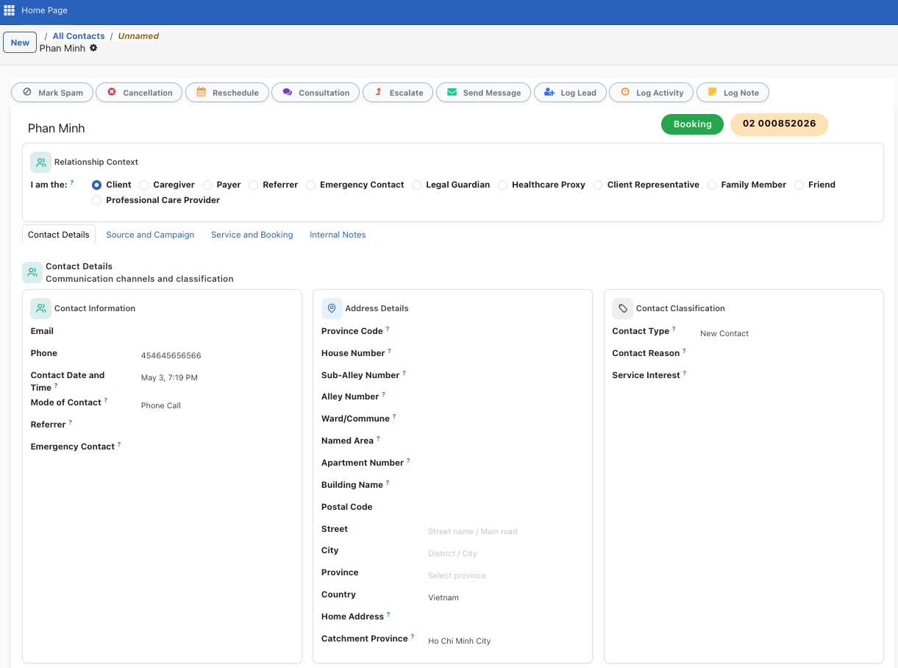

How to Create a Booking
- Step 1: Click "Booking" on the dashboard, or navigate to Healthcare → Field Service → Bookings.
- Step 2: Click the "New" button.
- Step 3: Select the Client (patient) from the dropdown.
- Step 4: Choose the Service Type (Home Visit, Clinic Visit, Consultation, etc.).
- Step 5: Set the Scheduled Date & Time for the appointment.
- Step 6: Set the Priority level (Normal, High, Urgent, Emergency).
- Step 7: Add any Symptoms or Service Requirements in the notes fields.
- Step 8 : Create a Quote
- Step 9: Click "Save" to create the booking.

Key Booking Fields
Feature | Description
Client | The patient receiving the service
Service Type | Home Visit, Clinic Visit, Telemedicine, Emergency, etc.
Scheduled Date & Time | When the service is scheduled
Priority | Low, Normal, High, Urgent, or Emergency
Clinical Urgency | Routine, Urgent, Emergency, or Critical
Service Location | Home, Clinic, Hospital, Care Facility, or Remote
Symptoms | Patient's reported symptoms or chief complaint
Diagnosis | Medical diagnosis (required for MOH compliance)
Cetegory of service | Category of service
Referring Doctor | Contact who referred this patient

3.2 Booking Lifecycle & Stages
Every booking moves through a series of stages. You can see all bookings in a Kanban board and drag them between stages.
Feature | Description
Draft | Booking created but not yet confirmed
Confirmed | Booking is confirmed and ready for staff assignment
Staff Assigned | Healthcare staff have been assigned to this booking
In Progress | The healthcare service is currently being delivered
Completed | Service has been delivered and clinical notes submitted
Completed — Pending Invoice | Service done by part-time staff; awaiting Operations invoicing
Closed | Invoice paid, cash collected — booking is finalised
Cancelled | Booking was cancelled (with a cancellation reason)

3.3 Staff Assignment
After a booking is confirmed, you need to assign healthcare staff. The platform provides multiple ways to do this:

Visual Scheduler (Timeline)
The Visual Scheduler shows all staff availability on a timeline. You can drag and drop bookings onto available staff slots.
- Step 1: Open a booking and click "Assign Staff" button.
- Step 2: The timeline view opens, showing all healthcare staff.
- Step 3: Find an available slot and drag the booking to assign it.
- Step 4: The booking automatically updates with the assigned staff.
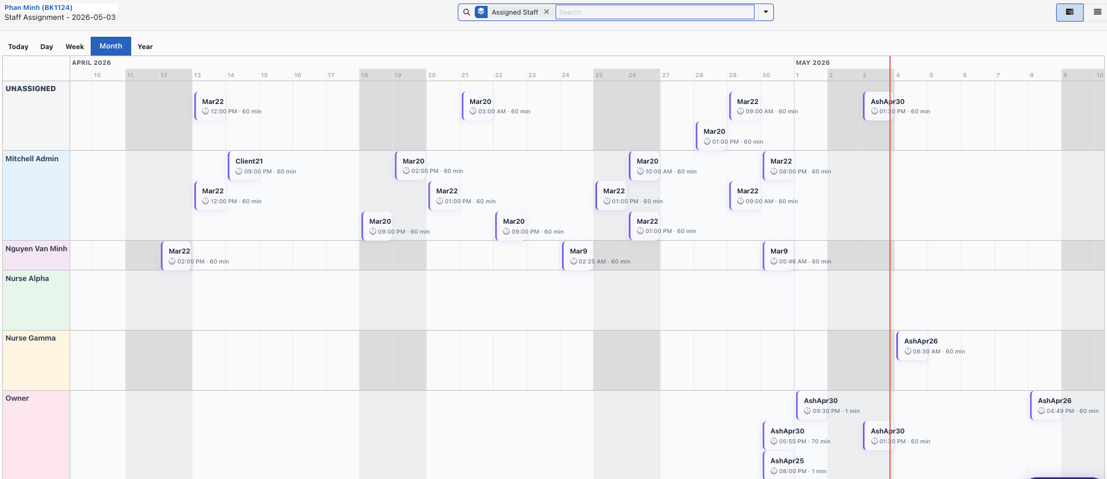

3.4 Healthcare Quotes & Pricing
Each booking can have a Healthcare Quote — a detailed price breakdown of the services to be delivered. The platform uses an Advanced Pricing Engine that automatically applies pricing rules based on various conditions.

How to Create and Manage a Quote
- Step 1: Open a booking and click the "Quote" smart button.
- Step 2: A Healthcare Quote form opens as a popup.
- Step 3: Click "Add Products" to add services from the product catalog.
- Step 4: The catalog is automatically filtered to show products matching the client's region.
- Step 5: Click "Recalc Pricing" to apply all pricing rules (distance, after-hours, weekend, holidays, etc.).
- Step 6: Review the Pricing Breakdown showing which rules were applied.
- Step 7: Save the quote.

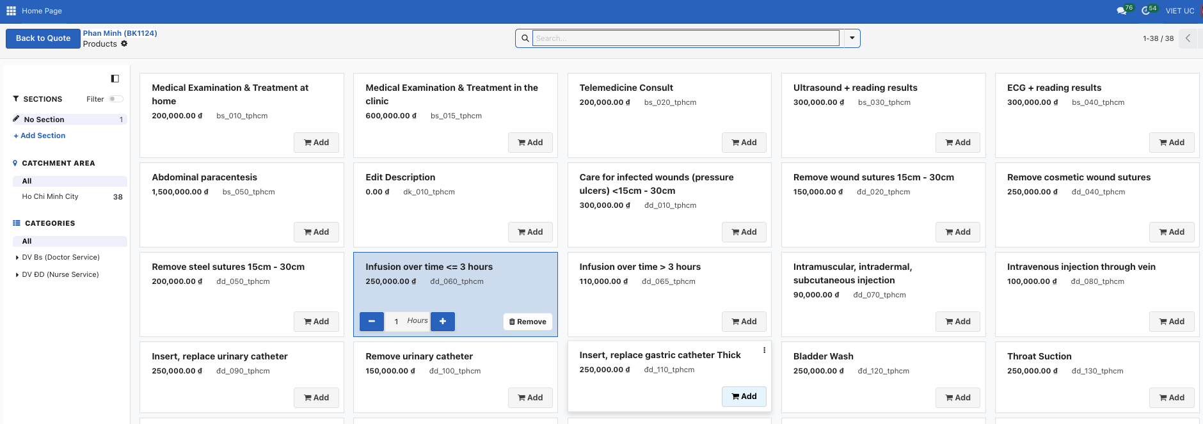 Pricing Rules That Apply Automatically
Feature | Description
After-Hours Surcharge | Applied when appointment is before 8 AM or after 6 PM
Weekend Surcharge | Applied for Saturday/Sunday bookings
Holiday Surcharge | Applied for public holidays (with multiplier: e.g., 3× for TET)
Distance Surcharge | Applied based on travel distance (per km above threshold)
Service Location | Different pricing for Home Visit vs Clinic Visit
Bulk Pricing | Discounts for multiple service units
Per-Unit Charges | Additional charges per wound, injection, IV bag, etc.
📌 Note: Pricing rules require Board Approval before they become active. Draft rules are not applied.

3.5 Mobile App
Notification of the booking comes to Nurse on mobile app
- Step 1: Open the booking in the "In Progress" stage.
- Step 2: Fill in Clinical Notes and/or Treatment Performed fields.
- Step 3: Update procedure counts if applicable (injections, medications, wounds, IV bags).
- Step 4: Click "Complete Service" button.
- Step 5: The system validates that clinical notes are submitted.
- Step 6: The system validates that a quote/invoice exists.
- Step 7: The booking moves to "Completed" stage.
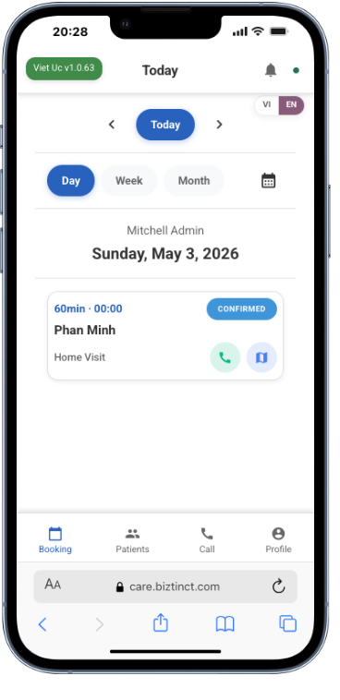
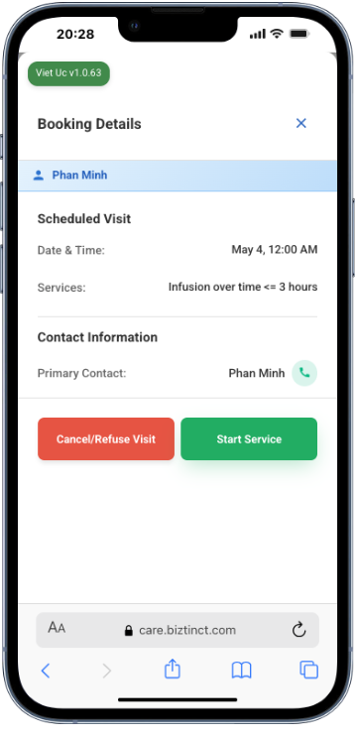
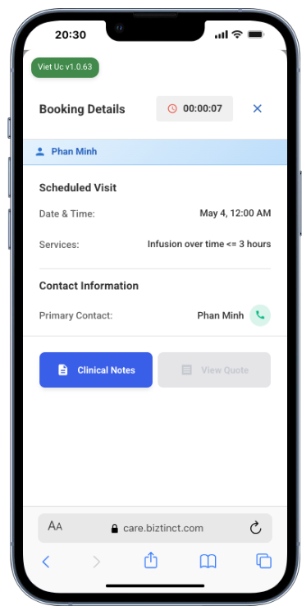
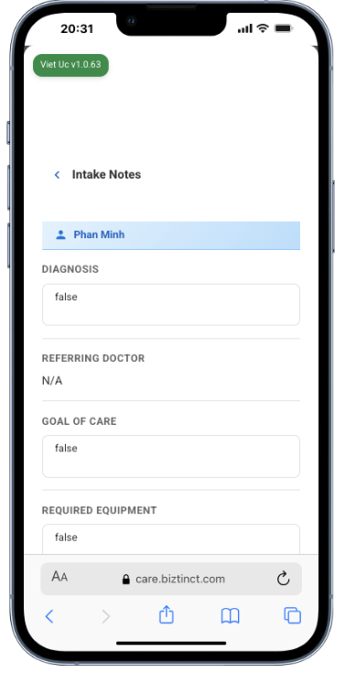

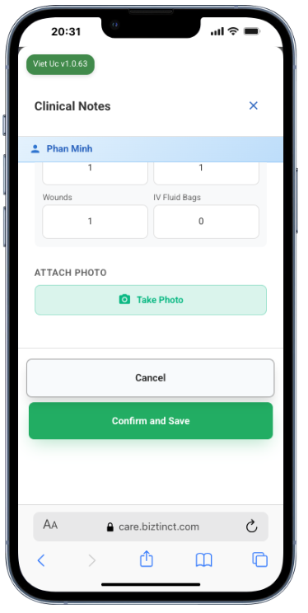
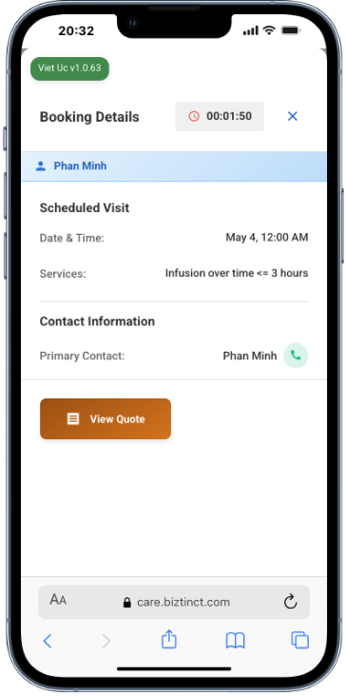
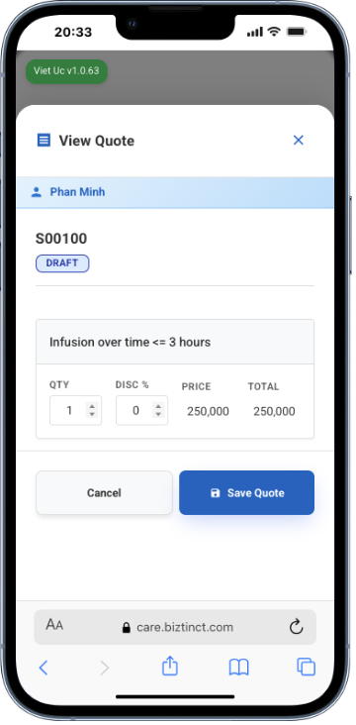
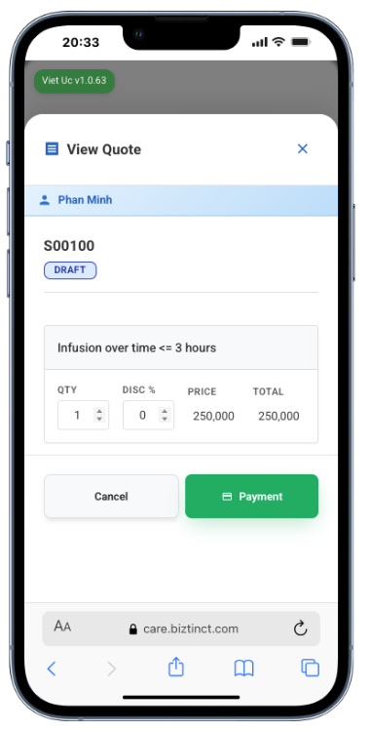
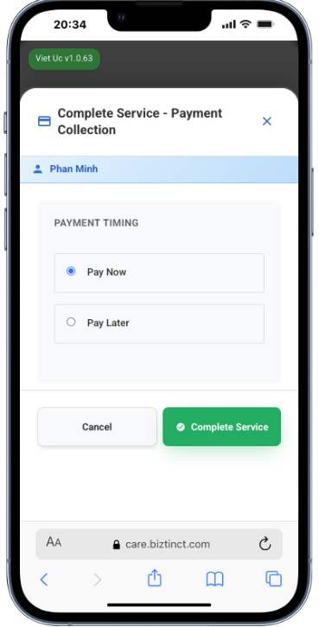

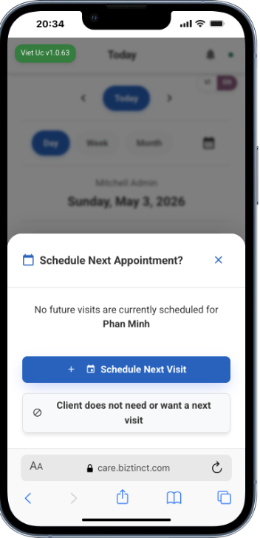

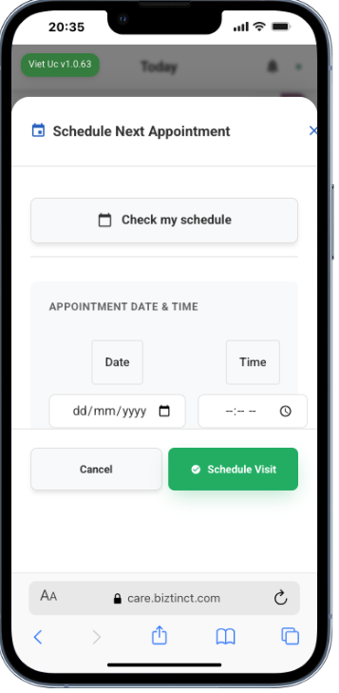

4. Finance Module
The Finance module handles everything related to billing, invoicing, payments, and accounts receivable management.
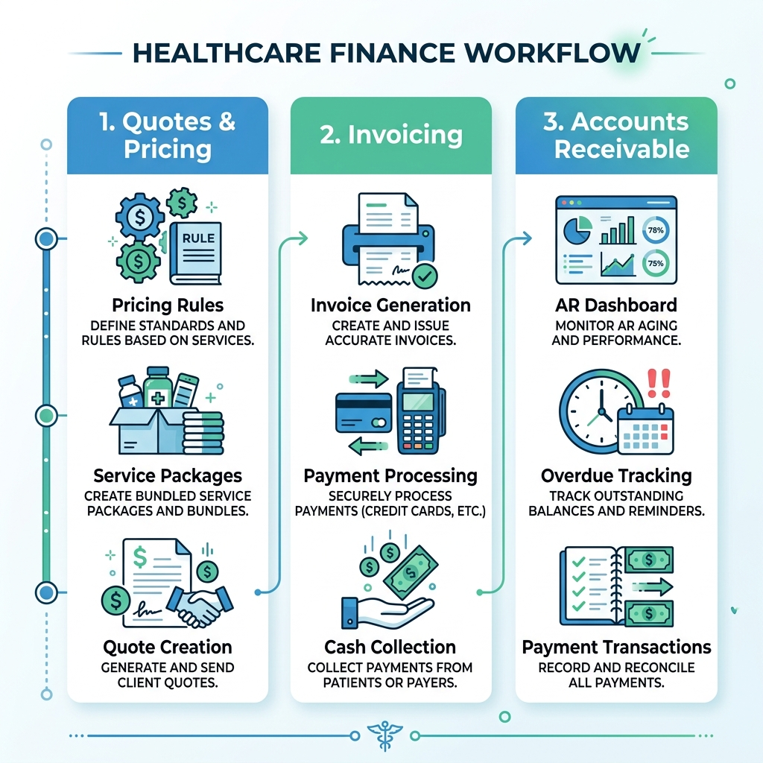

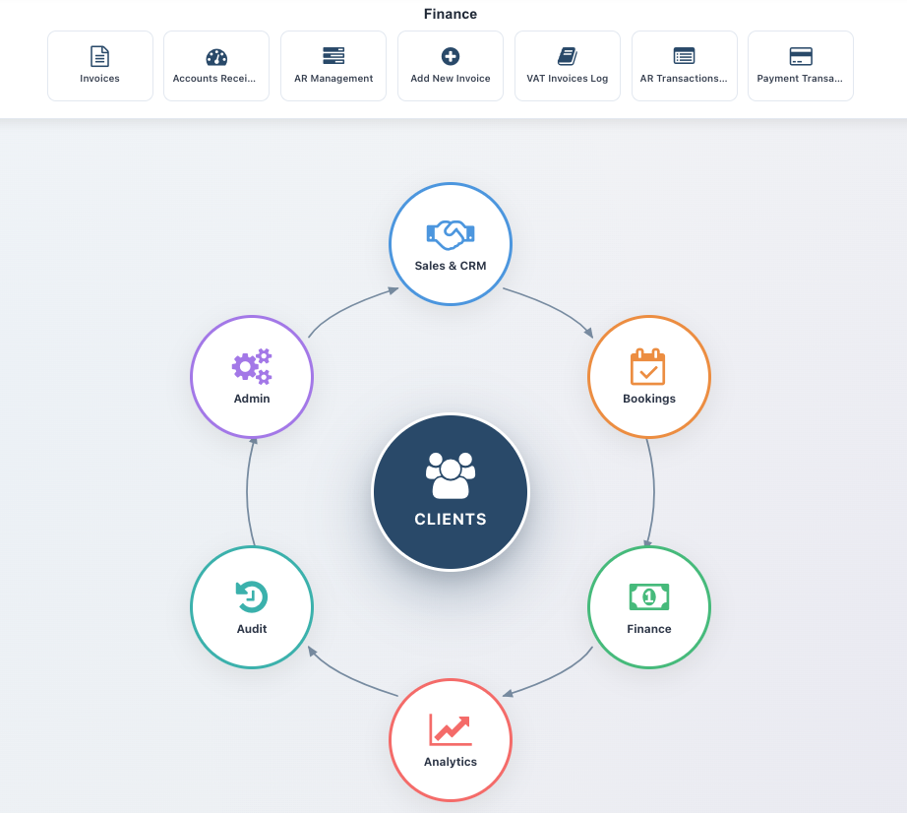

4.2 Invoices
View and manage all invoices. Invoices can be created from healthcare quotes after service completion.

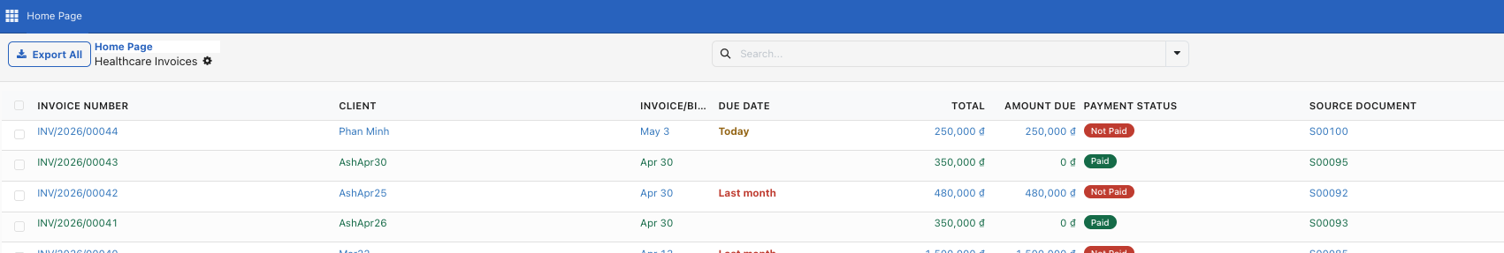

4.3 Accounts Receivable (AR Dashboard)
The AR Dashboard gives you a real-time overview of outstanding payments, aging analysis, and collection status.
Navigate to Accounts → AR Dashboard on the main dashboard.

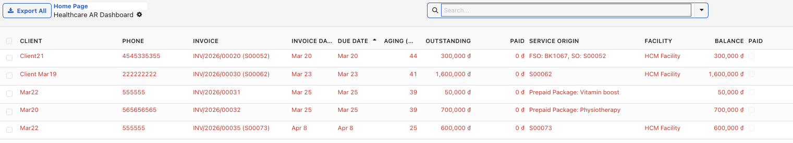

4.3 AR Management
Track payments collected by staff in the field , refund/credit , Account payment from here.

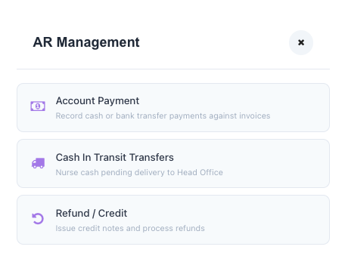
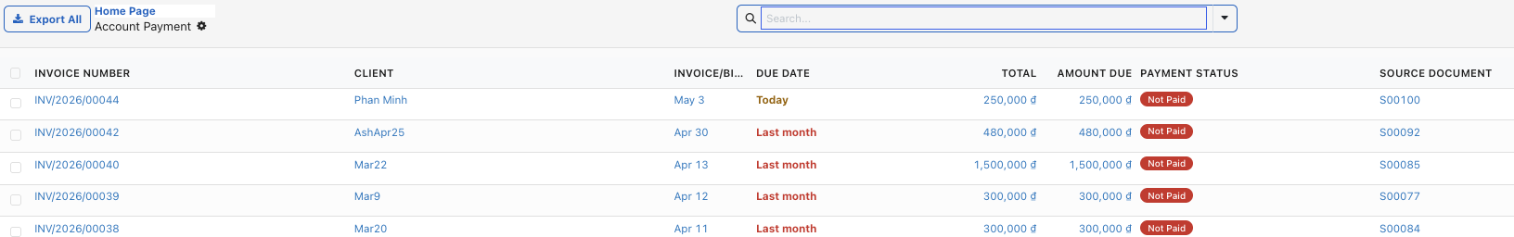
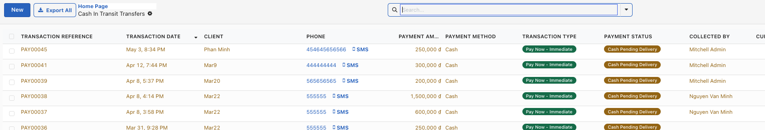

4.3 VAT Invoices log
Track VAT invoices here

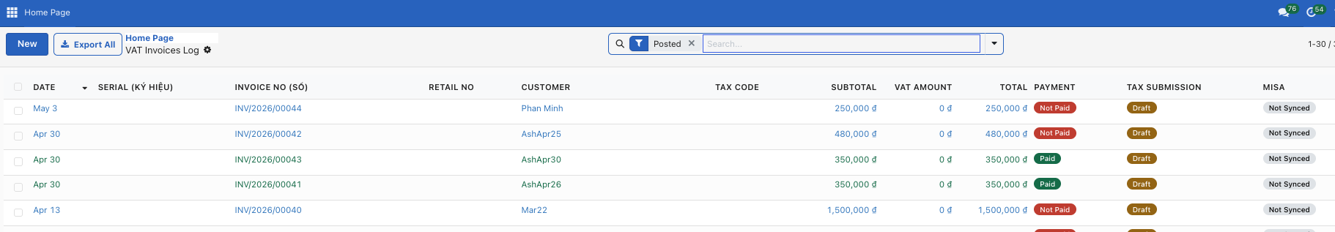

4.4 AR Transactions
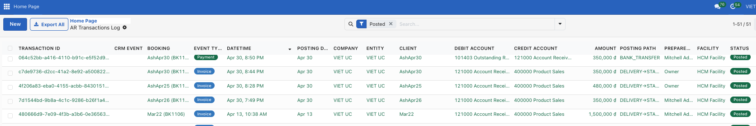

4.5 Payment Transactions

4.6 Service Packages
Service Packages allow you to create bundled service offerings for clients. For example, a "10-Visit Home Care Package" at a discounted rate.

How to Create a Service Package
- Step 1: Navigate to Healthcare → Service Packages → Client Packages.
- Step 2: Click "New" to create a package.
- Step 3: Set the package name, included services, and total price.
- Step 4: Assign the package to a client.
- Step 5: Services are consumed from the package as bookings are completed.
[INSERT SCREENSHOT: Service Package form]
Feature | Description
Package Products | Configure the products/services that can be included in packages
Client Packages | Assign and manage packages for individual clients
All Healthcare Products | View the complete product catalog

5. Admin Module
The Admin module provides system administration tools for managing users, roles, configurations, and audit trails.

5.1 User Management
Create and manage user accounts. Each user is assigned an Access Role that controls what they can see and do in the system.

How to Create a New User
- Step 1: Navigate to Configuration → Users (on the dashboard) or use the Admin menu.
- Step 2: Click "New" to create a user.
- Step 3: Enter the user's Name, Email (used as login), and Phone.
- Step 4: Select an Access Role from the dropdown.
- Step 5: Click "Save" to create the account.
- Step 6: Click "Send Password Reset" to email login credentials to the user.
[INSERT SCREENSHOT: User creation form]

How to Deactivate a User
- Step 1: Open the user's record.
- Step 2: Click the "Deactivate" button in the header.
- Step 3: Confirm the deactivation.
- Step 4: The user can no longer log in but their data is preserved.
💡 Tip: You can reactivate a user at any time by clicking the 'Activate' button.

5.2 Access Roles
Access Roles define the permissions for a group of users. The platform comes with pre-configured roles:
Feature | Description
Receptionist | Can manage contacts, create leads, and view client records
Nurse / Head Nurse | Can manage bookings, clinical notes, and staff assignments
Doctor | Can access clinical protocols, diagnoses, and medical records
Sales | Can manage CRM pipeline, contacts, and follow-ups
Operations Manager | Can manage bookings, staff, quotes, and invoicing
Finance | Can access billing, invoicing, AR, and payment management
Manager | Full access to operations, finance, and clinical modules
Admin | Full system access including configuration and user management
Owner / Board | Highest level — includes pricing rule approval and audit access
[INSERT SCREENSHOT: Access Roles list]

5.3 Configuration & Lookups
Configuration items are the master data that powers the platform. Access these from the Configuration card on the dashboard.
Feature | Description
Patient Categories | Classify clients (e.g., Elderly, Paediatric, Chronic Care)
Service Types | Define available service types with pricing and duration
Symptoms | Master list of symptoms for booking intake
Referral Sources | Track how clients heard about you (Doctor Referral, Online, etc.)
Insurance Providers | Configure insurance companies and their plans
Urgency Levels | Define urgency levels with response time targets
Vietnamese Districts | District and ward data for address management
Catchment Provinces | Define service areas (Hanoi, HCMC, etc.) with timezone settings
Public Holidays | Configure holidays with pricing multipliers (e.g., TET = 3×)
Healthcare Facilities | Your clinics, hospitals, and care facilities
Portable Equipment | Track medical equipment assigned to staff
Field Requirements | Configure mandatory fields per model and booking stage
[INSERT SCREENSHOT: Configuration submenu cards]

5.4 Pricing Engine & Rules
The Advanced Pricing Engine allows you to define complex pricing rules that are automatically applied when calculating service costs.

Key Concepts
Feature | Description
Pricing Engine | The calculation engine that processes all rules in sequence
Level 1 Rules | Base rules applied first (e.g., after-hours surcharge)
Level 2 Rules | Cascading rules applied after Level 1 (e.g., cumulative discounts)
Approval Workflow | All pricing rules require Board approval before becoming active
Rule Conditions | Distance, time, service type, location, weekends, holidays, etc.
Rule Actions | Add amount, multiply, percentage, fixed price, per-unit, discount

How to Create a Pricing Rule
- Step 1: Navigate to Configuration → Pricing Rules on the dashboard.
- Step 2: Click "New" to create a rule.
- Step 3: Set the rule name, sequence (order of execution), and level.
- Step 4: Configure conditions (e.g., After Hours Only = Yes, Distance Min = 10 km).
- Step 5: Set the action (e.g., Add Amount = 50,000 đ).
- Step 6: Choose which products/categories this rule applies to.
- Step 7: Save the rule (it starts in "Draft" status).
- Step 8: Click "Submit for Approval" to send it to the Board for review.
- Step 9: A Board member reviews and clicks "Approve" to activate the rule.
[INSERT SCREENSHOT: Pricing Rule form]
📌 Note: If an approved rule is modified, it automatically resets to Draft and requires re-approval.

5.5 Audit Log
The Audit Log tracks all significant changes made in the system. Only Admin and Owner roles can access this feature.
Navigate to Audit Log on the main dashboard. You can filter by user, date, model (Booking, Invoice, Client, etc.), and action type.
[INSERT SCREENSHOT: Audit Log list view]

6. Glossary & Quick Reference

6.1 Common Terms
Feature | Description
FSO / Booking | Field Service Order — a single healthcare service visit
Lead | A potential client who has shown interest
Quote | A price estimate for services (Healthcare Quote)
AR | Accounts Receivable — money owed to you by clients
Catchment Province | The geographic area your services cover
Pricing Engine | Automated system that calculates service prices
PWA | Progressive Web App — the mobile interface for field staff
Clinical Notes | Documentation of the healthcare service delivered
Service Package | A bundle of prepaid services for a client
Red Invoice | Vietnamese tax-compliant invoice (Hóa đơn đỏ)

6.2 Keyboard Shortcuts
Feature | Description
Ctrl+K / Cmd+K | Open search bar on dashboard
Escape | Close search or cancel current action
Enter | Confirm / Save in most forms

6.3 Getting Help
If you need assistance, please contact your system administrator or the Viet Uc IT support team. Include the booking reference number (e.g., FSO00123) when reporting issues.

