VIET UC HEALTHCARE PLATFORM
User Manual
Version 1.0 — May 2026

Confidential — For Internal Use Only

Table of Contents
Table of Contents 2
1. Introduction & Dashboard Overview 4
1.1 The Dashboard — Your Home Screen 4
Dashboard Modules at a Glance 5
2. Sales & CRM Module 7
2.1 Contacts — Initial Contact Wizard 7
How to Log a New Contact 7
2.2 Follow-up Activities 8
How to Schedule a Follow-up 8
2.3 Dashboard (Contact) 10
3. Bookings Module 13
3.1 Creating a New Booking 14
How to Create a Booking 17
Key Booking Fields 17
3.2 Booking Lifecycle & Stages 18
3.3 Staff Assignment 18
Visual Scheduler (Timeline) 18
3.4 Healthcare Quotes & Pricing 19
How to Create and Manage a Quote 19
3.5 Mobile App 20
4. Finance Module 27
4.2 Invoices 28
4.3 Accounts Receivable (AR Dashboard) 29
4.3 AR Management 29
4.3 VAT Invoices log 30
4.4 AR Transactions 30
4.5 Payment Transactions 30
5. Glossary & Quick Reference 30
5.1 Common Terms 30
5.2 Keyboard Shortcuts 31
5.3 Getting Help 31

1. Introduction & Dashboard Overview
Welcome to the Viet Uc Healthcare Platform — your all-in-one system for managing healthcare services from first contact to final invoice. This manual will guide you through every feature, step by step.

1.1 The Dashboard — Your Home Screen
When you log in, you'll see the main dashboard with module cards arranged around a central "CLIENTS" hub. Each card represents a major area of the platform. Simply click any card to dive into that module.
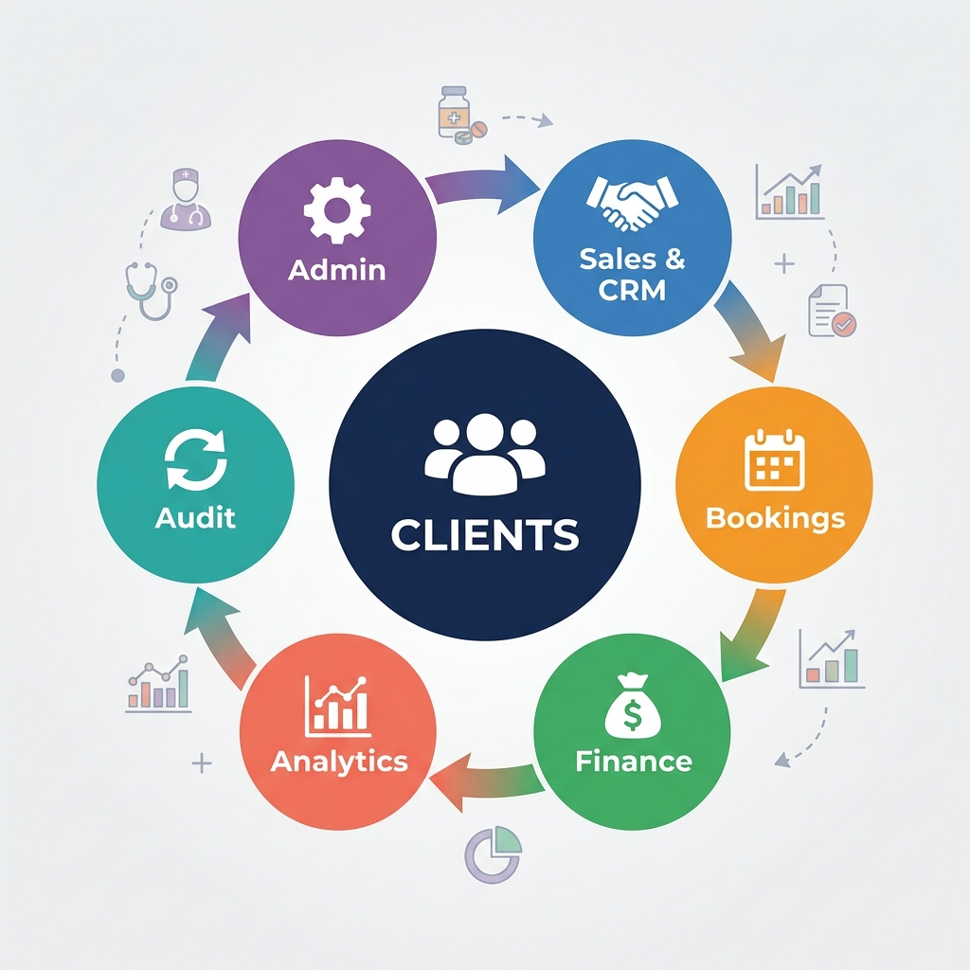
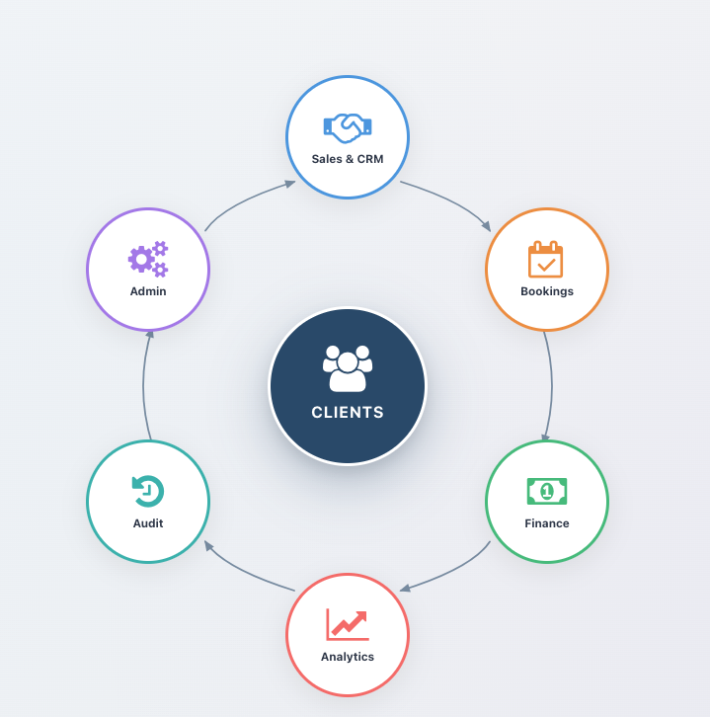

Dashboard Modules at a Glance
Feature | Description
CRM | Manages Initial contacts , Leads and Clients
Client | View and manage all client records
Booking | Create and manage healthcare service bookings
Staff | Schedule staff, manage workload
Accounts | Billing, invoices, payments, and AR management
Configuration | System settings, pricing rules, and lookups
Audit Log | Track all changes made in the system
💡 Tip: Use the search bar (Ctrl+K / Cmd+K) on the dashboard to quickly find any module or submenu.

2. Sales & CRM Module
The Sales & CRM module is your starting point for acquiring new clients. It helps you track every interaction — from the very first phone call to converting a contact into a paying client.
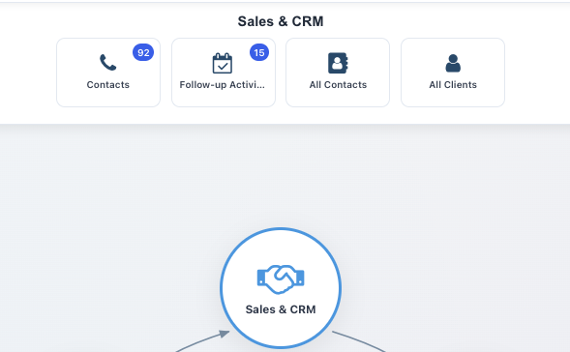

2.1 Contacts — Initial Contact Wizard
The Initial Contact Wizard is designed for your sales team to quickly log a new enquiry. It captures essential information in a guided, step-by-step form.

How to Log a New Contact
- Step 1: Click "CRM" on the dashboard, or navigate to Healthcare → Sales & CRM → Contacts.
- Step 2: The Initial Contact Wizard opens automatically.
- Step 3: Fill in the contact's name, phone number, and email.
- Step 4: Select the Contact Reason (e.g., "Enquiry about Home Visit Services").
- Step 5: Add any notes about the conversation.
- Step 6: Click "Save" to create the contact record and a CRM lead.
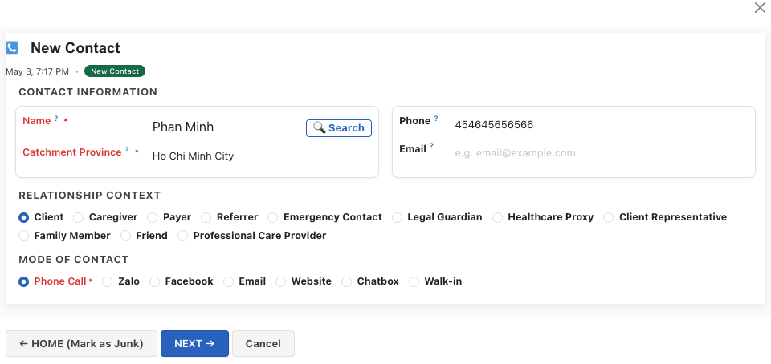

2.2 Follow-up Activities
After the initial contact, follow-up activities help your team stay on top of every contact. Schedule calls, meetings, or send information.

How to Schedule a Follow-up
- Step 1: Navigate to Sales & CRM → Follow-up Activities.
- Step 2: The Follow-up Wizard shows all pending activities.
- Step 3: Select a contact and choose the activity type (Call, Meeting, Email, etc.).
- Step 4: Set the date and add notes.
- Step 5: Click "Schedule" to create the follow-up reminder.
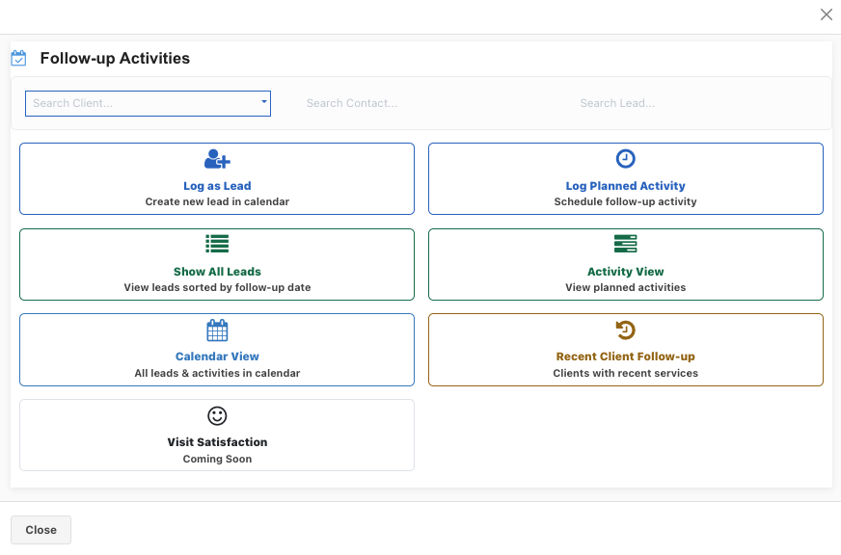2.3 All Contacts & All Clients
These two views give you a bird's-eye view of your contact database:
Feature | Description
All Contacts | Every person who has ever contacted your organisation, grouped by contact status  Initial Contact->Lead-> Booking (Client created)
All Clients | Only confirmed clients/patients, sorted by creation date.
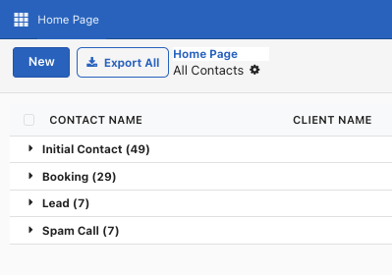

2.3 Dashboard (Contact)
- Once you click on any of the contact, it opens up the dashboard
- Clicking the center circle with the name of the client , it opens up the details for the contact
- You can also fill up the details for the contact by clicking on the outer circles eg Map, Led Info , Relations etc
Buttons | Description
Mark Spam | Mark the contact as Spam
Booking | Create a booking
Consultation | Select a person from whom consultation is required
Escalate | Escalate the contact to be referred to a particular Duty Doctor / Head Nurse/ Operations Manager
Send Message | Send message to a particular person
Log Activity | To-do / Email / Call / Meeting / Attach Document

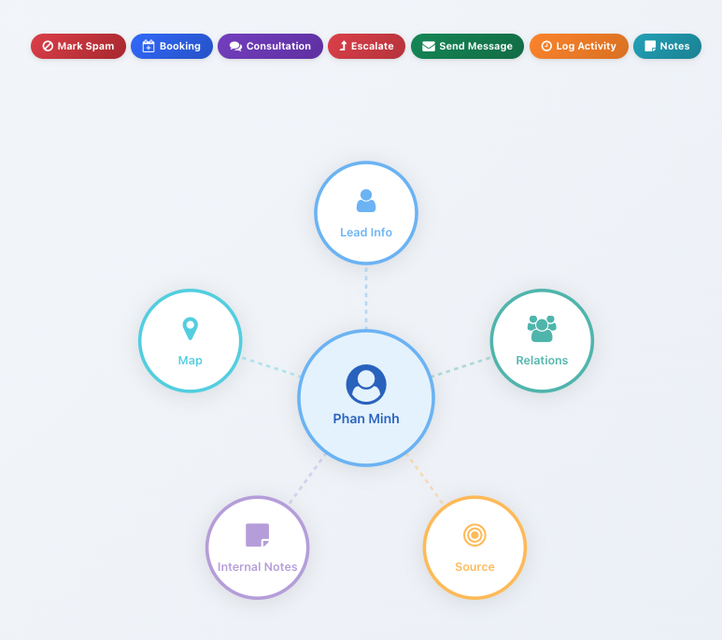
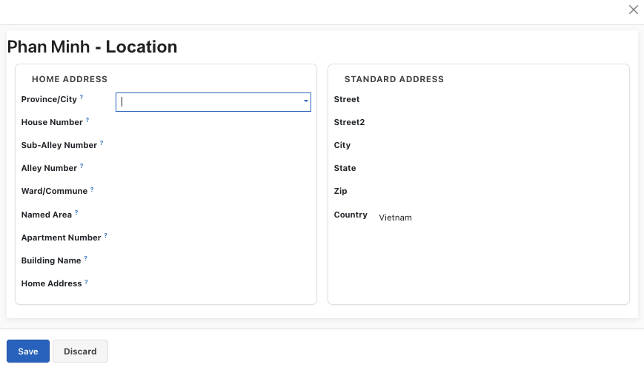
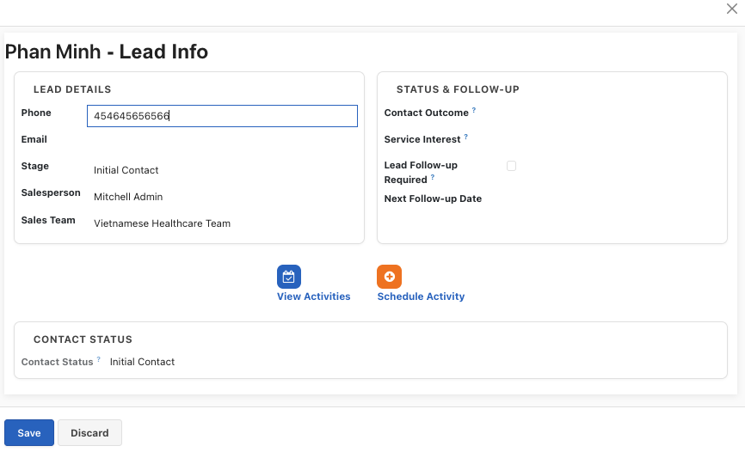

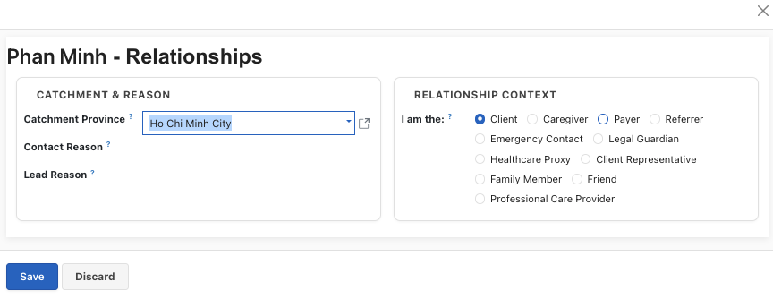

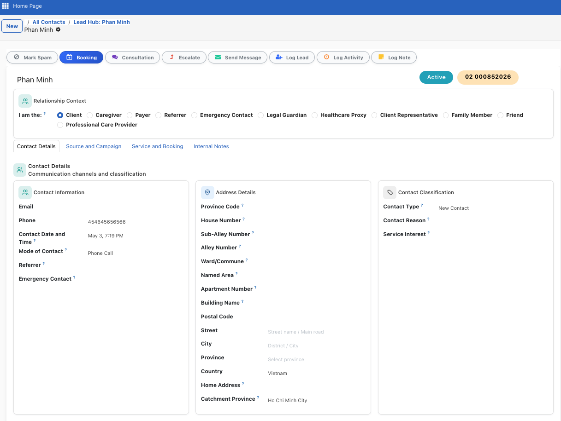

3. Bookings Module
The Bookings module is the heart of the platform. It manages the entire lifecycle of a healthcare service — from scheduling an appointment to completing the visit and generating an invoice.
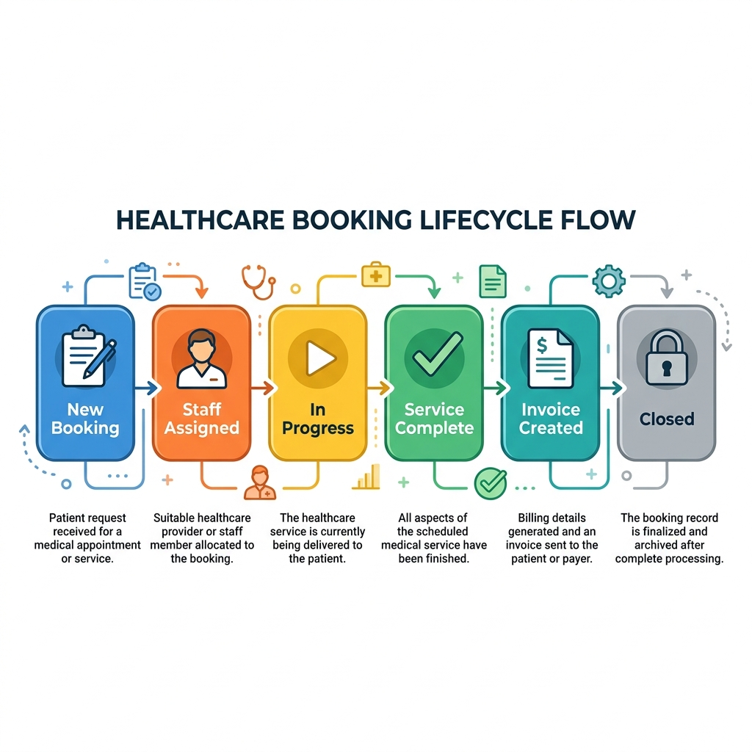

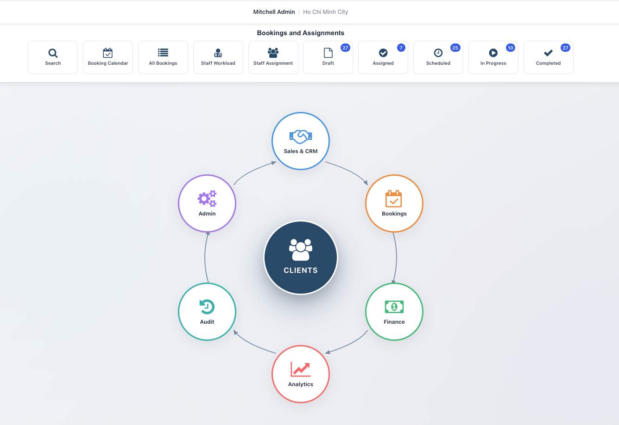

3.1 Creating a New Booking
A booking represents a single healthcare service visit. You can create bookings from the dashboard or from within a client's record.

Booking from Dashboard
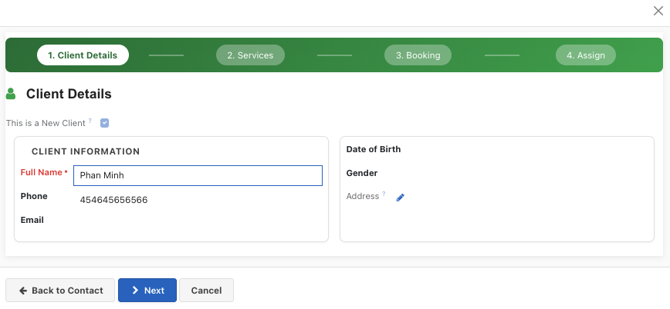
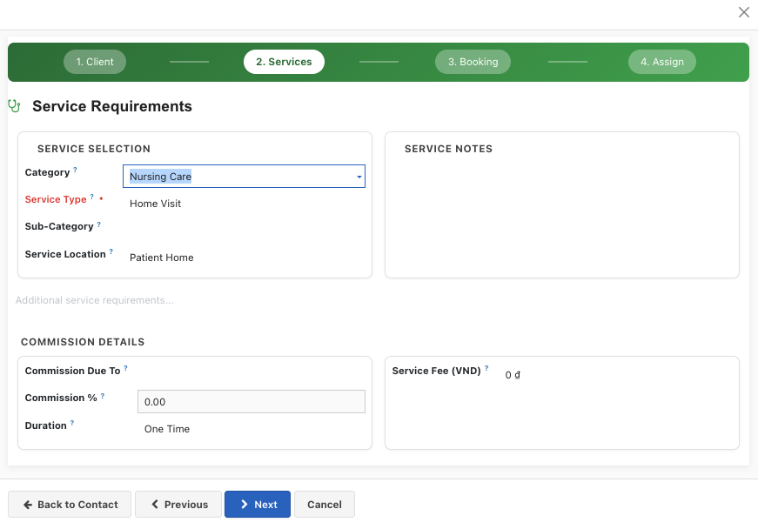

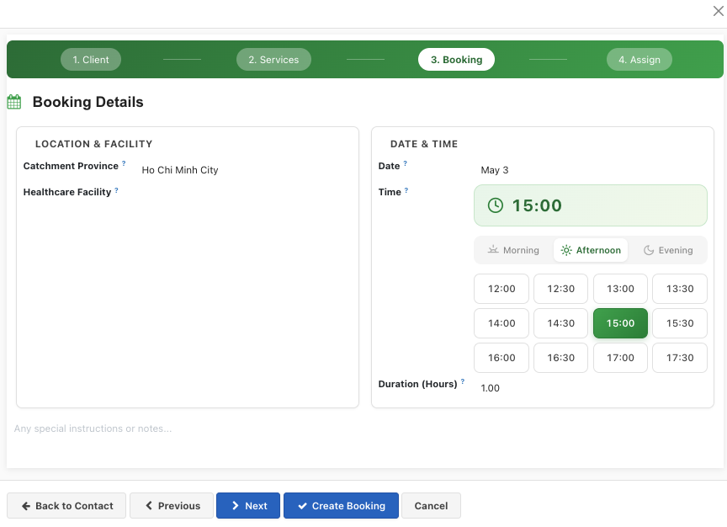
Booking from Client center
- Clicking on the center circle will allow user to fill in all details in one form

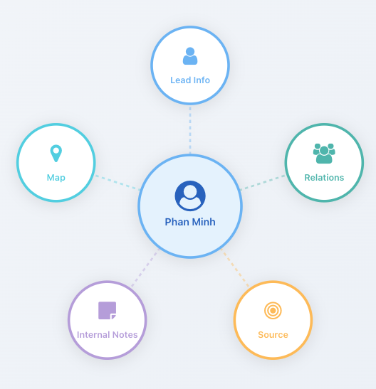
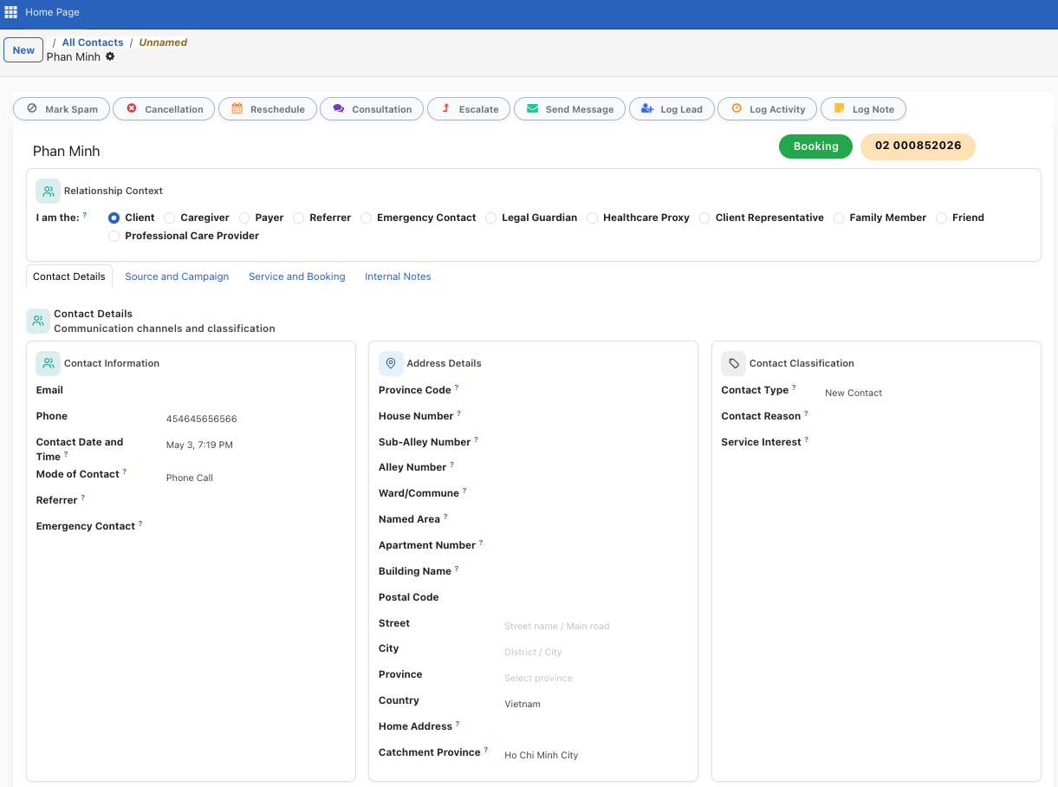

How to Create a Booking
- Step 1: Click "Booking" on the dashboard, or navigate to Healthcare → Field Service → Bookings.
- Step 2: Click the "New" button.
- Step 3: Select the Client (patient) from the dropdown.
- Step 4: Choose the Service Type (Home Visit, Clinic Visit, Consultation, etc.).
- Step 5: Set the Scheduled Date & Time for the appointment.
- Step 6: Set the Priority level (Normal, High, Urgent, Emergency).
- Step 7: Add any Symptoms or Service Requirements in the notes fields.
- Step 8 : Create a Quote
- Step 9: Click "Save" to create the booking.

Key Booking Fields
Feature | Description
Client | The patient receiving the service
Service Type | Home Visit, Clinic Visit, Telemedicine, Emergency, etc.
Scheduled Date & Time | When the service is scheduled
Priority | Low, Normal, High, Urgent, or Emergency
Clinical Urgency | Routine, Urgent, Emergency, or Critical
Service Location | Home, Clinic, Hospital, Care Facility, or Remote
Symptoms | Patient's reported symptoms or chief complaint
Diagnosis | Medical diagnosis (required for MOH compliance)
Cetegory of service | Category of service
Referring Doctor | Contact who referred this patient

3.2 Booking Lifecycle & Stages
Every booking moves through a series of stages. You can see all bookings in a Kanban board and drag them between stages.
Feature | Description
Draft | Booking created but not yet confirmed
Confirmed | Booking is confirmed and ready for staff assignment
Staff Assigned | Healthcare staff have been assigned to this booking
In Progress | The healthcare service is currently being delivered
Completed | Service has been delivered and clinical notes submitted
Completed — Pending Invoice | Service done by part-time staff; awaiting Operations invoicing
Closed | Invoice paid, cash collected — booking is finalised
Cancelled | Booking was cancelled (with a cancellation reason)

3.3 Staff Assignment
After a booking is confirmed, you need to assign healthcare staff. The platform provides multiple ways to do this:

Visual Scheduler (Timeline)
The Visual Scheduler shows all staff availability on a timeline. You can drag and drop bookings onto available staff slots.
- Step 1: Open a booking and click "Assign Staff" button.
- Step 2: The timeline view opens, showing all healthcare staff.
- Step 3: Find an available slot and drag the booking to assign it.
- Step 4: The booking automatically updates with the assigned staff.
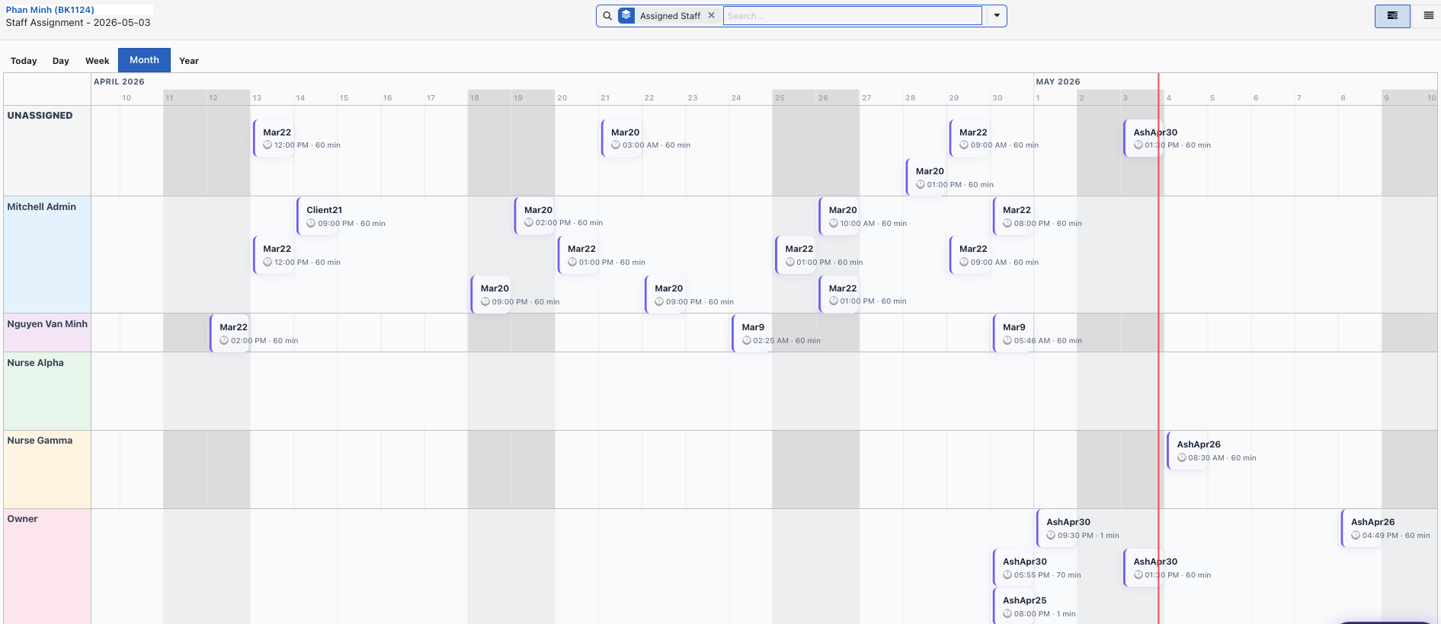

3.4 Healthcare Quotes & Pricing
Each booking can have a Healthcare Quote — a detailed price breakdown of the services to be delivered. The platform uses an Advanced Pricing Engine that automatically applies pricing rules based on various conditions.

How to Create and Manage a Quote
- Step 1: Open a booking and click the "Quote" smart button.
- Step 2: A Healthcare Quote form opens as a popup.
- Step 3: Click "Add Products" to add services from the product catalog.
- Step 4: The catalog is automatically filtered to show products matching the client's region.
- Step 5: Click "Recalc Pricing" to apply all pricing rules (distance, after-hours, weekend, holidays, etc.).
- Step 6: Review the Pricing Breakdown showing which rules were applied.
- Step 7: Save the quote.
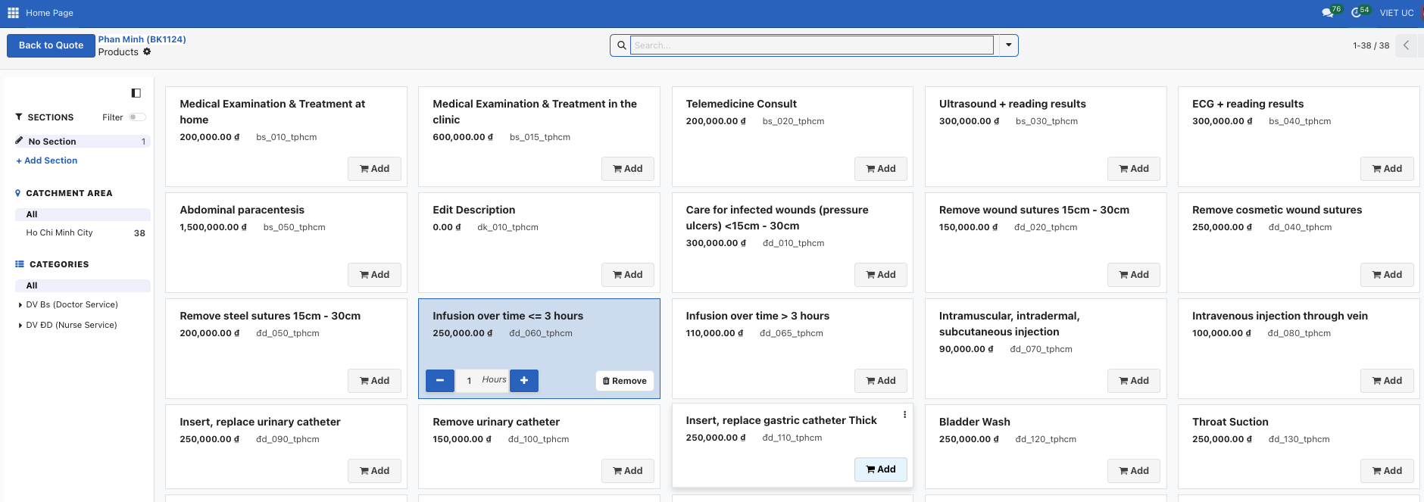 Pricing Rules That Apply Automatically
Feature | Description
After-Hours Surcharge | Applied when appointment is before 8 AM or after 6 PM
Weekend Surcharge | Applied for Saturday/Sunday bookings
Holiday Surcharge | Applied for public holidays (with multiplier: e.g., 3× for TET)
Distance Surcharge | Applied based on travel distance (per km above threshold)
Service Location | Different pricing for Home Visit vs Clinic Visit
Bulk Pricing | Discounts for multiple service units
Per-Unit Charges | Additional charges per wound, injection, IV bag, etc.
📌 Note: Pricing rules require Board Approval before they become active. Draft rules are not applied.

3.5 Mobile App
Notification of the booking comes to Nurse on mobile app
- Step 1: Open the booking in the "In Progress" stage.
- Step 2: Fill in Clinical Notes and/or Treatment Performed fields.
- Step 3: Update procedure counts if applicable (injections, medications, wounds, IV bags).
- Step 4: Click "Complete Service" button.
- Step 5: The system validates that clinical notes are submitted.
- Step 6: The system validates that a quote/invoice exists.
- Step 7: The booking moves to "Completed" stage.
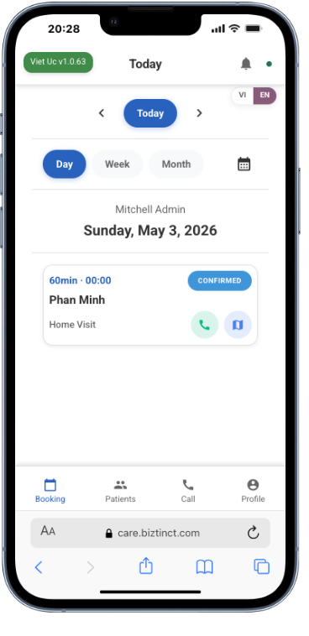
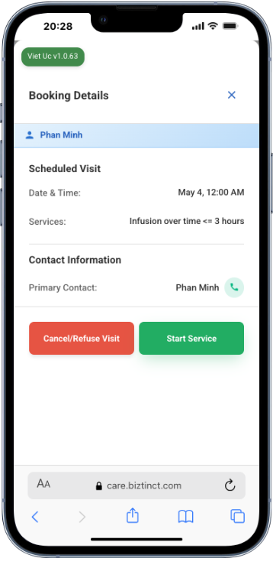
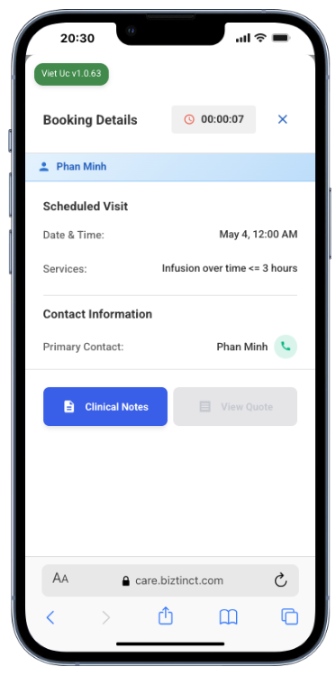
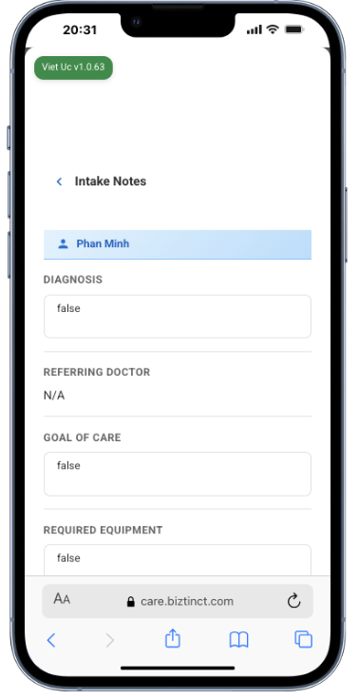

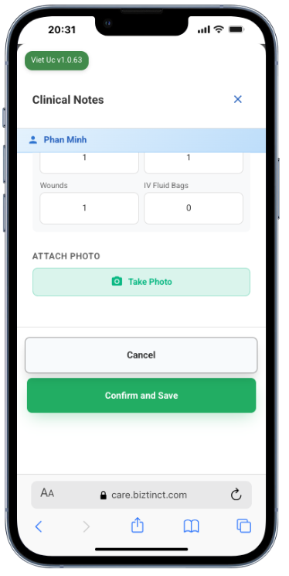
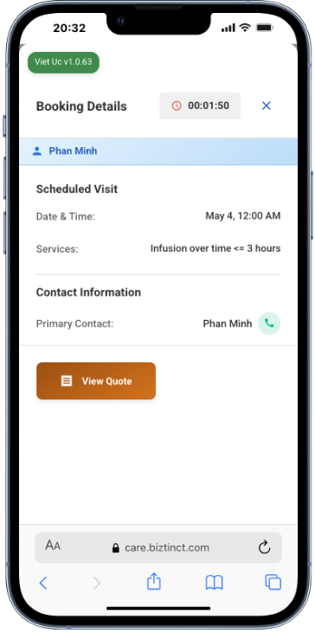
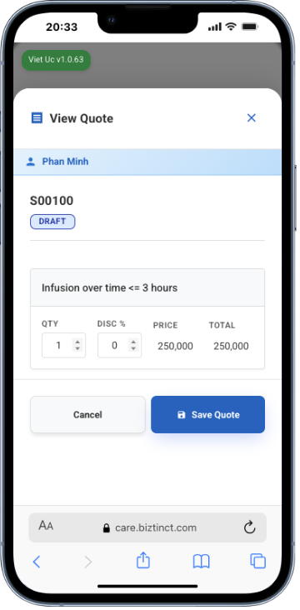
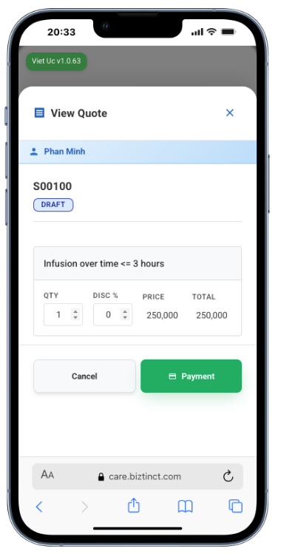
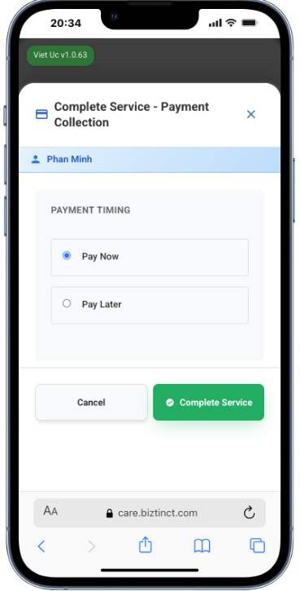

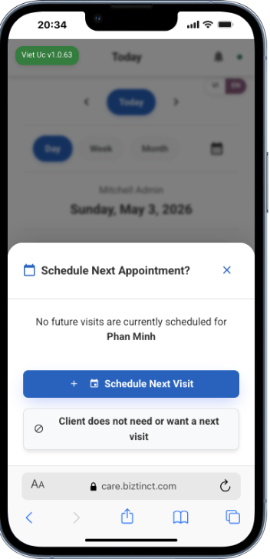

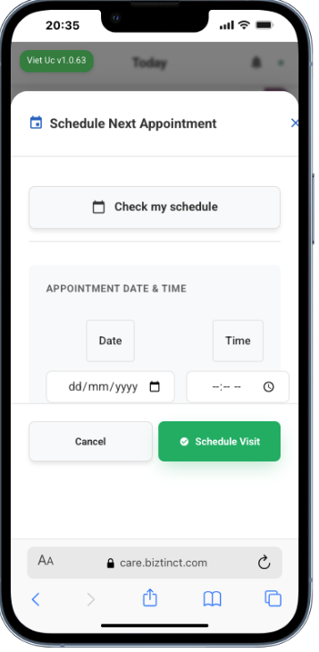

4. Finance Module
The Finance module handles everything related to billing, invoicing, payments, and accounts receivable management.
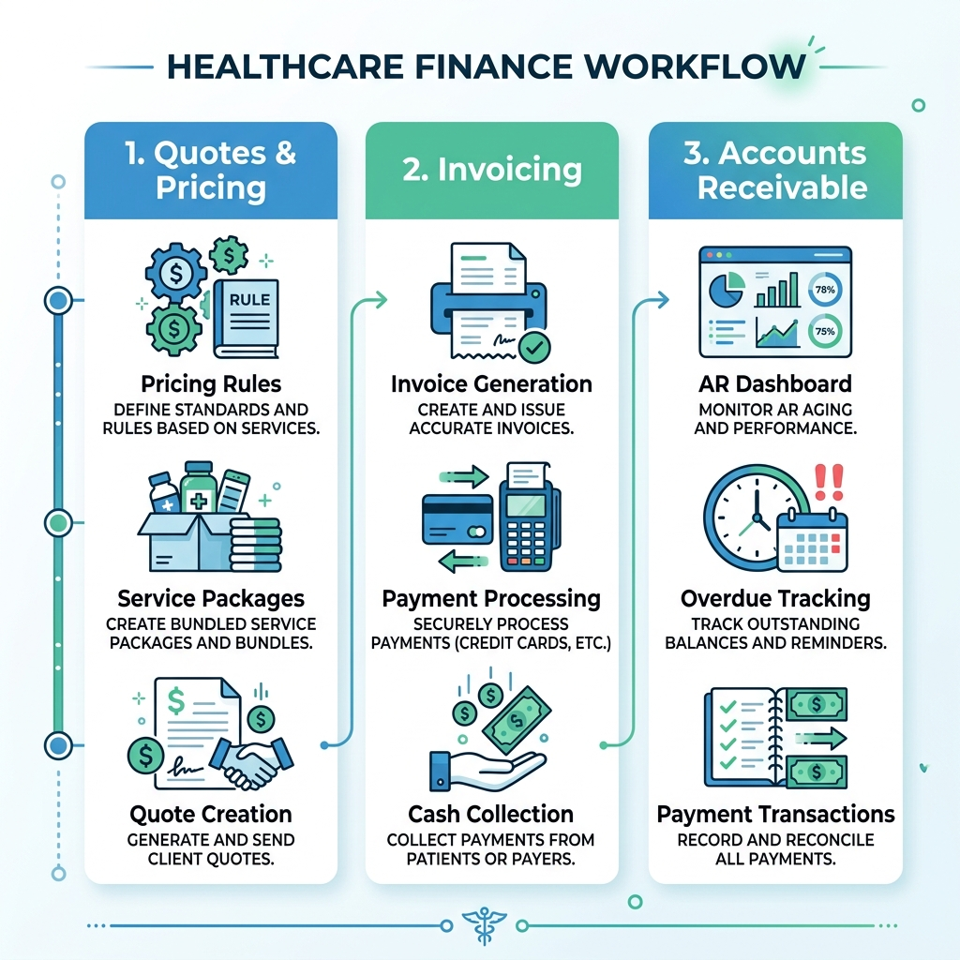

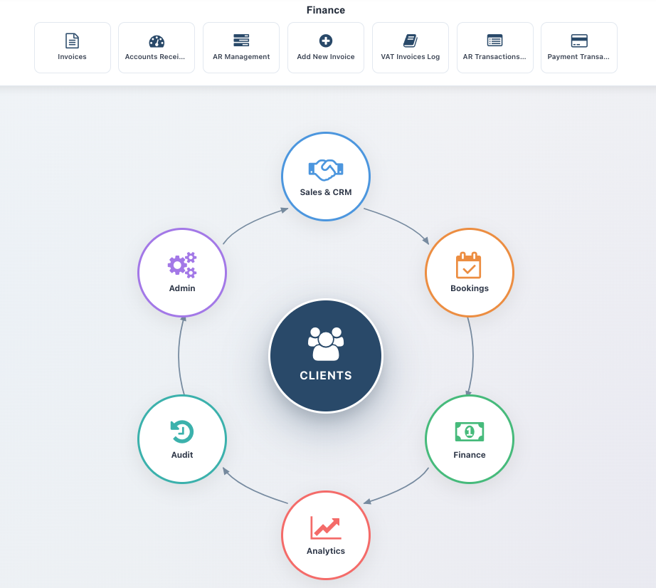

4.2 Invoices
View and manage all invoices. Invoices can be created from healthcare quotes after service completion.

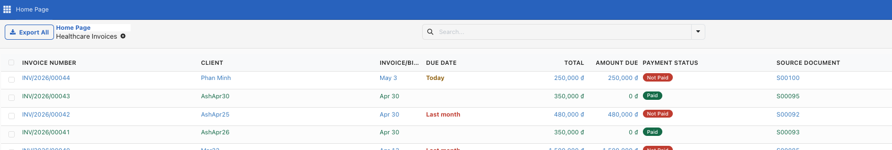

4.3 Accounts Receivable (AR Dashboard)
The AR Dashboard gives you a real-time overview of outstanding payments, aging analysis, and collection status.
Navigate to Accounts → AR Dashboard on the main dashboard.
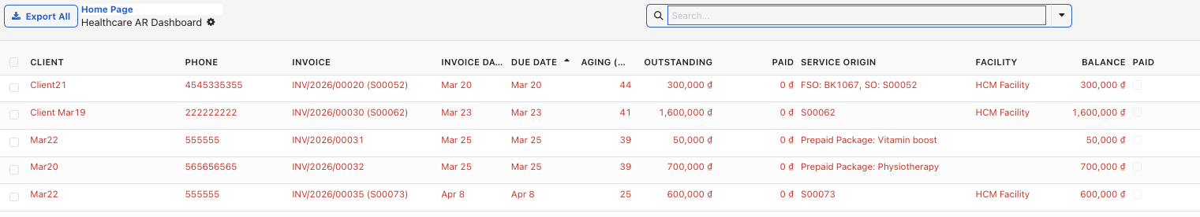

4.3 AR Management
Track payments collected by staff in the field , refund/credit , Account payment from here.
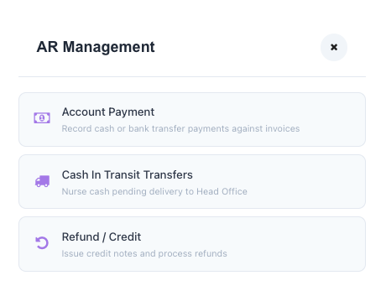
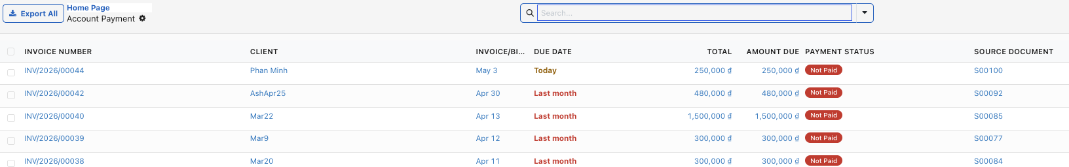
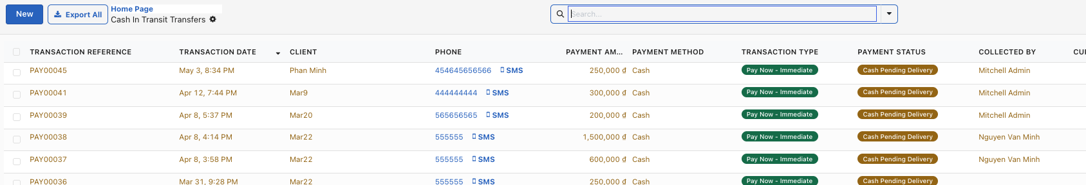

4.3 VAT Invoices log
Track VAT invoices here

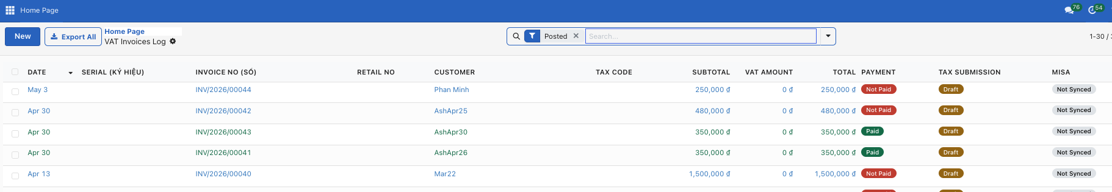

4.4 AR Transactions
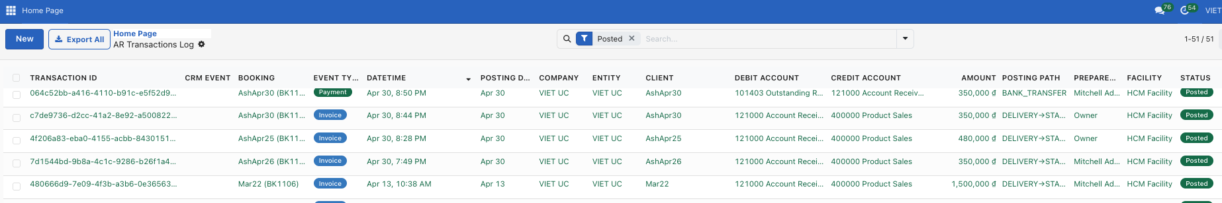

4.5 Payment Transactions
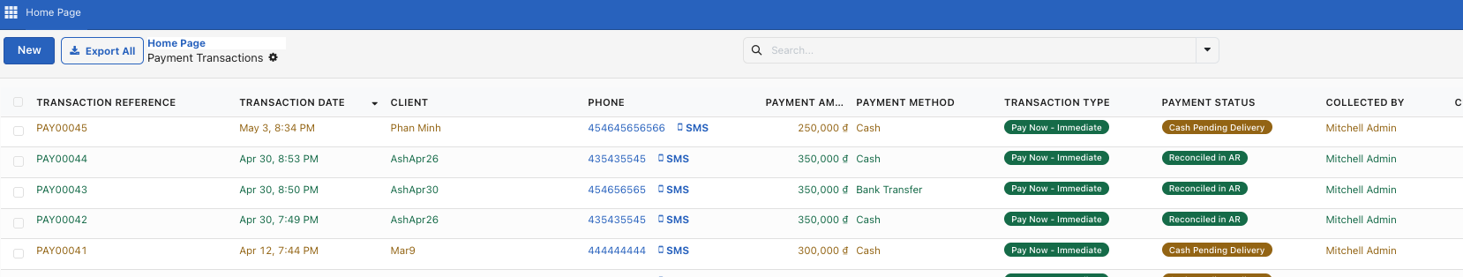

5. Glossary & Quick Reference

5.1 Common Terms
Feature | Description
FSO / Booking | Field Service Order — a single healthcare service visit
Lead | A potential client who has shown interest
Quote | A price estimate for services (Healthcare Quote)
AR | Accounts Receivable — money owed to you by clients
Catchment Province | The geographic area your services cover
Pricing Engine | Automated system that calculates service prices
PWA | Progressive Web App — the mobile interface for field staff
Clinical Notes | Documentation of the healthcare service delivered
Service Package | A bundle of prepaid services for a client
Red Invoice | Vietnamese tax-compliant invoice (Hóa đơn đỏ)

5.2 Keyboard Shortcuts
Feature | Description
Ctrl+K / Cmd+K | Open search bar on dashboard
Escape | Close search or cancel current action
Enter | Confirm / Save in most forms

5.3 Getting Help
If you need assistance, please contact your system administrator or the Viet Uc IT support team. Include the booking reference number (e.g., FSO00123) when reporting issues.

