Ron’s Follow-ups
- Beta version Acceptance
  - Scenarios
    - New Contact – Junk call
    - New Contact – represents client becomes Lead
    - New Contact is new client books service (process booking through invoicing)
    - New Contact – is caregiver makes booking for new client (process booking through invoicing)
    - New Contact – is caregiver makes booking for existing client(process booking through invoicing)
    - Repeat Contact – is caregiver makes booking for existing client(process booking through invoicing)
    - New Contact is payer makes booking for existing client (process booking through invoicing)
    - New Contact – is caregiver makes booking for new client (booking is deferred)
    - New Contact – is caregiver makes booking for new client (booking is cancelled)
    - New Contact makes prepayment with bookings
    - Pre-paid bookings processed through completion of service
    - Test payment options (on service; receive cash/bank transfer; pay later then receive payment cash/bank transfer; cash in transit transferred to front desk.
  - Criteria
    - Each scenario is recorded accurately without error message;
    - Completed services have clinical notes (nurses notes and MOH clinical fields)
    - Retail and VAT Invoices are details including price estimate correct
    - Accounts Receivable entries generate correct journal entries.

- Current Version issues
  - Essential: fix now
    - Error occurs in new client name/Client ID when continuing to the next step after a New Client is recorded (see Data Entry Error below)
    - Error occurs when entering New Contact Ron 10 Contact select Next this image shows wrong existing contact
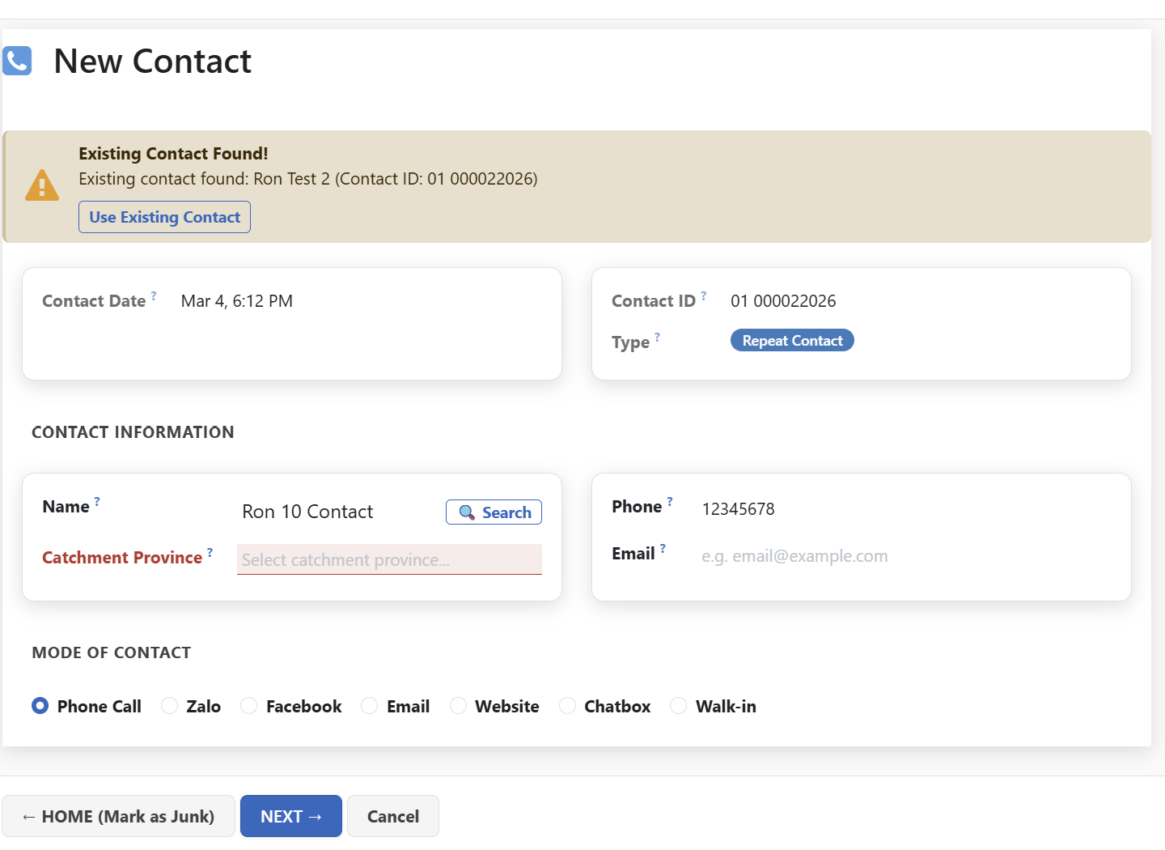
And selecting next has a mix of English and Vietnamese text

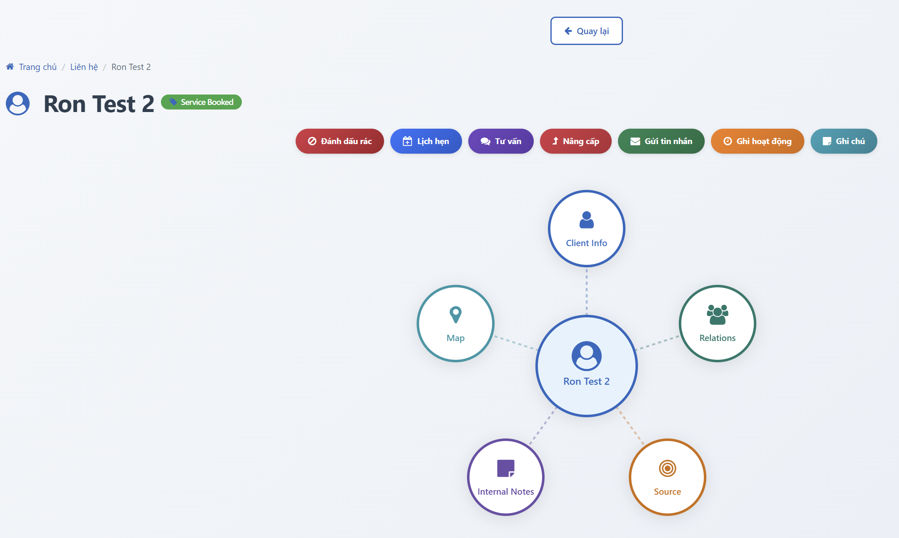
    - When the Home Page Menu “Clients” (Central menu option) is selected the Client Master File appears. This is not logical at this step. Give the user option to either select a client from the client master file; or add a new client.
      - If the user wants to select a client show the client master file (what you have now)
      - If the user wants to add a new client activate this menu set:
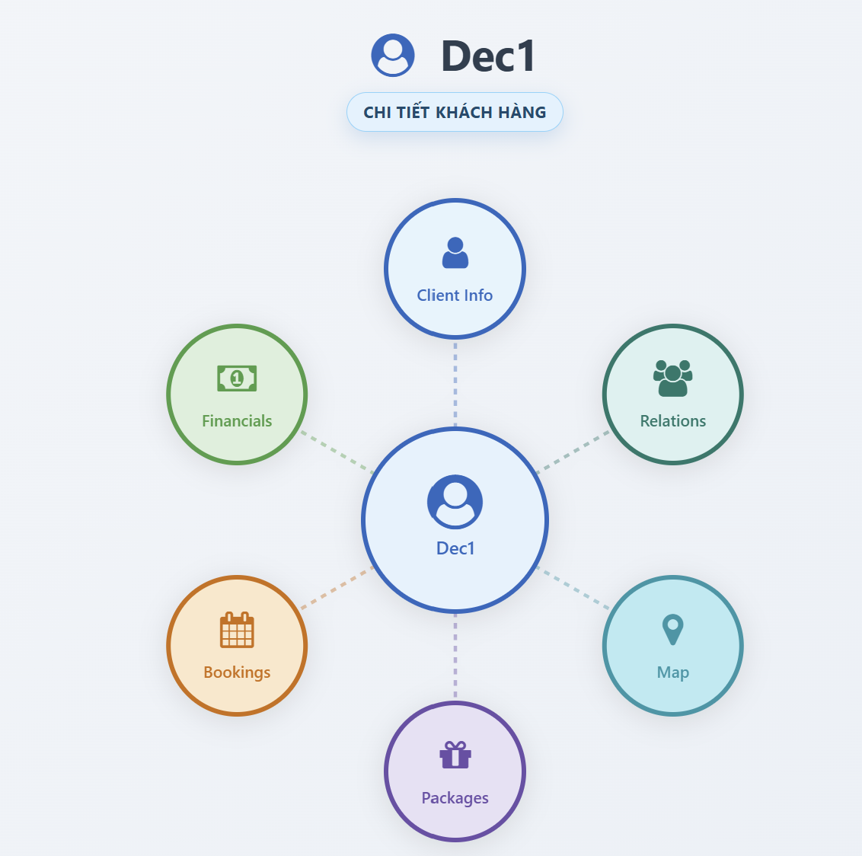
This should immediately open the add new client form.
    - Invoices in Home page Menu. Rename as “Finance”
Finance has 5 sub-menus shown in this sequence:
      - Invoices: show table of all invoices; allow filter and export
      - Accounts Receivable: show table for all invoices with unpaid balances. This table is used to generate statements of account to send to clients and manage cash collection; and to calculate one of the OM KPIs.
Show this as a listing of unpaid invoices: with date, client, name and phone number of person paying; Company ID (VAFHS/CSTNVU), Facility ID, Original Total of the invoice, amount paid to date, balance outstanding, aging (days) of outstanding balance (blank if balance zero) Other fields can be hidden.
      - AR Management: This has 3 components (Popup with 3 tags?)
        - Account Payment (Cash or Bank Transfer)
        - Cash In Transit transfers to Head Office
        - Refund/Credit
      - Add new Invoice (for prepayments; part time nurse/doctor; services without invoice; or service provided in the clinic)
      - VAT Invoices Log (shows details of every VAT Invoice created) Interim Table for validating MISA entries see iv below
      - AR Transactions Log (shows journal entries for every Accounts Receivable transaction) Interim Table for validating MISA entries see iv below
    - Interim fix for deferred items:
      - every completed booking/sale has a retail invoice; and a record of VAT Invoice items if the service is not prepaid. (see VAT Log – supplied by Dung)
      - log of correct journal transactions for sales and accounts receivable updates (see accounting transaction log and double entry posting table below)
      - Show Items 1 and 2 as tables in Analytics and make them available for download.
    - Admin.
Reduce the long list of sub-menus in admin to the following:
      - Price Lists (select from the following)
I cannot see a list of products/prices; or pricing rules. Where are they?
        - Price list table (with edit/replacement option)
Note: the price list table identifies: Treating Clinic (company); service category; Service Item; Service Item Code; Units; Price per Unit; Option for custodian to add other fields;
        - Pricing Rules table (with edit/replacement option)
        - Packages (with edit/delete/add options)
      - Field Management
        - make field compulsory using tick box (pop-up; select table; select field to make compulsory; only admin or app custodian can do this); optionally add new client here
        - make field lookup (pop-up; select table; select field; add lookup values; only admin or app custodian can do this lookup tables can have multiple columns with details (e.g. facility can have name, type, address…….)
      - User Management:
        - Add/Remove Users
        - Assign or edit Role categories
        - Assign or edit Roles/functions for individual users
      - Portable Equipment
    - Analytics:
Two submenus:
      - Dashboard. Allow user to tailor the dashboard (if it is possible now it is not obvious)
      - Tables. Pop-up to select any table in the system; filter it; export; save template for reuse (this functionality has been lost)
    - Activate Voip24/7
    - Activate Contact/Client source (Social Media; website; google ads; keyword)
  - Minor: cosmetic or minor issues that do not affect functionality can be deferred to Beta Testing stage. These include:
    - Form and Table Design
    - Renaming labels/details
    - Formatting and Display
    - Standardisation of app menus
    - Correct username and assigned catchment province on each page
    - Faint display on forms/popups
    - Ensure each transaction is recorded in audit (date/time stamp; user; action)
    - Remove reference to leads in the dashboard (we are interested in contacts, new and repeat contacts and clients
    - Add Language management in Admin
    - Company and user preferences
    - Make sub-menus vanish when user re-selects a main menu
    - Notifications icon top RH side –change it to a bell and, if it changes have it moving/change colour/and/or size until it is viewed
    - Add a Field Status (active/archive/delete); and reason for archive or delete fields (picklist) on every Form/table; default is active; user can change to archive or delete; administrator or app custodian can physically archive/delete.
    - Ensure audit is working for all recorded items.
    - Catchment province, modes of contact, phone number should all be automatically captured (from website and VOIP)
  - Deferred: Previously Agreed Deliverables Deferred to follow-up stage
    - Automated links with other applications:
      - Link to Viettel digital Signatures for VAT Invoices
      - Submission of VAT Invoices to Tax Department
      - Updating Misa with Sales (invoice) and Accounts Receivable Transactions
      - MOH Clinical Details (no action at this stage)
      - MOH Digital Prescriptions (no action at this stage)
      - Full Field mapping (no action required at this stage)

Data entry error
New Contact Form creates new contact (Ron07 is contact) Next -> 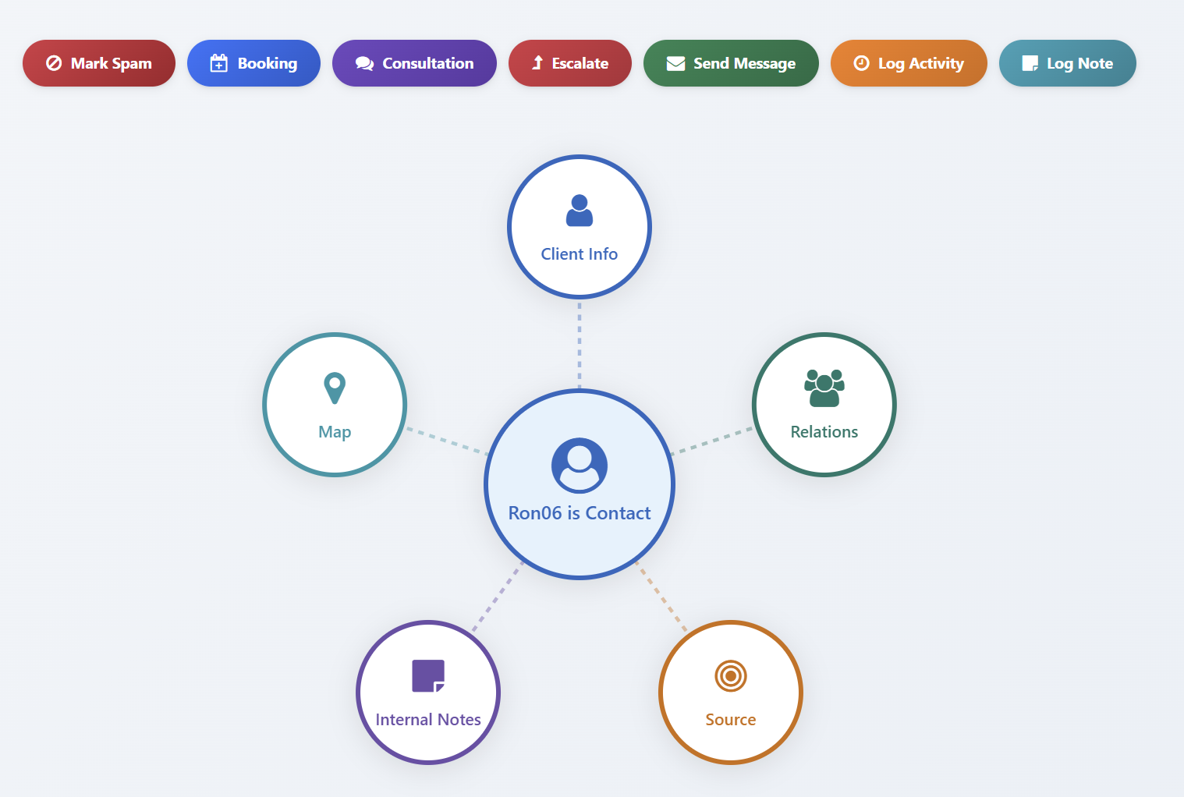
Select Booking ->
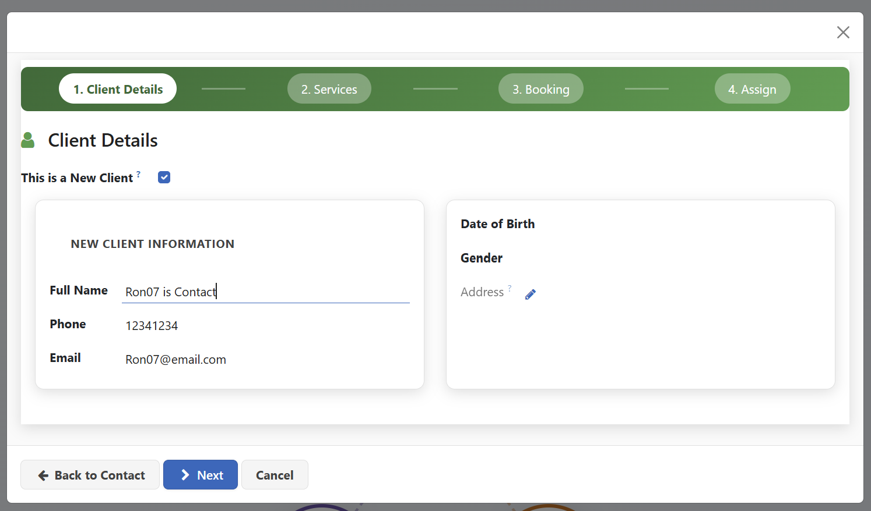
Here the app assumes “Ron07 is contact” is the client. This should not be assumed. My intention here is to be a new client; and to make a booking. When selecting booking at this stage it should open the same form as if selecting the central menu:
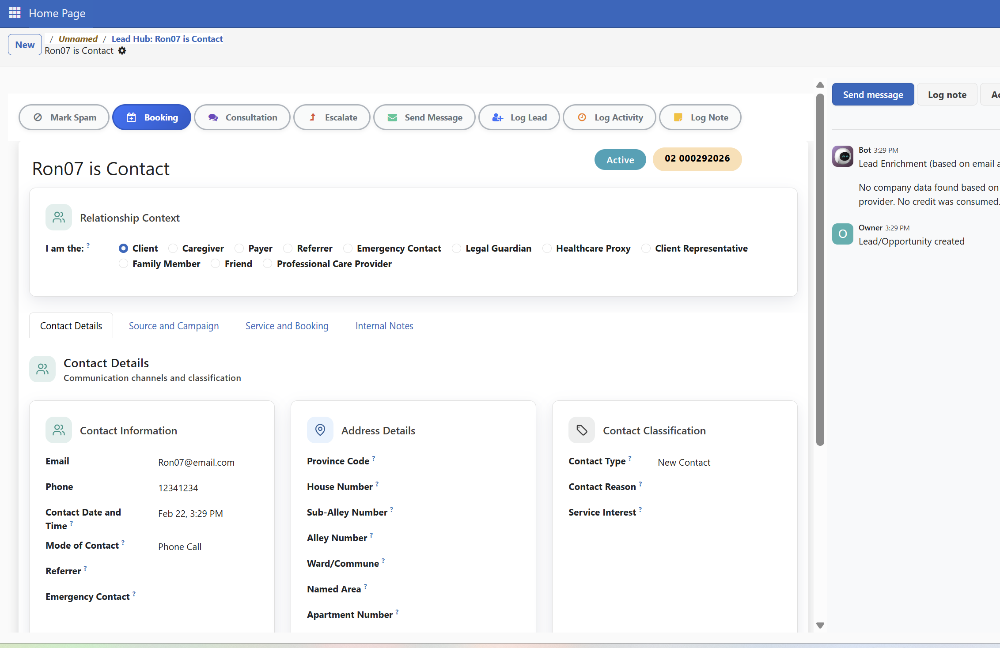
Define the contact as a referrer;
Try to select a client name there is no list;
Manually enter a new client name (Ron07 is Contact New Client 01); ->
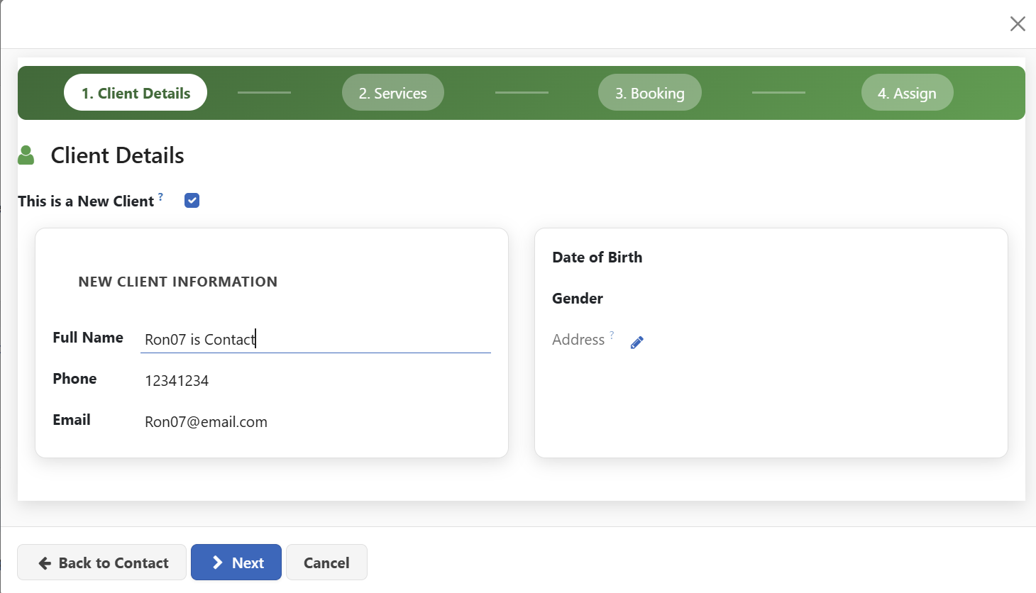
Ron07 is Contact becomes the new client. This should show Ron07 is Contact New Client 01 with a new ID if this name is not already in the CMF (OR if it is in the data base already does not have links to this contact phone or other details).
Note: In Vietnam many people have exactly the same name. When the user is given an option to select a person (client or otherwise) also display the phone number, address national id and any other identifying fields such as tax number.
The Address edit works well here and it looks good; it does not work everywhere there is an address.
There are intermittent form hanging issues in this process (e.g. when I try to cancel or go back a step it hangs – intermittently); there are error messages e.g. when I try to select a new contact name an error message pops up on the top RHS

Please test the entire system to make sure no unnecessary errors pop up. That is distracting for the users

- Accounting Transaction Log
1. Universal fields (every transaction)
These must exist on every journal line.
Field | Purpose
Transaction ID | Immutable system ID (UUID)
CRM Event ID | Links journal to originating event
Event Type | Payment / Service Delivery / Refund / Handover
Transaction DateTime | When the event occurred
Posting Date | Accounting date (usually same day)
Company / Entity | Hanoi vs HCMC
Debit Account | Ledger account
Credit Account | Ledger account
Amount | Numeric
Currency  Amount in Words | VND  Text
Prepared By | System / User ID
Posting Path | e.g. DELIVERY→PREPAID, DELIVERY→NURSE_CASH
Status | Draft / Posted / Reversed

Double-Entry Posting Table (VAT-Exempt Services)
Legend
- SR = Service Revenue (this is the sale)
- UR = Unearned Revenue (prepayments)
- AR = Accounts Receivable
- CIT = Cash in Transit – Nurse
- CASH = Cash / Bank (company-controlled)

A. Prepayment received (before service)
Event | Debit | Credit
Customer prepays | CASH (or CIT if nurse collects) | UR

B. Service delivered – prepaid
Event | Debit | Credit
Service completed | UR | SR

C. Service delivered – postpaid (no immediate payment)
Event | Debit | Credit
Service completed | AR | SR

D. Service delivered + customer pays immediately (normal case)
Entry 1 — record the sale
Debit | Credit
AR | SR
Entry 2 — record payment
Debit | Credit
CASH | AR

E. Service delivered + nurse receives cash (edge case)
Entry 1 — record the sale
Debit | Credit
CIT | SR
Entry 2 — nurse hands cash to front desk
Debit | Credit
CASH | CIT

F. Payment received later (after postpaid sale)
Event | Debit | Credit
Customer pays | CASH | AR

G. Refund before service delivery
Event | Debit | Credit
Refund prepaid amount | UR | CASH

H. Refund after service delivery
Event | Debit | Credit
Refund customer | Refunds / Sales Returns (or SR) | CASH

Hard rules
- Service Revenue = sale of service account
- Service Revenue is credited only on service completion
- Cash receipt never credits Service Revenue
- Allowed debits when crediting Service Revenue:
  - Unearned Revenue
  - Accounts Receivable
  - Cash in Transit – Nurse
- Cash/Bank is debited only on payment or handover
- Cash in Transit is debited when a nurse receives cash
- Accounts receivable is credited when a client makes a payment
- No journal may debit Cash/Bank and credit Service Revenue directly

Hanoi Retail Invoice Note: Address and numbering system are not the same for Hanoi and HCMC

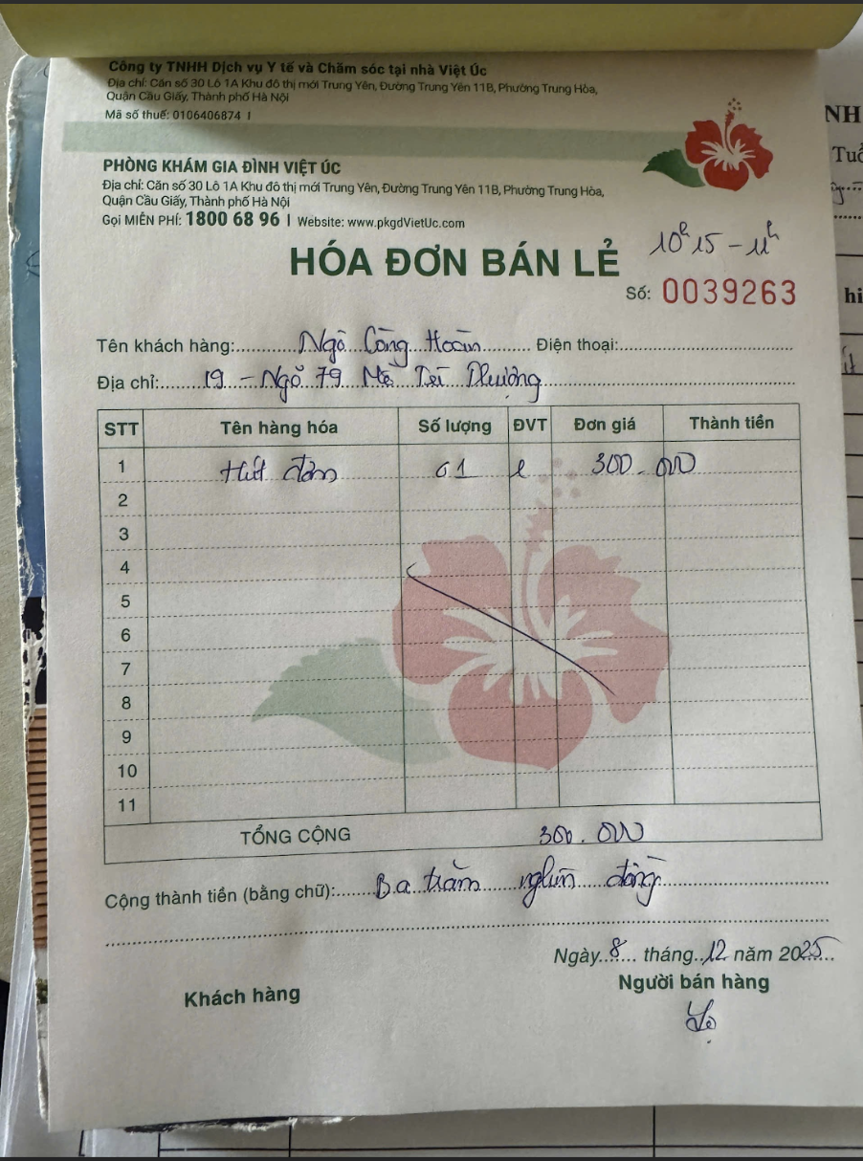

Hanoi VAT Invoice Note: Serial Number changes Annually; Invoice number is sequential; Invoice formats should be the same but Hanoi / HCMC have different address and numbering systems.
