Muse Visions – Android JSON Sudoku Solver

Open Sudoku Solver is a Native Android application that can be used to solve Sudoku Puzzles stored on a web server in JSON format.

User interface
The app is composed by two main activities. The first one is illustrated below and shows
a View to show the Sudoku Puzzle as well as some controls to verify and solve it.
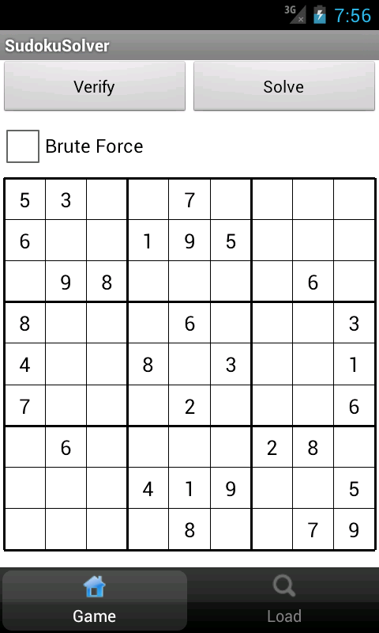
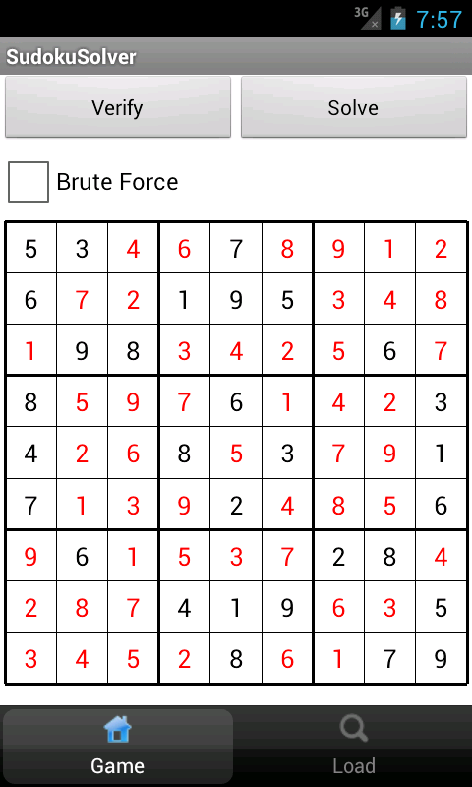

A second view is used to load puzzles from an online server.
Once the view is loaded, a request is sent to a PHP page that scans all *json files in the current folder and composes a global JSON Array of JSON Arrays. This is then sent back to the caller and used to populate a list view.

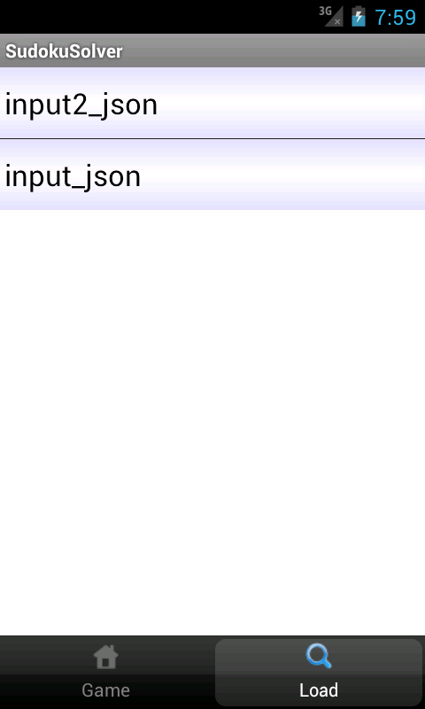
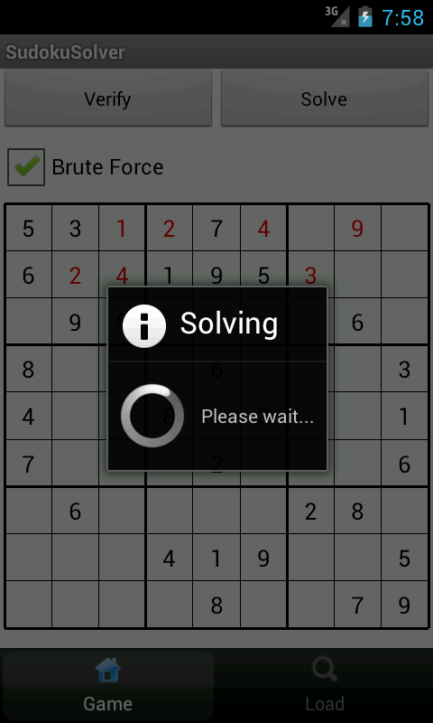

Each element in the list correspond to a valid JSON Array, and can be loaded into the main view by tapping on it.

Sudoku solver

Brute Force
A Brute force Sudoku solver has been implemented and tested on the device. For reference documentation about the implementation please see SudokuSolverBruteForce.java.

It can be observed that as the brute force solver tries all combinations, it doesn't converge in reasonable time and is therefore a not viable method for the assigned task.

Optimised Solver
An optimised solver has been found online ( credit: Kevin Coulombe, http://www.byteauthor.com/2010/08/sudoku-solver-update/), and imported into the application code.
This solution converges in a fraction of a second and is therefore the preferred implementation.

Input format

Open Sudoku Solver accepts puzzles in the following JSON format (zero indicates values that need to be solved):
[
5, 3, 0, 0, 7, 0, 0, 0, 0,
6, 0, 0, 1, 9, 5, 0, 0, 0,
0, 9, 8, 0, 0, 0, 0, 6, 0,
8, 0, 0, 0, 6, 0, 0, 0, 3,
4, 0, 0, 8, 0, 3, 0, 0, 1,
7, 0, 0, 0, 2, 0, 0, 0, 6,
0, 6, 0, 0, 0, 0, 2, 8, 0,
0, 0, 0, 4, 1, 9, 0, 0, 5,
0, 0, 0, 0, 8, 0, 0, 7, 9
]

As multiple puzzles are stored in the server, a single Array of Arrays is generated by a php script and returned to the application which can then populate a list of games (see backend/generate.php).

Each time a puzzle is solved, it is uploaded again to the server appending a “.solution” suffix to the original file name, and a pop-up message informs the user about this.

The web address used to fetch the data is as follow:
http://www.musevisions.com/sudoku/generate.php

This can be changed as needed.

Appendix: Error handling
The app expects well formed JSON arrays as specified above.
Non-well formed arrays will result in silent exceptions being thrown and depending on the type of error the resulting grid may be empty or contain spurious values.

License
JSON Sudoku solver is covered under the Creative Commons Attribution 3.0 Unported License
http://creativecommons.org/licenses/by/3.0/

Credits
Sudoku solver Java implementation: Kevin Coulombe
http://www.byteauthor.com/2010/08/sudoku-solver-update/

NOTE: If no Internet connection is available a message will show telling the user so.

