
CORPORATE PROFILE
AI-Enabled Healthcare Management Platform for Grassroots Communities
Community & Family Development | Cagayan Province, Philippines
Program Leader: Fernando M. Jaminola Jr.
From access to grassroots affordability to specialized healthcare, NO Cagayano Barangay resident left behind.

1. Company Overview
AdvanCare is an integrated, community-based healthcare ecosystem that makes care accessible, affordable and coordinated for barangay residents in Cagayan Province. Developed by Cagayan State University in partnership with the Province of Cagayan, it links people, services and communities through a mobile app, an operations dashboard and a network of caregivers, rural health units, doctors, transport providers and donors.
AdvanCare positions itself as One Closed Care Loop: one booking, one record and one payment, with real-time updates for the family, caregiver, clinic and barangay. It is community-driven, technology-enabled and people-centered.

2. Vision and Mission
Vision: Healthier communities and stronger futures, with no Cagayano Barangay resident left behind.
Mission: To connect barangay residents to trusted local healthcare and caregiving support, and to carry them through a complete care journey, from first contact and affordable subscription to transport, triage, telehealth and follow-up care.
Core values: Inclusive and accessible; affordable and sustainable; responsive and reliable; healthier communities, stronger futures.

3. The Problem We Address
Care exists, but reliable, affordable support does not reach everyone. Aging farmers and fishers, people with special needs and their families face distance, high costs and scattered services.
- Hard to find trusted care: families struggle to find and match screened caregivers.
- Costly and far away: care, transport and out-of-hospital costs strain remote households.
- Fragmented support: booking, records, updates and payments are scattered, and care breaks down after discharge.
Key indicators cited:
- 56% of Cagayan deaths in 2020 had no medical attendant (PSA, 2020).
- The median age of Filipino farmers is 57 (DA via PCO).
- 31% of farmers lived in poverty in 2018 (PSA, 2018).

4. Our Solution: One Closed Care Loop
The patient journey runs through four stages: Connect in Local Language → Match & Track → Follow Up → Improve.
- Connect in local language: links barangay residents to trusted local healthcare and caregiving support in English, Bisaya or the local language.
- Match and track: matches patient needs with a caregiver or healthcare professional, and tracks patient details, appointments, medical records and payment data.
- Follow up: supports continuity of care with reminders, updates and post-visit coordination.
- Improve: predictive analytics on seven years of DOH disease trends to anticipate community health needs, guide capacity building, equipment investment and facility strengthening.

The five components of the care loop
- Affordable subscription in three tiers, with a 50% LGU subsidy.
- RHU and barangay-led initiatives: local health teams, mobile checkups, basic care and health education.
- Reliable transport: non-emergency rides to clinics and hospitals, safely and on time.
- Out-of-hospital triage (MediBox): health workers assess a patient's needs early and guide the next step to the right level of care.
- Multi-language telehealth: remote consultation, connectivity to specialists and health professional support.

5. Products and Services
- Mobile app: request care, book transport, consult a doctor, access RHU services, get assessed, track requests and receive updates.
- Care Coordination System and Operations Dashboard: a command center for administrators and coordinators covering service requests, scheduling, provider matching and service tracking.
- Caregiver matching: home and hospital bedside caregivers, at ₱300 per 8 hours (barangay level) and ₱500 per 8 hours (clinical or hospital level).
- Non-emergency medical transport for patients.
- Telehealth: doctor consultations and prescriptions.
- MediBox: portable telehealth and triage kits, 25 sets planned (10 sets each with Starlink and gensets).
- Discounted vitamins and medical supplies, including items not covered by PhilHealth YAKAP.
- Care Assistant chatbot and a donor network for community support.

6. Subscription Plans
All plans include the Care Assistant (chatbot), discounted vitamins and medical supplies, telehealth services and MediBox.
 | Silver(Low Income Families, 4P’s, PWD’s and Indigeneous people) | Gold(Medium Income Families) | Platinum(Medium Income Families)
Annual price | ₱1,800 | ₱3,000 | ₱4,200
Monthly price | ₱150 | ₱250 | ₱350
LGU/Congressional District Discount * | ₱900/yr (50% discount) | Optional | Optional
Daily Rate for each Household | ₱2.5 | ₱8.33 | ₱11.67
Non-emergency transport SLA | Urban 3 hrs,  Rural 4 hrs | Urban 2 hrs  Rural 1 hr | Urban 1 hr  Rural 2 hrs
Caregiver SLA | Hospital 2 hrs  Barangay 3 hrs | Hospital 1.5 hrs  Barangay 2 hrs | Hospital 1 hr  Barangay 1 hr
Funding source | Public funds (PWD Law, Expanded Senior Citizen Act, Indigent 4Ps via LGU; provincial, congressional district and LGU funding)* or private donors | Optional for working PWDs and citizens | Optional for working PWDs and citizens
Unemployed 65+ eligible | Yes | No | No
SLA (Service Level Agreement): the guaranteed timeframe for service delivery for each membership tier.
Plans are priced to fit low to middle income households, with a 50% LGU subsidy and a 50% out-of-pocket share at the barangay level. 4Ps members receive a free subscription paid by Local Government Units.

7. Target Market
Primary focus: low-income and rural households in Cagayan Province.
- Aging farmers and fishers: older adults needing affordable, reliable healthcare and wellness support.
- People with special needs: individuals needing accessible, personalized care and inclusive community support.
- Low-income families: families needing affordable, quality care.
- Barangay and care partners: underserved rural communities, barangay health workers, clinics, hospitals and youth community caregivers.

National Target Pool Breakdown (5,400,000 total potential user )
Segment | People | Share | Basic Rate | Revenue for 1 year
TAM, Total Addressable Market | 5,400,000 | 10% of 54M | ₱1,800/yr | ₱9.72B
SAM, Serviceable Available Market | 2,700,000 | 50% of TAM | ₱1,800/yr | ₱4.86B
SOM, Serviceable Obtainable Market | 1,350,000 | 50% of SAM (25% of TAM) | ₱1,800/yr | ₱2.43B

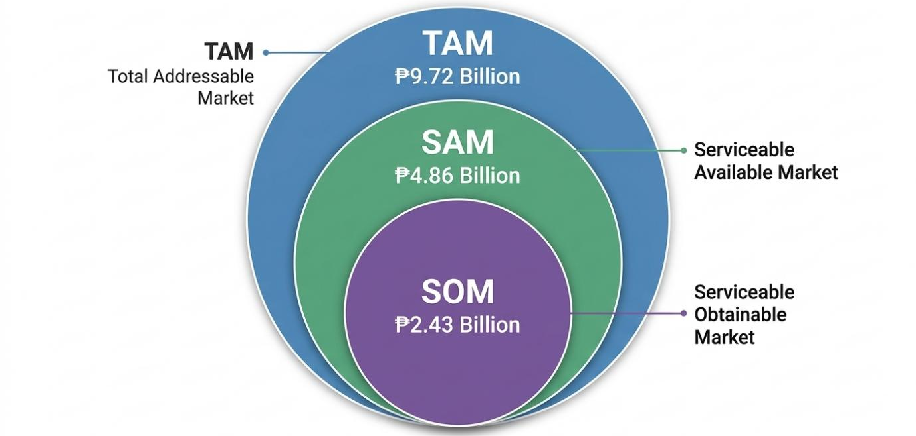

8. Competitive Positioning
AdvanCare builds on what exists and goes further for Cagayan's farmers, fishers, PWDs and low and middle income families.
Criteria | PhilHealth | Maxicare | Metrobank Health & Wellness | AdvanCare
Target beneficiaries | All Filipinos | Individuals and families, mostly urban | Corporate employees, individuals, families | Farmers, fishers, PWDs, low and middle income families in Cagayan
Service scope | Health insurance, hospital coverage, primary care | HMO, hospital, clinic, dental, optical | Health plans, wellness, telehealth | Healthcare, livelihood support, medical transport, insurance guidance, telehealth
Geographic coverage | Nationwide | Major cities | Metro Manila and key cities | Cagayan Province, scalable nationwide
Intergenerational focus | No | No | No | Yes (youth, elderly, PWDs)
Financial model | Contribution-based | Monthly premiums | Insurance premiums | Self-sustaining revenue loops
Community integration | Limited | Limited | Minimal | Strong LGUs, local partners, human capital development
What makes AdvanCare different: others match, track or staff care; AdvanCare closes the loop.
- Intergenerational care: youth community caregivers earn a livelihood while elders share knowledge with the next generation.
- Tiered, SLA-backed care: clear response times and affordable 8-hour caregiver rates.
- One coordinated record: one booking, record and payment, with updates for family, caregiver, clinic and barangay.

9. Business Model
- Customer segments: aging farmers and fishers, people with special needs, remote communities, and urban and rural poor needing assistance.
- Value propositions: non-emergency transport; affordable, coordinated and trusted care; tele-consultation and prescriptions; free membership for 4Ps members paid by LGUs; discounted vitamins and supplies excluded by PhilHealth YAKAP.
- Channels: Local Government Units, Barangay Health Workers, partner hospitals, mobile app, pharmacies, Caregiver Corps and emergency transports.
- Customer relationships: care coordination, subscription, family updates and follow-up care.
- Revenue streams: 50% LGU subsidy; Silver, Gold and Platinum subscriptions (₱150, ₱250, ₱350 per month); 10% of the 1.2 million population at ₱3,000 per year, or ₱360M gross yearly revenue; 10% cut on transport booking; 5% commission on caregiver booking; banner advertising from healthcare suppliers.
- Key activities: transportation, caregiver matching, out-of-hospital triage, discounted medical supplies, care record management and tele-consultation.
- Key resources: mobile platform, caregiver network, care records, telemedicine equipment, AI models and DOH data.
- Key partners: LGUs, Barangay Health Workers, hospitals, DOH and local health offices, doctors, nurses and midwives, transport providers, caregiver pool and pharmacies.
- Cost structure: workforce and training, technology, equipment and supplies, marketing and support.
- Projected net profit in two years: ₱180M.

Two-year work plan
The schedule covers planning, partnerships and baseline; equipment and telehealth setup; recruitment and training; platform, automation and cloud systems; household enrollment and pilot care; municipal and provincial service expansion; staffing and quality support; LGU billing and financial review; sustainability and agreement renewals; and evaluation, final report and continuation. A parallel research track covers data gathering, digitization of missing data in four LGUs, modeling, and validation and testing.

10.Project Team
Fernando Jaminola Jr.

Researcher, Assistant Professor, and Startup Community Coach; MTCRE-certified with expertise in product management, technical support, climate control, energy management, and electronic security, with experience at Philips and Sensormatic Corp. across the Asia-Pacific region.


Charmie Calvo, DIT

Marvin Uanang

11. Budget Summary
Item | Year 1 | Year 2
Personal services | ₱2,974,560 | ₱2,734,560
Maintenance and other operating expenses | ₱13,064,199 | ₱2,867,000
Yearly total | ₱16,038,759 | ₱5,601,560
Grand total: ₱21,640,319

13. The Ask
AdvanCare proposes a ₱1 million seed fund for six months of software development, in exchange for 15% equity to venture capital.

14. Accreditation and Partners
  Provincial Government of Cagayan | 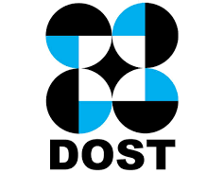  Department of Science and Technology (DOST)

15. Corporate Address and Contact
Corporate address: Springleaf, 57 Zone 2, Maharlika Highway, Alimannao, Penablanca PH 3502
Contact person: Fernando Jaminola Jr.
Email: fjaminola@gmail.com
Mobile: 09566699710

