**ASSIGNMENT - 1**

1.Screenshot of the report view page which appears when power desktop starts.

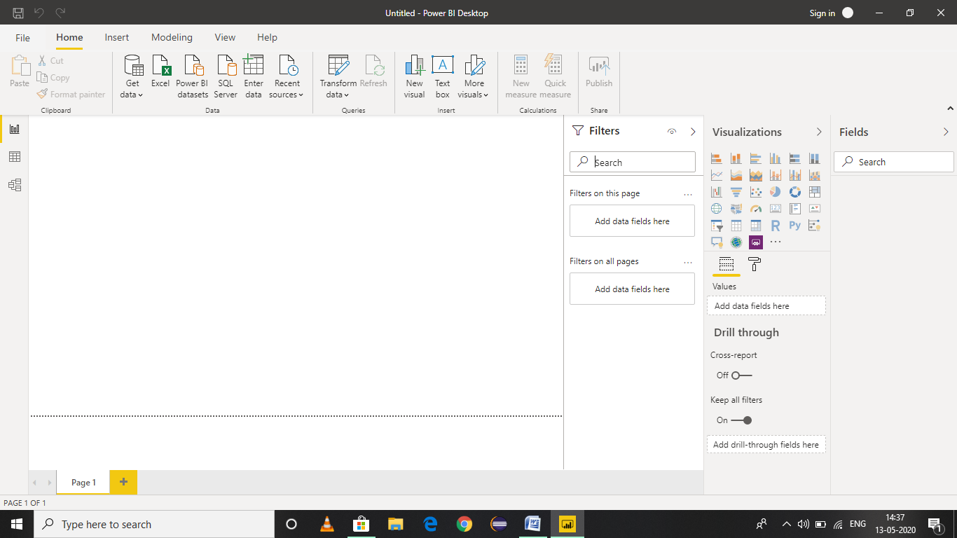

2. Screenshots :

(a) Report View

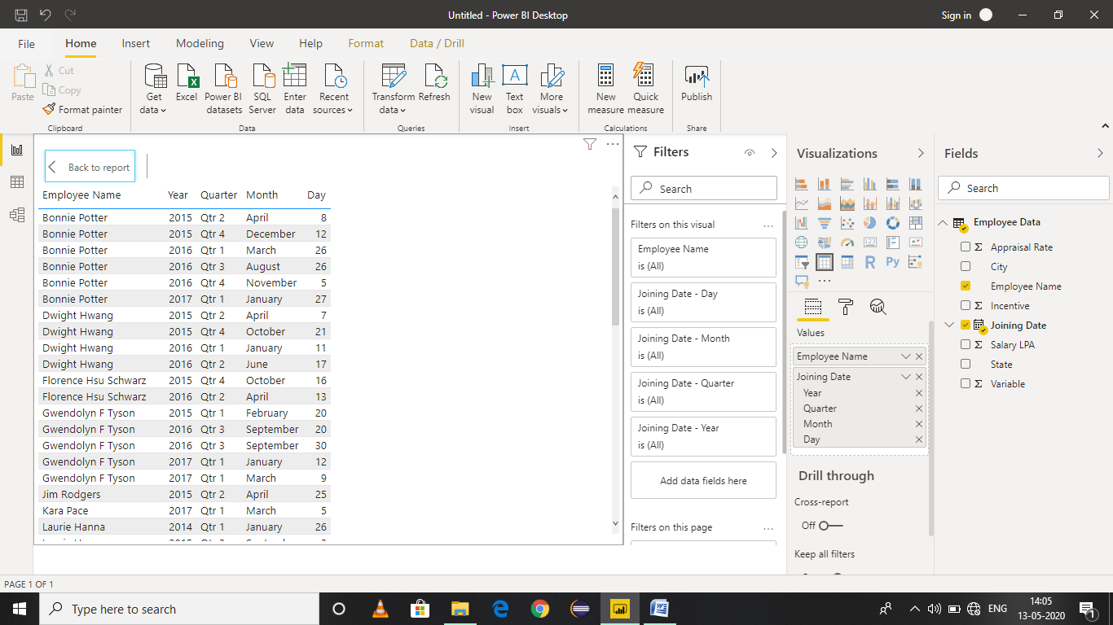

(b) Data View

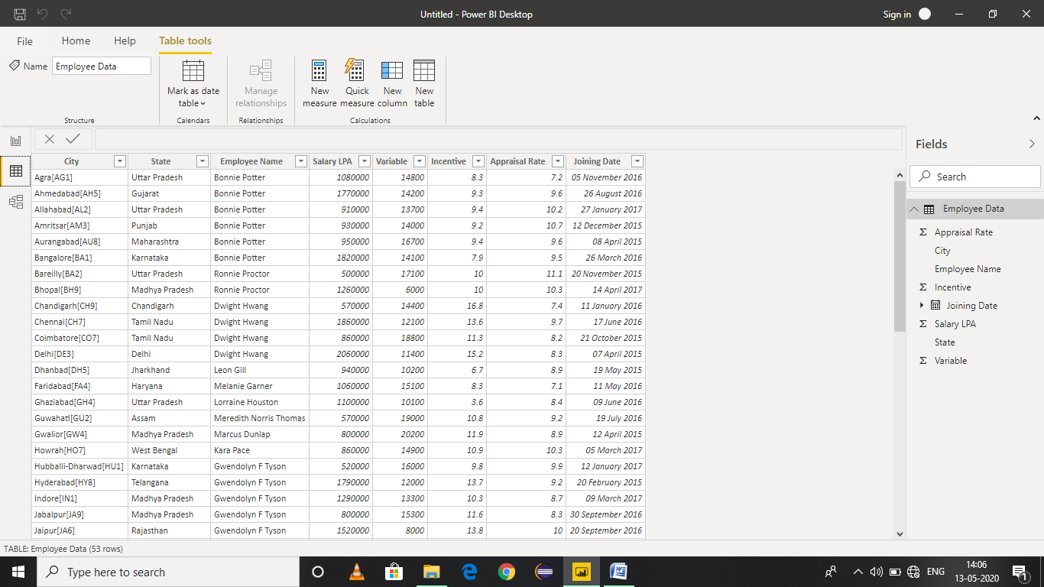

(c) Model View

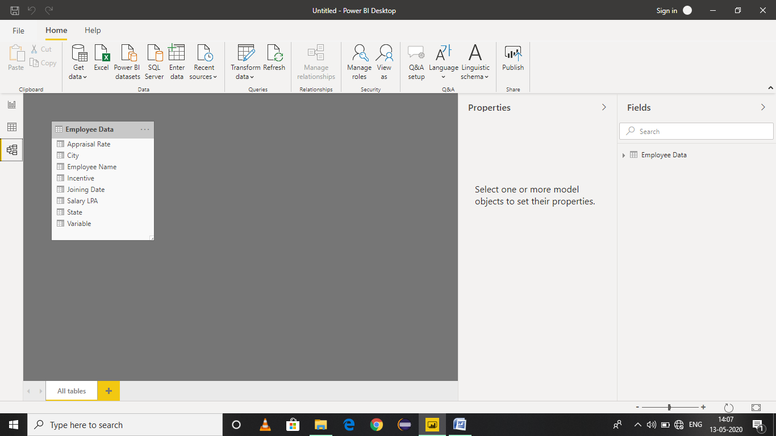

(d) Power Query Editor

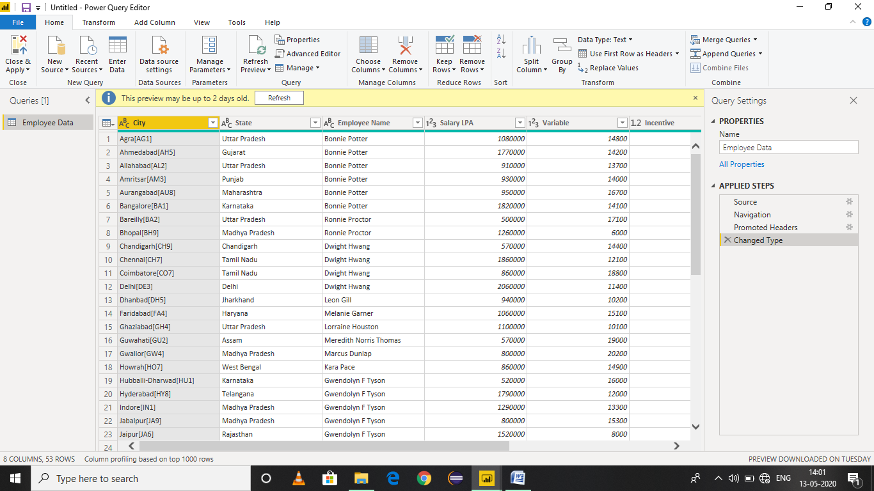

(e) Advance Editor

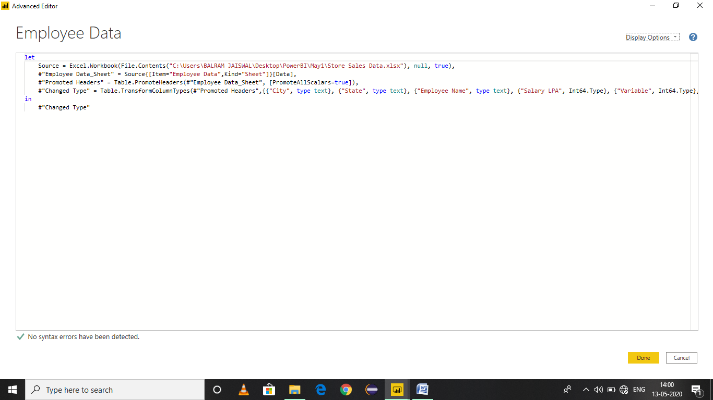

3. Details :

(a) Power BI Desktop:

Power BI Desktop is a free application you install on your local computer that lets you connect to, transform, and visualize your data. With Power BI Desktop, you can connect to multiple different sources of data, and combine them (often called modeling) into a data model. This data model lets you build visuals, and collections of visuals you can share as reports, with other people inside your organization. Most users who work on business intelligence projects use Power BI Desktop to create reports, and then use the Power BI service to share their reports with others.

The most common uses for Power BI Desktop are as follows:

* Connect to data
* Transform and clean that data, to create a data model
* Create visuals, such as charts or graphs, that provide visual representations of the data
* Create reports that are collections of visuals, on one or more report pages
* Share reports with others by using the Power BI service

People most often responsible for such tasks are often considered *data analysts* (sometimes referred to as *analysts*) or business intelligence professionals (often referred to as *report creators*). However, many people who don't consider themselves an analyst or a report creator use Power BI Desktop to create compelling reports, or to pull data from various sources and build data models, which they can share with their coworkers and organizations.

There are three views available in Power BI Desktop, which you select on the left side of the canvas. The views, shown in the order they appear, are as follows:

* **Report**: In this view, you create reports and visuals, where most of your creation time is spent.
* **Data**: In this view, you see the tables, measures, and other data used in the data model associated with your report, and transform the data for best use in the report's model.
* **Model**: In this view, you see and manage the relationships among tables in your data model.

COST : Power BI Desktop is free for individual users, anyone can download it from Microsoft Store.

(b) Power BI Pro :

Power BI Pro is an individual user license that lets users read and interact with reports and dashboards that others have published to the Power BI service. Users with this license type can share content and collaborate with other Power BI Pro users. Only Power BI Pro users can publish or share content with other users or consume content that's created by others, unless a Power BI Premium capacity hosts that content.

COST: The Pro plan costs **$9.99**/user/month. Users can try it a free trial for 60 days before purchasing the subscription.

(c) Power BI Premium :

Power BI Premium is used to get dedicated and enhanced resources for the organization, so users in the organization can use the Power BI service with better performance and responsiveness. For example, with a Power BI Premium subscription organization's users get access to:

* Greater scale and performance
* Flexibility to license by capacity
* Unify self-service and enterprise BI
* Extend on-premises BI with Power BI Report Server
* Support for data residency by region (Multi-Geo)
* Share data with anyone without purchasing a per-user license

COST : The Premium plan starts at $4,995 a month per dedicated cloud compute and storage resource.