**ASSIGNMENT – 2**

1. Connect to the Store Sales Data and do the following:
2. Remove all the blank rows.
3. Update the column header if not updated

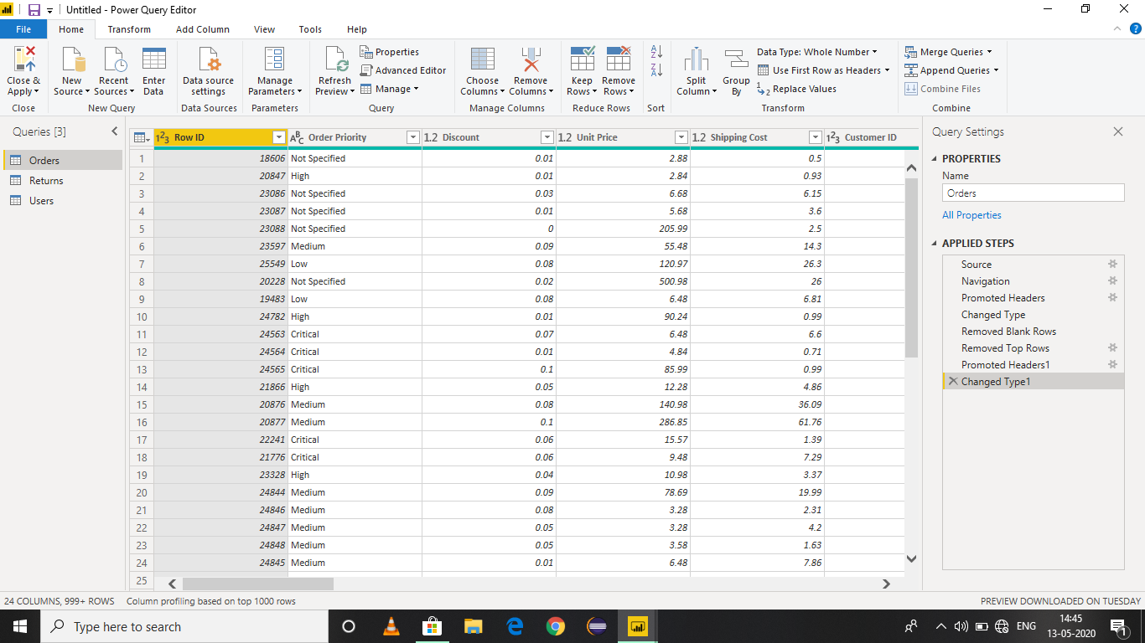

(c)Create a text table and show the sales in terms of

* Customers
* Product Category
* Regions

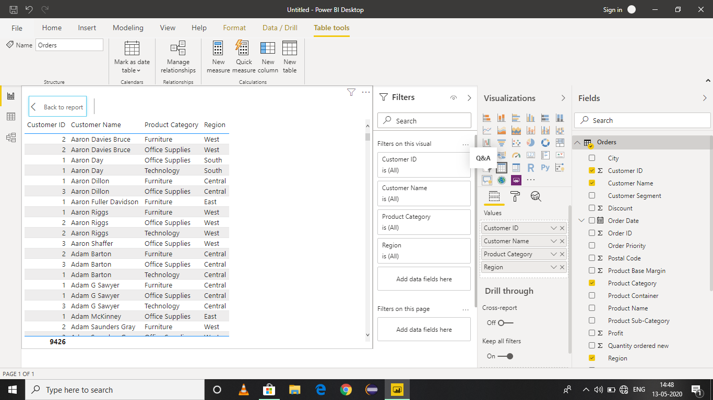

2.Create a line and clustered column chart showing the Sales and Discount as per the State or Province.

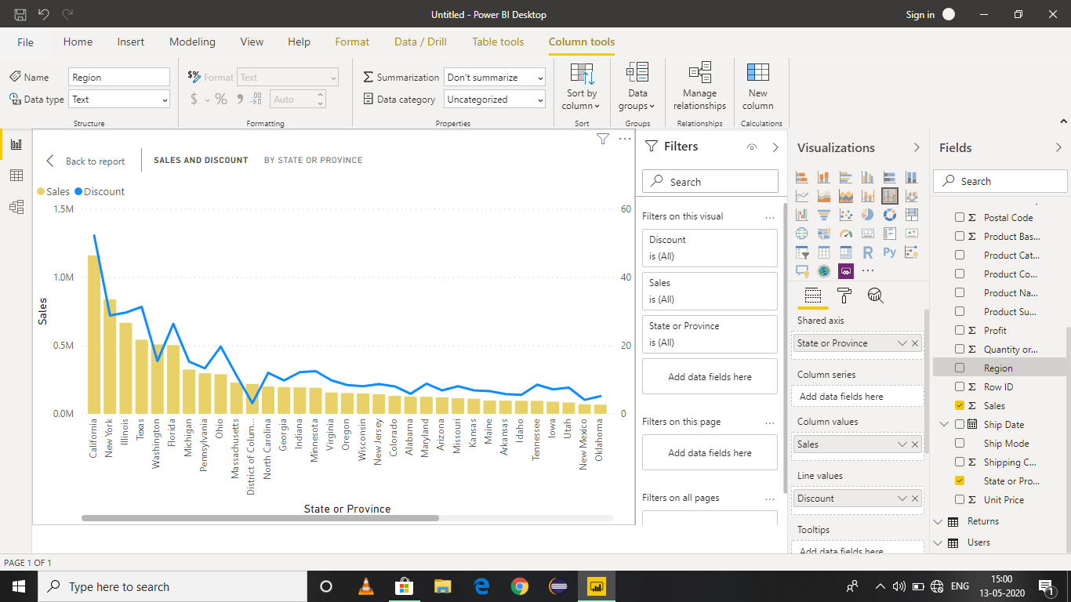

Answer: New York state has the highest sales.

(3) Create a Donut chart showing sales in terms of product category.

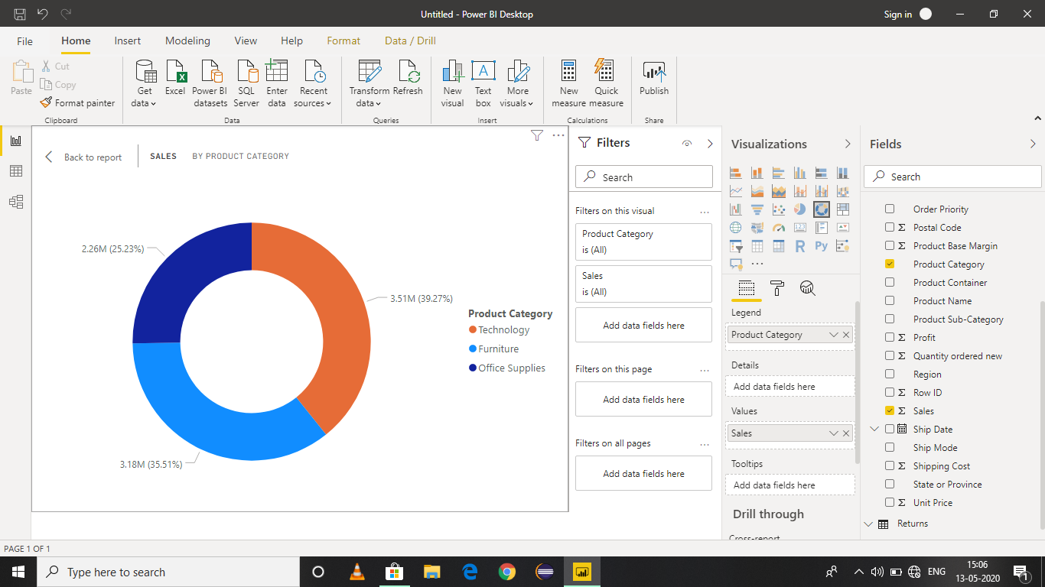

(4) Create a slicer and show the regions in dropdown. See how the visuals mentioned above behaving when a particular region is selected.

Region: Central

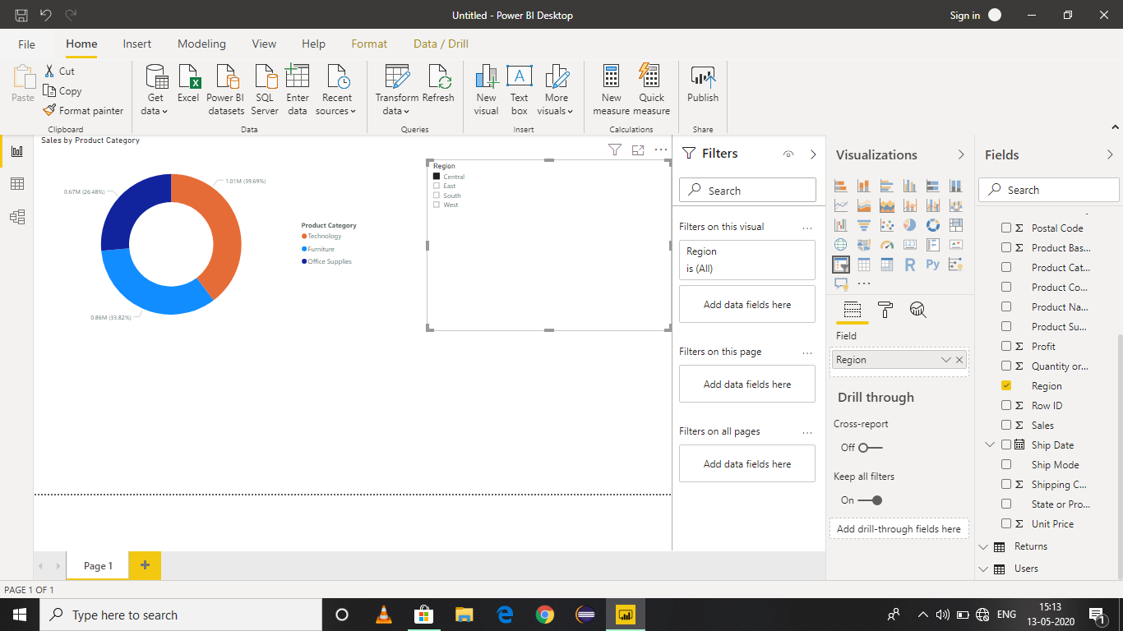

Region : East

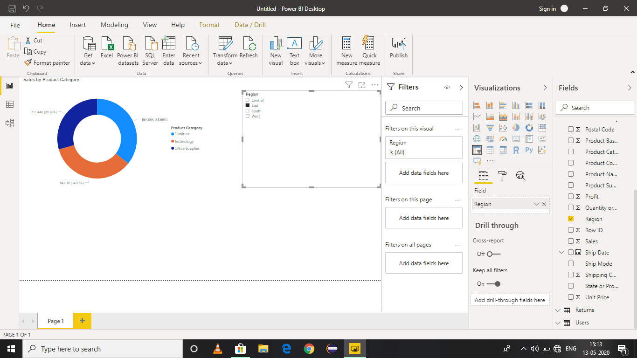

Region : South

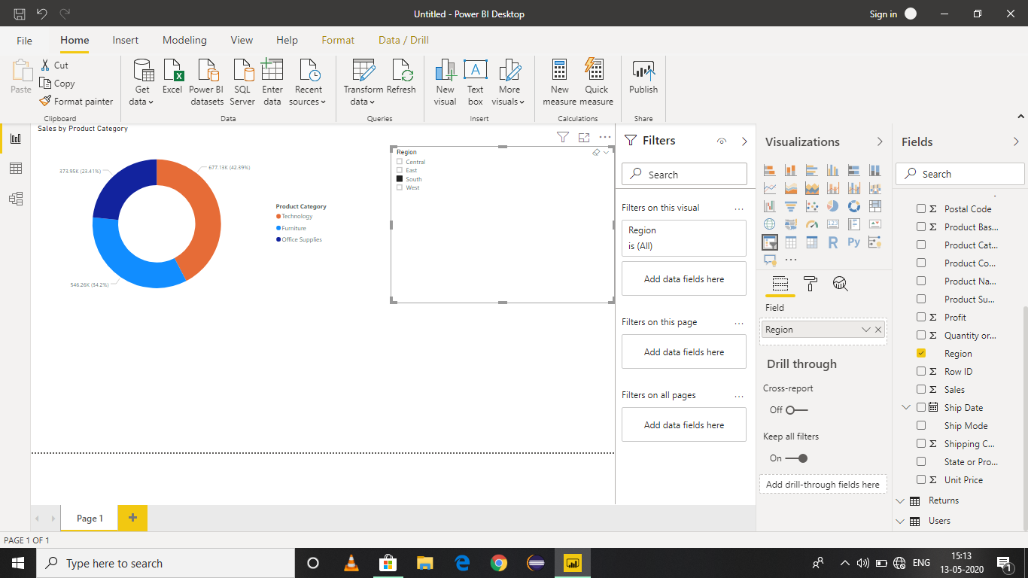

Region : West

