ASSIGNMENT-3

1.Split the column CITY and separate the code associate with each city like.

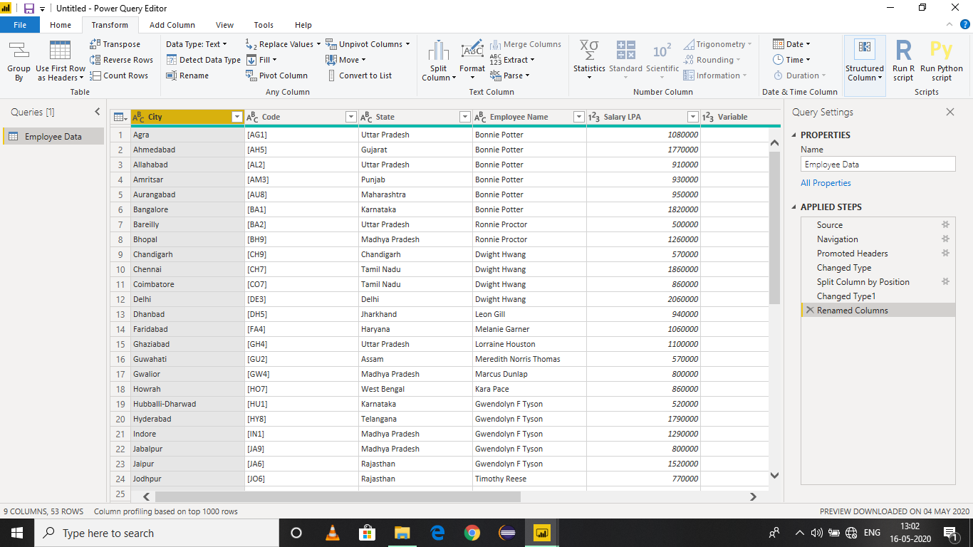

2.Extract the first name from Employee Name and transform the column.

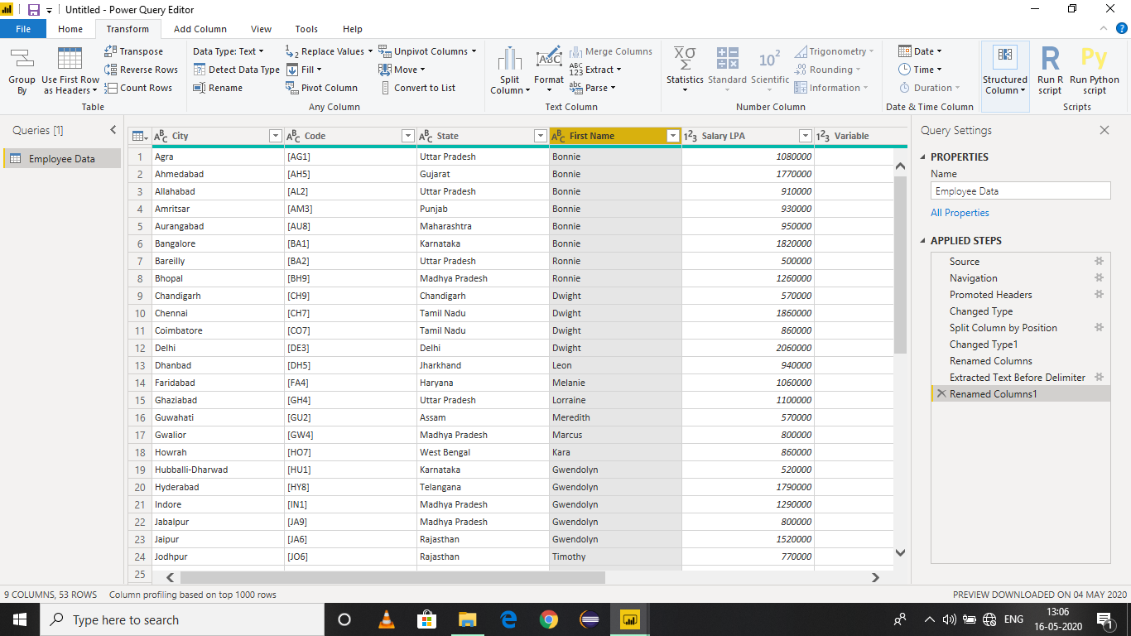

3.Using the joining date column extract the year and no. of date for that month.

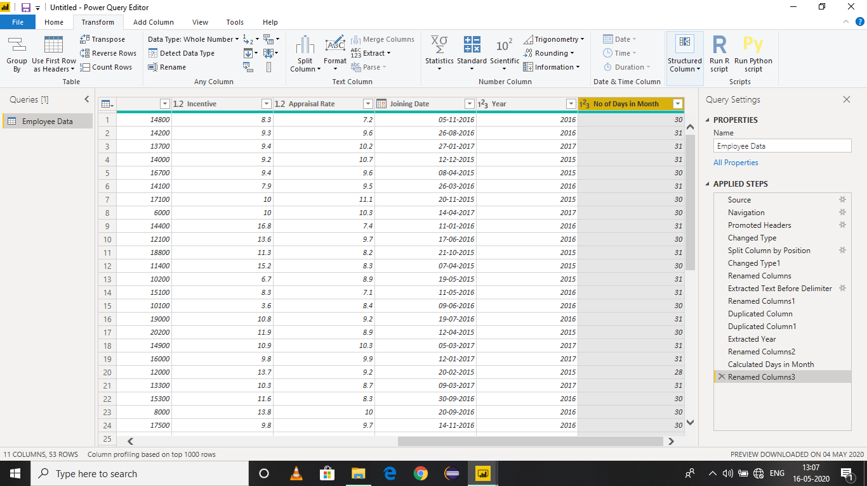

4.Create a visual and show how much salary has been paid to each state and which state has lowest payout.

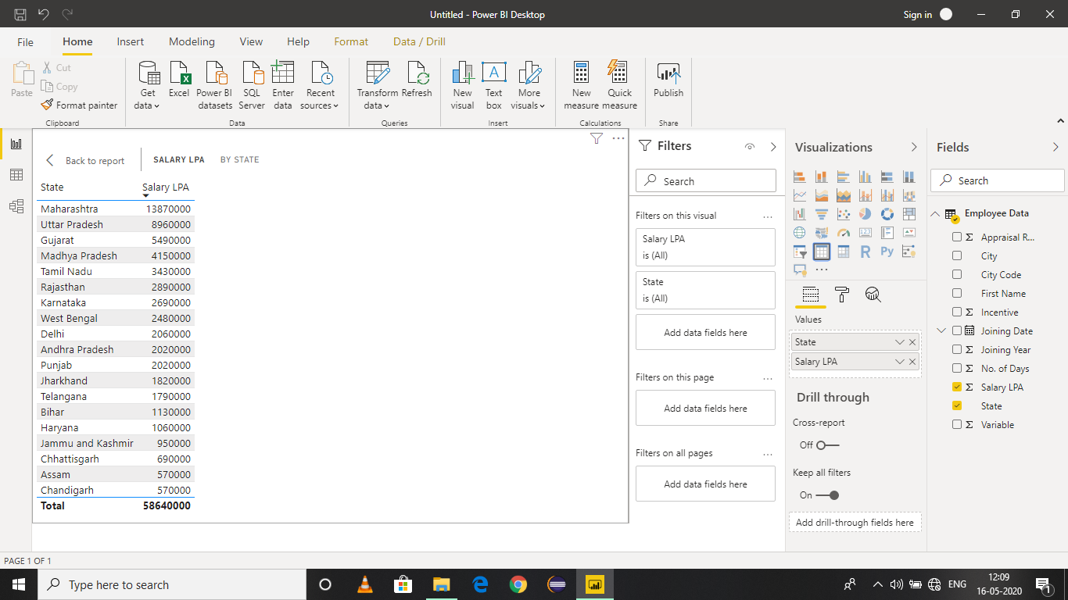

Assam and Chandigarh state has lowest payout.