Oil Price Predictor(In USD)

*WireFrame Documentation*

Login And Registration Page

We have divided Oil Price Predictor Login Page into Two Sections: -

1. First page consists of Register Page For the new user.

* Here User will fill up their email id, password and their username and register for the prediction page.

1. Second page consists of Login Page For the registered user.

* Here User will fill up their email id, password Login to the prediction page where they can able to predict the price of oil (In USD.)

Register Page

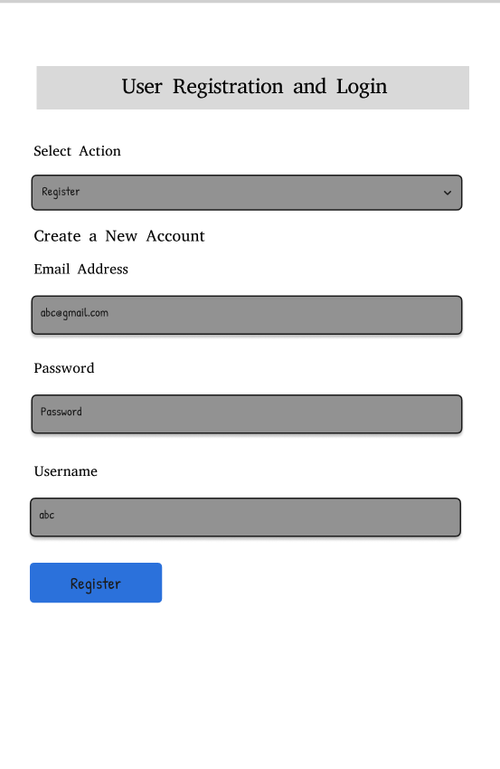

Login Page

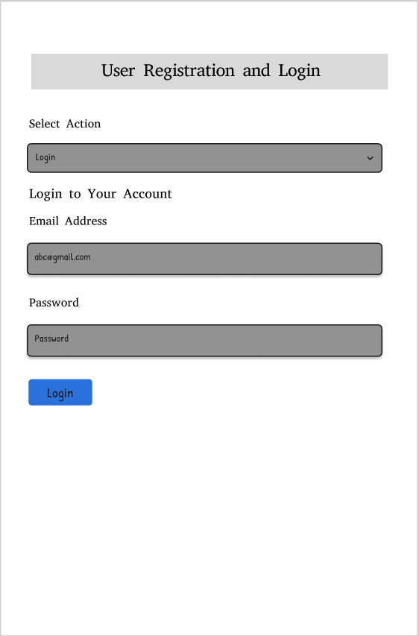

Prediction Page

