**Lab - 1**

**1.Screenshots of functioning web server**

1. Local Server running Screenshot

Local server Web page - http://localhost:8080

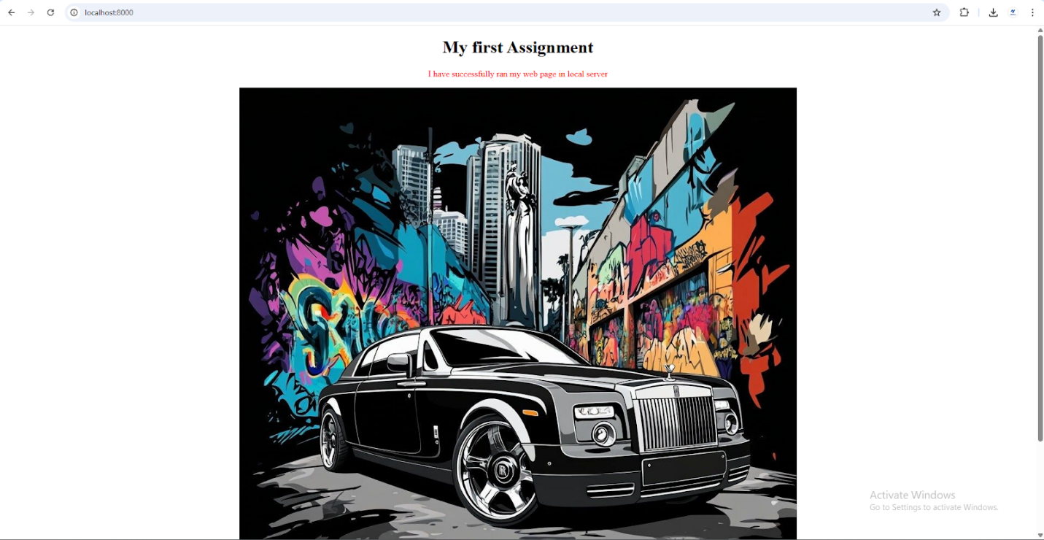

(b) 1. AWS Server running Screenshot

(b) 2. AWS Web Page Screenshot

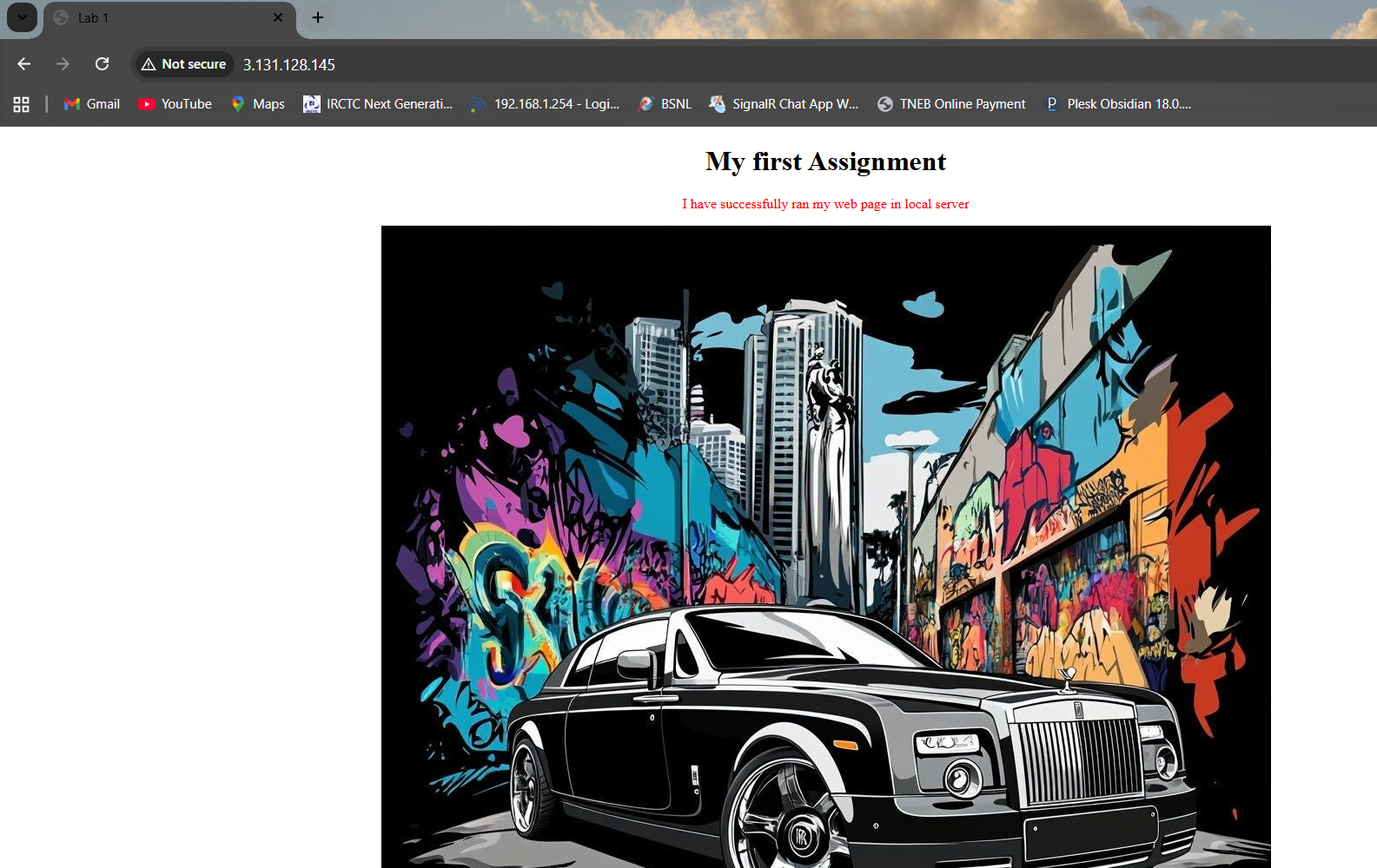

(d) Netlify Server running Screenshot

Netlify web page - https://68bd83537d8b72aa7af8a8a6--cerulean-flan-8b45cb.netlify.app/

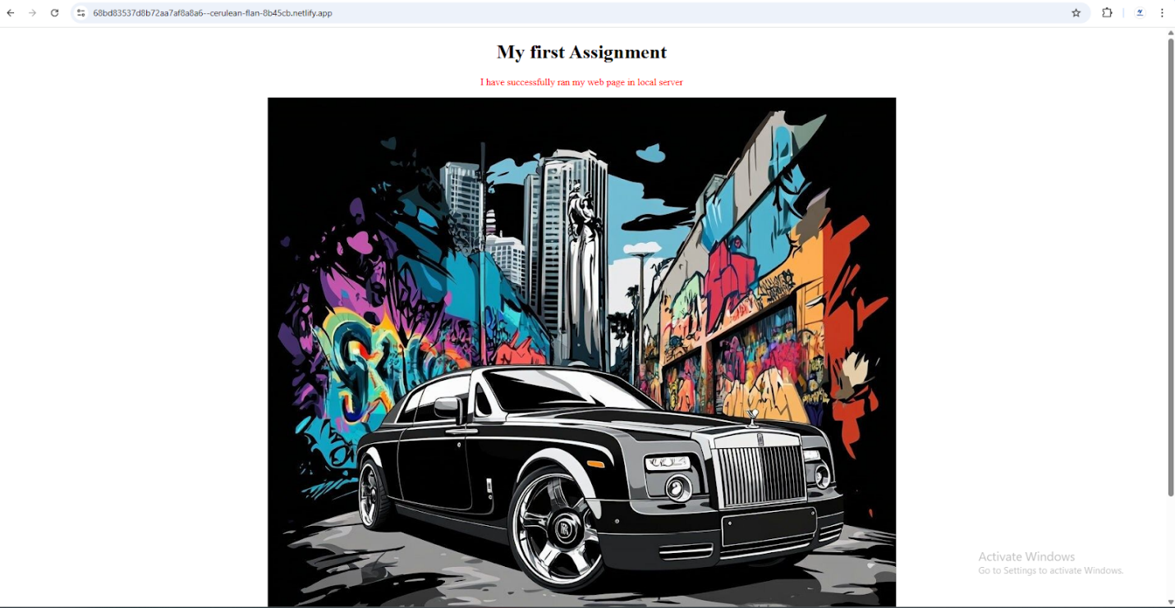

**2. Source Code**

**<!DOCTYPE html>**

**<html lang="en">**

**<head>**

**<meta charset="UTF-8">**

**<meta name="viewport" content="width=device-width, initial-scale=1.0">**

**<title>Lab 1</title>**

**<style>**

**body{**

**text-align: center;**

**}**

**</style>**

**</head>**

**<body>**

**<h1>My first Assignment</h1>**

**<!-- <p style="color: blueviolet;">Lab 1</p> -->**

**<p style="color: red;">I have successfully ran my web page in local server</p>**

**<img src="./rolls_ryoce.jpg" alt="">**

**</body>**

**</html>**

**3. Summarize:**

**Analysis**

Setting up my local webserver worked well and gave me a clear idea of how webpages can be created, served, and viewed through a browser. I created a simple HTML file, ran the server, and successfully viewed my page, which confirmed that my setup was correct. This built my confidence in handling basic hosting tasks. Deploying the webpage to Netlify also went smoothly. Netlify provided an easy and quick way to host my site online, and I was able to generate a live URL almost instantly.

The main challenges I faced were with cloud hosting platforms. On AWS, I managed to deploy my project successfully, but the process was more complex than expected. Configuring security groups, setting permissions, and ensuring the server was accessible required extra effort. It helped me understand the importance of networking rules and proper configuration in cloud environments. Azure, on the other hand, gave me difficulties from the start. I was unable to create a resource group due to verification issues, which blocked my deployment.

In the future, I plan to deepen my knowledge of AWS and Azure, practicing deployments across both platforms to strengthen my skills in real-world hosting