CSA1302-THEORY OF COMPUTATION

Name: V. Sai Krishna
Reg. No. : 192372259

CO3: Construct regular expressions, and use the pumping lemma and closure properties to analyze regular languages.

1 Write a C program to check whether a given string belongs to the language
defined by a Context Free Grammar (CFG)
S → 0A1 A → 0A | 1A | ε

Output:
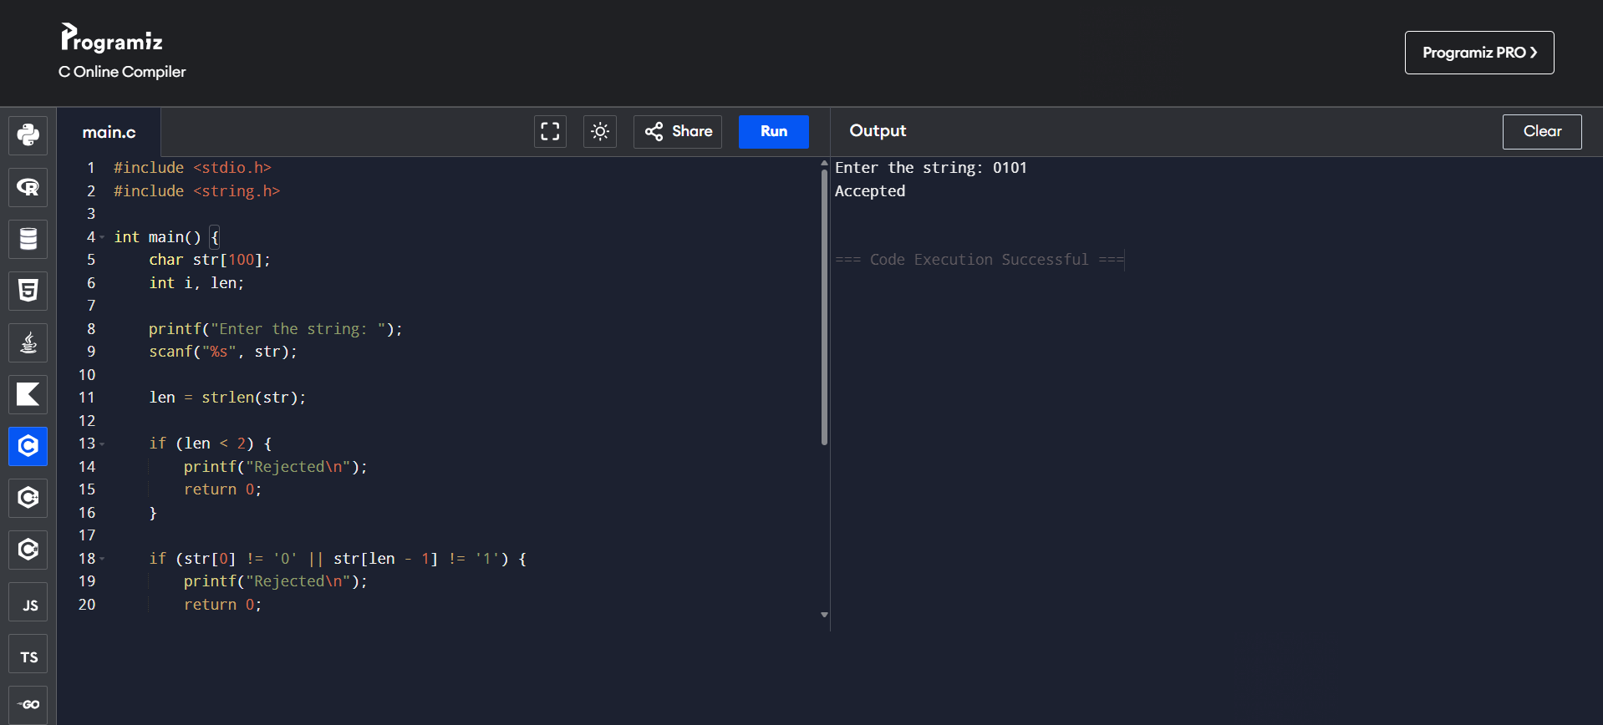

2 Write a C program to check whether a given string belongs to the language
defined by a Context Free Grammar (CFG)
S → 0S0 | 1S1 | 0 | 1 | ε

Output:
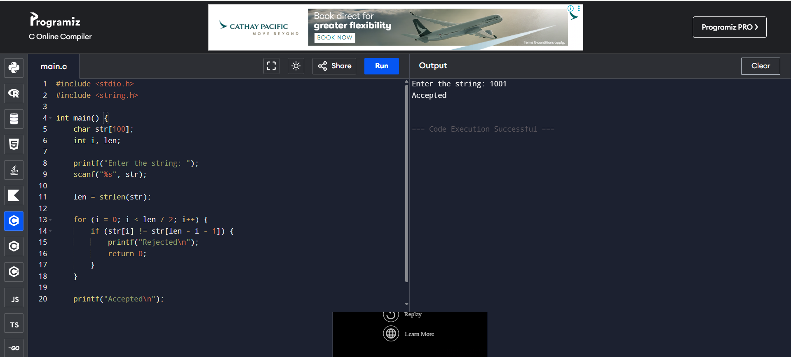

3 Write a C program to check whether a given string belongs to the language
defined by a Context Free Grammar (CFG)
S → 0S0 | A A → 1A | ε

Output:
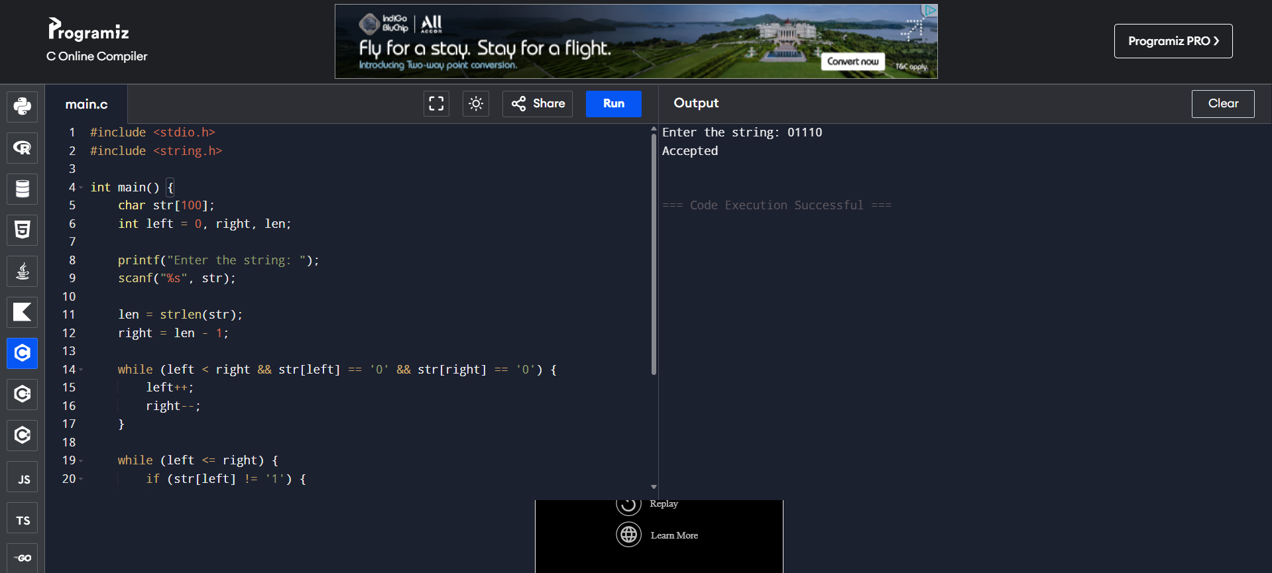
4 Write a C program to check whether a given string belongs to the language
defined by a Context Free Grammar (CFG)
S → 0S1 | ε

Output:
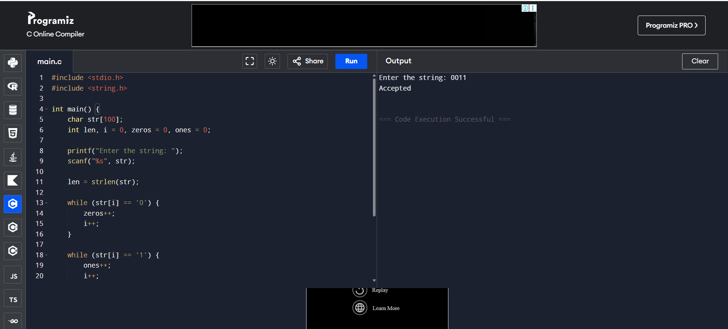

5 Write a C program to check whether a given string belongs to the language
defined by a Context Free Grammar (CFG)
S → A101A A → 0A | 1A | ε

Output:
