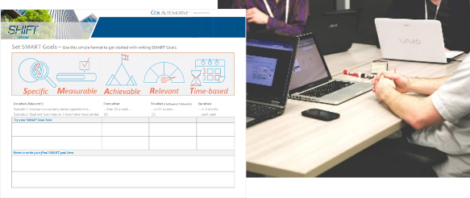

**Connect**

***Your team meeting***

**PREPARE FOR YOUR TEAM MEETING**

1. Write a SMART development goal for yourself for motivating your team.
2. Review the principles you have covered in this module, and the goals you've created so far.
3. Take a look at the SMART goal you wrote for the team in "What will you need to focus on". If you are comfortable with that goal, prepare to share with the team for their feedback and input. Otherwise, draft a team goal for a key outcome your team is responsible for.
4. Make copies of the documents you will be using, enough for each person on your team.

**meet with your team**

1. Hold a meeting with your team of direct reports to share what you've learned about setting goals.
2. Revise your proposed SMART team goal together based on their feedback and suggestions.
3. Ask each to draft an individual SMART goal to prepare for a 1-to-1 with you later this week.

| Journal ***Set Goals Week 4 Day 1 Connect*** DATE:___________________ |
| --- |
|  |
|  |
|  |
|  |
|  |
|  |
|  |
|  |
|  |
|  |
|  |
|  |
|  |
|  |
|  |
|  |
|  |
|  |
|  |
|  |
|  |
|  |
|  |
|  |
|  |
|  |
|  |
|  |
|  |
|  |
| Journal Module: ____________________________ Week #: ____ Day #: ____ DATE:___________________ |
|  |
|  |
|  |
|  |
|  |
|  |
|  |
|  |
|  |
|  |
|  |
|  |
|  |
|  |
|  |
|  |
|  |
|  |
|  |
|  |
|  |
|  |
|  |
|  |
|  |
|  |
|  |
|  |
|  |
|  |

| Journal Module: ____________________________ Week #: ____ Day #: ____ DATE:___________________ |
| --- |
|  |
|  |
|  |
|  |
|  |
|  |
|  |
|  |
|  |
|  |
|  |
|  |
|  |
|  |
|  |
|  |
|  |
|  |
|  |
|  |
|  |
|  |
|  |
|  |
|  |
|  |
|  |
|  |
|  |
|  |

| Journal Module: ____________________________ Week #: ____ Day #: ____ DATE:___________________ |
| --- |
|  |
|  |
|  |
|  |
|  |
|  |
|  |
|  |
|  |
|  |
|  |
|  |
|  |
|  |
|  |
|  |
|  |
|  |
|  |
|  |
|  |
|  |
|  |
|  |
|  |
|  |
|  |
|  |
|  |
|  |

| Journal Module: ____________________________ Week #: ____ Day #: ____ DATE:___________________ |
| --- |
|  |
|  |
|  |
|  |
|  |
|  |
|  |
|  |
|  |
|  |
|  |
|  |
|  |
|  |
|  |
|  |
|  |
|  |
|  |
|  |
|  |
|  |
|  |
|  |
|  |
|  |
|  |
|  |
|  |
|  |