Name____________________________________________________________

Assignment 1: Modeling Metabolic Switches in Glycolysis

Objective
To build a mathematical model of the early stages of glycolysis. You will progress from simple "Mass Action" kinetics to advanced "Hill Kinetics" to understand how enzymes regulate energy flow.

Part 1: Basic Kinetics (Mass Action)
Glycolysis begins with hexokinase converting Glucose into Glucose-6-Phosphate (G6P).
- Reaction: $Glucose+ATP \underset{→}{k} G6P$
- Task: Write the Ordinary Differential Equation (ODE) for the rate of change of Glucose $\frac{d[G]}{dt}$ using the Law of Mass Action.
- Simulation: Plot how glucose depletes over time using a constant rate k.
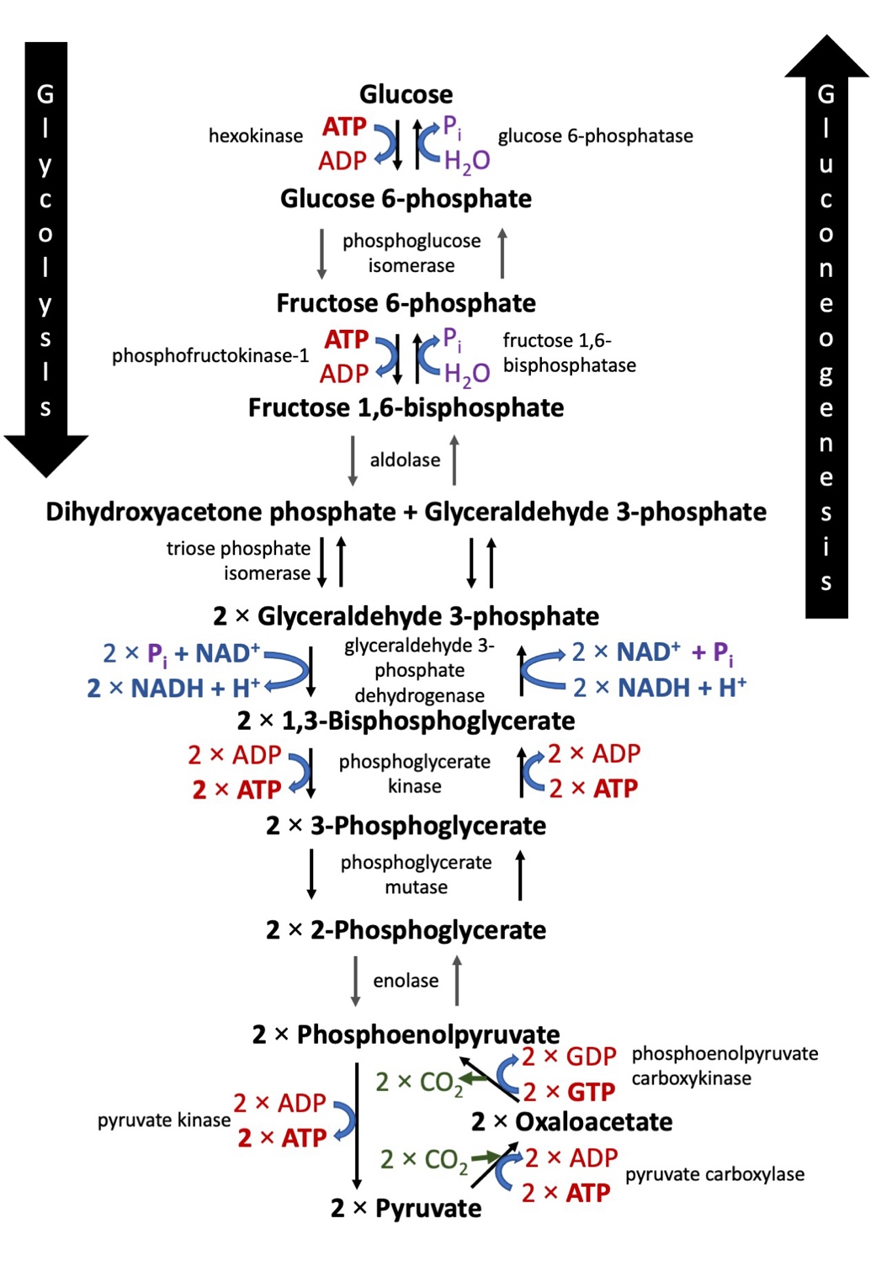
https://upload.wikimedia.org/wikipedia/commons/8/86/Glycolysis%26Gluconeogenesis.jpg
Part 2: Enzyme Saturation (Michaelis-Menten)
In reality, enzymes like hexokinase have a "speed limit." They can only process substrate so fast before they become saturated.
- Task: Replace your Mass Action equation with the Michaelis-Menten formula:
$$V=\frac{V_{max}*[G]}{K_{m}+[G]}$$
- Comparison: Explain what happens to the reaction speed when Glucose concentration is very high ($\left[G\right]≫K_{m})$.
Part 3: Feedback & Cooperativity (The Hill Equation)
Phosphofructokinase (PFK) is the "master switch" of glycolysis. It exhibits cooperativity, meaning the binding of one molecule makes it easier for others to bind.
- Task: Use the Hill Equation to model PFK:
$$V=\frac{V_{max}*{[G]}^{n}}{K^{n}+{[G]}^{n}}$$
- Analysis: In the unit, we saw that the Repressilator requires n > 1 to oscillate. Two scenarios can be tested:
  - n = 1 (No cooperativity)
  - n = 4 (Strong positive cooperativity)
- Observation: How does a higher n change the shape of the Glucose depletion curve? (Hint: Look for a "switch-like" or sigmoidal behavior).

Grade Criteria | Excellent (10 pts) | Satisfactory (7 pts) | Needs Improvement (5 pts)
Mathematical Modeling | All ODEs (Mass Action, MM, Hill) are derived correctly with defined variables. | ODEs are mostly correct but contain minor notation errors. | Equations are missing or incorrectly applied to the reaction.
Computational Implementation | Code runs without errors; plots are clearly labeled and accurately reflect the math. | Notebook runs but plots lack labels or have minor scaling issues. | Code does not run or plots do not reflect the intended models.
Analysis of n (Cooperativity) | Provides a deep explanation of how n > 1 creates a "switch" behavior, referencing the unit materials. | Correctly identifies that n > 1 is faster/steeper but lacks biological context. | Incorrect interpretation of the Hill coefficient.
Parameter Sweeps | Successfully varied K_{m} or V_{max} to show how they affect the system steady state. | Varied parameters but did not clearly explain the result. | No evidence of testing different parameters.

