Test company

Test Report

Example python test

## 2023-08-31

# Test Details

|  |  |
| --- | --- |
| test_module | Example python test |
| relevant_documents | Example test document x Smart Example test document y |
| Description | This is the description of the example test module |
| *version | 1.0 |

# Test Session Summary

|  |  |
| --- | --- |
| Start: Thu Jan 1 01:00:00 1970 End: Wed Jan 11 19:43:13 2023 Duration: 19368 days, 18:43:13.562000  passed: 1 (33.33%) skipped: 0 (0.00%) broken: 0 (0.00%) failed: 2 (66.67%) unknown: 0 (0.00%) |  |

|  |  |
| --- | --- |
| Test case 2 | failed |
| Test case 3 | failed |

|  |  |
| --- | --- |
| Test case 1 | passed |

Test case 2 [ failed ]

|  |  |
| --- | --- |
| Duration | 0ms |
| Preconditions | Something must happen before. |
| Requirements | Requirement 1  Requirement 2 |

## Description

This is the description of test case 2.

## Details

AssertionError: assert 42 == 666

Test case 3 [ failed ]

|  |  |
| --- | --- |
| Duration | 1ms |
| Preconditions | Something must happen before. |
| Requirements | Requirement 1  Requirement 2 |

## Description

This is the description of test case 2.

## Details

AssertionError: assert 42 == 43

## Test Body

[Attachment] something

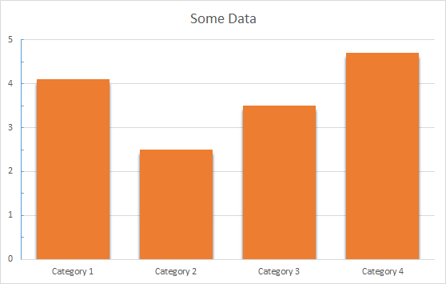

Test case 1 [ passed ]

|  |  |
| --- | --- |
| Duration | 1ms |
| Preconditions | Something must happen before. |
| Requirements | Requirement 1  Requirement 2 |

## Description

This is the description of test case 1.