# **TASK:1(A)**

Implementation of Graph search algorithms (**Breadth first search and Depth First Search**) using following constraints.

**Aim**: To Implement of Graph search algorithms (Breadth first search and Depth First Search) using Python.

**Algorithm:**

BFS

* **Step 1**: Start by putting any one of the graph’s vertices at the back of the queue.
* **Step 2**: Now take the front item of the queue and add it to the visited list.
* **Step 3**: Create a list of that vertex's adjacent nodes. Add those which are not within the visited list to the rear of the queue.
* **Step 4**: Keep continuing steps two and three till the queue is empty.

**Program:**

from collections import deque

def bfs(graph, start):

queue, visited = deque([start]), set()

print("BFS:", end=" ")

while queue:

node = queue.popleft()

if node not in visited:

print(node, end=" ")

visited.add(node)

queue.extend(neighbor for neighbor in graph[node] if neighbor not in visited)

print()

# Example graph

graph = { 'A': ['B', 'C'],

'B': ['A', 'D', 'E'],

'C': ['A', 'F'],

'D': ['B'],

'E': ['B', 'F'],

'F': ['C', 'E']

}

bfs(graph, 'A')

**Output:**



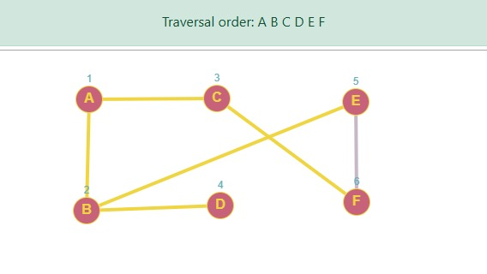

# **TASK:1(B)**

**Algorithm**

DFS –

* **Step 1**: Declare a queue and insert the starting Vertex.
* **Step 2**: Initialize a visited array and mark the starting Vertex as visited.
* **Step 3**: Remove the First vertex of queue.
* **Step 4**: Mark that vertex as visited
* **Step 5**: Insert all the unvisited neighbors of the vertex into queue.
* **Step 6:** stop.

**Program:**

from collections import deque

def dfs(graph, start):

stack = [start]

visited = set()

print("DFS:", end=" ")

while stack:

node = stack.pop()

if node not in visited:

print(node, end=" ")

visited.add(node)

# Add neighbors in reverse to maintain order

stack.extend(reversed([neighbor for neighbor in graph[node] if neighbor not in visited]))

print()

graph = {

'A': ['B', 'C'],

'B': ['A', 'D', 'E'],

'C': ['A', 'F'],

'D': ['B'],

'E': ['B', 'F'],

'F': ['C', 'E']

}

dfs(graph, 'A')

**Ouput:**



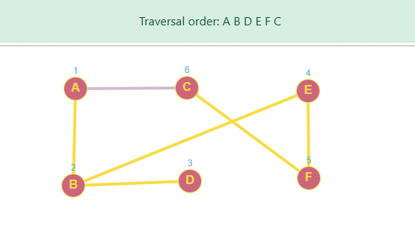

**Result:**

Thus the Implementation of Graph search algorithms (Breadth first search and Depth First Search) using Python was successfully executed and output was verified.