Table 1. Sample Descriptives

|  |  |  |  |  |  |  |  |  |
| --- | --- | --- | --- | --- | --- | --- | --- | --- |
|  | 1993-2003 | | 2004-2015 | |  |  |  |  |
|  | mean | sd | mean | sd |  | min | max | Proportion Missing |
| Depression (CESD) | 1.105 | 1.666 | 1.236 | 1.825 | *** | 0.00 | 8.00 | 0.028 |
| Depression Deviance from Individual Means | -0.066 | 1.207 | 0.041 | 1.199 | *** | -6.22 | 7.18 | 0.028 |
| Retired | 0.464 | 0.499 | 0.653 | 0.476 | *** | 0.00 | 1.00 | 0.002 |
| Unemployed | 0.128 | 0.335 | 0.080 | 0.271 | *** | 0.00 | 1.00 | 0.002 |
| Age | 63.593 | 9.068 | 69.399 | 10.792 | *** | 27.00 | 103.00 | 0.000 |
| Unemployment Rate | 4.996 | 1.116 | 6.546 | 1.929 | *** | 2.20 | 12.20 | 0.003 |
| Unemployment Deviance from Individual Means | -0.766 | 0.947 | 0.483 | 1.761 | *** | -3.83 | 6.42 | 0.003 |
| Mean Wealth | 15.373 | 0.170 | 15.396 | 0.151 | *** | 0.00 | 18.37 | 0.000 |
| Negative Net Worth | 0.019 | 0.136 | 0.038 | 0.191 | *** | 0.00 | 1.00 | 0.000 |
| Log Income | 10.622 | 1.080 | 10.704 | 1.111 | *** | 0.00 | 16.42 | 0.000 |
| Male | 0.403 | 0.491 | 0.414 | 0.492 | ** | 0.00 | 1.00 | 0.000 |
| Married | 0.773 | 0.419 | 0.661 | 0.473 | *** | 0.00 | 1.00 | 0.000 |
| Individuals | 7,501 | | 9,947 | |  |  |  |  |
| Person-Waves | 32,110 | | 51,123 | |  |  |  |  |

Note: * p<.05; ** p< .01; *** p<.001 for differences in means/proportions between periods.

Table 2. Results of Individual Fixed Effect Models on Depressive Symptoms (CESD).

|  |  |  |  |  |  |  |
| --- | --- | --- | --- | --- | --- | --- |
|  | Model 1 | | | Model 2 | | |
| Age | -0.138 | (0.024) | *** | -0.138 | (0.024) | *** |
| Year | 0.150 | (0.024) | *** | 0.150 | (0.024) | *** |
| Log Income | -0.028 | (0.006) | *** | -0.028 | (0.006) | *** |
| Log Wealth | -0.034 | (0.045) |  | -0.034 | (0.045) |  |
| Married | -0.474 | (0.021) | *** | -0.473 | (0.021) | *** |
| Negative Net Worth | 0.206 | (0.034) | *** | 0.205 | (0.034) | *** |
| Unemployment Rate (U/E) | -0.054 | (0.006) | *** | -0.054 | (0.006) | *** |
| Retired | -0.238 | (0.040) | *** | -0.238 | (0.040) | *** |
| Retired x U/E | 0.042 | (0.006) | *** | 0.042 | (0.006) | *** |
| Unemployed | -0.086 | (0.065) |  | -0.086 | (0.065) |  |
| Unemployed x U/E | 0.051 | (0.011) | *** | 0.051 | (0.011) | *** |
| Retired x PGS |  |  |  | 0.027 | (0.039) |  |
| Unemployed x PGS |  |  |  | 0.044 | (0.064) |  |
| Year x PGS |  |  |  | -0.003 | (0.001) | * |
| U/E x PGS |  |  |  | 0.008 | (0.005) |  |
| Unemployed x U/E x PGS |  |  |  | -0.007 | (0.011) |  |
| Retired x U/E x PGS |  |  |  | -0.006 | (0.006) |  |
| R-Squared | 0.016 | | | 0.016 | | |

Note: n= 80,572; * p<.05; ** p< .01; *** p<.001.

Table 3. Results of Individual Fixed Effect GxE Models Over Periods.

|  |  |  |  |  |  |  |
| --- | --- | --- | --- | --- | --- | --- |
|  | 1993- 2003 | | | 2004-2015 | | |
| Age | -0.085 | (0.042) | * | -0.064 | (0.032) | * |
| Retired | -0.106 | (0.090) |  | -0.155 | (0.054) | ** |
| Unemployed | -0.018 | (0.134) |  | -0.059 | (0.092) |  |
| U/E | -0.058 | (0.013) | *** | -0.032 | (0.007) | *** |
| Married | -0.574 | (0.044) | *** | -0.510 | (0.032) | *** |
| Log Wealth | 0.037 | (0.056) |  | -0.098 | (0.092) |  |
| Log Income | -0.041 | (0.010) | *** | -0.018 | (0.008) | * |
| Negative Net Worth | 0.178 | (0.068) | ** | 0.194 | (0.041) | *** |
| Year | 0.113 | (0.042) | ** | 0.075 | (0.032) | * |
| Retired x U/E | 0.021 | (0.017) |  | 0.029 | (0.008) | *** |
| Unemployed x U/E | 0.034 | (0.025) |  | 0.044 | (0.013) | *** |
| U/E x PGS | -0.018 | (0.013) |  | 0.013 | (0.006) | * |
| Retired x PGS | -0.154 | (0.090) | + | 0.030 | (0.053) |  |
| Unemployed x PGS | -0.013 | (0.137) |  | 0.038 | (0.090) |  |
| Retired x U/E x PGS | 0.025 | (0.017) |  | -0.011 | (0.008) |  |
| Unemployed x U/E x PGS | -0.008 | (0.026) |  | -0.006 | (0.013) |  |
| N | 30,850 | | | 49,722 | | |
| R-Squared | 0.021 | | | 0.011 | | |

Note: n= 80,572; + p < 0.1; * p<.05; ** p< .01; *** p<.001.

Figure 1. PGS Quintiles and Proportions with Persistently Elevated Depressive Symptoms.

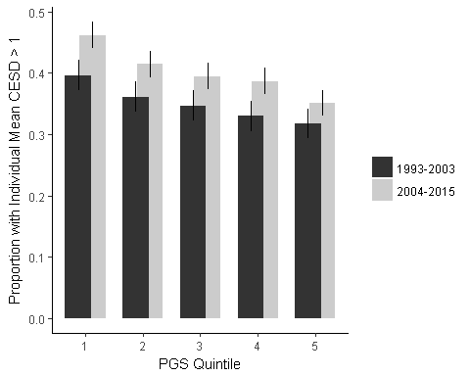

Figure 2. Unemployment Rate over time.

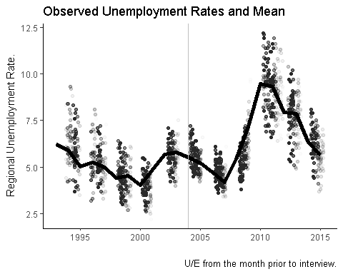

Note: Vertical break indicates earlier and later period.

Figure 3. CESD and Unemployment Rate by PGS Quintile

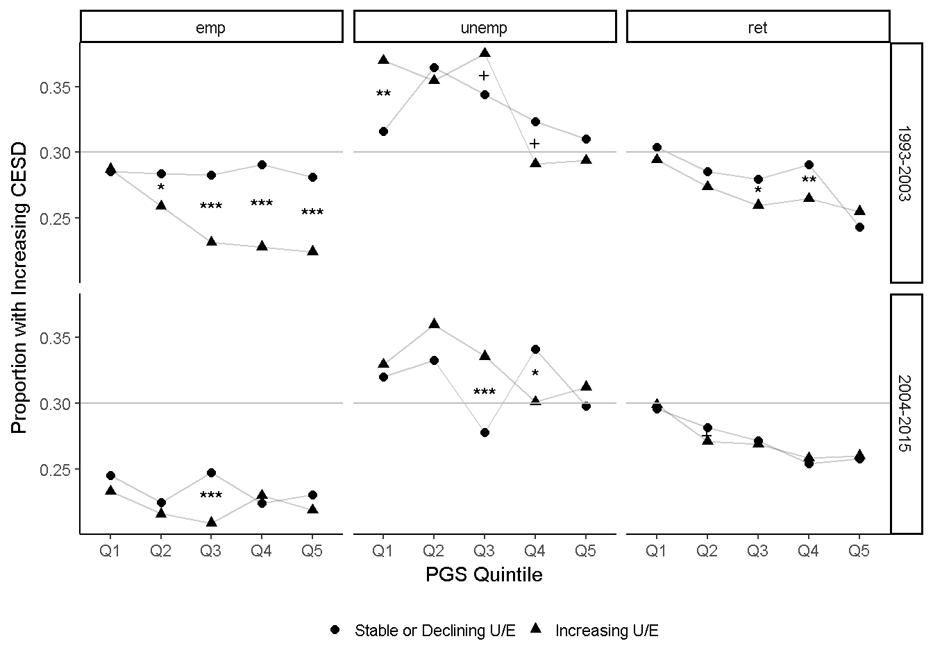

Note: n= 80,572; + p < 0.1; * p<.05; ** p< .01; *** p<.001.

Figure 4.

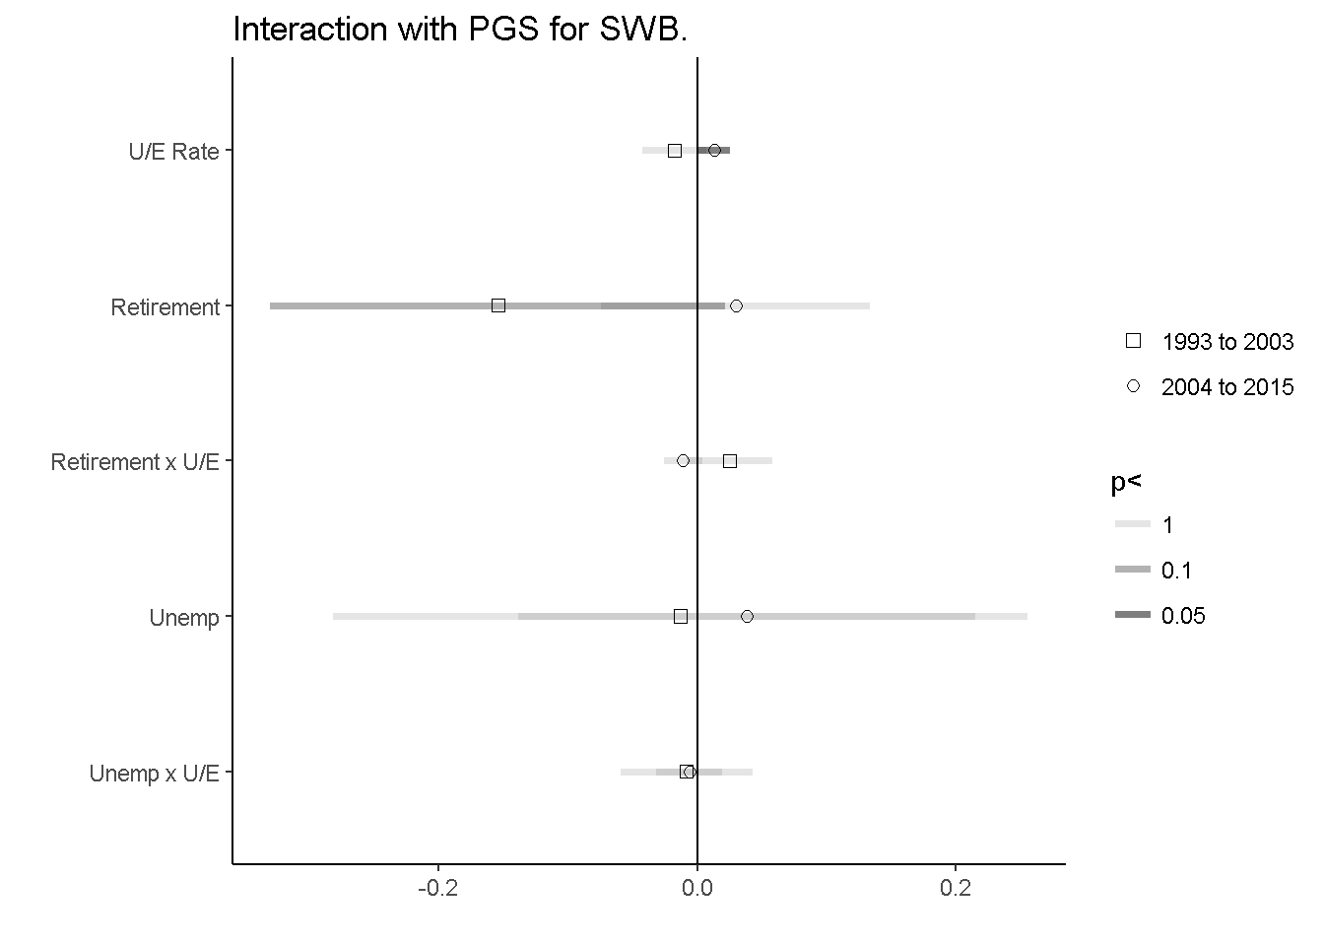

Note: plotted interaction effects of Table 3, along with 95% confidence intervals.

Supplemental

Figure S-1.

