tabfig

Bryce Bartlett

December 21, 2017

Table 1 full descriptives.

## Warning: package 'bindrcpp' was built under R version 3.4.2

c("1993-2003", "2004-2015") Table: c(32110, 51123) Table: c(7501, 9947)

|  |  |  |  |  |  |  |  |  |
| --- | --- | --- | --- | --- | --- | --- | --- | --- |
|  | mean | sd | mean | sd | pval | min | max | propmiss |
| cesd | 1.105 | 1.666 | 1.236 | 1.825 | *** | 0.00 | 8.00 | 0.028 |
| md_cesd | -0.066 | 1.207 | 0.041 | 1.199 | *** | -6.22 | 7.18 | 0.028 |
| ret | 0.464 | 0.499 | 0.653 | 0.476 | *** | 0.00 | 1.00 | 0.002 |
| unemp | 0.128 | 0.335 | 0.080 | 0.271 | *** | 0.00 | 1.00 | 0.002 |
| age | 63.593 | 9.068 | 69.399 | 10.792 | *** | 27.00 | 103.00 | 0.000 |
| pm_uer | 4.996 | 1.116 | 6.546 | 1.929 | *** | 2.20 | 12.20 | 0.003 |
| md_uer | -0.766 | 0.947 | 0.483 | 1.761 | *** | -3.83 | 6.42 | 0.003 |
| lnwlth | 15.373 | 0.170 | 15.396 | 0.151 | *** | 0.00 | 18.37 | 0.000 |
| negwlth | 0.019 | 0.136 | 0.038 | 0.191 | *** | 0.00 | 1.00 | 0.000 |
| lninc | 10.622 | 1.080 | 10.704 | 1.111 | *** | 0.00 | 16.42 | 0.000 |
| male | 0.403 | 0.491 | 0.414 | 0.492 | ** | 0.00 | 1.00 | 0.000 |
| marr | 0.773 | 0.419 | 0.661 | 0.473 | *** | 0.00 | 1.00 | 0.000 |

## Individual level descriptives

n=9947

|  |  |  |  |  |  |
| --- | --- | --- | --- | --- | --- |
|  | mean | sd | min | max | propmiss |
| male | 0.422 | 0.494 | 0.00 | 1.00 | 0 |
| nwave | 8.368 | 2.654 | 1.00 | 11.00 | 0 |
| icesd | 1.241 | 1.370 | 0.00 | 8.00 | 0 |
| pgs.swb | 0.000 | 1.000 | -3.43 | 3.45 | 0 |
| iuer | 6.102 | 1.019 | 3.79 | 11.70 | 0 |
| ret | 0.537 | 0.368 | 0.00 | 1.00 | 0 |
| unemp | 0.101 | 0.209 | 0.00 | 1.00 | 0 |
| dead | 0.099 | 0.299 | 0.00 | 1.00 | 0 |

Figure 1. PGS Quintiles and ICESD.

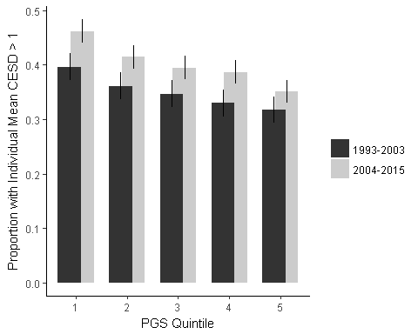

Figure 2. Unemployment Rate over time.

## Warning: Removed 218 rows containing non-finite values (stat_summary).

## Warning: Removed 218 rows containing missing values (geom_point).

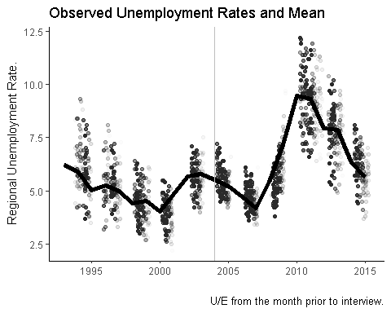

Figure 3. CESD and Unemployment Rate by PGS Quintile

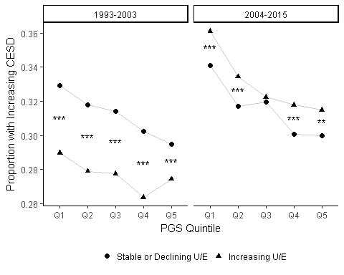

Table __. Results of environment and interaction models.

ee = mktab(plm.e); ee$eff=row.names(ee)  
be = mktab(plm.gxe); be$eff = row.names(be)  
  
bm = data.frame(eff=ee$eff)  
bm = merge(bm,ee,all=TRUE)  
kable(merge(bm,be,by='eff',all=TRUE))

|  |  |  |  |  |  |  |
| --- | --- | --- | --- | --- | --- | --- |
| eff | Estimate.x | se.x | sig.x | Estimate.y | se.y | sig.y |
| age | -0.138 | (0.024) | *** | -0.138 | (0.024) | *** |
| iwendy | 0.150 | (0.024) | *** | 0.150 | (0.024) | *** |
| lninc | -0.028 | (0.006) | *** | -0.028 | (0.006) | *** |
| lnwlth | -0.034 | (0.045) |  | -0.034 | (0.045) |  |
| marr | -0.474 | (0.021) | *** | -0.473 | (0.021) | *** |
| negwlth | 0.206 | (0.034) | *** | 0.205 | (0.034) | *** |
| pm_uer | -0.054 | (0.006) | *** | -0.054 | (0.006) | *** |
| ret | -0.238 | (0.040) | *** | -0.238 | (0.040) | *** |
| ret:pm_uer | 0.042 | (0.006) | *** | 0.042 | (0.006) | *** |
| unemp | -0.086 | (0.065) |  | -0.086 | (0.065) |  |
| unemp:pm_uer | 0.051 | (0.011) | *** | 0.051 | (0.011) | *** |
| ret:pgs.swb | NA | NA | NA | 0.027 | (0.039) |  |
| unemp:pgs.swb | NA | NA | NA | 0.044 | (0.064) |  |
| iwendy:pgs.swb | NA | NA | NA | -0.003 | (0.001) | * |
| pm_uer:pgs.swb | NA | NA | NA | 0.008 | (0.005) |  |
| unemp:pm_uer:pgs.swb | NA | NA | NA | -0.007 | (0.011) |  |
| ret:pm_uer:pgs.swb | NA | NA | NA | -0.006 | (0.006) |  |

Table __. Results of Cross-year interaction models.

|  |  |  |  |  |  |  |
| --- | --- | --- | --- | --- | --- | --- |
|  | 1993-2003.Estimate | 1993-2003.se | 1993-2003.sig | 2004-2015.Estimate | 2004-2015.se | 2004-2015.sig |
| age | -0.085 | (0.042) | * | -0.064 | (0.032) | * |
| ret | -0.106 | (0.090) |  | -0.155 | (0.054) | ** |
| unemp | -0.018 | (0.134) |  | -0.059 | (0.092) |  |
| pm_uer | -0.058 | (0.013) | *** | -0.032 | (0.007) | *** |
| marr | -0.574 | (0.044) | *** | -0.510 | (0.032) | *** |
| lnwlth | 0.037 | (0.056) |  | -0.098 | (0.092) |  |
| lninc | -0.041 | (0.010) | *** | -0.018 | (0.008) | * |
| negwlth | 0.178 | (0.068) | ** | 0.194 | (0.041) | *** |
| iwendy | 0.113 | (0.042) | ** | 0.075 | (0.032) | * |
| ret:pm_uer | 0.021 | (0.017) |  | 0.029 | (0.008) | *** |
| unemp:pm_uer | 0.034 | (0.025) |  | 0.044 | (0.013) | *** |
| pm_uer:pgs.swb | -0.018 | (0.013) |  | 0.013 | (0.006) | * |
| ret:pgs.swb | -0.154 | (0.090) | + | 0.030 | (0.053) |  |
| unemp:pgs.swb | -0.013 | (0.137) |  | 0.038 | (0.090) |  |
| ret:pm_uer:pgs.swb | 0.025 | (0.017) |  | -0.011 | (0.008) |  |
| unemp:pm_uer:pgs.swb | -0.008 | (0.026) |  | -0.006 | (0.013) |  |

Results figure.

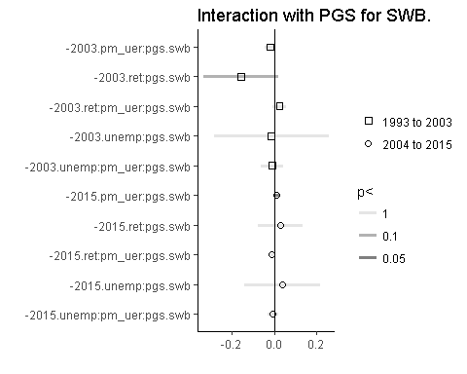

## Some supplemental stuff.

First difference model (because the u/e rate is dependent on the last level, i.e. not random).

fd.gxe <- plm(cesd ~ pm_uer*(ret + unemp)+  
 (pm_uer*(ret + unemp)):pgs.swb, data=analyze,   
 index=c("hhidpn", "iwendy"),   
 na.action=na.omit, model="fd")

## These series are constants and have been removed: raracem, has_pgs, iwstat, black.x, orace, greatmod, version, black.y

summary(fd.gxe)

## Oneway (individual) effect First-Difference Model  
##   
## Call:  
## plm(formula = cesd ~ pm_uer * (ret + unemp) + (pm_uer * (ret +   
## unemp)):pgs.swb, data = analyze, na.action = na.omit, model = "fd",   
## index = c("hhidpn", "iwendy"))  
##   
## Unbalanced Panel: n=9947, T=1-11, N=80600  
## Observations used in estimation: 70653  
##   
## Residuals :  
## Min. 1st Qu. Median 3rd Qu. Max.   
## -8.2255 -0.8736 -0.0461 0.9306 8.1159   
##   
## Coefficients :  
## Estimate Std. Error t-value Pr(>|t|)   
## (intercept) 0.04353 0.00647 6.73 0.000000000017 ***  
## pm_uer -0.02210 0.00614 -3.60 0.00032 ***  
## ret -0.02276 0.04540 -0.50 0.61625   
## unemp 0.04415 0.06913 0.64 0.52306   
## pm_uer:ret 0.01485 0.00712 2.08 0.03714 *   
## pm_uer:unemp 0.02970 0.01103 2.69 0.00708 **   
## pm_uer:pgs.swb 0.00599 0.00602 0.99 0.32043   
## ret:pgs.swb -0.01824 0.04511 -0.40 0.68590   
## unemp:pgs.swb -0.02221 0.06887 -0.32 0.74711   
## pm_uer:ret:pgs.swb -0.00354 0.00705 -0.50 0.61542   
## pm_uer:unemp:pgs.swb 0.00130 0.01095 0.12 0.90564   
## ---  
## Signif. codes: 0 '***' 0.001 '**' 0.01 '*' 0.05 '.' 0.1 ' ' 1  
##   
## Total Sum of Squares: 201000  
## Residual Sum of Squares: 201000  
## R-Squared: 0.00132  
## Adj. R-Squared: 0.00118  
## F-statistic: 9.36445 on 10 and 70642 DF, p-value: 0.00000000000000104

fd.gxe2 <- lapply(split(analyze,analyze[,'period']), function(x)  
 plm(cesd ~ pm_uer + pm_uer:pgs.swb, data=x,   
 index=c("hhidpn", "iwendy"),   
 na.action=na.omit, model="fd"))

## These series are constants and have been removed: raracem, has_pgs, iwstat, black.x, orace, greatmod, recession, period, version, black.y  
## These series are constants and have been removed: raracem, has_pgs, iwstat, black.x, orace, greatmod, period, version, black.y

lapply(fd.gxe2,summary)

## $`1993-2003`  
## Oneway (individual) effect First-Difference Model  
##   
## Call:  
## plm(formula = cesd ~ pm_uer + pm_uer:pgs.swb, data = x, na.action = na.omit,   
## model = "fd", index = c("hhidpn", "iwendy"))  
##   
## Unbalanced Panel: n=7386, T=1-5, N=31065  
## Observations used in estimation: 23679  
##   
## Residuals :  
## Min. 1st Qu. Median 3rd Qu. Max.   
## -8.1065 -0.9617 -0.0793 0.8969 8.0270   
##   
## Coefficients :  
## Estimate Std. Error t-value Pr(>|t|)   
## (intercept) 0.07281 0.01083 6.73 0.000000000018 ***  
## pm_uer -0.03367 0.00922 -3.65 0.00026 ***  
## pm_uer:pgs.swb -0.01195 0.00921 -1.30 0.19424   
## ---  
## Signif. codes: 0 '***' 0.001 '**' 0.01 '*' 0.05 '.' 0.1 ' ' 1  
##   
## Total Sum of Squares: 65600  
## Residual Sum of Squares: 65600  
## R-Squared: 0.000642  
## Adj. R-Squared: 0.000557  
## F-statistic: 7.60094 on 2 and 23676 DF, p-value: 0.000501  
##   
## $`2004-2015`  
## Oneway (individual) effect First-Difference Model  
##   
## Call:  
## plm(formula = cesd ~ pm_uer + pm_uer:pgs.swb, data = x, na.action = na.omit,   
## model = "fd", index = c("hhidpn", "iwendy"))  
##   
## Unbalanced Panel: n=9946, T=1-6, N=49726  
## Observations used in estimation: 39780  
##   
## Residuals :  
## Min. 1st Qu. Median 3rd Qu. Max.   
## -8.0724 -0.9697 -0.0469 0.9382 7.9870   
##   
## Coefficients :  
## Estimate Std. Error t-value Pr(>|t|)   
## (intercept) 0.04628 0.00854 5.42 0.00000006 ***  
## pm_uer -0.00578 0.00378 -1.53 0.13   
## pm_uer:pgs.swb 0.00614 0.00379 1.62 0.11   
## ---  
## Signif. codes: 0 '***' 0.001 '**' 0.01 '*' 0.05 '.' 0.1 ' ' 1  
##   
## Total Sum of Squares: 115000  
## Residual Sum of Squares: 115000  
## R-Squared: 0.000124  
## Adj. R-Squared: 0.000074  
## F-statistic: 2.47213 on 2 and 39777 DF, p-value: 0.0844

## Pooled dummy first difference model

Note that results below display the same associtions with a reduced model; using a first-difference model eliminates 10,000 observations and statistical significance.

fd.gxe <- plm(cesd ~ (pm_uer + pm_uer:pgs.swb + lnwlth + lninc + negwlth + marr + unemp + ret)*period, data=analyze,   
 index=c("hhidpn",'iwendy'),   
 na.action=na.omit, model="within")

## These series are constants and have been removed: raracem, has_pgs, iwstat, black.x, orace, greatmod, version, black.y

summary(fd.gxe)

## Oneway (individual) effect Within Model  
##   
## Call:  
## plm(formula = cesd ~ (pm_uer + pm_uer:pgs.swb + lnwlth + lninc +   
## negwlth + marr + unemp + ret) * period, data = analyze, na.action = na.omit,   
## model = "within", index = c("hhidpn", "iwendy"))  
##   
## Unbalanced Panel: n=9947, T=1-11, N=80572  
##   
## Residuals :  
## Min. 1st Qu. Median 3rd Qu. Max.   
## -5.896 -0.562 -0.124 0.397 7.227   
##   
## Coefficients :  
## Estimate Std. Error t-value  
## pm_uer -0.05194 0.00742 -7.00  
## lnwlth 0.04580 0.05182 0.88  
## lninc -0.01797 0.00889 -2.02  
## negwlth 0.19465 0.06043 3.22  
## marr -0.62214 0.02675 -23.25  
## unemp 0.18296 0.02898 6.31  
## ret -0.03753 0.01993 -1.88  
## period2004-2015 1.95176 1.03888 1.88  
## pm_uer:pgs.swb 0.00929 0.00406 2.29  
## pm_uer:period2004-2015 0.04751 0.00788 6.03  
## lnwlth:period2004-2015 -0.14576 0.06964 -2.09  
## lninc:period2004-2015 -0.01115 0.01091 -1.02  
## negwlth:period2004-2015 0.01754 0.06917 0.25  
## marr:period2004-2015 0.16768 0.02507 6.69  
## unemp:period2004-2015 0.09748 0.03769 2.59  
## ret:period2004-2015 0.16497 0.02573 6.41  
## pm_uer:pgs.swb:period2004-2015 -0.00755 0.00204 -3.69  
## Pr(>|t|)   
## pm_uer 0.0000000000025 ***  
## lnwlth 0.37683   
## lninc 0.04324 *   
## negwlth 0.00128 **   
## marr < 0.0000000000000002 ***  
## unemp 0.0000000002746 ***  
## ret 0.05971 .   
## period2004-2015 0.06029 .   
## pm_uer:pgs.swb 0.02204 *   
## pm_uer:period2004-2015 0.0000000016491 ***  
## lnwlth:period2004-2015 0.03634 *   
## lninc:period2004-2015 0.30690   
## negwlth:period2004-2015 0.79981   
## marr:period2004-2015 0.0000000000228 ***  
## unemp:period2004-2015 0.00971 **   
## ret:period2004-2015 0.0000000001444 ***  
## pm_uer:pgs.swb:period2004-2015 0.00022 ***  
## ---  
## Signif. codes: 0 '***' 0.001 '**' 0.01 '*' 0.05 '.' 0.1 ' ' 1  
##   
## Total Sum of Squares: 116000  
## Residual Sum of Squares: 115000  
## R-Squared: 0.0156  
## Adj. R-Squared: -0.123  
## F-statistic: 65.8096 on 17 and 70608 DF, p-value: <0.0000000000000002

## Factor based analysis with plm.

summary(  
 plm(cesd~age + (ret + unemp)*pm_uer + marr + iwendy +  
 (ret+unemp)*pm_uer + lninc+lnwlth+negwlth +  
 (pm_uer + (ret+unemp)*pm_uer):pgs.quart5,  
 index='hhidpn',model='within',data=analyze)  
)

## These series are constants and have been removed: raracem, has_pgs, iwstat, black.x, orace, greatmod, version, black.y

## Oneway (individual) effect Within Model  
##   
## Call:  
## plm(formula = cesd ~ age + (ret + unemp) * pm_uer + marr + iwendy +   
## (ret + unemp) * pm_uer + lninc + lnwlth + negwlth + (pm_uer +   
## (ret + unemp) * pm_uer):pgs.quart5, data = analyze, model = "within",   
## index = "hhidpn")  
##   
## Unbalanced Panel: n=9946, T=1-11, N=80569  
##   
## Residuals :  
## Min. 1st Qu. Median 3rd Qu. Max.   
## -5.931 -0.563 -0.123 0.397 7.117   
##   
## Coefficients :  
## Estimate Std. Error t-value  
## age -0.137430 0.024310 -5.65  
## ret -0.173524 0.088141 -1.97  
## unemp 0.010168 0.140960 0.07  
## pm_uer -0.049939 0.012419 -4.02  
## marr -0.474726 0.020961 -22.65  
## iwendy 0.149268 0.024193 6.17  
## lninc -0.028320 0.006173 -4.59  
## lnwlth -0.034170 0.045324 -0.75  
## negwlth 0.207563 0.033715 6.16  
## ret:pm_uer 0.040162 0.014556 2.76  
## unemp:pm_uer 0.033573 0.023320 1.44  
## pm_uer:pgs.quart5(-0.83,-0.251] -0.011340 0.017423 -0.65  
## pm_uer:pgs.quart5(-0.251,0.26] -0.004133 0.017236 -0.24  
## pm_uer:pgs.quart5(0.26,0.835] -0.011899 0.017496 -0.68  
## pm_uer:pgs.quart5(0.835,3.45] 0.005256 0.017140 0.31  
## ret:pgs.quart5(-0.83,-0.251] -0.086411 0.124077 -0.70  
## ret:pgs.quart5(-0.251,0.26] -0.065801 0.123775 -0.53  
## ret:pgs.quart5(0.26,0.835] -0.108736 0.124347 -0.87  
## ret:pgs.quart5(0.835,3.45] -0.069007 0.123497 -0.56  
## unemp:pgs.quart5(-0.83,-0.251] -0.460172 0.202273 -2.28  
## unemp:pgs.quart5(-0.251,0.26] 0.058849 0.198634 0.30  
## unemp:pgs.quart5(0.26,0.835] -0.145959 0.203376 -0.72  
## unemp:pgs.quart5(0.835,3.45] 0.058959 0.206028 0.29  
## ret:pm_uer:pgs.quart5(-0.83,-0.251] 0.008493 0.020443 0.42  
## ret:pm_uer:pgs.quart5(-0.251,0.26] -0.004158 0.020357 -0.20  
## ret:pm_uer:pgs.quart5(0.26,0.835] 0.004211 0.020538 0.21  
## ret:pm_uer:pgs.quart5(0.835,3.45] -0.000469 0.020266 -0.02  
## unemp:pm_uer:pgs.quart5(-0.83,-0.251] 0.075887 0.033470 2.27  
## unemp:pm_uer:pgs.quart5(-0.251,0.26] 0.010179 0.032906 0.31  
## unemp:pm_uer:pgs.quart5(0.26,0.835] 0.011626 0.033830 0.34  
## unemp:pm_uer:pgs.quart5(0.835,3.45] -0.009935 0.034129 -0.29  
## Pr(>|t|)   
## age 0.00000001581 ***  
## ret 0.0490 *   
## unemp 0.9425   
## pm_uer 0.00005793980 ***  
## marr < 0.0000000000000002 ***  
## iwendy 0.00000000069 ***  
## lninc 0.00000448197 ***  
## lnwlth 0.4509   
## negwlth 0.00000000075 ***  
## ret:pm_uer 0.0058 **   
## unemp:pm_uer 0.1500   
## pm_uer:pgs.quart5(-0.83,-0.251] 0.5151   
## pm_uer:pgs.quart5(-0.251,0.26] 0.8105   
## pm_uer:pgs.quart5(0.26,0.835] 0.4964   
## pm_uer:pgs.quart5(0.835,3.45] 0.7591   
## ret:pgs.quart5(-0.83,-0.251] 0.4862   
## ret:pgs.quart5(-0.251,0.26] 0.5950   
## ret:pgs.quart5(0.26,0.835] 0.3819   
## ret:pgs.quart5(0.835,3.45] 0.5763   
## unemp:pgs.quart5(-0.83,-0.251] 0.0229 *   
## unemp:pgs.quart5(-0.251,0.26] 0.7670   
## unemp:pgs.quart5(0.26,0.835] 0.4730   
## unemp:pgs.quart5(0.835,3.45] 0.7748   
## ret:pm_uer:pgs.quart5(-0.83,-0.251] 0.6778   
## ret:pm_uer:pgs.quart5(-0.251,0.26] 0.8381   
## ret:pm_uer:pgs.quart5(0.26,0.835] 0.8376   
## ret:pm_uer:pgs.quart5(0.835,3.45] 0.9815   
## unemp:pm_uer:pgs.quart5(-0.83,-0.251] 0.0234 *   
## unemp:pm_uer:pgs.quart5(-0.251,0.26] 0.7571   
## unemp:pm_uer:pgs.quart5(0.26,0.835] 0.7311   
## unemp:pm_uer:pgs.quart5(0.835,3.45] 0.7710   
## ---  
## Signif. codes: 0 '***' 0.001 '**' 0.01 '*' 0.05 '.' 0.1 ' ' 1  
##   
## Total Sum of Squares: 116000  
## Residual Sum of Squares: 114000  
## R-Squared: 0.0166  
## Adj. R-Squared: -0.122  
## F-statistic: 38.5131 on 31 and 70592 DF, p-value: <0.0000000000000002

Evidence of increasing uncertainty in retirement.

## `geom_smooth()` using method = 'gam'

## Warning: Removed 380308 rows containing non-finite values (stat_smooth).

## `geom_smooth()` using method = 'gam'

## Warning: Removed 398387 rows containing non-finite values (stat_smooth).

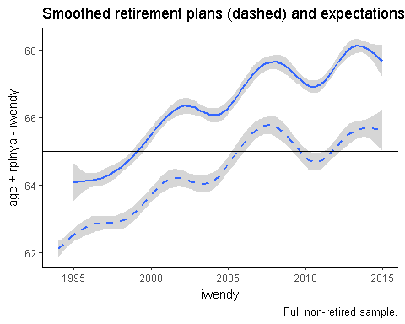

ggplot(cleandat,aes(x=iwendy,y=work65,  
 color=factor(ret),group=factor(ret))) +  
 geom_smooth() +  
 geom_smooth(aes(y=work62),lty=2) +  
 theme_classic() + geom_abline(slope=0,intercept=65) +  
 labs(title='Subjective probability for working past 62 (dashed) and 65.',  
 caption='Full sample.')

## `geom_smooth()` using method = 'gam'

## Warning: Removed 331846 rows containing non-finite values (stat_smooth).

## `geom_smooth()` using method = 'gam'

## Warning: Removed 344320 rows containing non-finite values (stat_smooth).

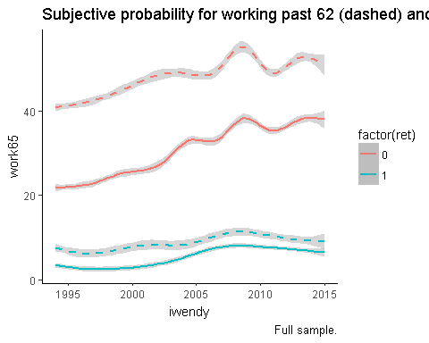

analyze = analyze %>%   
 mutate(rage = rplnya - iwendy + age)  
  
summary(  
 plm(cesd~age + pm_uer + marr + iwendy +   
 lninc+lnwlth+negwlth + rage +   
 pm_uer:pgs.quart,  
 index='hhidpn',model='within',  
 data=analyze )  
)

## These series are constants and have been removed: raracem, has_pgs, iwstat, black.x, orace, greatmod, version, black.y

## Oneway (individual) effect Within Model  
##   
## Call:  
## plm(formula = cesd ~ age + pm_uer + marr + iwendy + lninc + lnwlth +   
## negwlth + rage + pm_uer:pgs.quart, data = analyze, model = "within",   
## index = "hhidpn")  
##   
## Unbalanced Panel: n=5260, T=1-10, N=14194  
##   
## Residuals :  
## Min. 1st Qu. Median 3rd Qu. Max.   
## -4.93241 -0.34031 -0.00133 0.12212 6.17346   
##   
## Coefficients :  
## Estimate Std. Error t-value Pr(>|t|)  
## age -0.07663 0.06533 -1.17 0.2408  
## pm_uer -0.01643 0.01589 -1.03 0.3011  
## marr -0.37509 0.06499 -5.77 0.0000000081  
## iwendy 0.06928 0.06536 1.06 0.2892  
## lninc -0.01077 0.02030 -0.53 0.5956  
## lnwlth 0.24602 0.21766 1.13 0.2584  
## negwlth 0.24486 0.07653 3.20 0.0014  
## rage -0.00358 0.00378 -0.95 0.3432  
## pm_uer:pgs.quart(-0.669,0.00951] -0.01465 0.02125 -0.69 0.4906  
## pm_uer:pgs.quart(0.00951,0.674] -0.00238 0.02063 -0.12 0.9081  
## pm_uer:pgs.quart(0.674,3.45] -0.01582 0.02088 -0.76 0.4486  
##   
## age   
## pm_uer   
## marr ***  
## iwendy   
## lninc   
## lnwlth   
## negwlth **   
## rage   
## pm_uer:pgs.quart(-0.669,0.00951]   
## pm_uer:pgs.quart(0.00951,0.674]   
## pm_uer:pgs.quart(0.674,3.45]   
## ---  
## Signif. codes: 0 '***' 0.001 '**' 0.01 '*' 0.05 '.' 0.1 ' ' 1  
##   
## Total Sum of Squares: 11900  
## Residual Sum of Squares: 11800  
## R-Squared: 0.00749  
## Adj. R-Squared: -0.579  
## F-statistic: 6.12374 on 11 and 8923 DF, p-value: 0.000000000425

No appreciable differneces in survival (by quartile)

print(survplot)

