**Computer Components:**

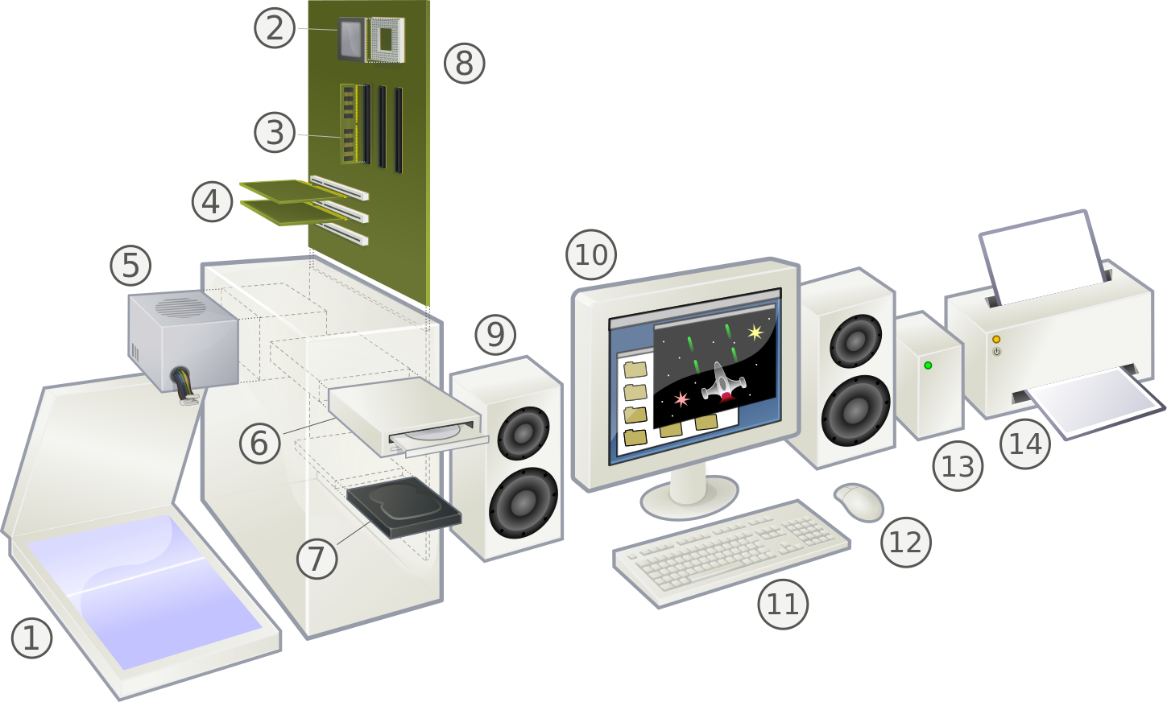

**(1) Scanner:** An input device that can convert the contents of a paper document into a digital image that can be stored in the computer.

**(2) CPU** **(Central Processing Unit)** or **the processor:** The "brain" of the computer where programs are run. It is one of the most expensive parts of the hardware. Modern CPUs can perform multiple tasks simultaneously.

**(3) RAM** **(Random Access Memory):** The computer's high-speed, short-term memory. It temporarily stores data and instructions for programs that run on the computer.

**(4) Expansion Cards:** Circuit boards that can be inserted to add functionality to a computer system (for example: network, sound, or video cards).

**(5) Power Supply**: Converts electricity from the wall into the form that the other computer components use.

**(6) Optical Drive**: An input/output device that reads data from and writes data to CDs and DVDs.

**(7) Hard Drive:** An input/output device that serves as the long-term storage memory of the computer. There are two primary kinds: mechanical drives that use a mechanical arm to read and write data on a rotating disk, and "solid state" drives that have no moving parts.

**(8) Motherboard**: A circuit board that holds and connects various components of the computer and allows their communication.

**(9) Speaker**: An input/output device that outputs sound from the computer.

**(10) Monitor:** An input/output device that displays information visually. Generally, monitors are output devices where the computer visually displays information. *Touchscreens* combine the functions of output and input.

**(11) Keyboard**: An input device on which the user can type to communicate with the computer.

**(12) Mouse**: An input device that allows the user to interact with visual objects displayed on the monitor.

**(13) External Hard Drive**: An input/output device that serves as an extra hard drive used for additional or backup storage.

**(14) Printer**: An output device that can transfer digital data onto paper.