**Computer Components:**

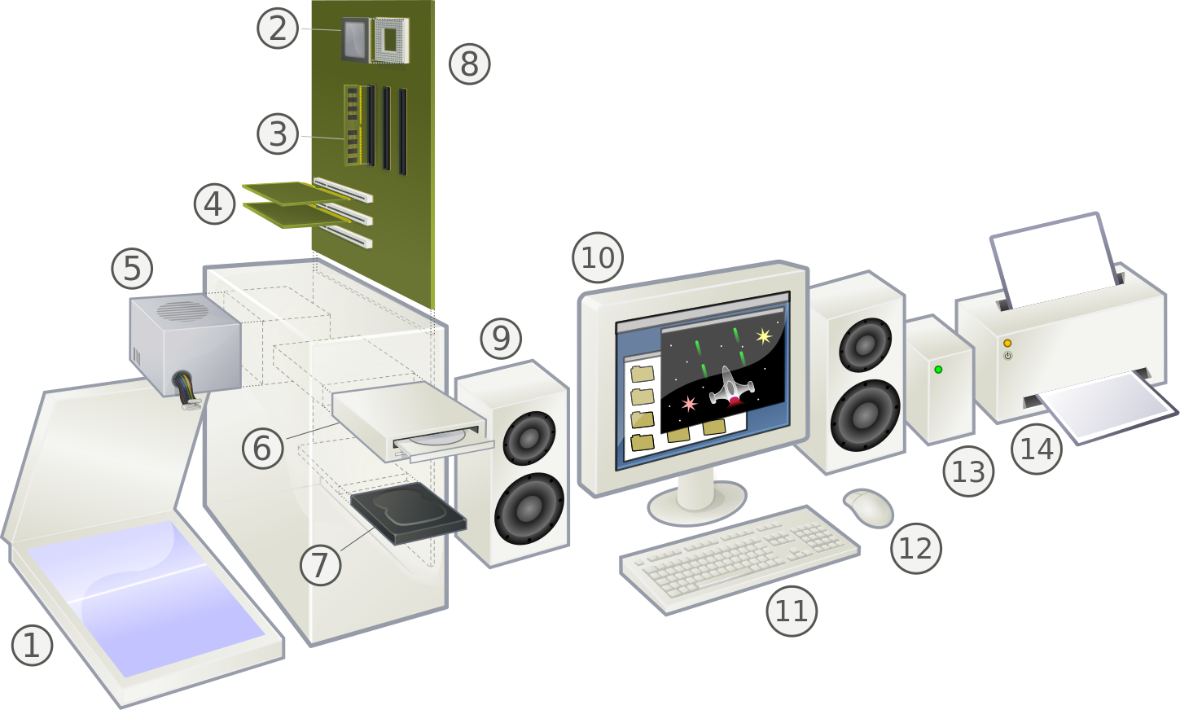

**(1) Scanner:** An input device that can optically scan an image, a writing etc. and convert it to a digital image that can be stored in the computer.

**(2) CPU:**(Central Processing Unit) A microprocessor chip which is the brain of the computer where all computing is done. Best CPU's can simultaneously perform multiple tasks. It is one of the most expensive parts of the hardware. Its speed is measured in gigahertz (GHz).

**(3) RAM:** (Random Access Memory) Computer's short-term memory. It temporarily stores data and instructions for programs that run on the computer. Its capacity is measured in gigabytes (GB) and its speed is measured in megahertz (MHz).

**(4) Expansion cards:** A circuit board that can be inserted to add functionality to a computer system.

**(5) Power supply unit**: It provides access to electricity which is the energy lifeline for all the components.

**(6) Optical Disc Drive**: Input/output device capable of reading data from and writing data to CDs and DVDs.

**(7) Hard Drive:** Long term memory of the computer. It has a rotating disk platter under a mechanical arm for reading and writing data to the drive. Its storage capacity is measured in gigabytes (GB).

**(8) Motherboard**: An electronic circuit board that holds and connects different components of the computer and allows their communication.

**(9) Speaker**: A device through which the computer outputs sound.

**(10) Monitor:** An output device where the computer visually displays information for the user. The size of the screen is measured in inches using the diagonal distance between opposite corners.

**(11) Keyboard**: An input device on which the user can type and communicate with the computer.

**(12) Mouse**: An input device that allows the user to visually interact with graphical objects displayed on the monitor.

**(13) External Hard Drive**: A supplementary hard disk that typically connects to a computer through the USB port and allows for extra data storage. It can be used as an input or an output device.

**(14) Printer**: A device that gives you printed output.