INFRASTRUCTURE REPOSITORY - PROFESSIONAL PORTFOLIO
Enterprise infrastructure administration portfolio for GitHub submission.
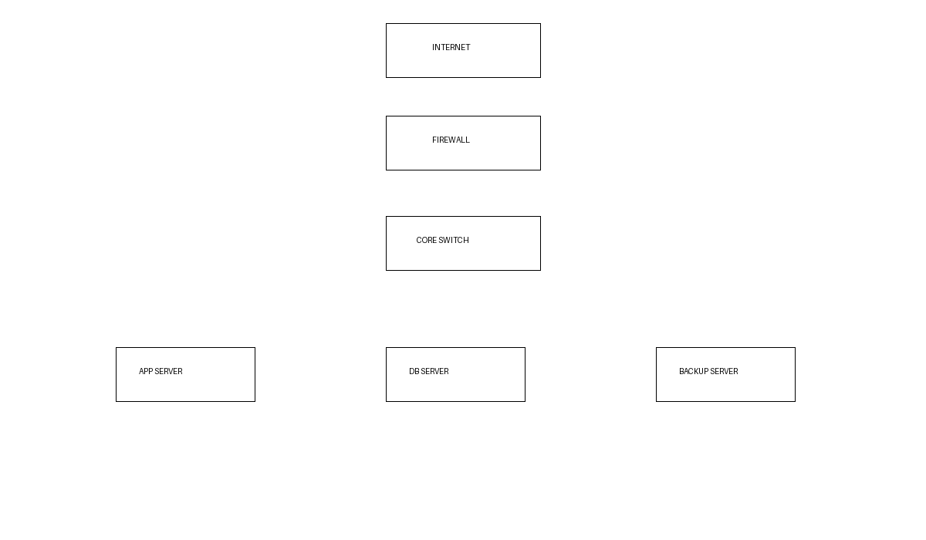
Contents
Ubuntu setup, Apache, Nginx, Firewall hardening, Backup strategy, DR plan, Zabbix, Grafana.

Professional Experience Demonstrated
Server configuration, infrastructure deployment, backup & recovery, monitoring, disaster recovery.

