NETWORK REPOSITORY - PROFESSIONAL PORTFOLIO
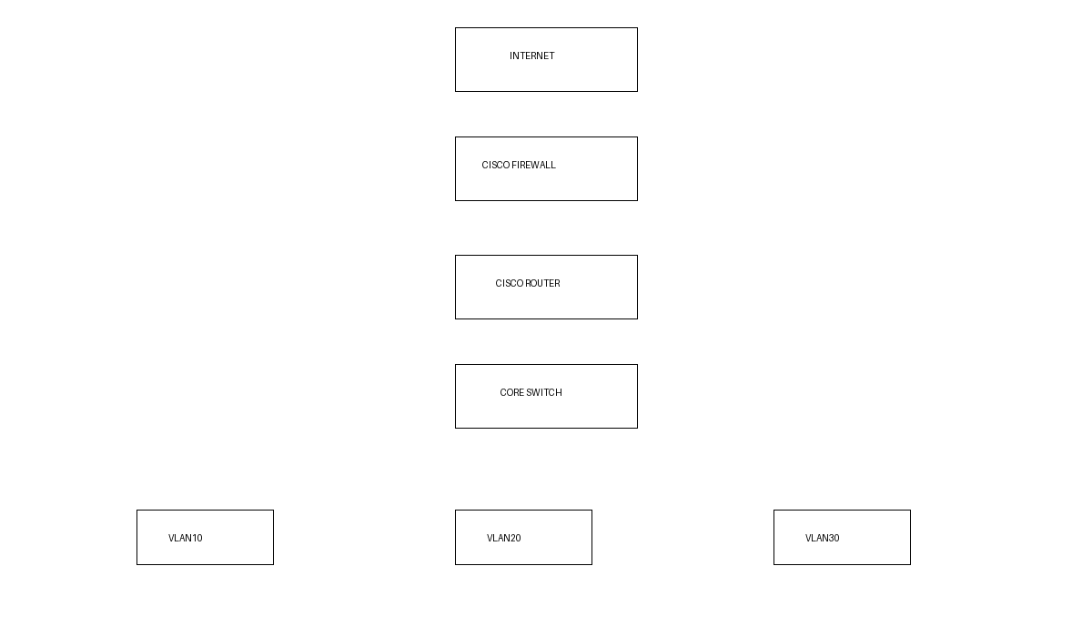
Contents
Cisco VLANs, routing, switching, VPNs, firewall rules, diagnostics and troubleshooting.

Sample Cisco Configuration
vlan 10
name FINANCE
interface fa0/1
switchport access vlan 10

