Teaching Tips to Accompany “Calculating Rb-Sr Isochrons”
by Andy Barth, Indiana University—Purdue, University, Indianapolis
Teaching Notes by David Mogk, Montana State University

Background Information

Isochron plots are typically constructed for two purposes: 1) to determine the age of a rock, and 2) to determine the initial isotopic ratio that is then used a petrogenetic tracer. Isochron plots are constructed by plotting the measured abundances of a parent isotope (P) vs. the radiogenic daughter products (D).

For the Rb/Sr system these plots are constructed by plotting the measured amount of 87Rb (P) v. ⁸⁷Sr (which is actually the sum of the initial amount of Sr in the system, Sr_{i}, plus the amount of radiogenic ⁸⁷Sr (P)). It is conventional to divide both the parent and daughter isotopes by the abundance of the stable and non-radiogenic isotope ⁸⁶Sr. Thus,

The equation used to represent the Rb-Sr system is:
This is the mathematical expression of a line: Y = mX + b

⁸⁷Sr/⁸⁶Sr = (⁸⁷Sr/⁸⁶Sr)₀ + (⁸⁷Rb/⁸⁶Sr) · (e^{λt-1}); e^{λt-1} ≈ λt
(measured) = Y-intercept + measured · (slope)
calculated calculated
λ is the decay constant, and for the breakdown of Rb to Sr is 1.42 x 10⁻¹¹

Calculating an Age:

1. Construct an isochron plot for the data provided in the accompanying spread sheet. (Plot ⁸⁷Rb/⁸⁶Sr = X and ⁸⁷Sr/⁸⁶Sr = Y)

2. In Excel you can calculate the SLOPE and INTERCEPT of a line that is best fit to these data. Use these formulae in Excel to calculate the slope and intercept:
=SLOPE(known Y's, known X’s); for the first example, Cathedral Peak Batholith =SLOPE(E4:E6, D4:D6)
=INTERCEPT(knownY’s, known X’s); for the first example,
=INTERCEPT(E4:E6, D4:D6)
3. Using the decay equation and the calculated slope from the isochron plot:
Slope = λt; or t = Slope/ (1.42 x 10⁻¹¹)

For the Cathedral Peak Batholith, the calculated slope is: 0.001336;
the calculated Sr_{i} (intercept) is: .7063

t = (.00136)/(1.42 x 10⁻¹¹) = 9.58 x 10⁷ ≈ 96 Ma (million years)

NOTE: This is a simple representation of this system, and does not account for relative error in the measurements! More sophisticated mathematical treatments are needed to do the error analysis. But, this is a good first approximation!

An example of an Rb-Sr isochron plot for the Eagle Creek Pluton, Sierra Nevada Batholith (from Winter, 2001, Chapter 9, Figure 12).

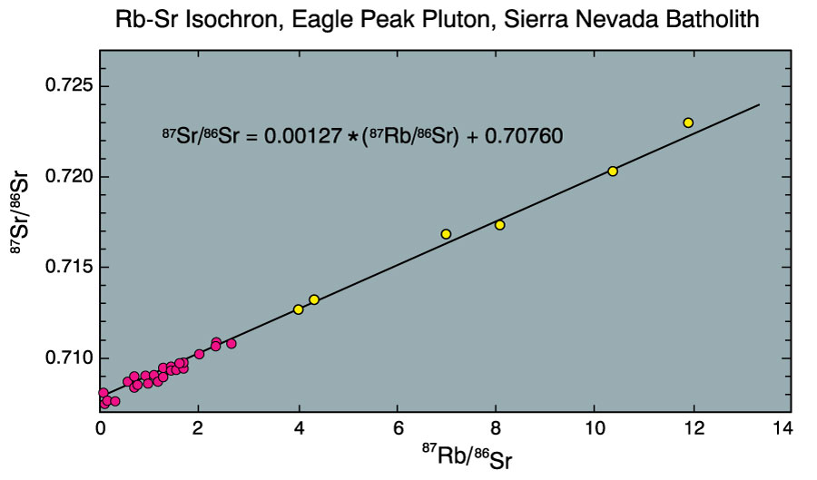
91 Ma

