Zadatak 1:  
Prikazati sve filmove koji se rade o zenama (malo za razmisliti)

**Query:**

**SELECT title FROM film WHERE description LIKE '%Woman%' OR description LIKE '%girl%' OR description LIKE '%feminism%';**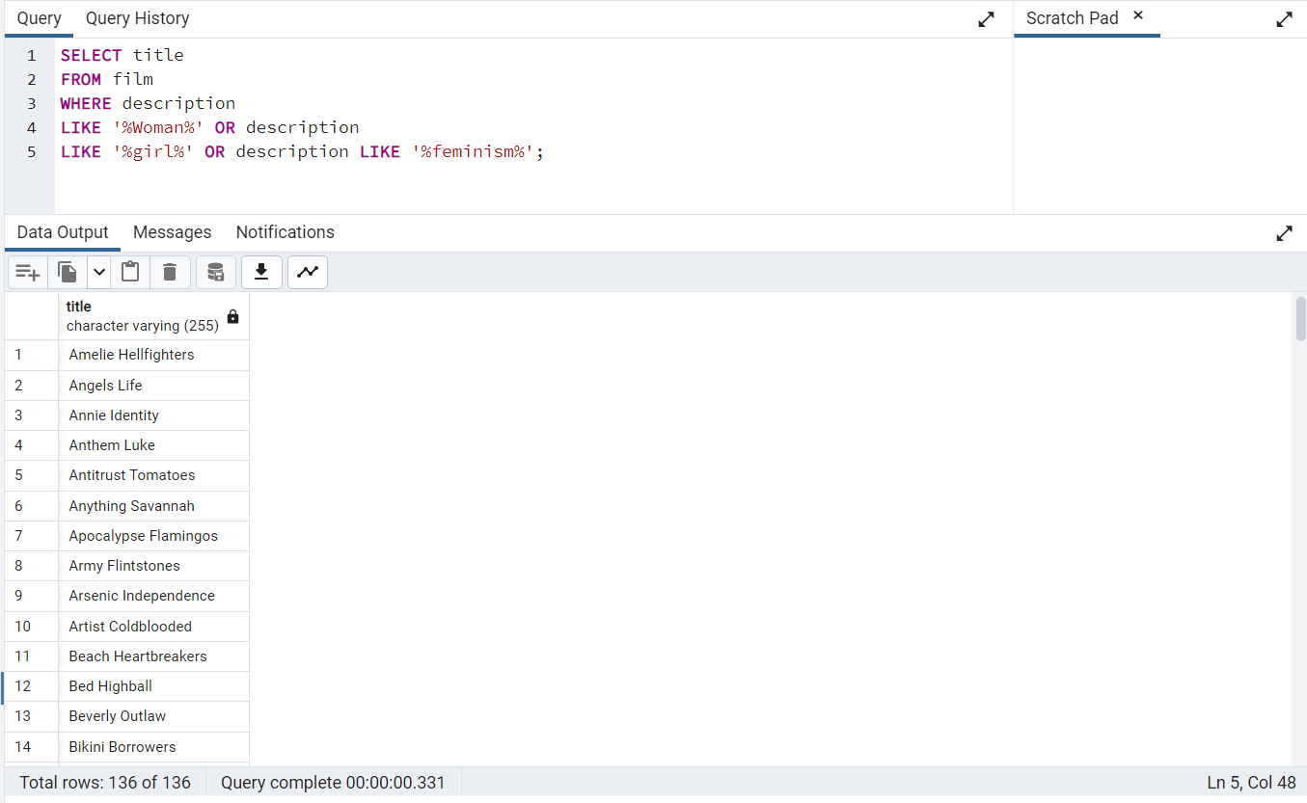

Zadatak 2:  
Prikazati sve kupce koji imaju ID izmedju 200 i 300

**Query:  
SELECT first_name, last_name FROM customer WHERE customer_id BETWEEN 200 AND 300;  
ili   
SELECT * FROM customer WHERE customer_id BETWEEN 200 AND 300;**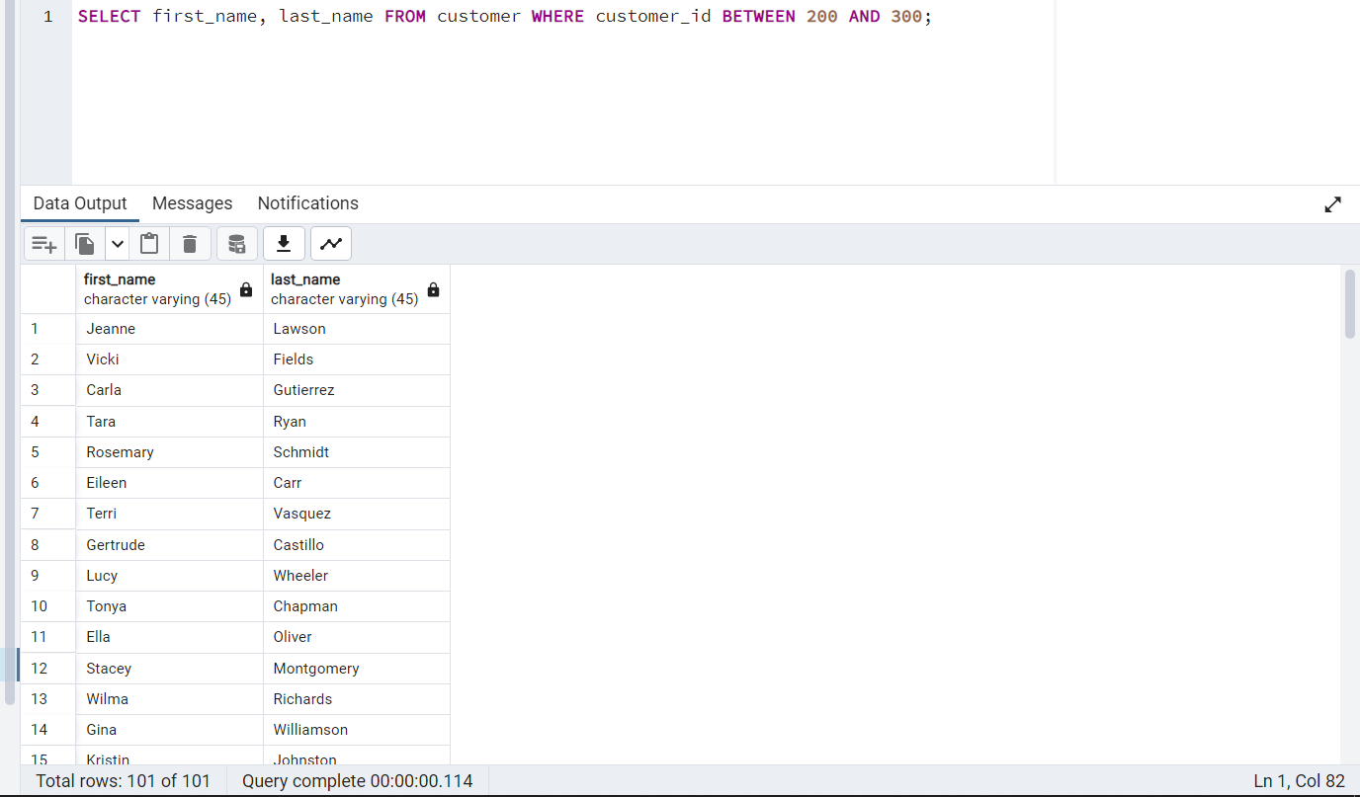

Zadatak 3:  
Koji prodavac (staff_id) je prodao vise filmova (tabela payment)?

**Query:  
SELECT staff_id, COUNT(payment_id) AS total_sold FROM payment GROUP BY staff_id ORDER BY total_sold DESC;**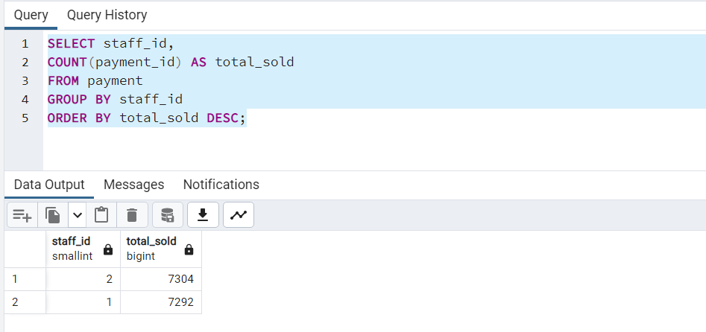

Zadatak 4:  
Da li je prodavac prodao vise filmova napravio veci profit od prodavca koji je prodao manje filmova?

**Query:  
SELECT staff_id, SUM(amount) AS total_earned FROM payment GROUP BY staff_id ORDER BY total_earned DESC;**