Domaci zadatak 5:

Na kojoj adresi zivi zaposleni Jon Stephens

**Query:  
  
SELECT address**

**FROM address**

**WHERE address_id = (SELECT address_id**

**FROM staff**

**WHERE first_name = 'Jon' AND last_name = 'Stephens');**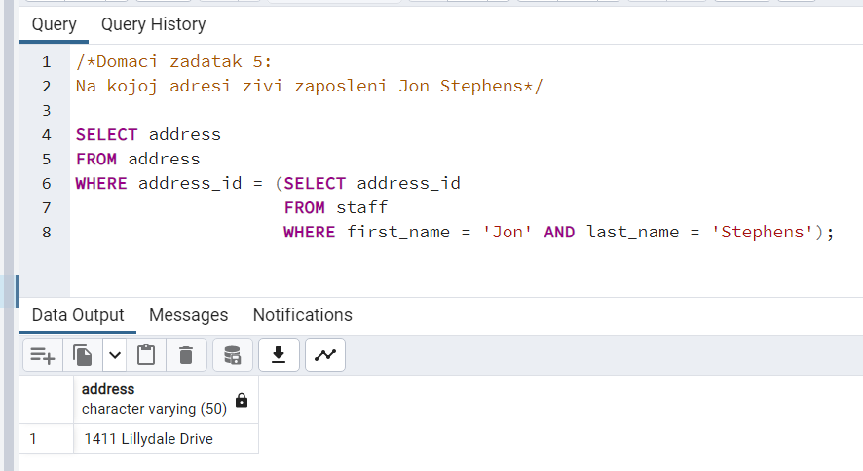

Domaci zadatak 6:

Pronaci filmove u kojima glumi Zero Cage

**Query:  
  
SELECT title**

**FROM film**

**WHERE film_id IN(SELECT film_id**

**FROM film_actor**

**WHERE actor_id = (SELECT actor_id**

**FROM actor**

**WHERE first_name = 'Zero' AND last_name = 'Cage'));**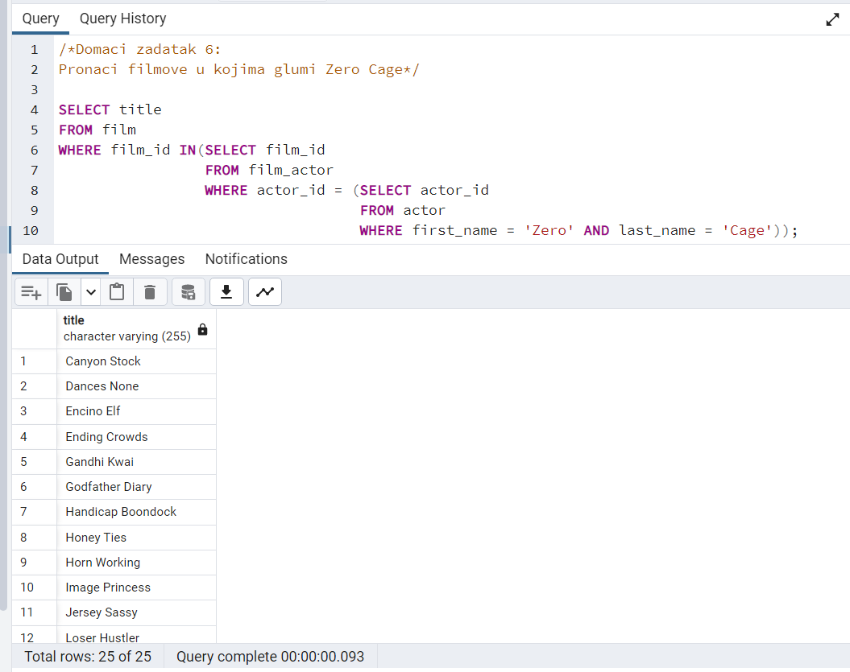

Domaci zadatak 7 (SAMO ZA VEZBU):

Koje filmove je iznajmila Olga Jimenez

**Query:  
  
SELECT title**

**FROM film**

**WHERE film_id IN (SELECT film_id**

**FROM inventory**

**WHERE inventory_id IN (SELECT inventory_id**

**FROM rental**

**WHERE customer_id = (SELECT customer_id**

**FROM customer**

**WHERE first_name = 'Olga' AND last_name = 'Jimenez')));**

