**Stephen Bradley C15801268**

**Enterprise Application Development**

**Worksheet 1**

**Q1. Index.js**

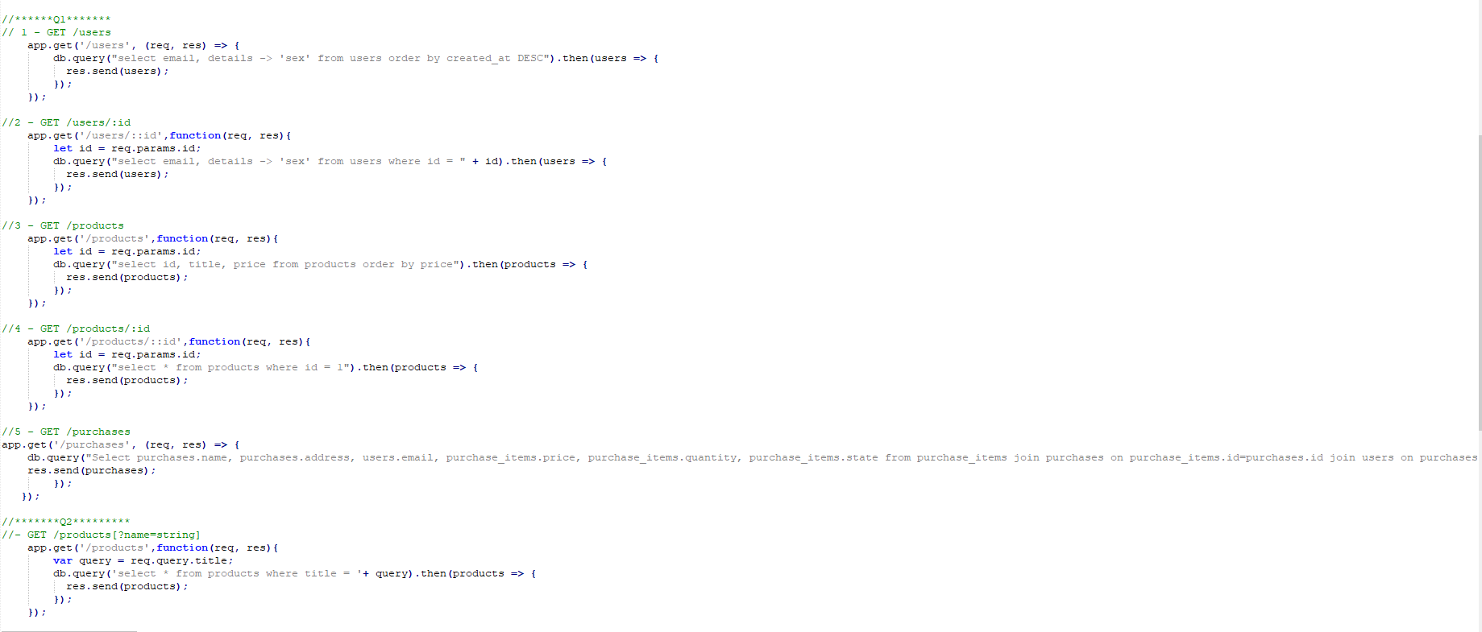

GET /users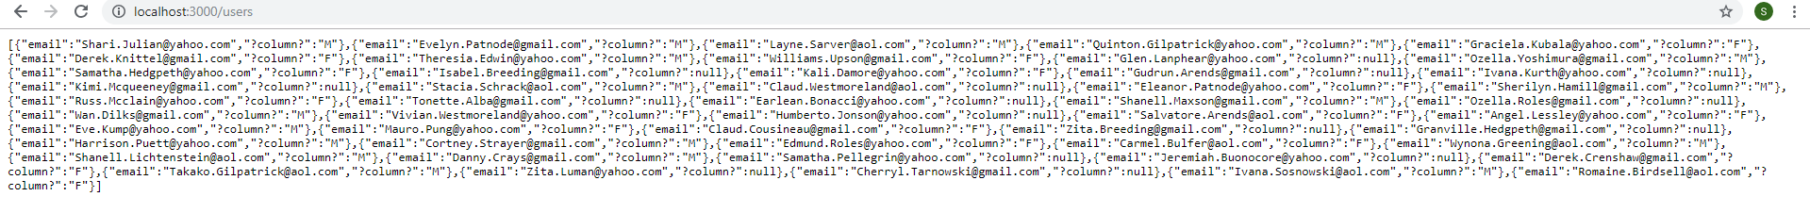

GET/ users/::id

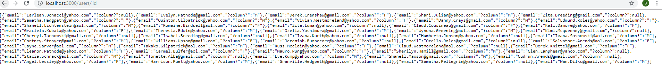

GET /products



GET /products/:id



GET /purchases

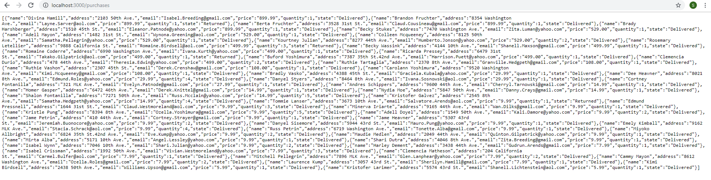

**Q2.**

GET /products[?name=string] with vulnerability for SQL injection

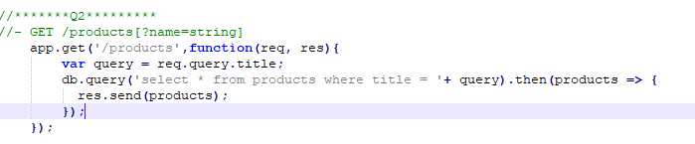

SQL injection to drop price column from products table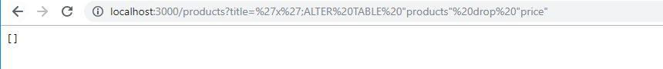

**Q3**

Parameterised query to prevent SQL injection

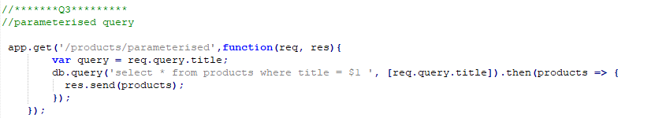

**Q4**

Sequelize configuration in index.js

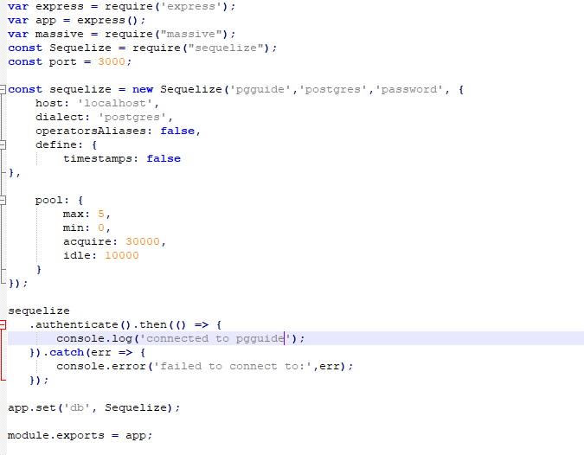

Run command ‘Sequelize init’ to create the following files and folders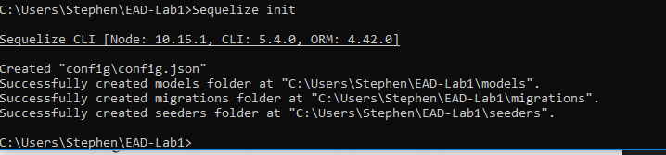

Run the command Sequelize migration:generate –name testingMigrations .

In the testingMigrations file configure the up and down functions. In the Up function the name of the password and email columns will be changed to newpassword and newemail. The down function will undo these changes if needed.

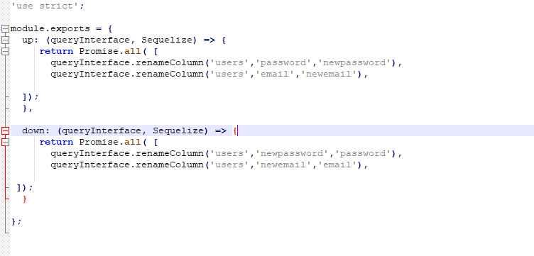

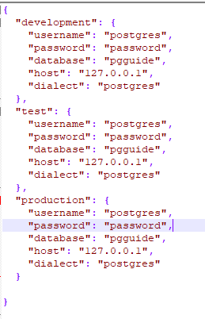

Change the values in the config.json file to those of your database

Run the command ‘sequelize db:migrate’ for the changes in the testingMigrations file to take place.

(To undo these changes run the command ‘sequelize db:migrate:undo’)

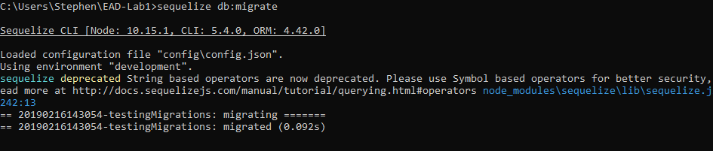

Set up the models for each table in the models folder as shown. To build the tables run the command ‘sequelize model:create –name x –attributes x,x,x’ for each table and the attributes of said table.

