**Lab 3**

GraphQL

C13506897

Nuno Abibo

**Part 1.**

Foreign key constraints

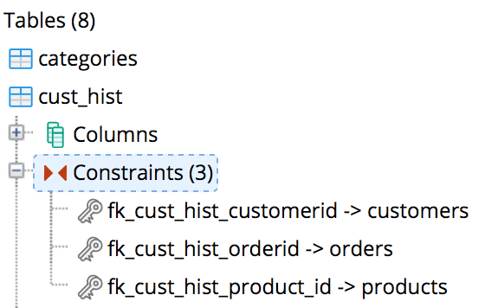

**Part 2.**

GraphQL query which returns the attributes from a single database relation.

