Problem Set 1 to 3:

Test each of these endpoints serves the expected data and briefly show how
you did this

GET /users
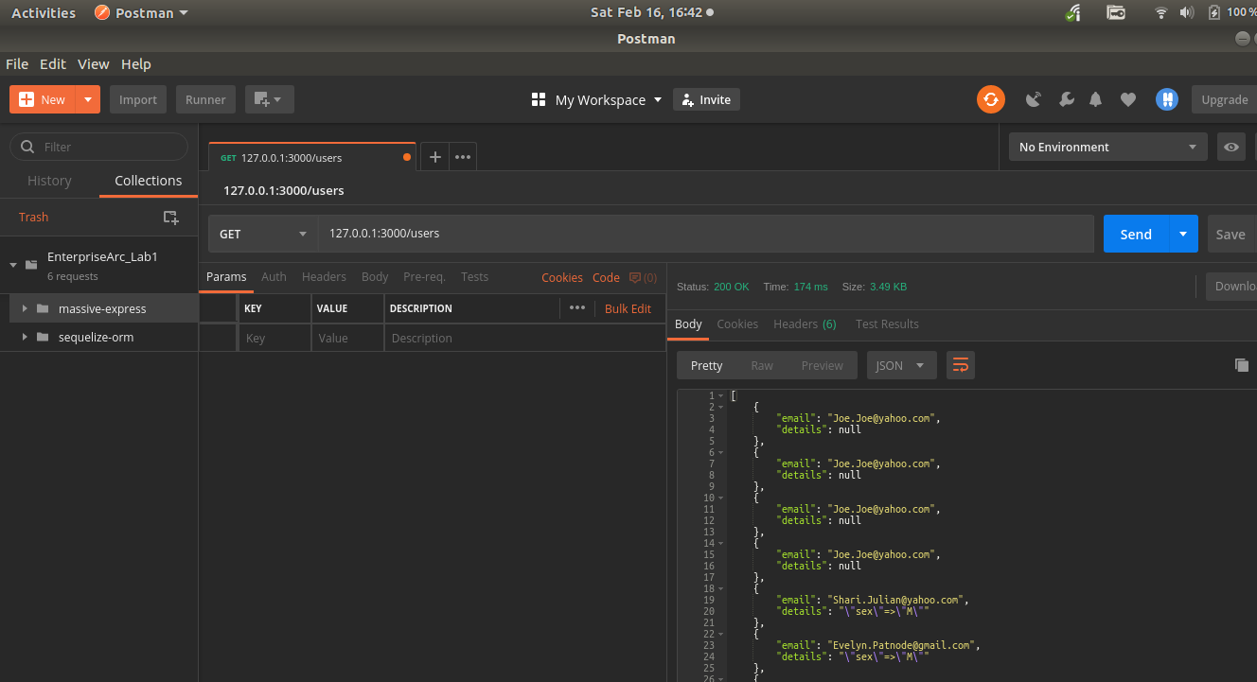
GET users/:id
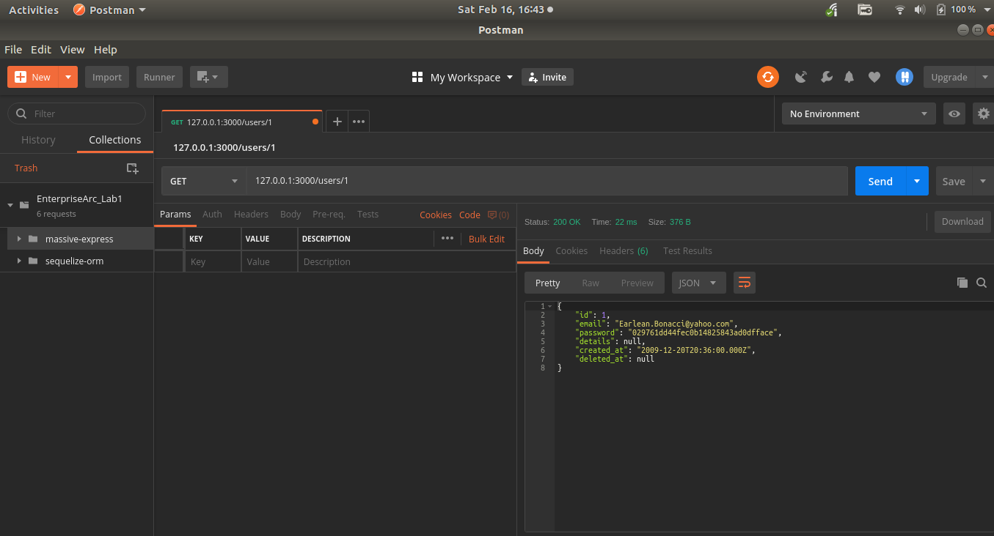

GET /products
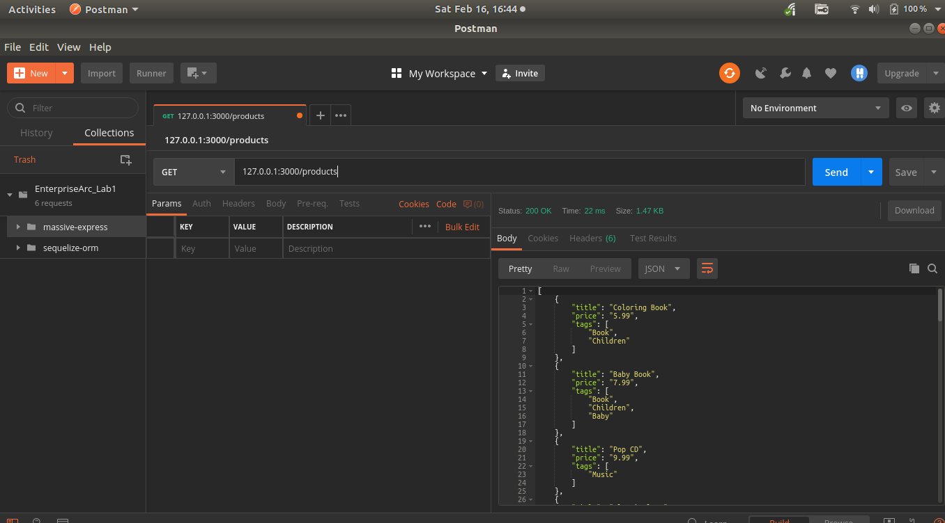
GET products:id
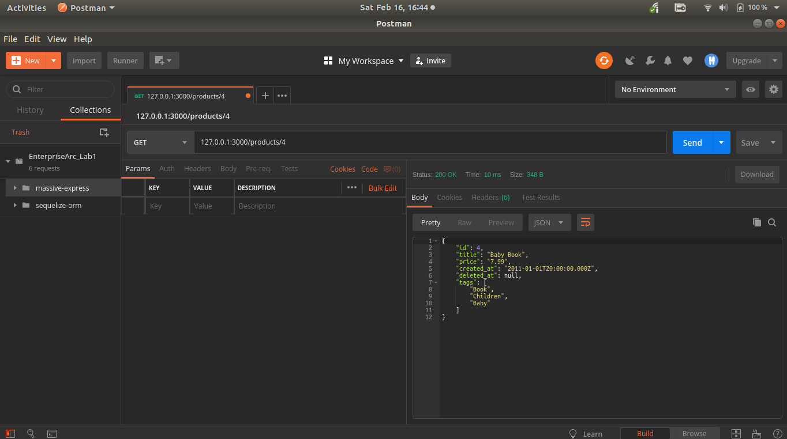

GET /purchases
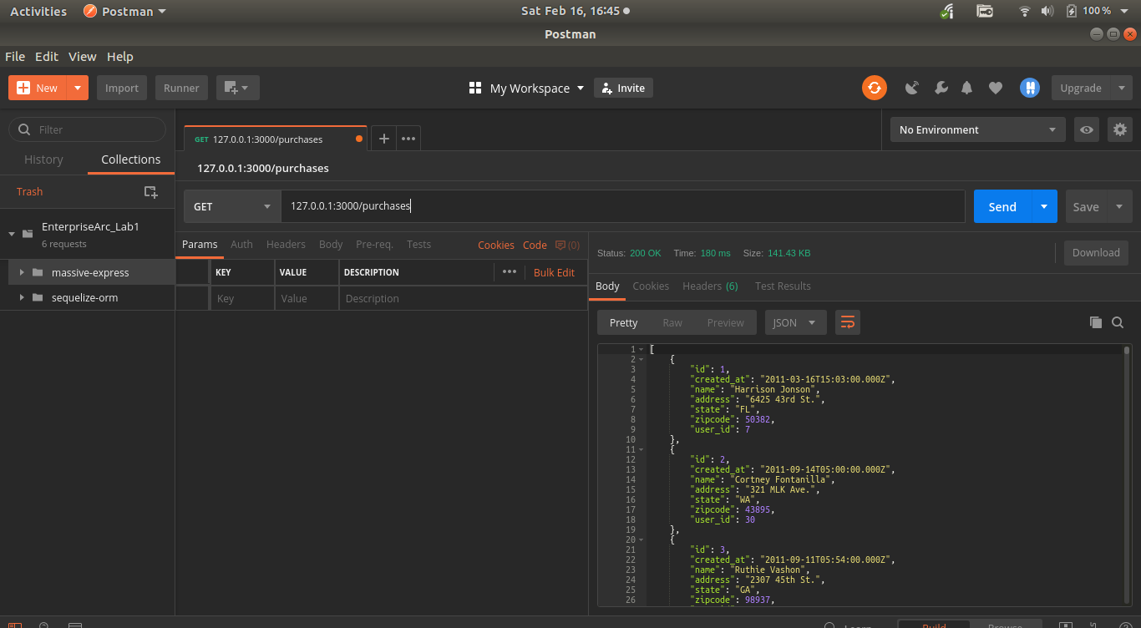
SQL INJECTION: GET /products[?name=string]
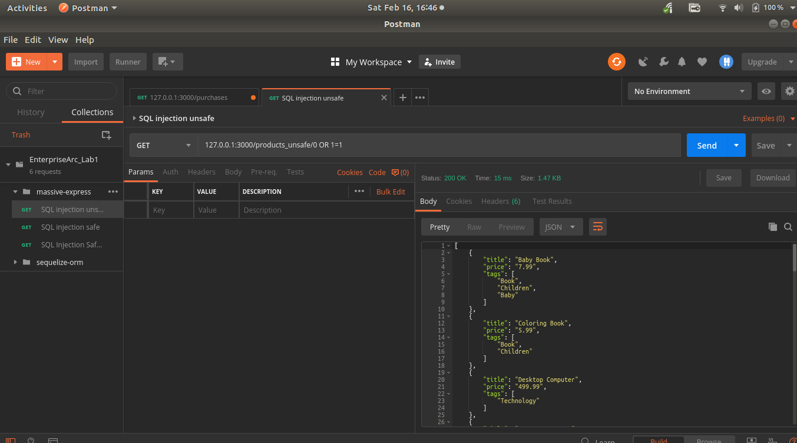

SQL INJECTION SOLUTIONS:
Using a parameterised query testing with allowed value
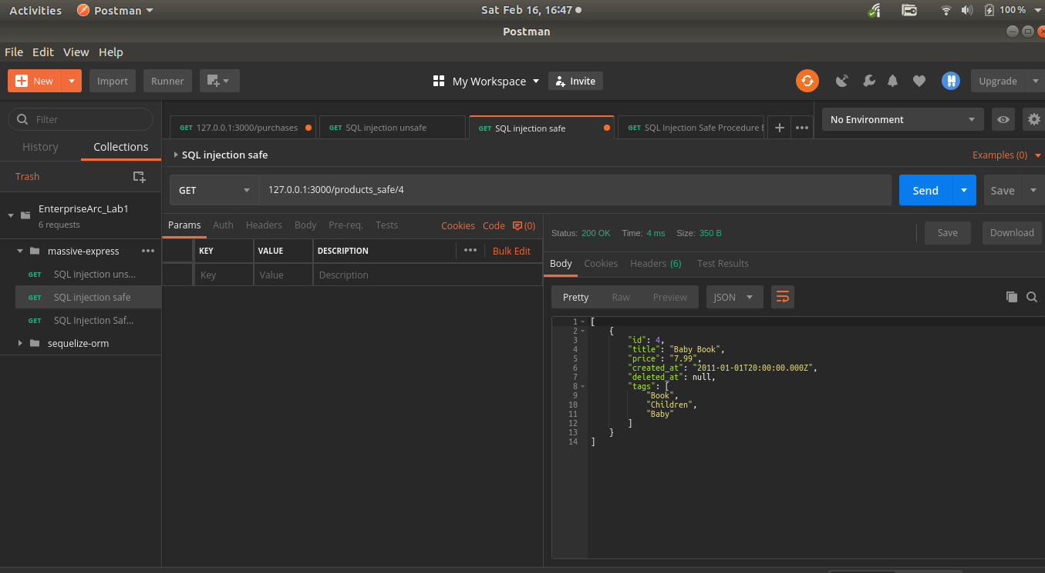
Testing with malicious sql
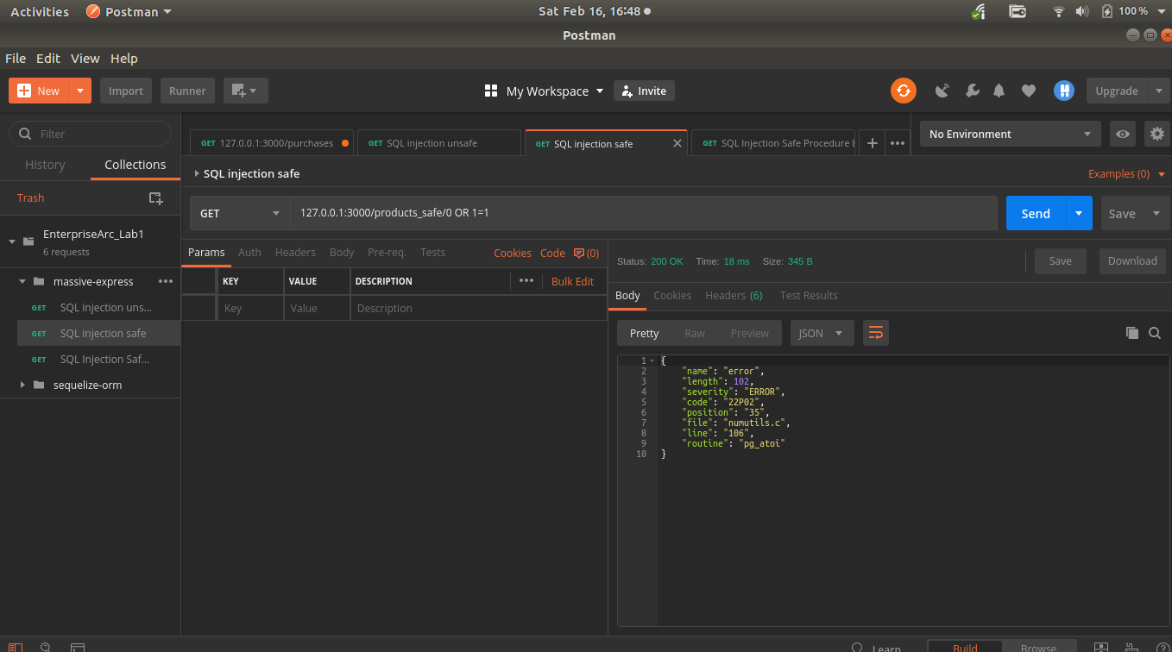

Problem Set 4 to 6:
GET /products[?name=string] //list all products
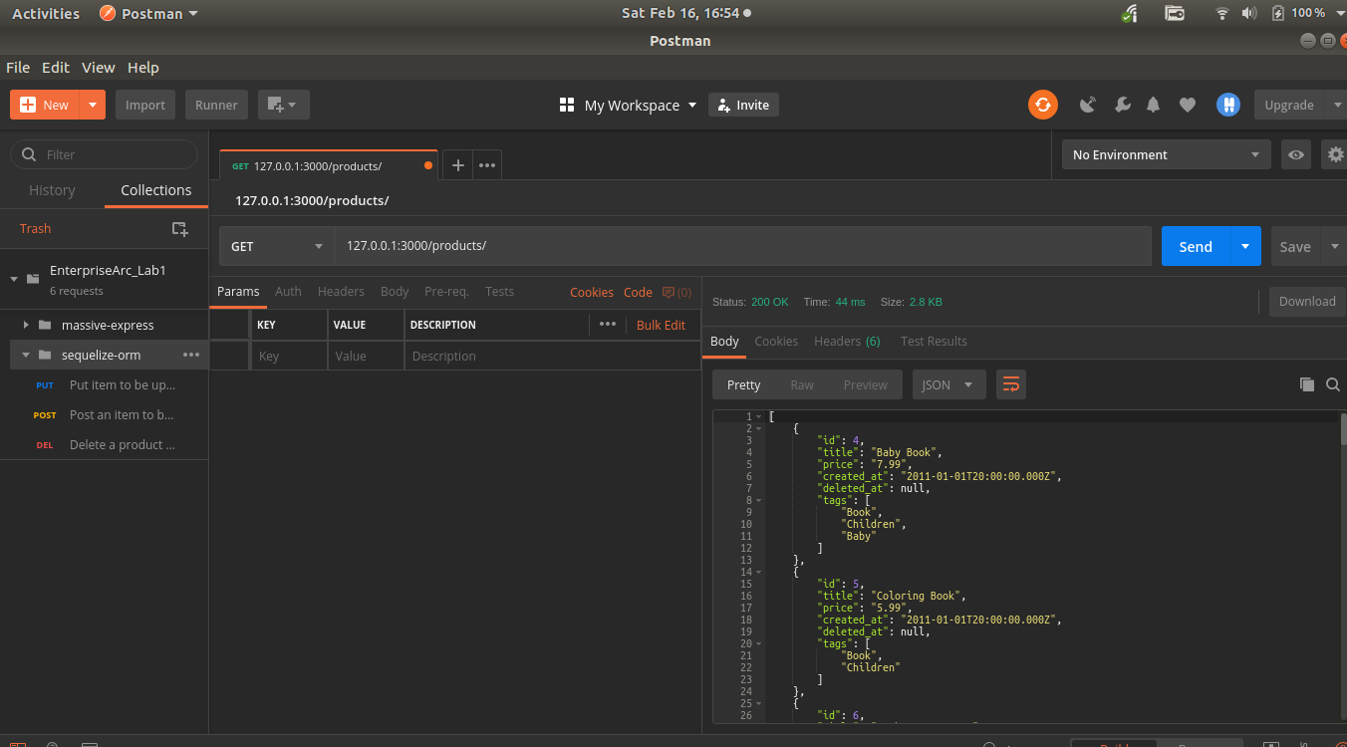

GET products/:id //Specific Product
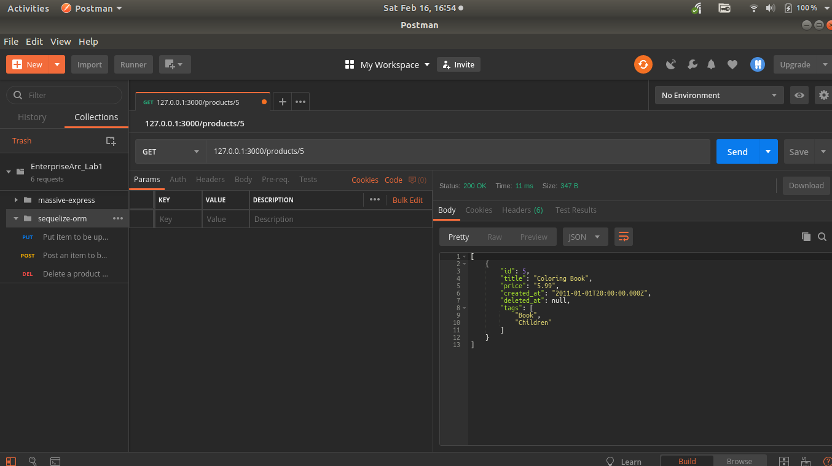

POST /products //Create a new product
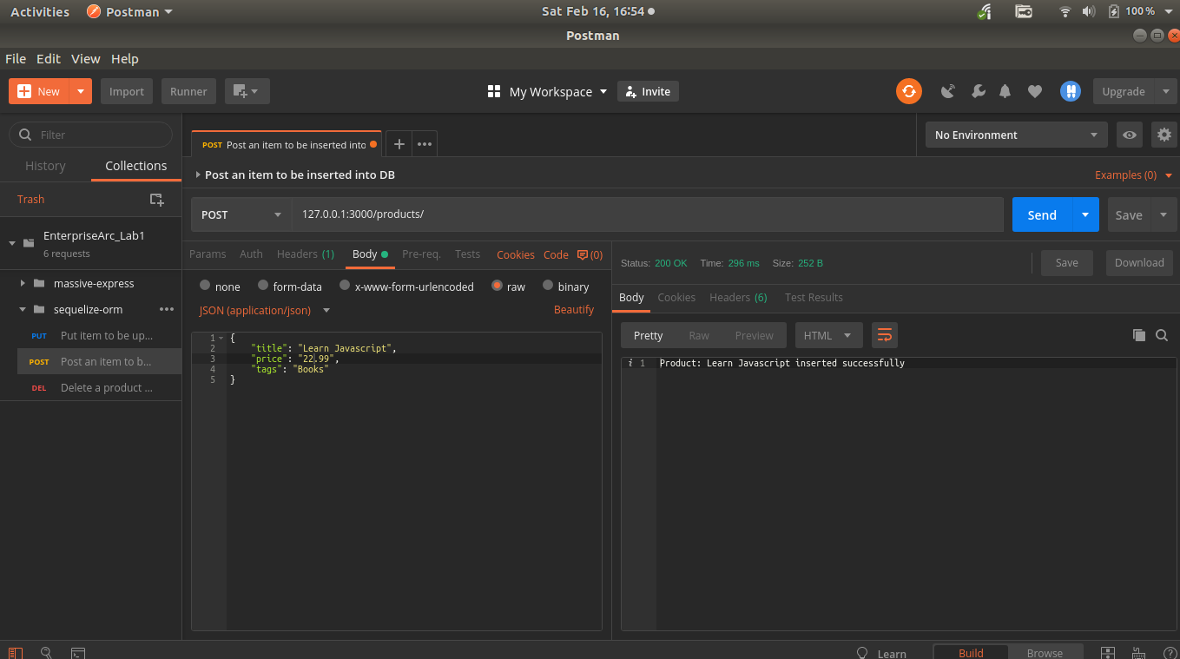

PUT /products/:id //Update an exisiting product
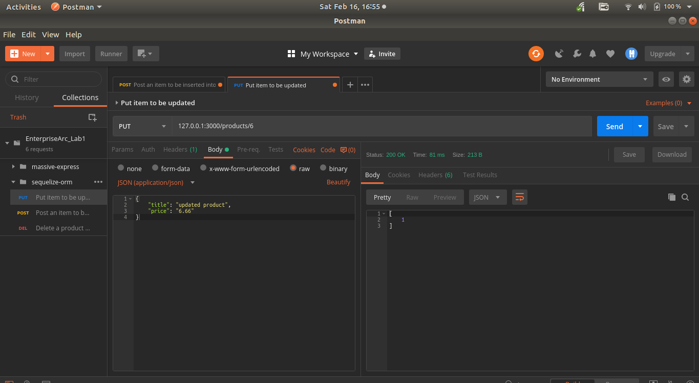

DELETE products/:id //Remove and eixiting object
NOTE: I couldnt get this to work wih the relationships preventing deletion
