
Enterprise Application Development
Lab1 Report

James Ward
C12404762


Table of Contents
Setting Up 1
Step (1) 1
Step (2) 1
Step (3) 2
Step (4) 2
Step (5) 3
Problem Sets (1) 3
Problem Sets (2) 7
Problem Sets (3) 7
Parameterized Approach 7
Stored Procedure 8
Problem Sets (4) 10
Sequelize Models 12
Problem Sets (5) 13
Problem Sets (6) 16
List all products / Find product by title 16
Get product by id 17
Create a new product instance 18
Update an existing product 19
Remove an existing product 20
Additional endpoints 21

Setting Up

Step (1)
Install Node JS (*) on your laptop or sign up for a free cloud-based Node provider. Verify that node and npm are installed and working correctly.

Node.js
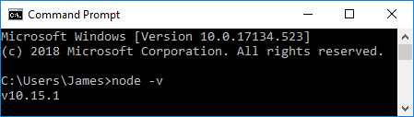

NPM
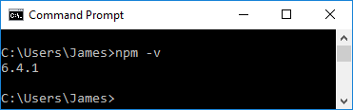

Step (2)
Create a new project folder, change into it and run the following npm init (entry point: index.js) npm install express –save. The following package.json file shows the show the required packages have been installed in the project.

Package.json
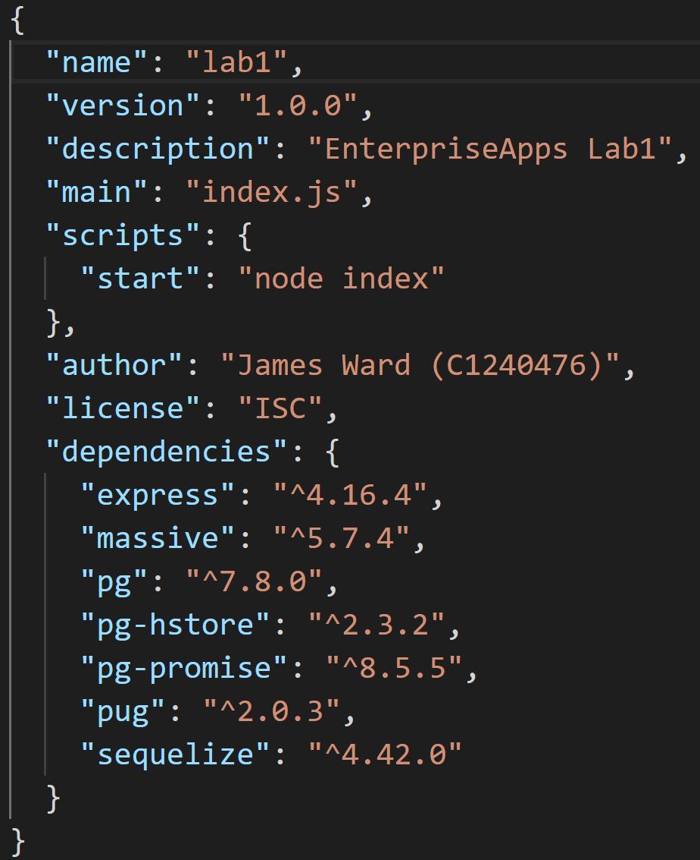

Node Server Port 3000
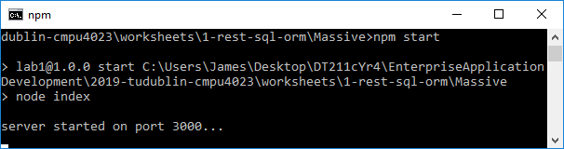

Step (3)
Install a recent of Postgres (*) on your laptop or sign up for a free cloud-based provider (**)

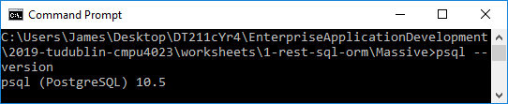

Step (4)
Load the sample database from the Postgres Guide.

Table snippets from Postgres DB
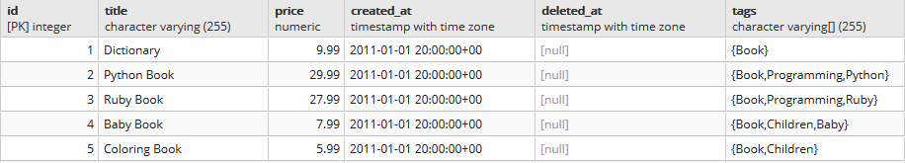
Figure 1: products
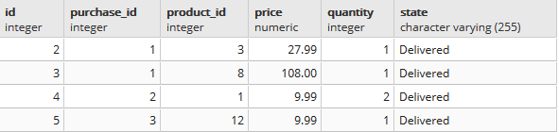Figure 2: purchase_items
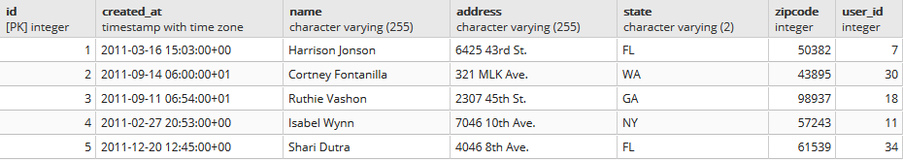
Figure 3: purchases
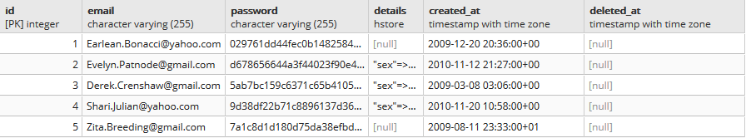
Figure 4: users

Step (5)
Install Massive JS
In the project directory I ran the command, npm install massive –save, massive can be seen in the package.json file above and it is included in the index.js file as follows.
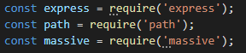

Problem Sets (1)
Note: In some of these entries the responses have been curtailed.

Figure 1: Home Page

( i ) List all users email and sex order by date created
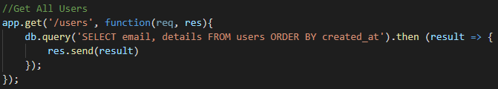
URL: http://localhost:3000/users
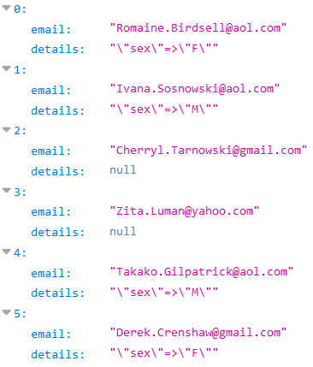

( ii ) Show email and gender of user by id
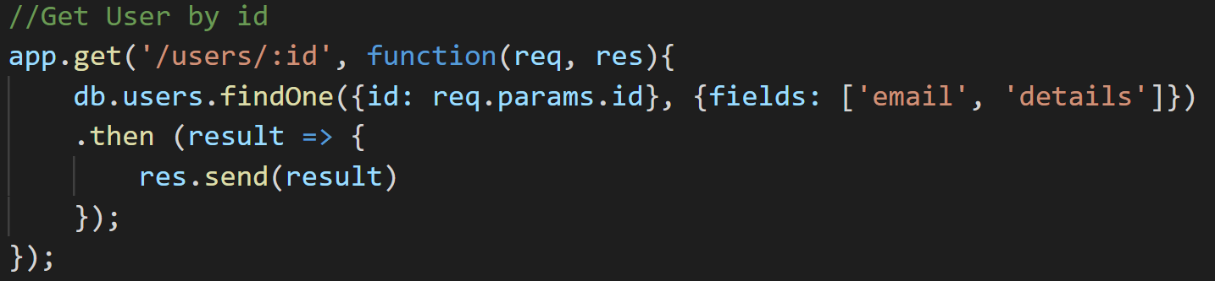
URL: http://localhost:3000/users/2
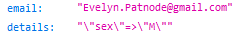

( iii ) Get all products ordered price ascending
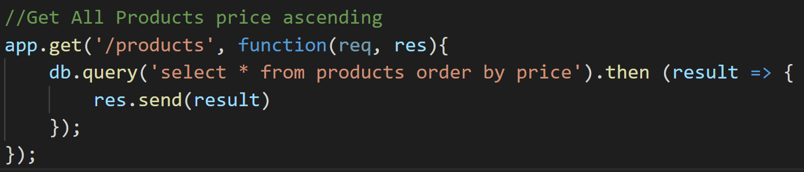
URL: http://localhost:3000/products
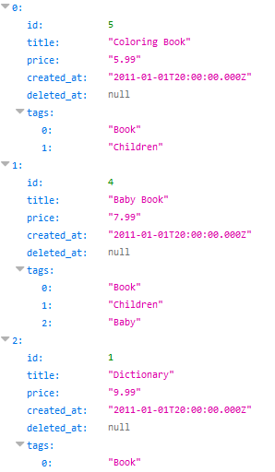

( iv ) Get specific product by id
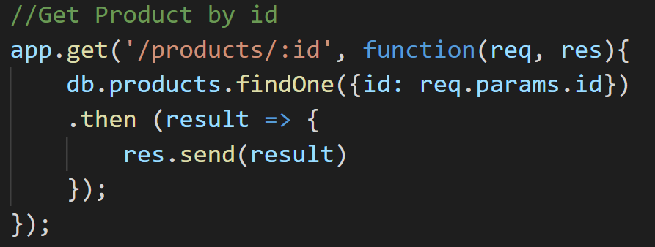
URL: http://localhost:3000/products/3
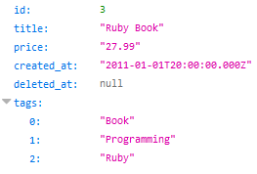

( v ) List purchase items to include the receiver’s name and, address, the purchaser’s email address and the price, quantity and delivery status of the purchased item. Order by price in descending order
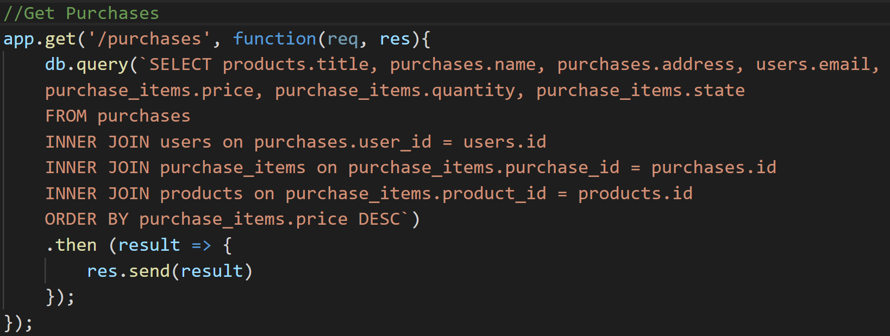
URL: http://localhost:3000/purchases
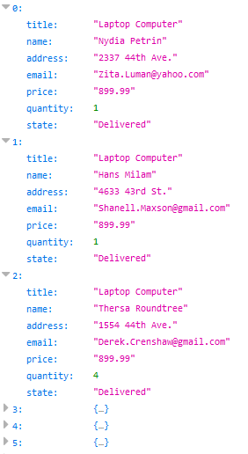

Problem Sets (2)

SQL Injection and Product Search
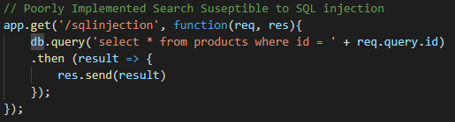
Provided with the following URL: http://localhost:3000/products?name=1|2 it injects the SQL or operator ( | ) into the search and returns the following.
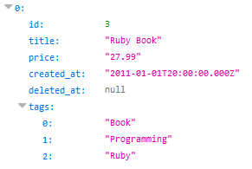

Problem Sets (3)
Provide 2 solutions to eliminate the security hole.
URL: http://localhost:3000/products?name=Dictionary

Parameterized Approach
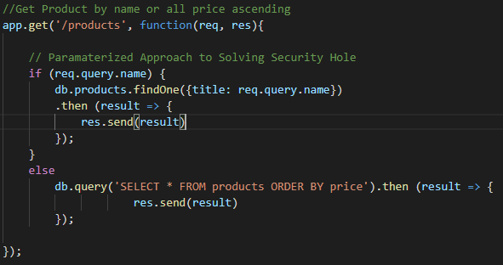
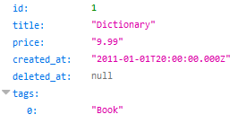

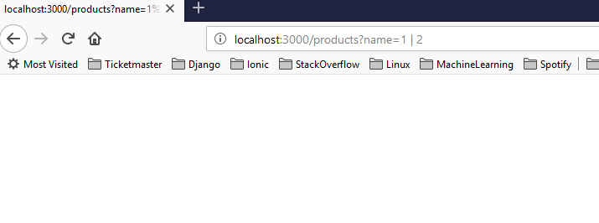
Figure 2: SQL Injection no longer working

Stored Procedure
The prepared function was written in PLSQL in pgAdmin4 and then referenced as a function using a query parameter as the argument.
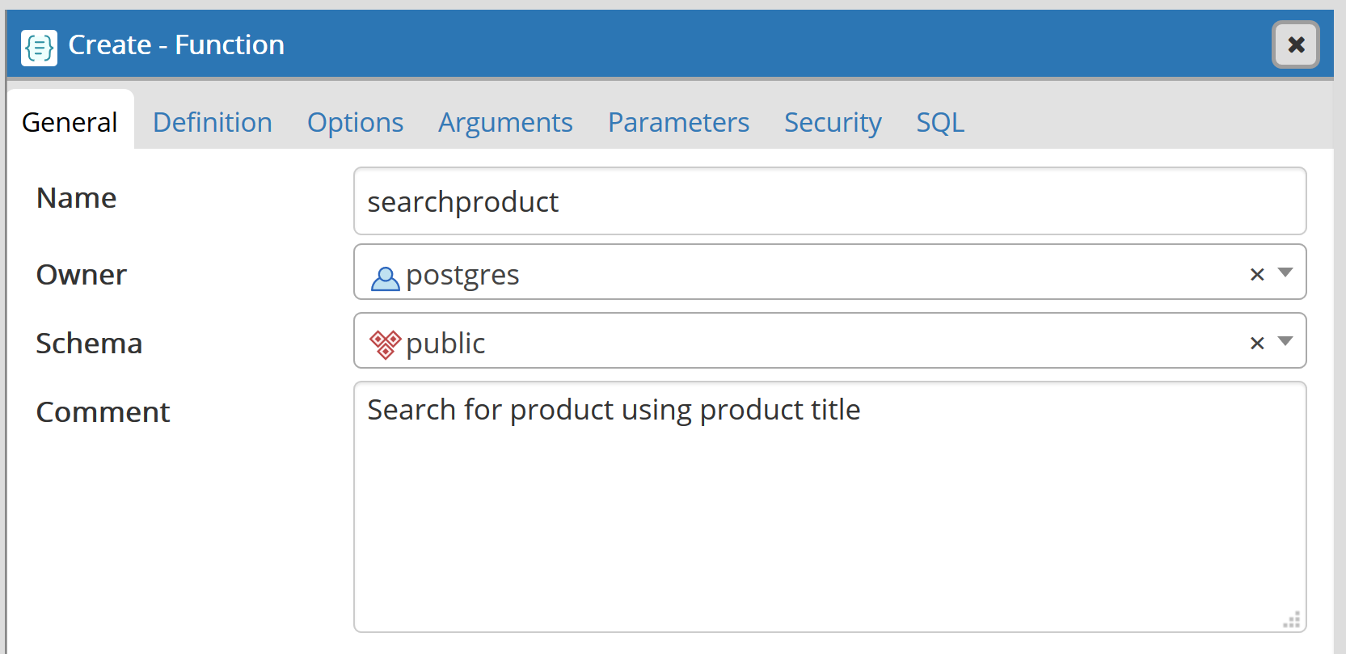
Figure 3: Create and Name Function

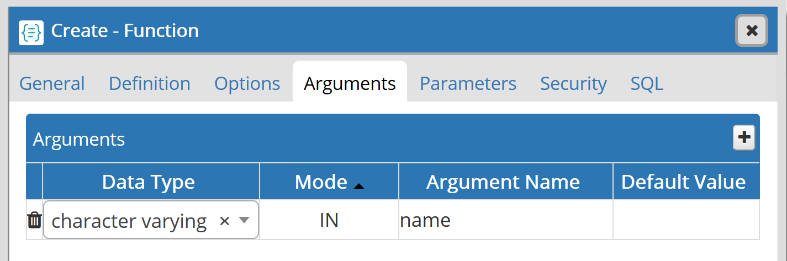
Figure 4: Define the functions input type and argument

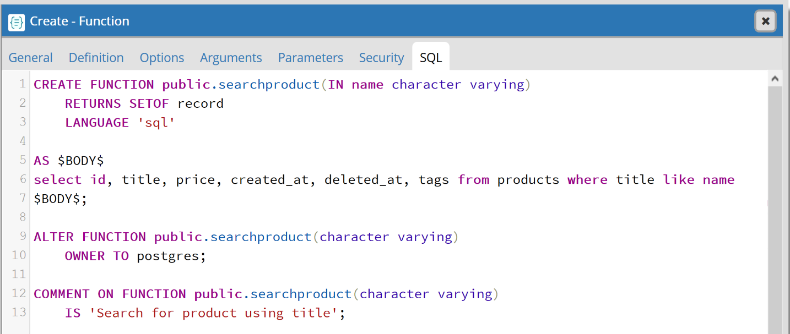
Figure 5: Write the required PLSQL

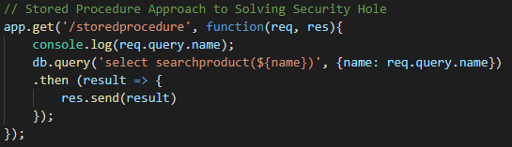
Figure 6: Call the stored procedure with query parameter
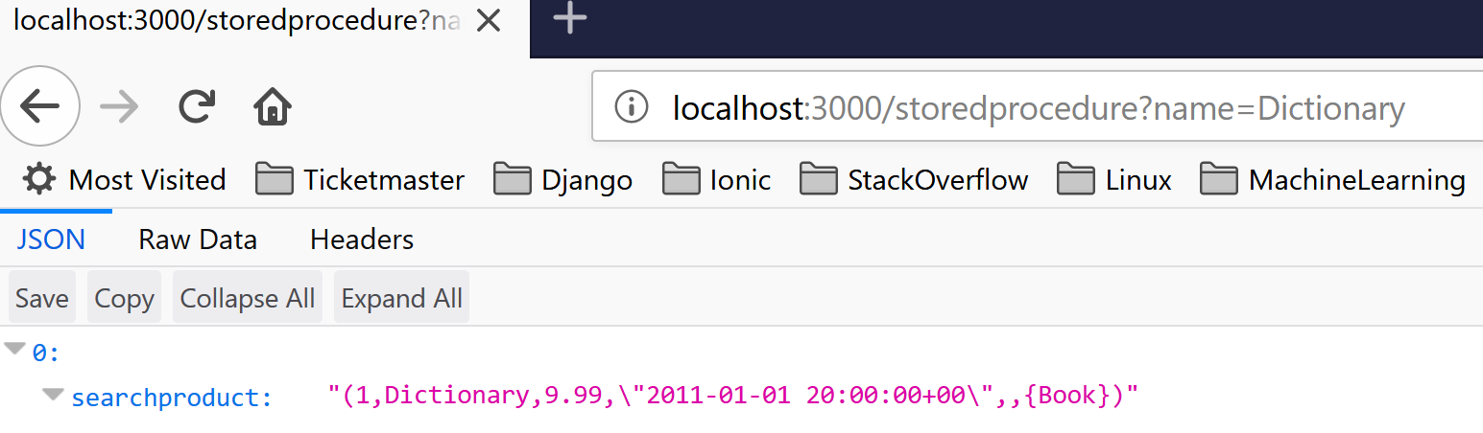
Figure 7: Returned item

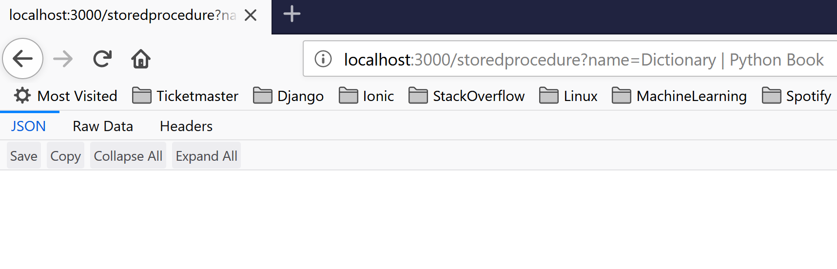
Figure 8: SQL Injection no longer working

Problem Sets (4)
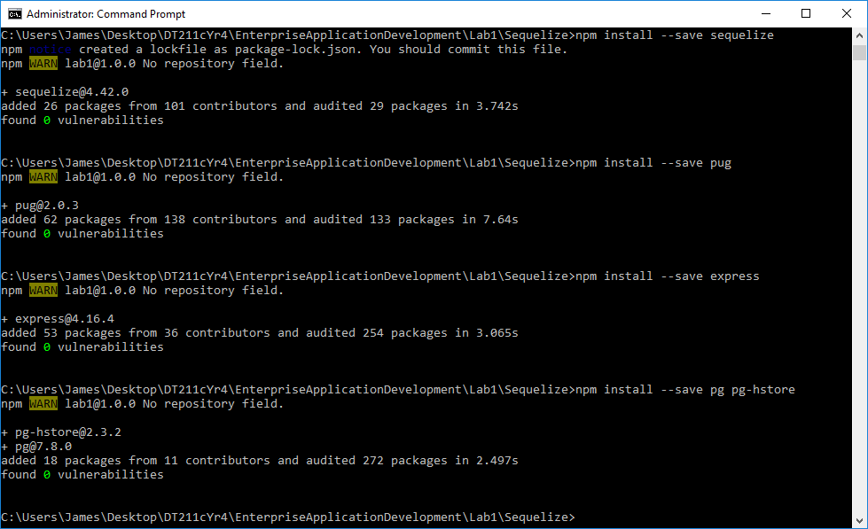
Required dependencies are installed to the new project.
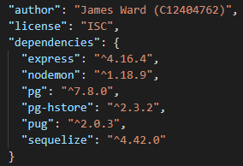
List of the dependencies in the package.json file.

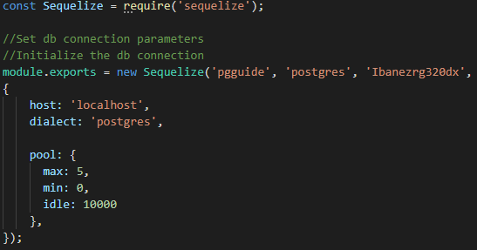
Connection to the database is created in a separate file and exported as a module.

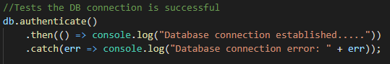
Test connection to the database using authenticate to verify authentication and connectivity.
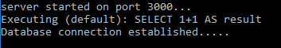
Correct message output, authentication confirmed, connection to the database is established.

Sequelize Models
Users | Purchases
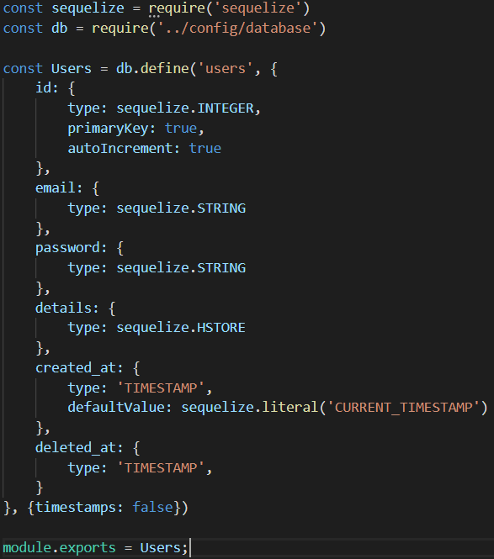 | 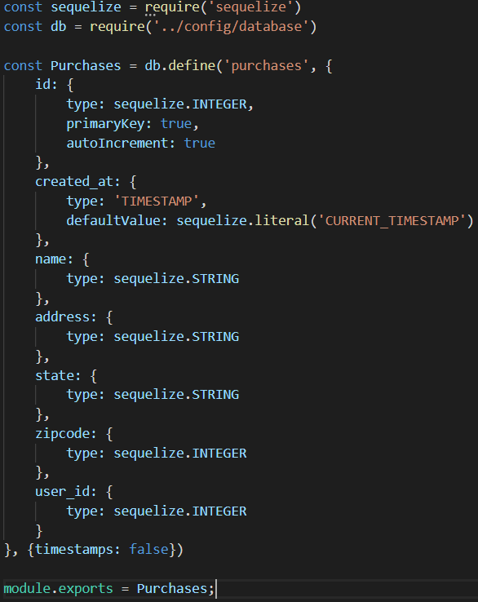
Purchase_Items | Products
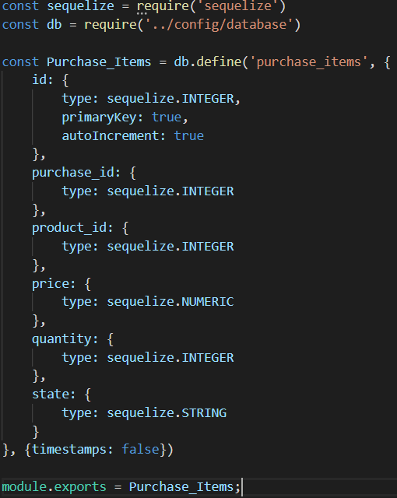 | 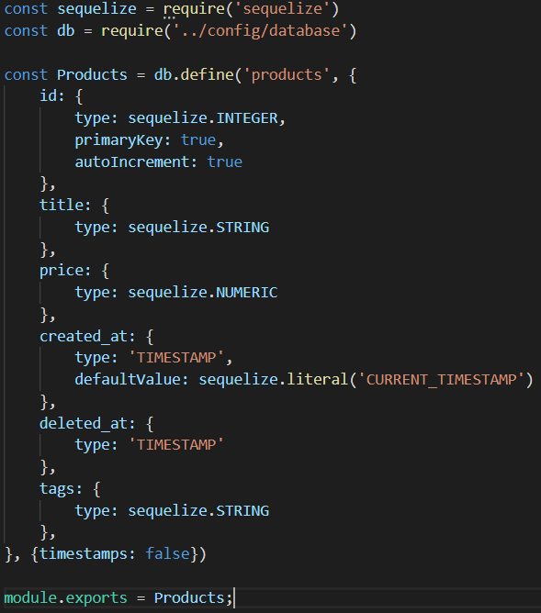
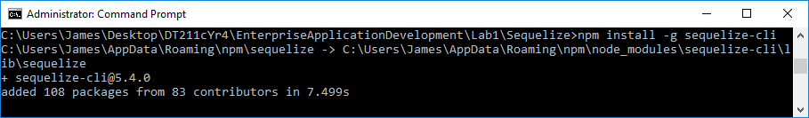
I installed the Sequelize CLI.
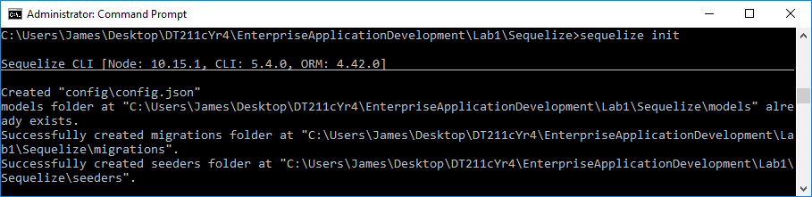
I initialized the project as a Sequelize project.
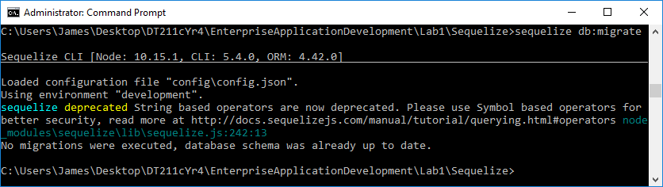
I created the models prior to migrating so no migrations were executed as nothing had changed.

Problem Sets (5)
Use your models and Javascript code to populate the database with some additional test data for all of the models.
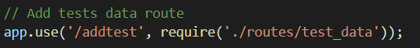
Base route for all database updates using javascript.

Create a product | Create a user
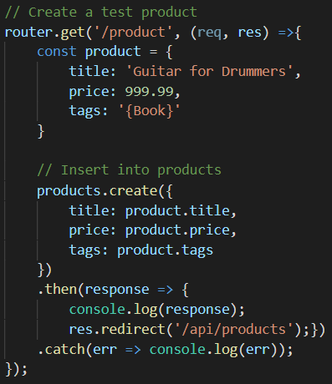  URL: http://localhost:3000/addtest/product  Response  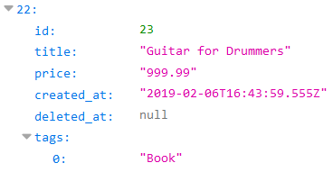 | 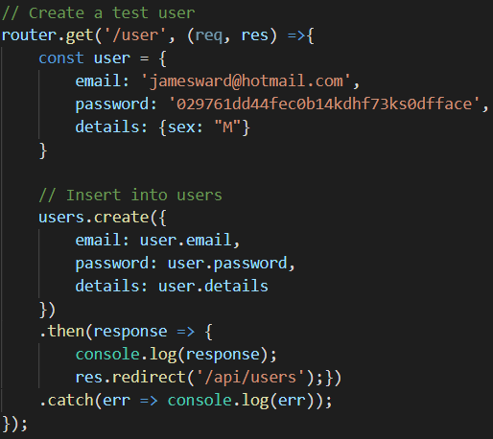  URL: http://localhost:3000/addtest/user  Response  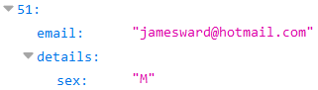

Create a Purchase | Create a purchase item
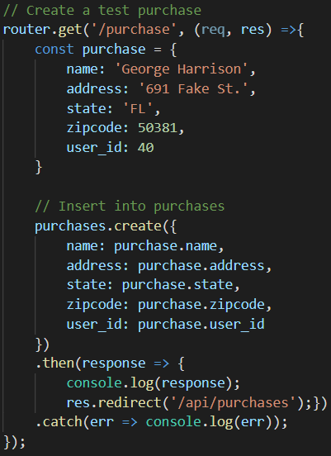  URL: http://localhost:3000/addtest/purchase  Response  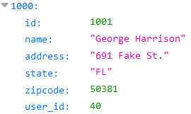 | 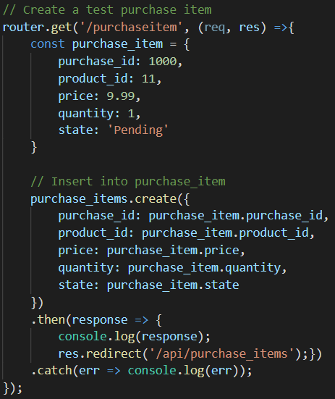  URL: http://localhost:3000/addtest/purchaseitem  Response  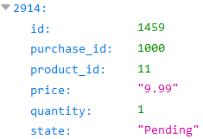

Problem Sets (6)
Reimplement the RESTful API using Sequelize and Express for your system. Your API should support the following CRUD operations as follows, returning JSON responses.

List all products / Find product by title
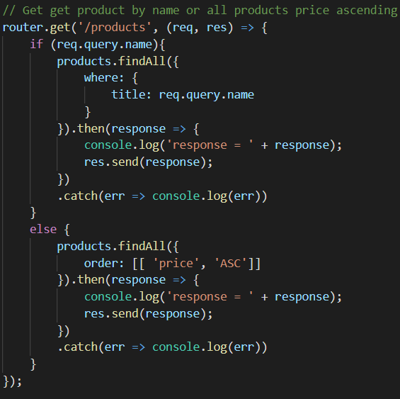
URL: http://localhost:3000/api/products
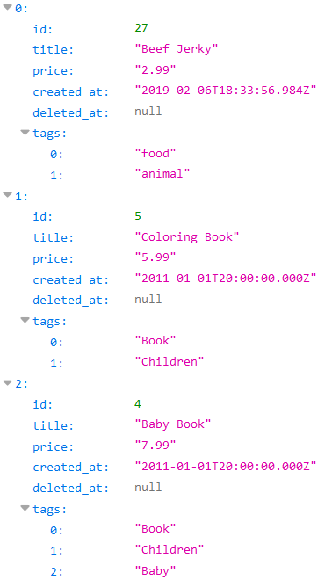
URL: http://localhost:3000/api/products?name=Dictionary
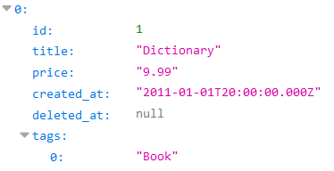

Get product by id
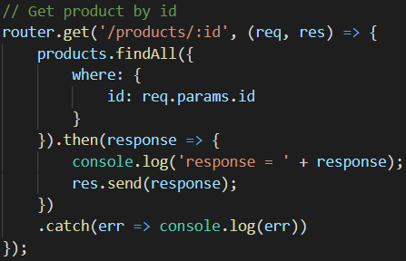
URL: http://localhost:3000/api/products/1
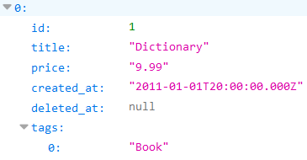

Create a new product instance
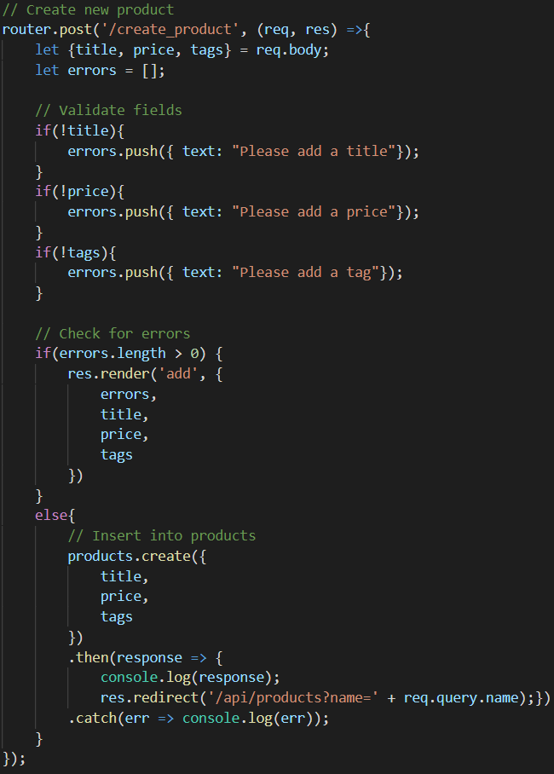
URL: http://localhost:3000/api/create_product
Post Request run from Postman
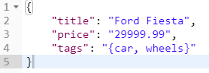
New product entry returned using the /products endpoint
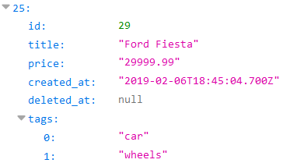

Update an existing product
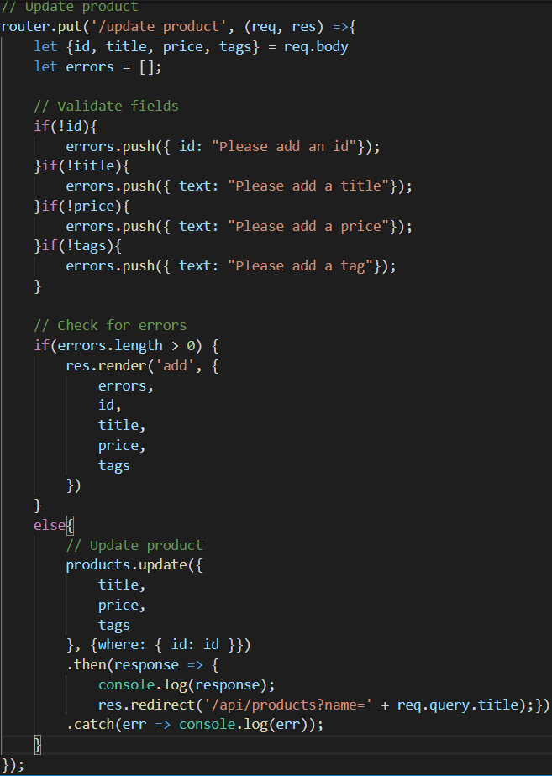
URL: http://localhost:3000/api/update_product
Put request body sent using Postman
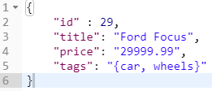
Product updated, returned using the /products endpoint
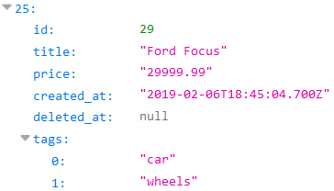

Remove an existing product
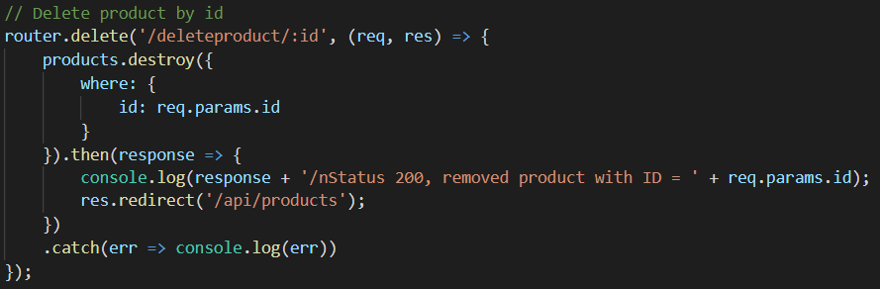
URL: http://localhost:3000/api/deleteproduct/25
Existing Product Fender Stratocaster id: 25 | Deleted Product Fender Stratocaster
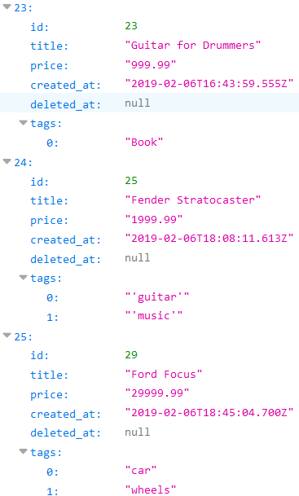 | 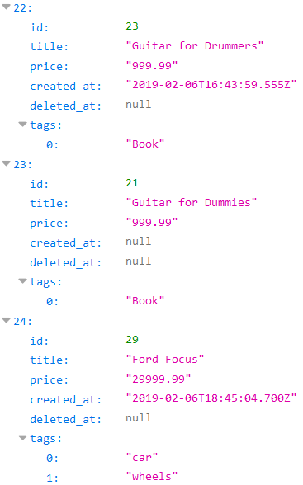

Additional endpoints
I created the following endpoints based on the requirements for Problem Set (1)
