
Enterprise Application Development
Lab2 Report

James Ward
C12404762


Table of Contents
Setting up the project and the database 3
Implement a JWT-secured version of the API 6
2.1 7
2.2 9
2.3 10
2.4 / 2.5 11
Extend the users table or add another linked “apikeys” table to include an access key (160 bits) and secret key (320 bits) 13
Implement a Hash-based message authentication (HMAC) 14
Server 14
Client 15

Setting Up

Installations
To run Docker on windows I am using VirtualBox and Kitematic

Docker CE Installed
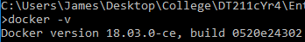

Docker Compose Installed
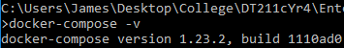

Node Installed
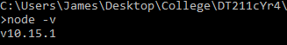

Npm Installed
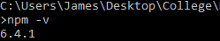

Prisma Installed
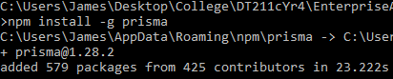

Start Node Project
Npm init
Npm install express –save
Npm install graphql –save
Npm install nodemon –save

Set Up Prisma

I created the docker-compose.yml file and pasted in the boilerplate code from the set up prisma tutorial. After creating the file, I launched prisma and connected to the database using command: docker-compose up -d. Initially I had trouble connecting to the prisma server, after finding this post on github https://github.com/prisma/prisma/issues/2761, I discovered that, instead of using localhost, prisma uses a default ip (http://192.168.99.100:4466/) set in the prisma.yml file that links it to the docker container on port 4466.

Docker Containers Running
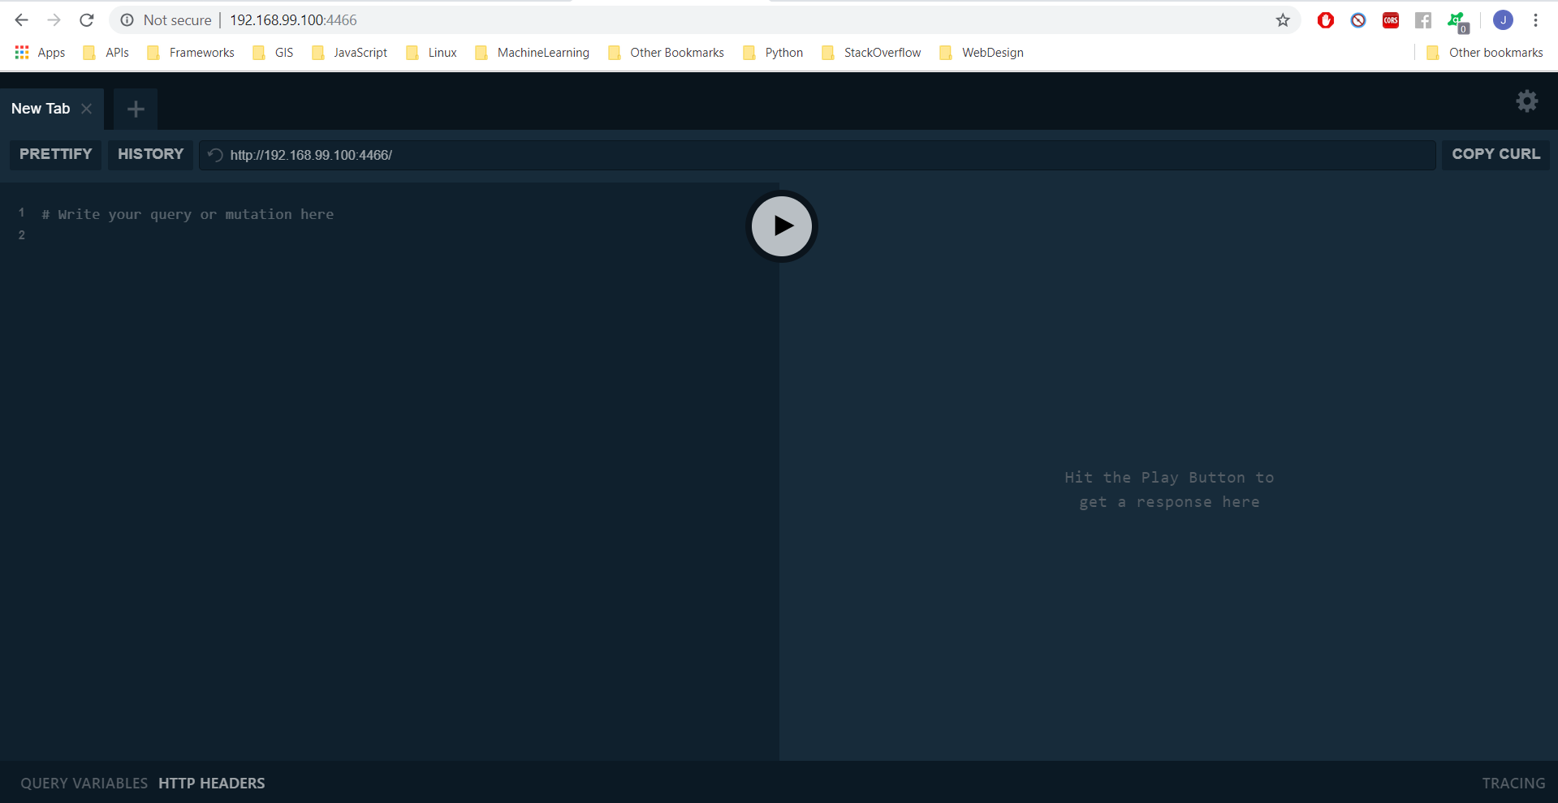

Bootstrap Prisma Config Files
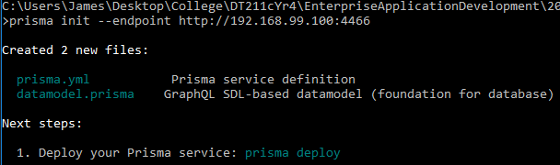

Deploy the Prisma Datamodel
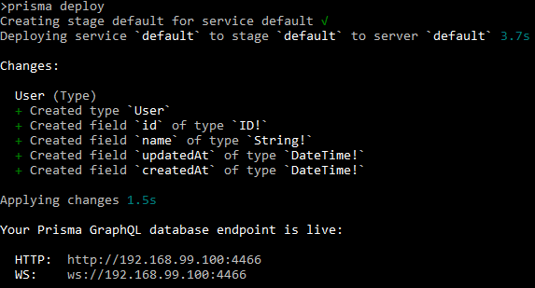

Generate the Prisma Client
To generate the prisma client the following lines of code needed to be appended to the prisma.yml file that was generated when prisma init was performed. I replaced the default generator from typescript to javascript to limit compatibility issues with the rest of the app.
generate:
- generator: javascript-client
output: ./generated/prisma-client/
After these lines of code have been added I ran the command: prisma generate this generates the client and stores it in the “output:” directory.

Finish Preparing the Node.js Application
First, I installed the required packages. Then I created the index.js file and added the boilerplate code to it provided by the getting started guide
Npm install –save graphql
Npm install –save prisma-client-lib

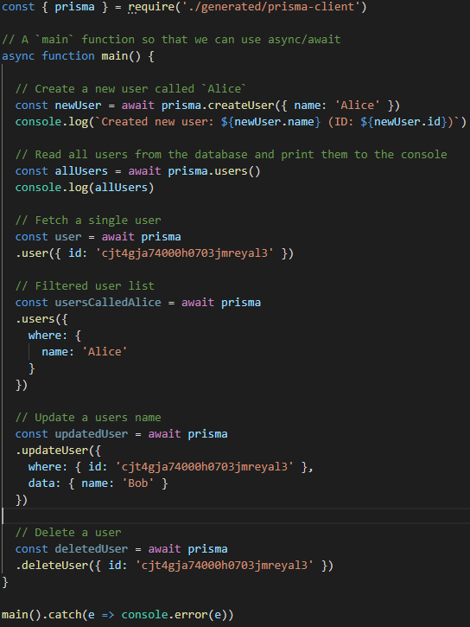
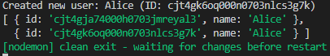

Change the Datamodel
First update the datamodel.prisma file as follows. The redeploy the app command: prisma deploy
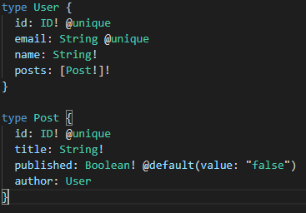
The index.js file was updated to insert data into the new database models. The new data that was entered was then queried to check the inserts had operated as expected.
