**LAB1**

1. GET /users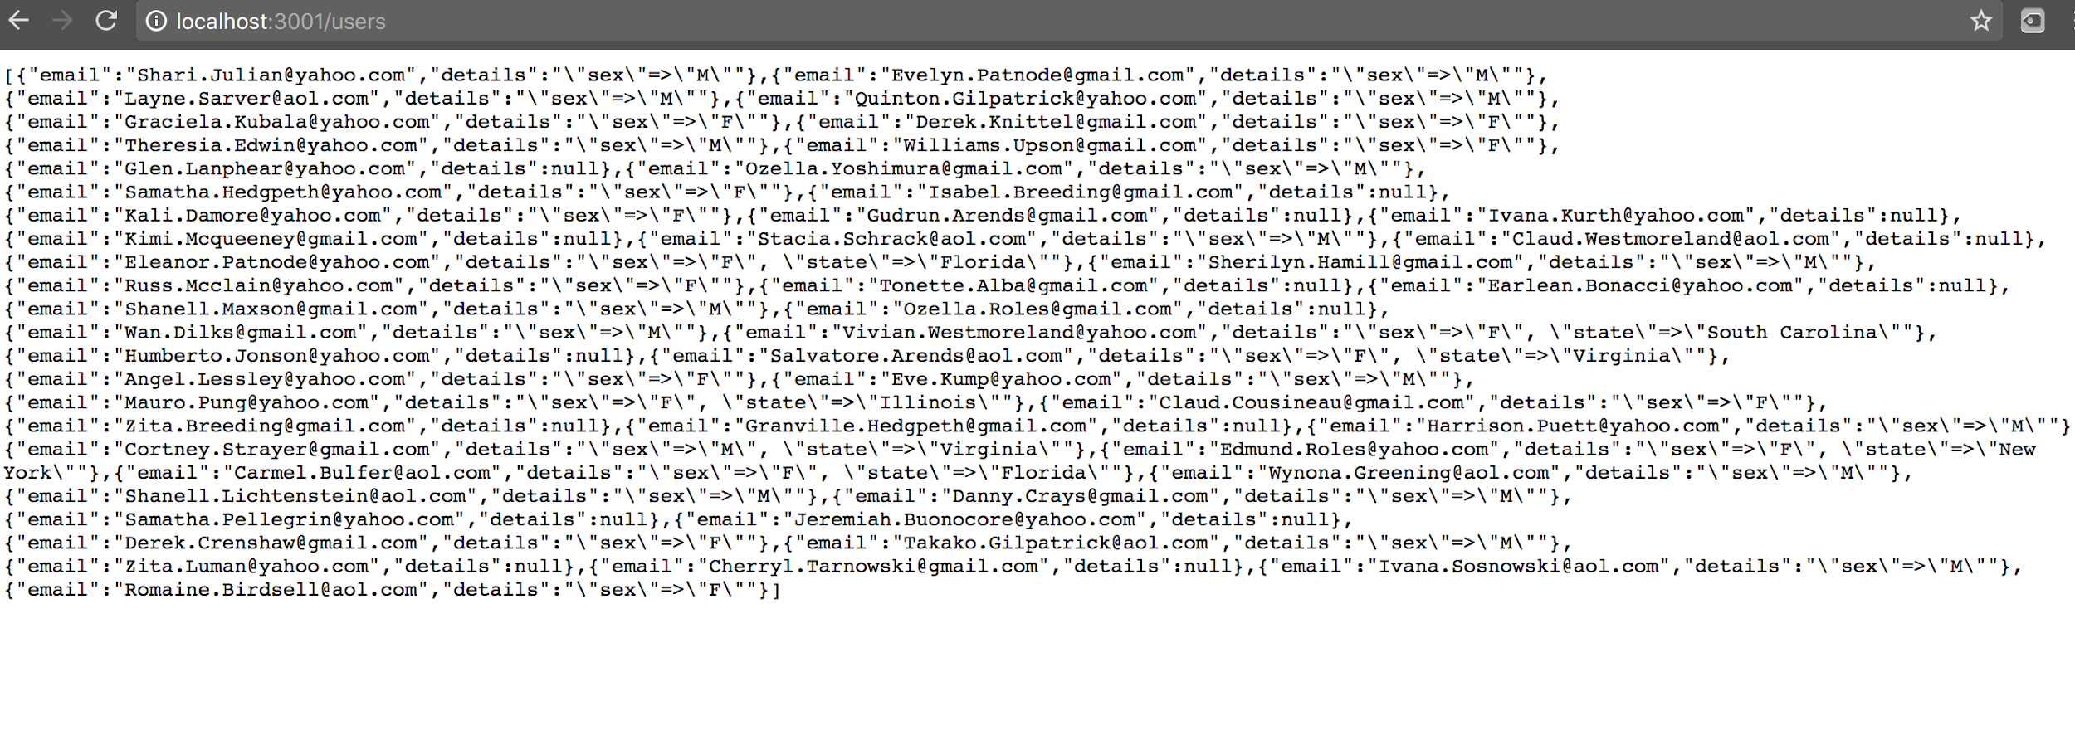

GET /users/:id

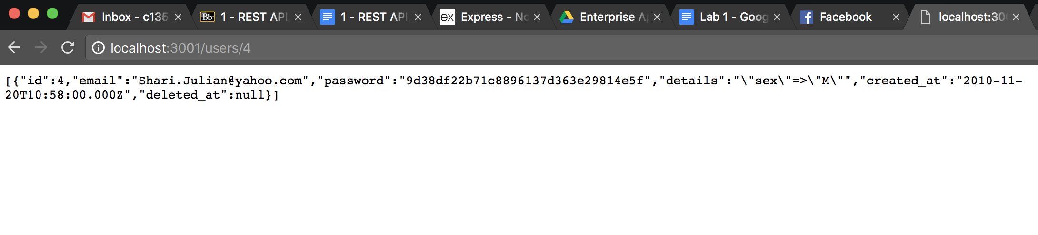

GET /products

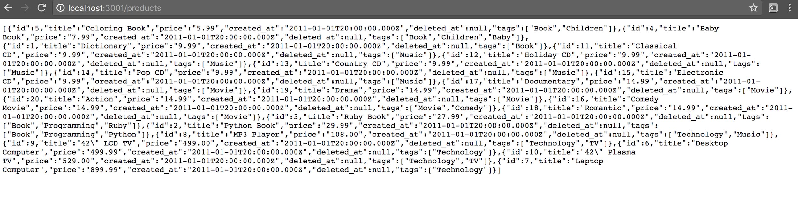

GET /products/:id

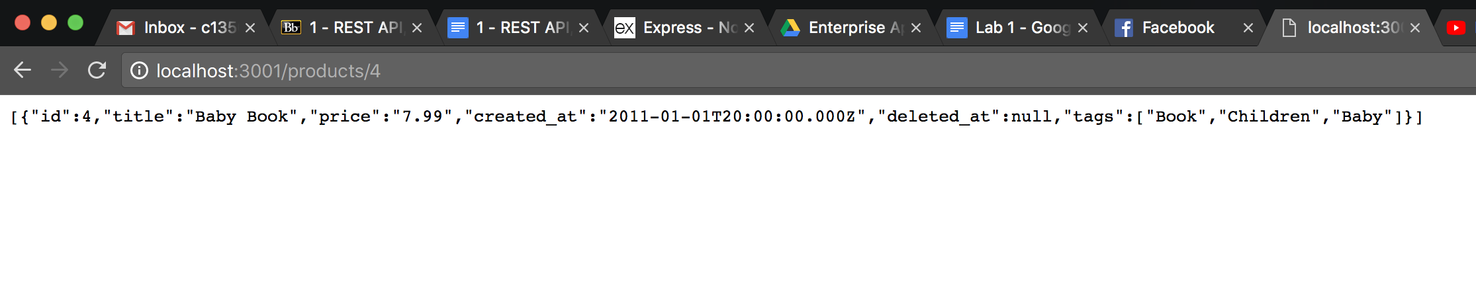

GET /purchases

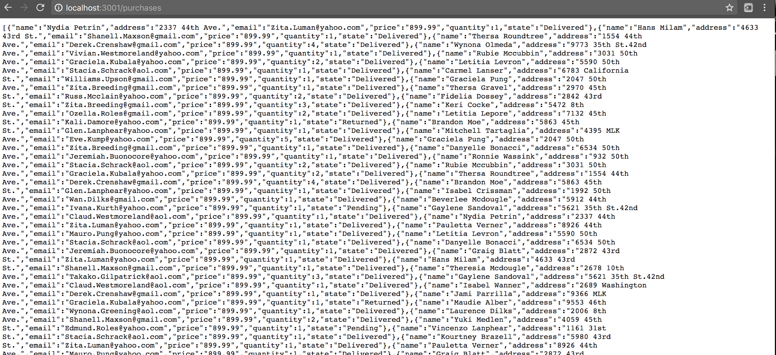

4.

