Using Node, Express and Massive create the following HTTP API endpoints serving the following resources as JSON documents

**List all users email and sex in order of most recently created. Do not include password hash in your output**

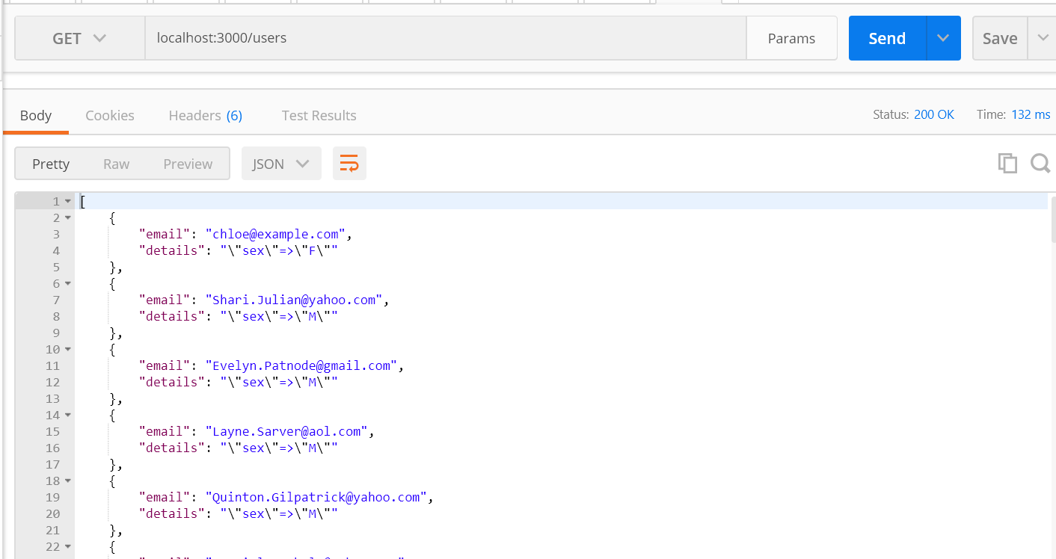

**Show above details of the specified user**

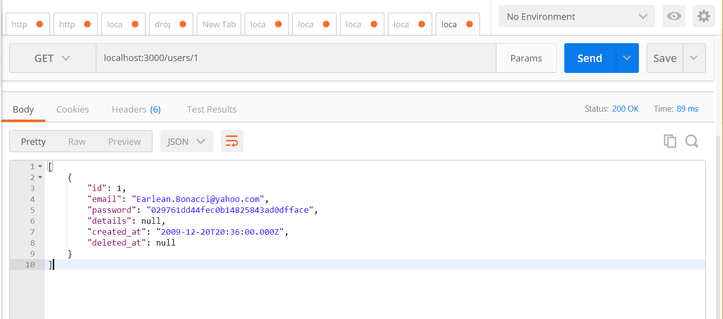

**List all products in ascending order of price**

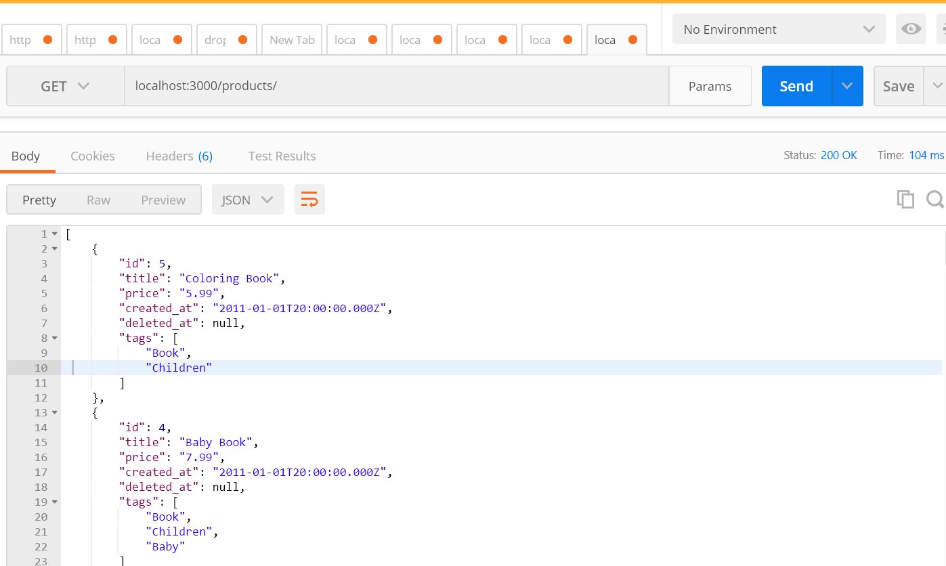

**Show details of the specified products**

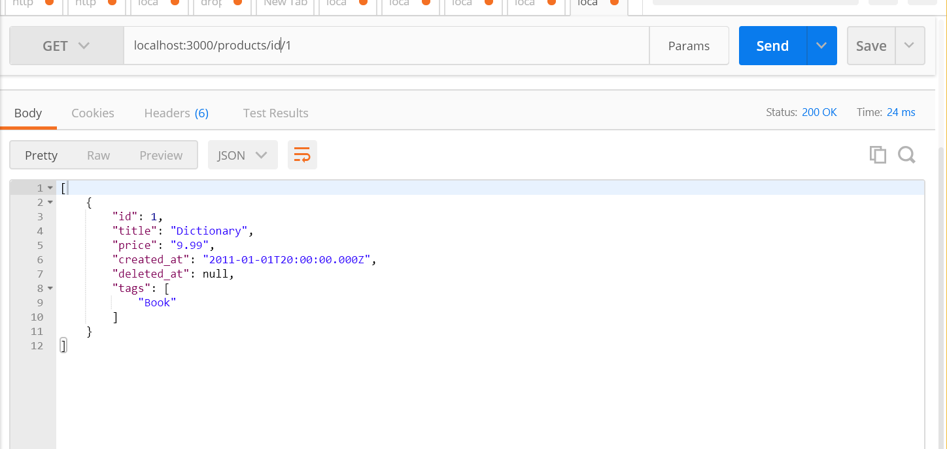

**List purchase items to include the receiver’s name and, address, the purchaser’s email address and the price, quantity and delivery status of the purchased item. Order by price in descending order**

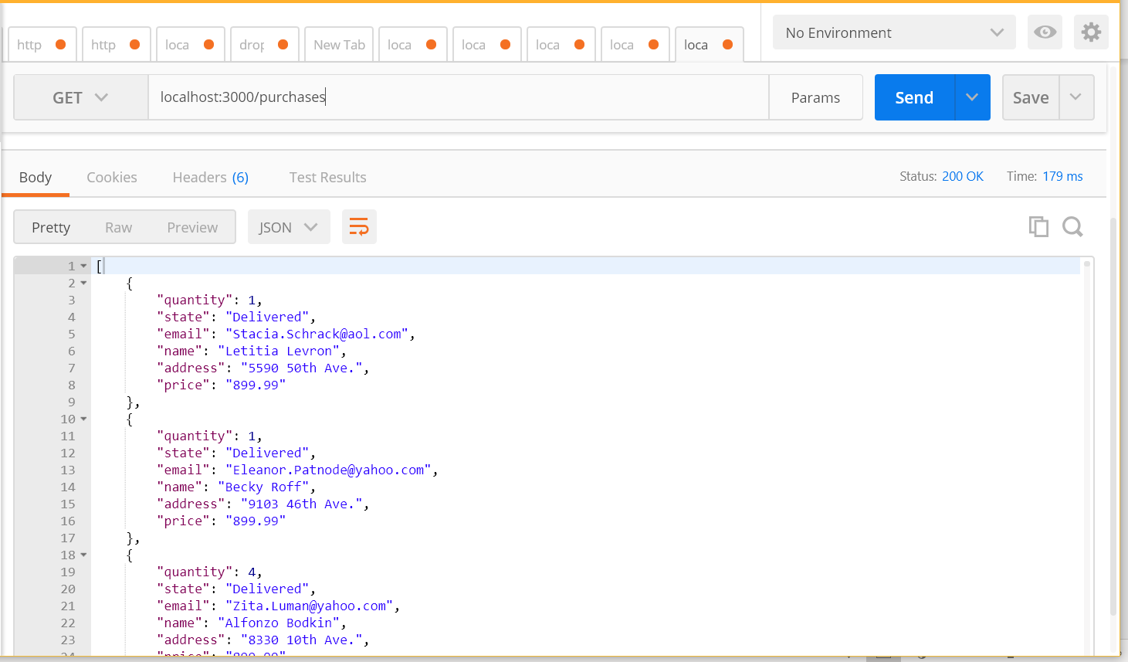

**Badly implemented get products by name**

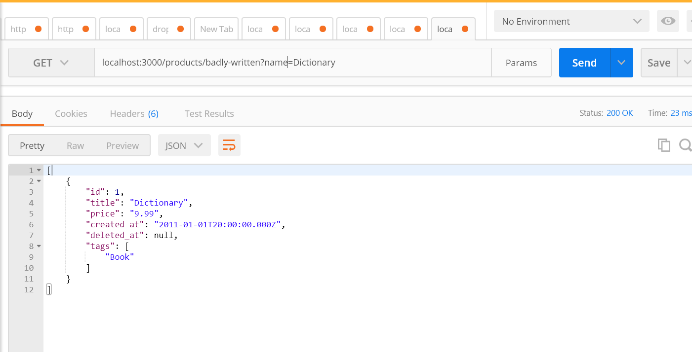

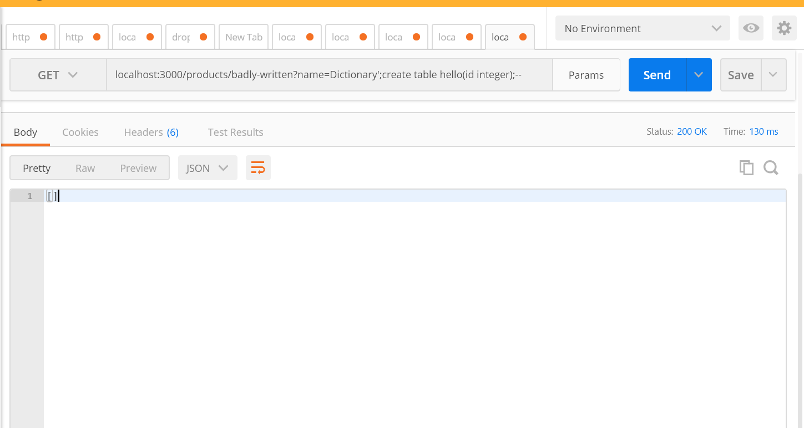

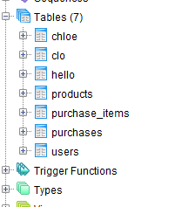

**Safe parametrised query- does not create a table**

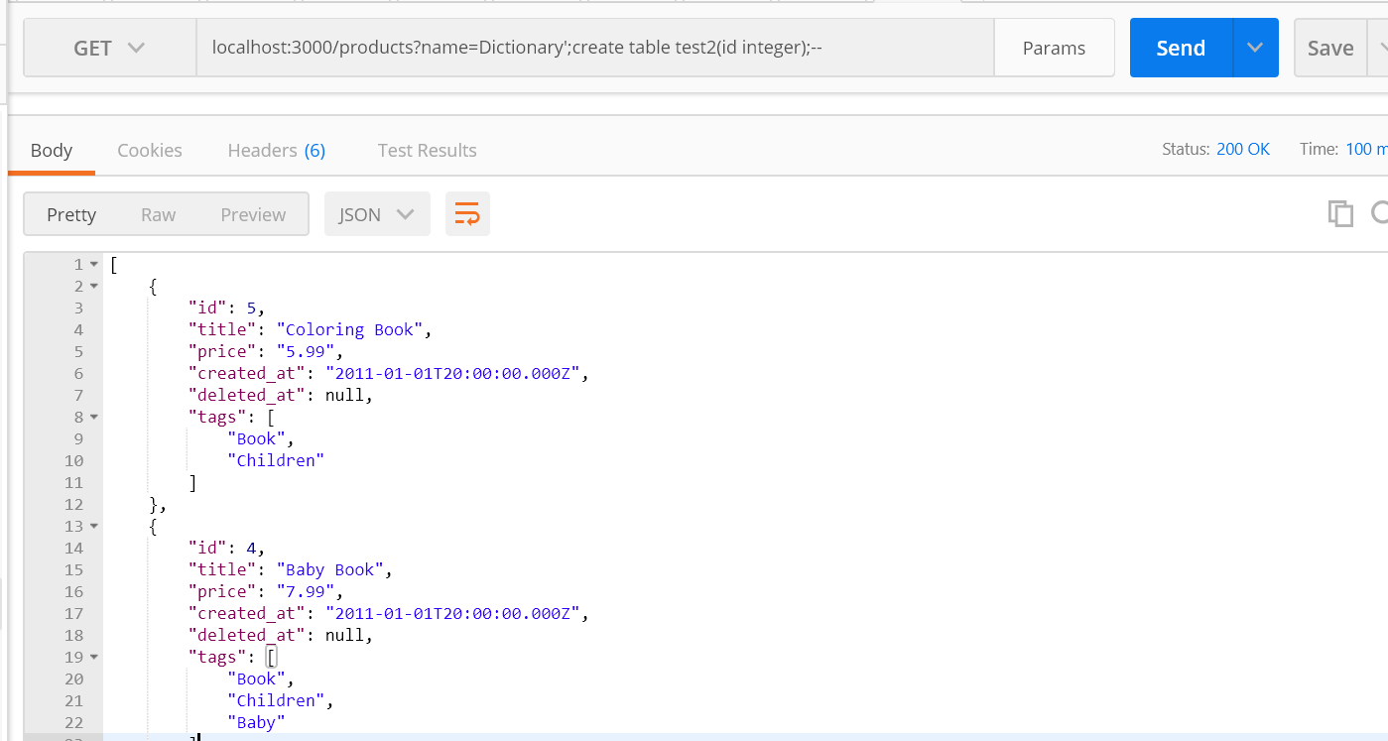

**Created a stored procedure – proc.sql**



**Run the function and does not allow for sql injection**

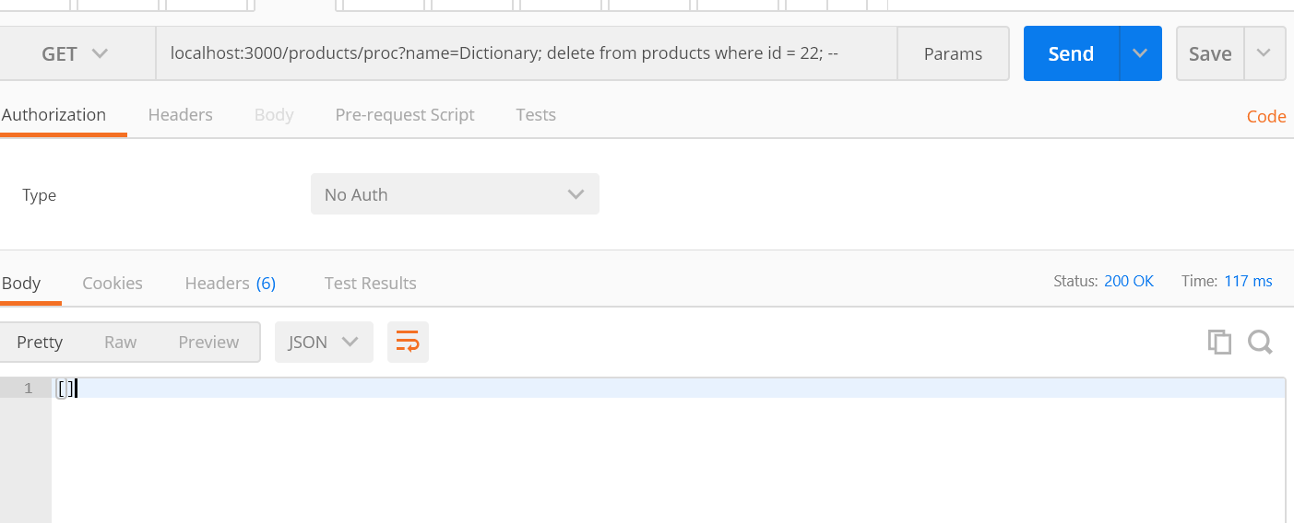

**SEQUILIZE PART – CONNECTION SUCCESS**

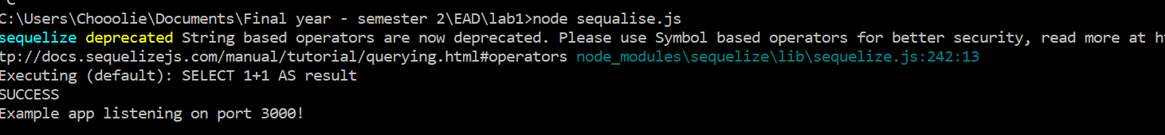

**Did this for all tables – purchases, products, users, purchase_items. And then populated them**

**Doing the next art – get-put-delete, post requests**

**List all products**

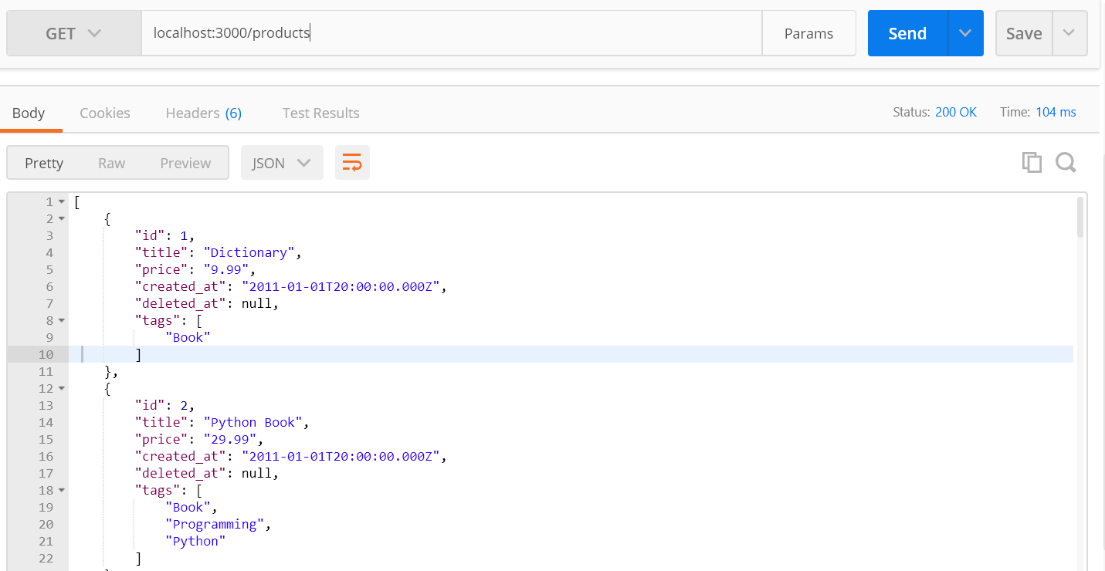

**List all details of specific id**

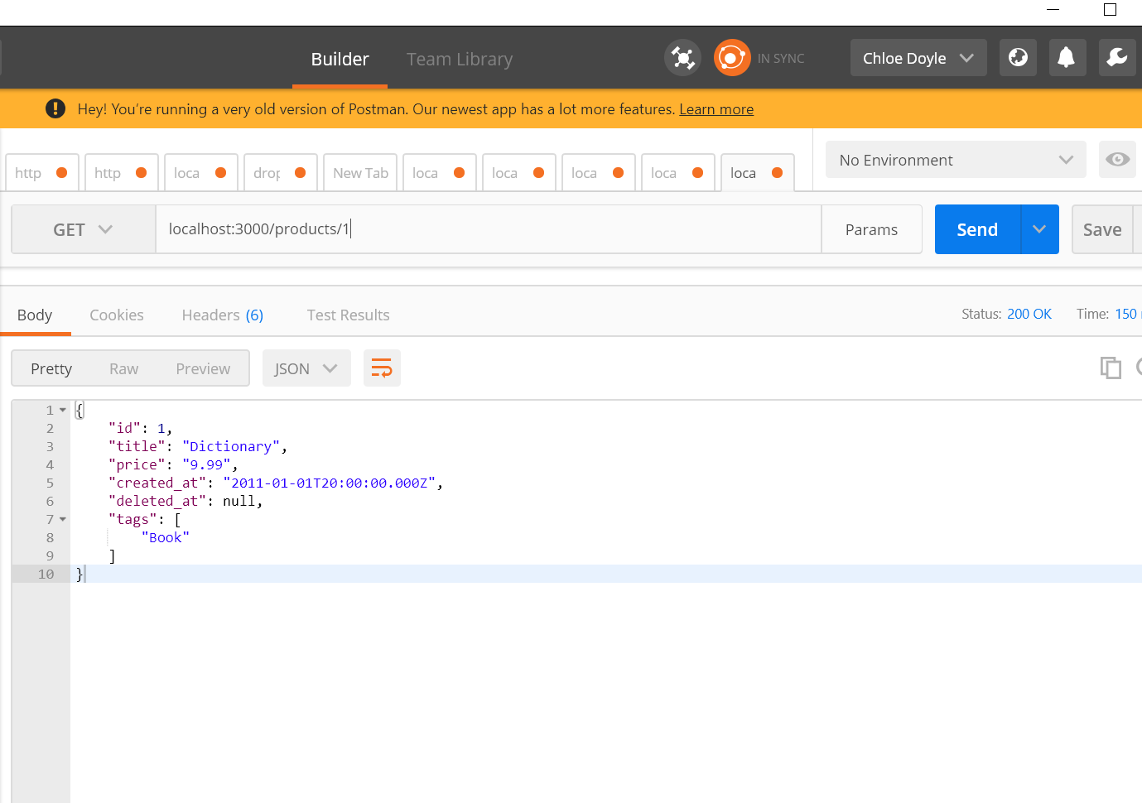

**Create a new product instance**

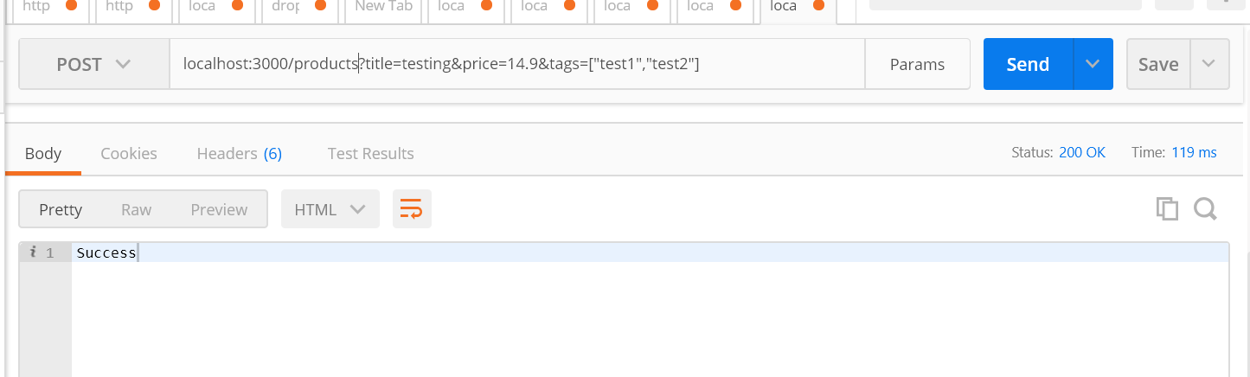

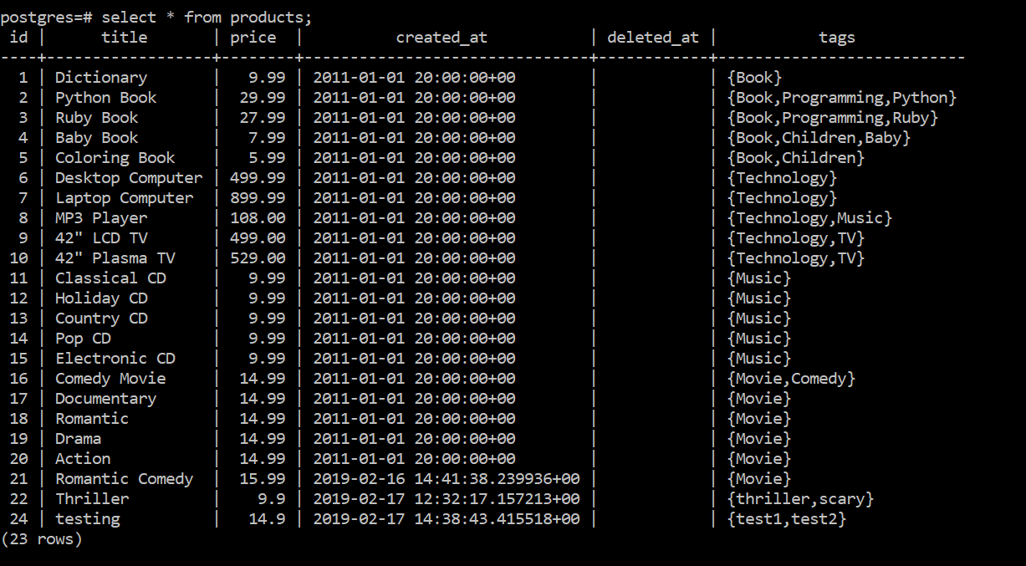

**Updating the price of item 24**

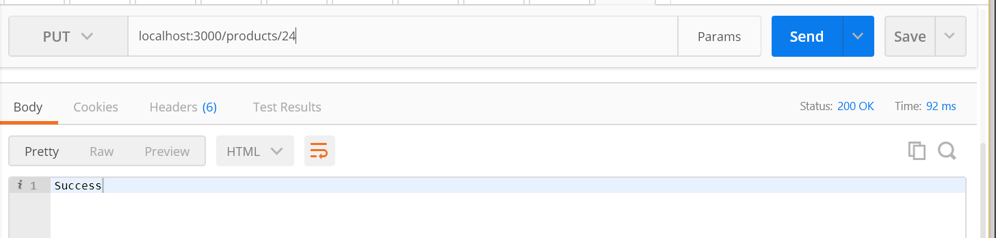

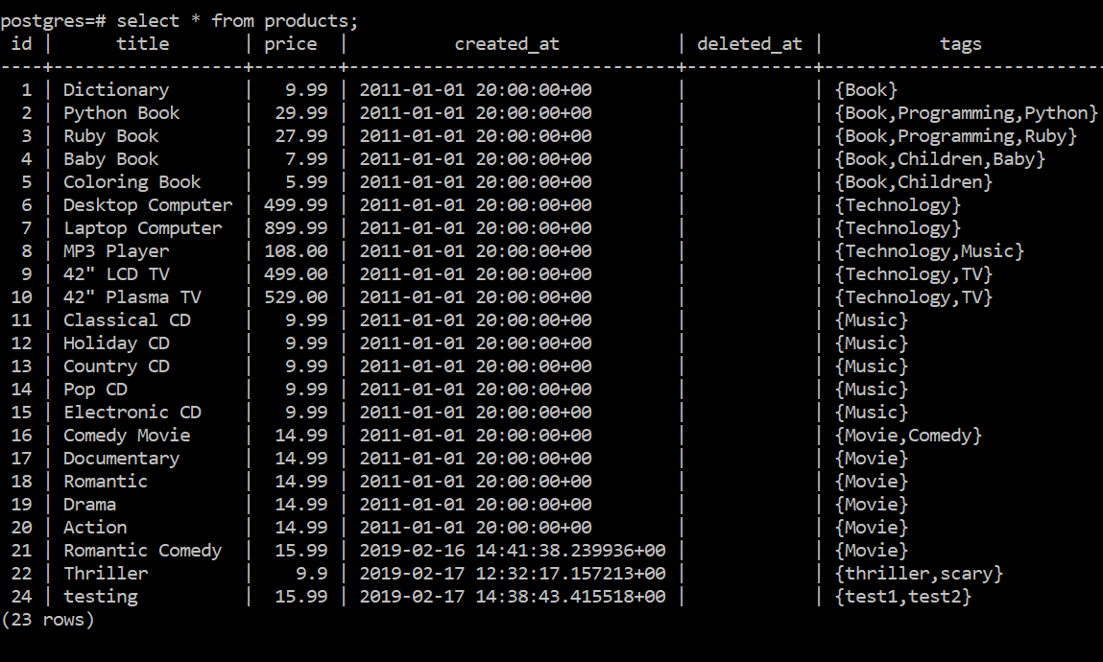

**Remove an existing product – deleting item 24**

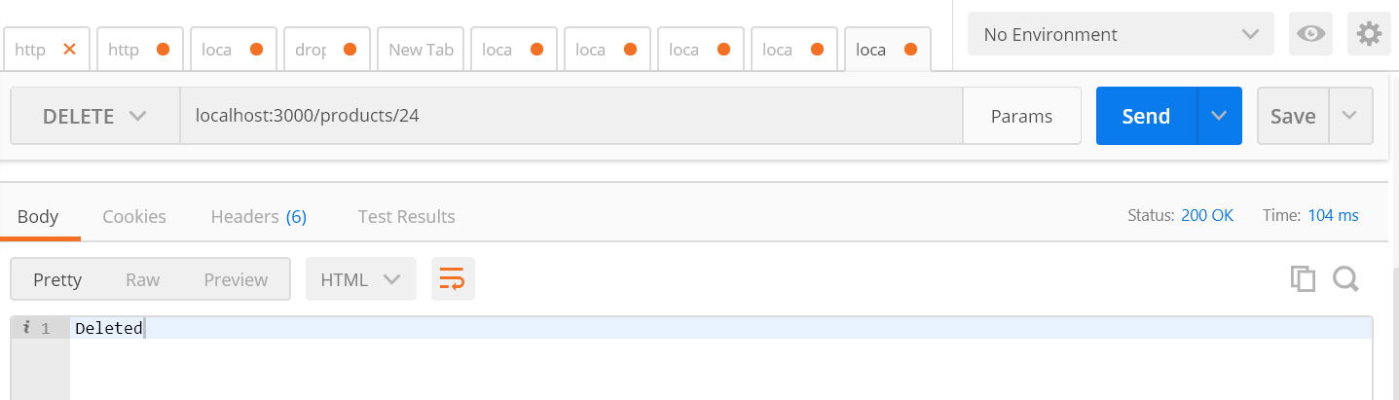

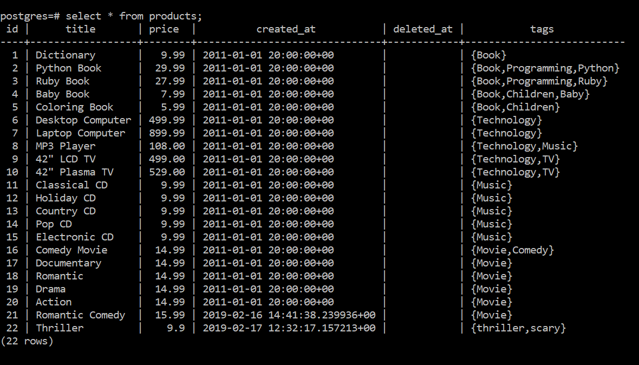

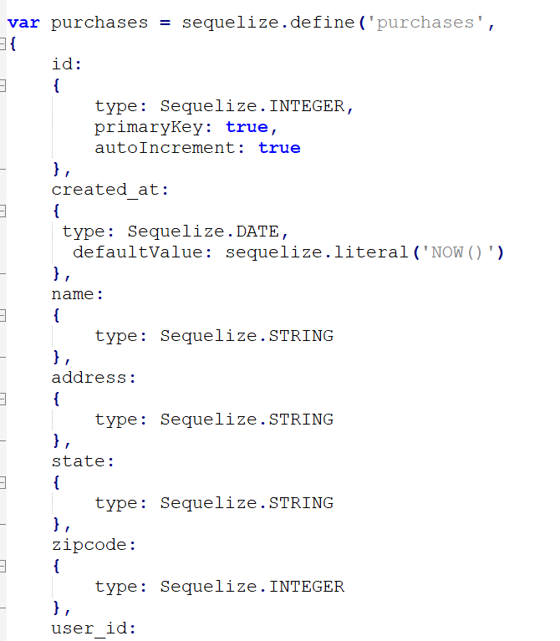

**Inserting into products**

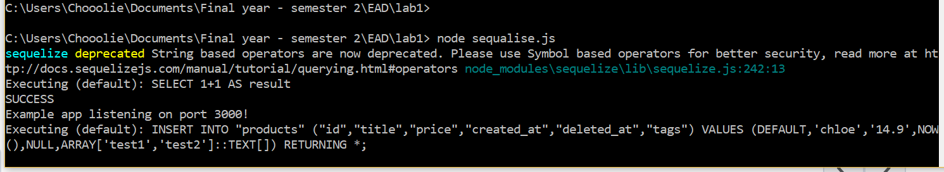

**New product create = romantic comedy**

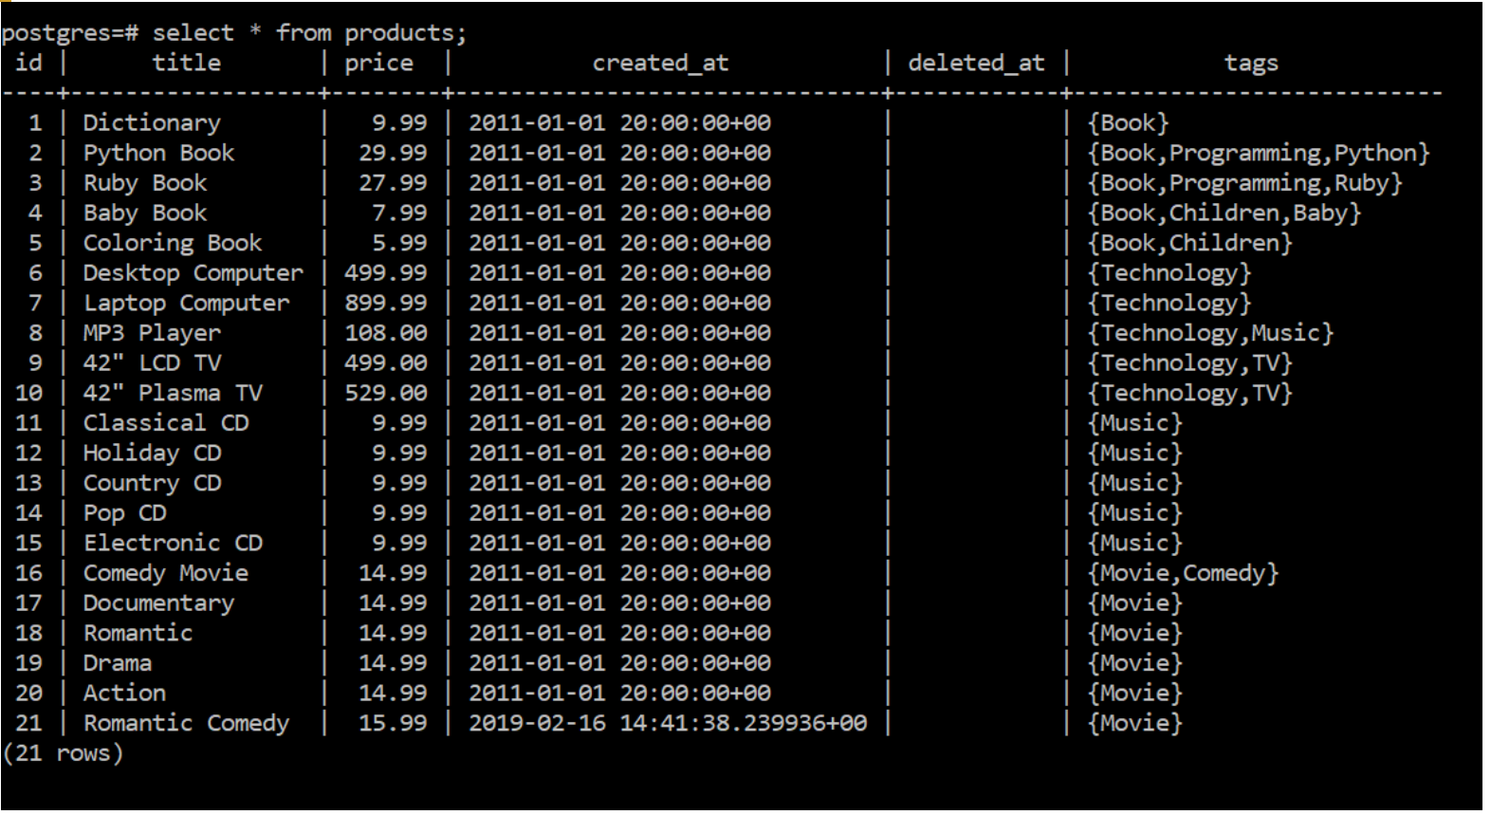

**Did and tested for all others too – like this**

