Screenshots:

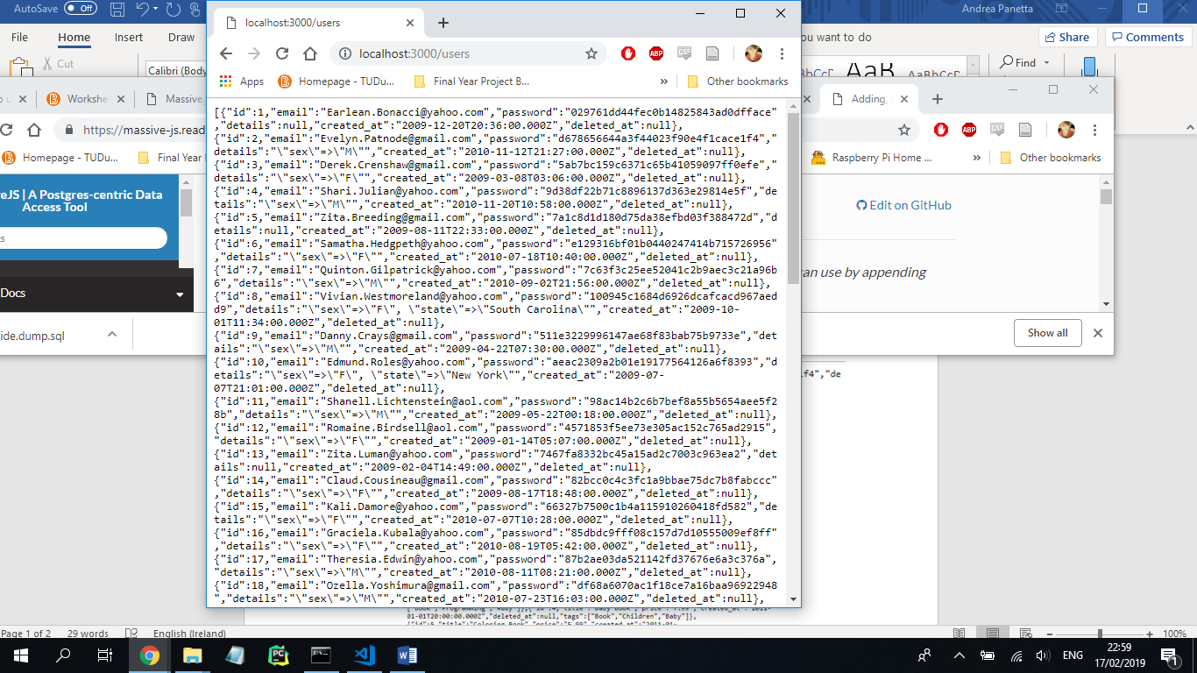

*Screenshot 1: GET /users*

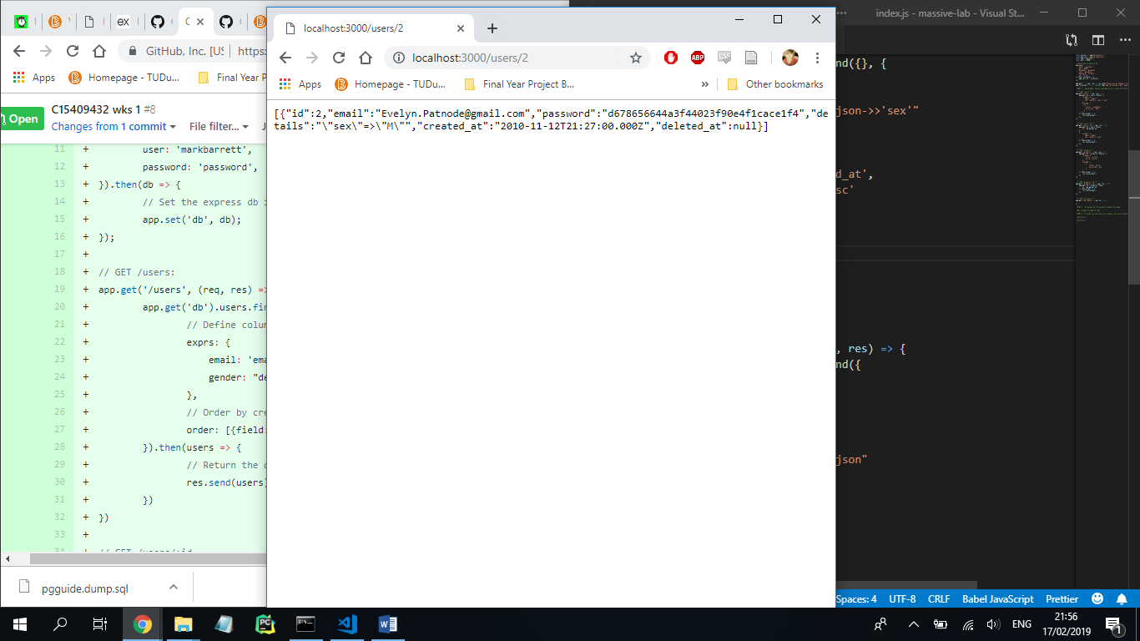

*Screenshot 2: GET /users/:id*

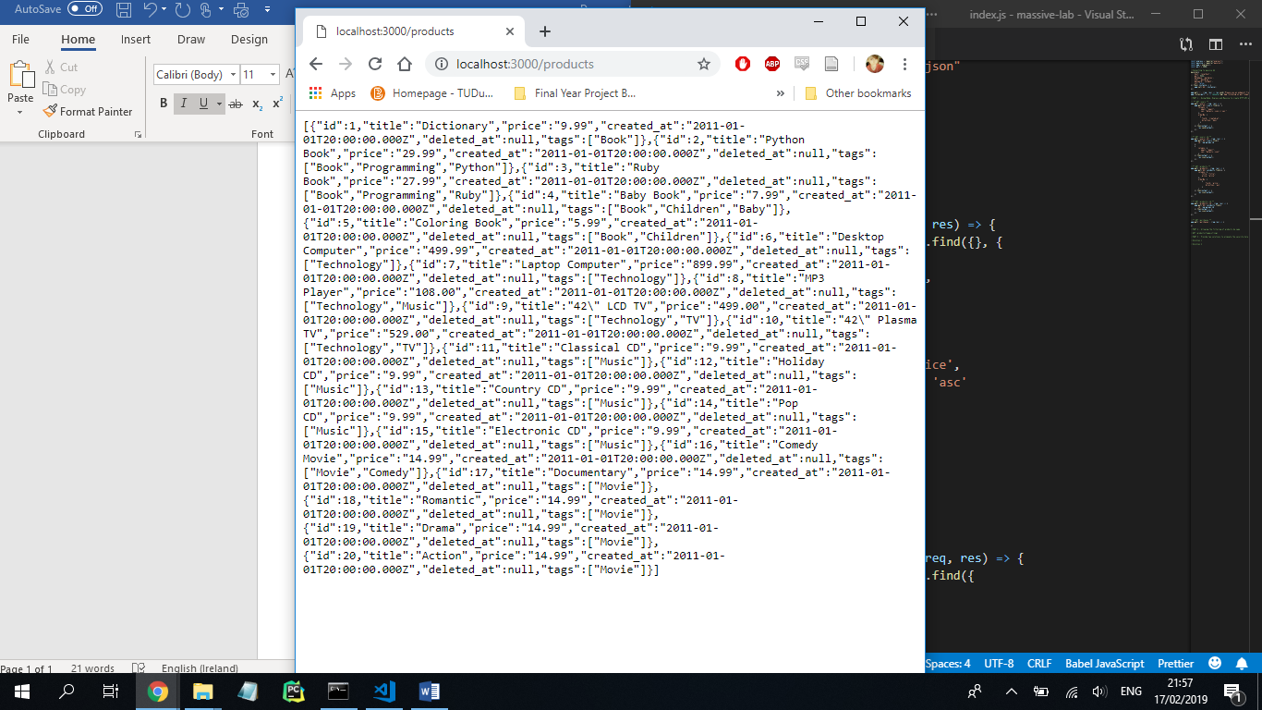

*Screenshot 3: GET /products*

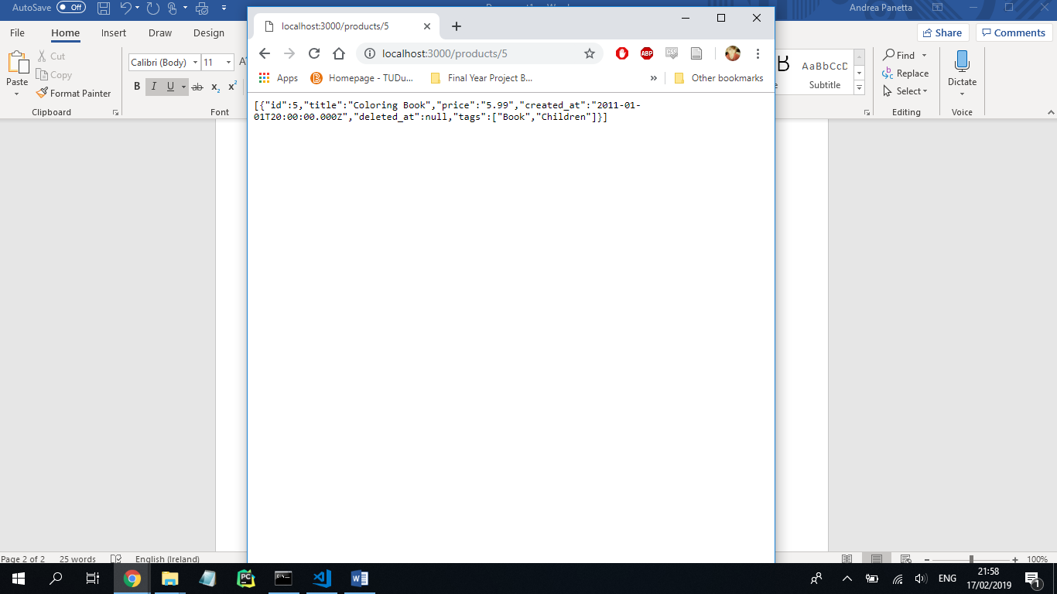

*Screenshot 4: GET /products/:id*

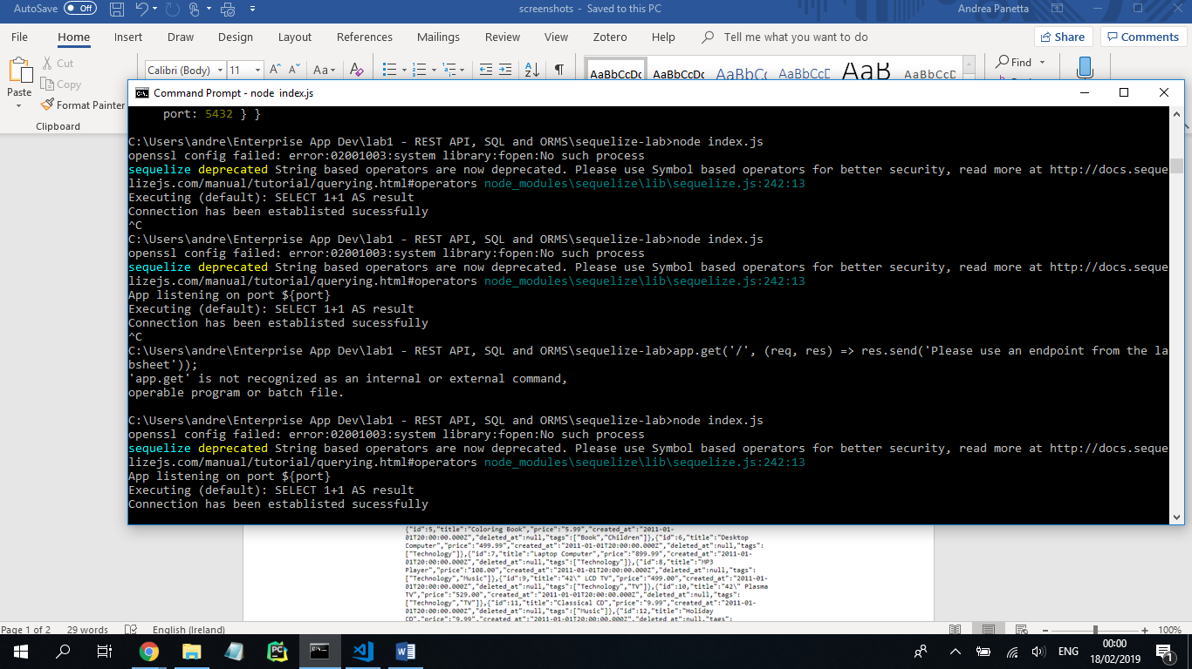

*Screenshot 5: Connection to database using Sequelize*