# Problem Set One

Part One – GET /users

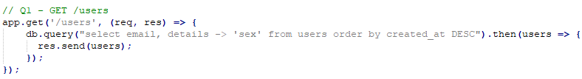

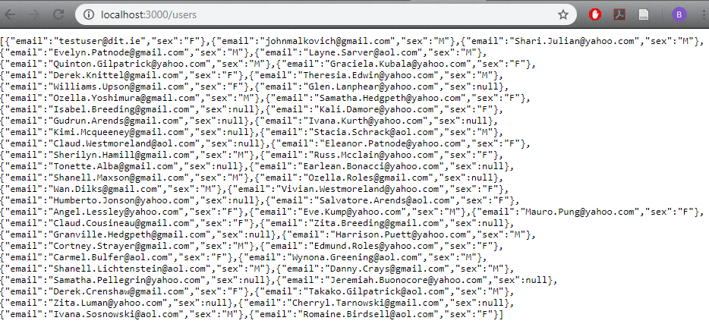

Part Two – GET /users/:id

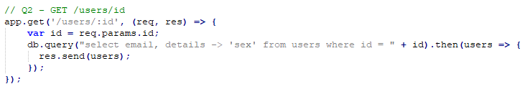

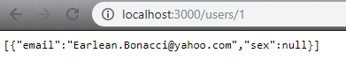

Part Three – GET /products

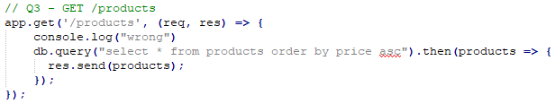

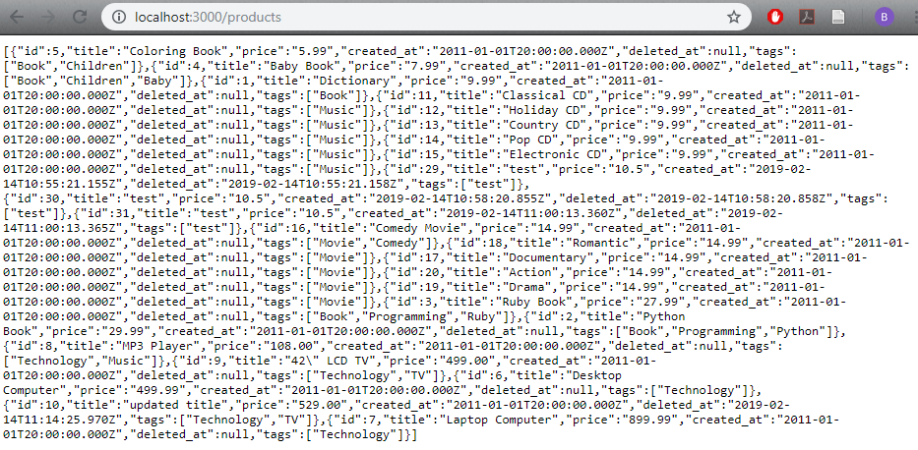

Part Four – GET /products/:id

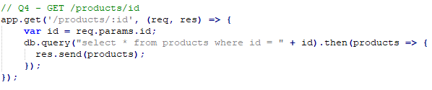



Part Five – GET /purchases

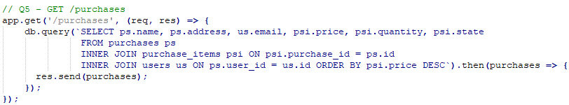

# 

# Problem Set Two

Part One – GET /products[?name=*string*]

If/else statement is used to differentiate between when a user enters string or not.

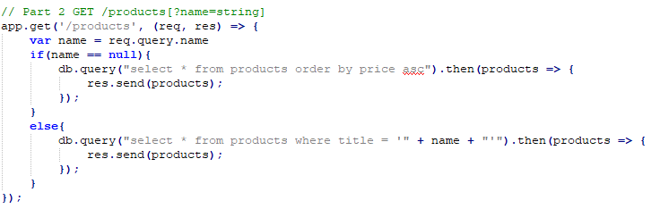

First implementation selects all products

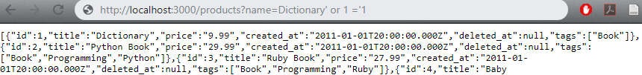

Following query deletes all from the user table

# Problem Set Three

Part One – Parameterised Query

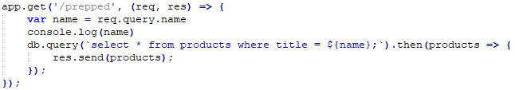

Searches for a single title work, sql injection attempts throw promise errors.

Part Two – Stored Procedure

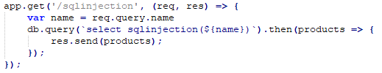

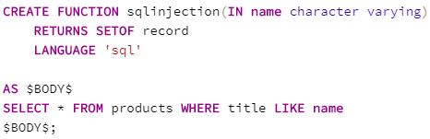

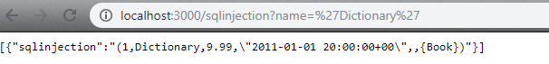

# Problem Set Four

config

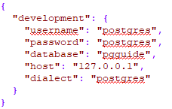

## Models

users.js

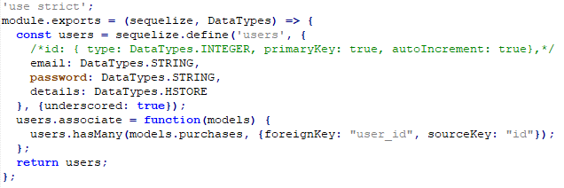

products.js

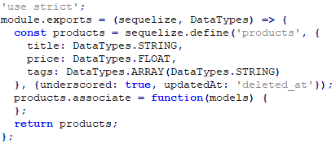

purchases.js

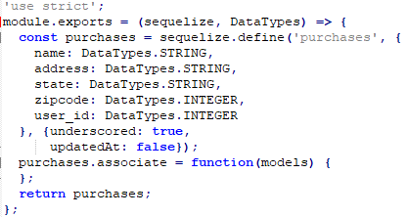

purchase_items.js

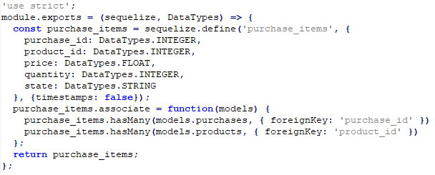

## Migrations

1MigrateUsers.js

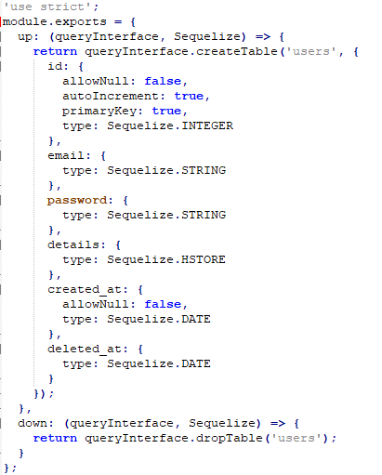

2MigrateProducts.js

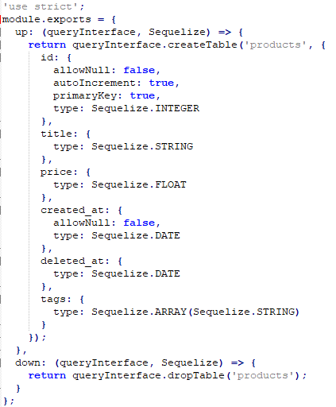

3MigratePurchases.js

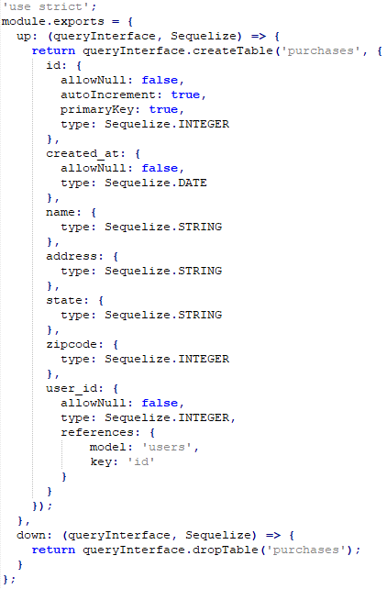

4MigratePurchaseItems.js

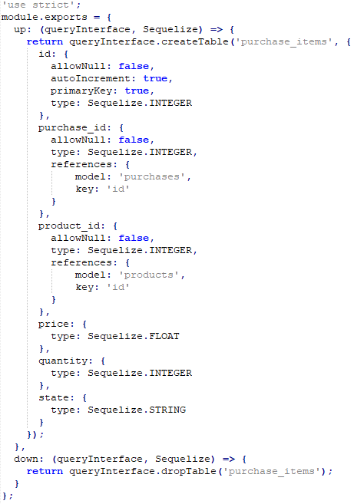

# Problem Set Five

The database was populated with test data using sequelize seeds. Hardcoded records were inserted using one seed file per table.

1updateusers.js

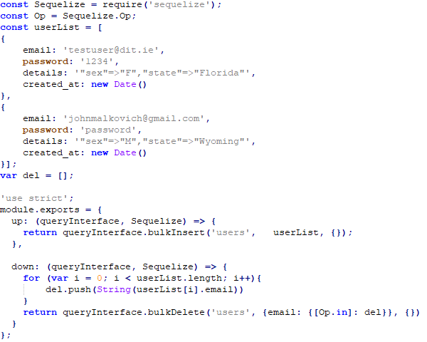

2updateproducts.js

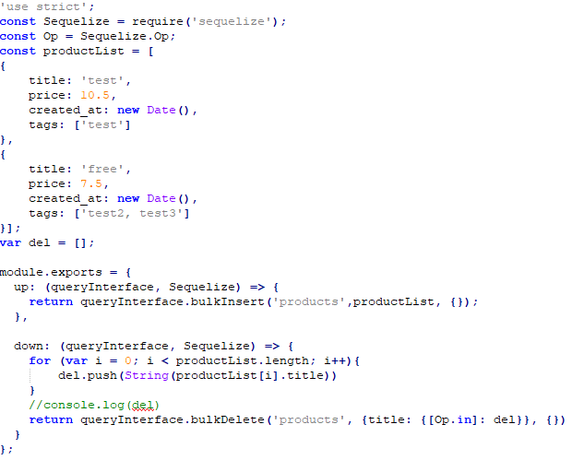

3updatepurchases.js

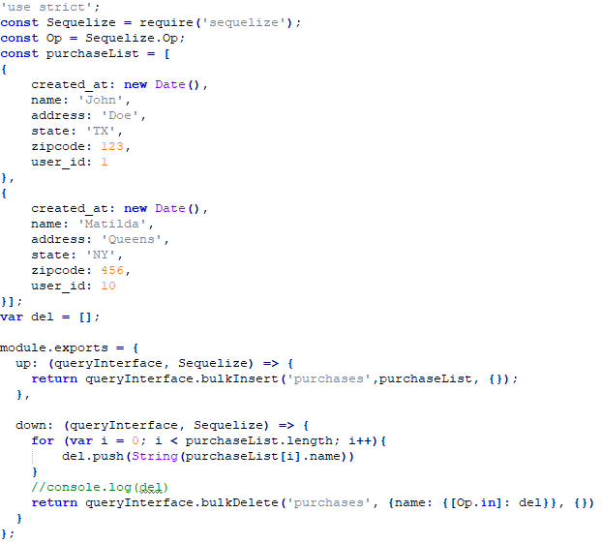

4updatepurchaseitems.js

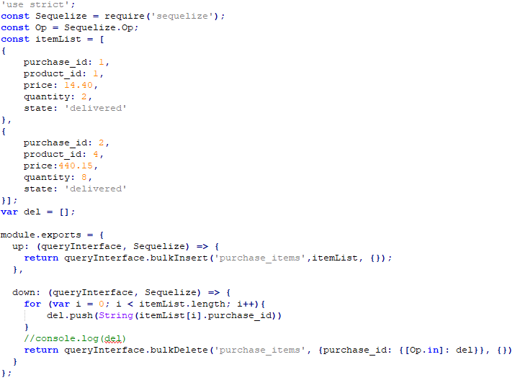

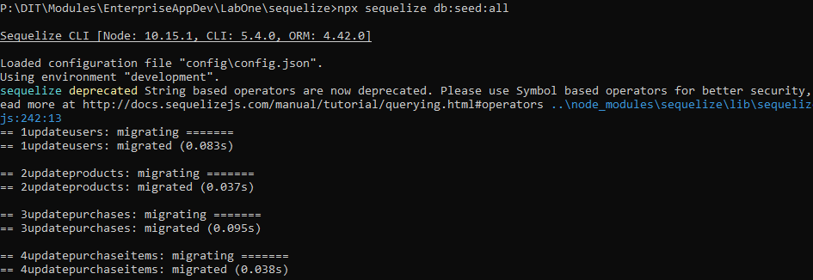

# Problem Set Six

Part One – GET /products[?name=*string*]

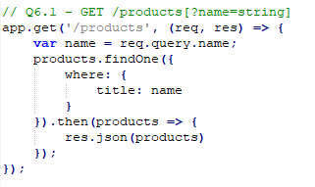



Part Two – GET /products/:id

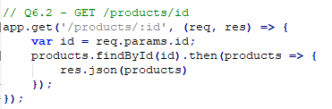

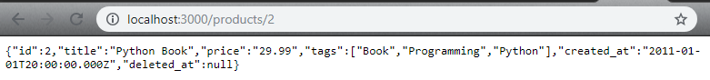

Part Three – POST /products

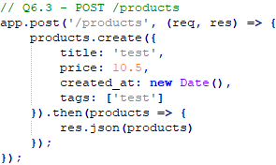

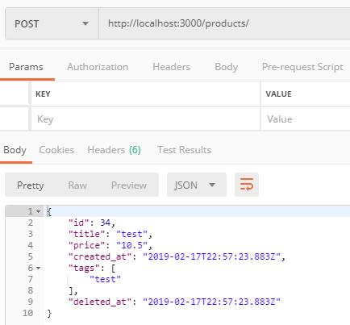



Part Four – PUT /products/:id

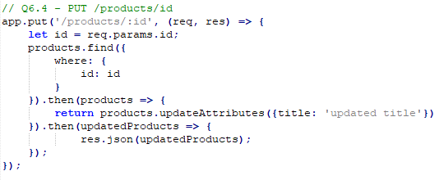

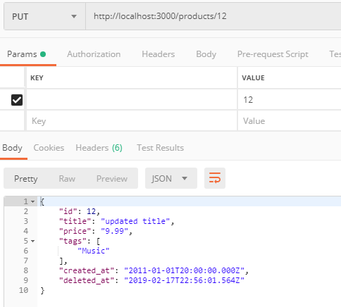



Part Five – DELETE /products/:id

