# Test cases for part 6:

To test the API routes for part 6 of the lab worksheet I user the application Postman.  
Below are screenshot of the query and the response of each route.

## GET /products

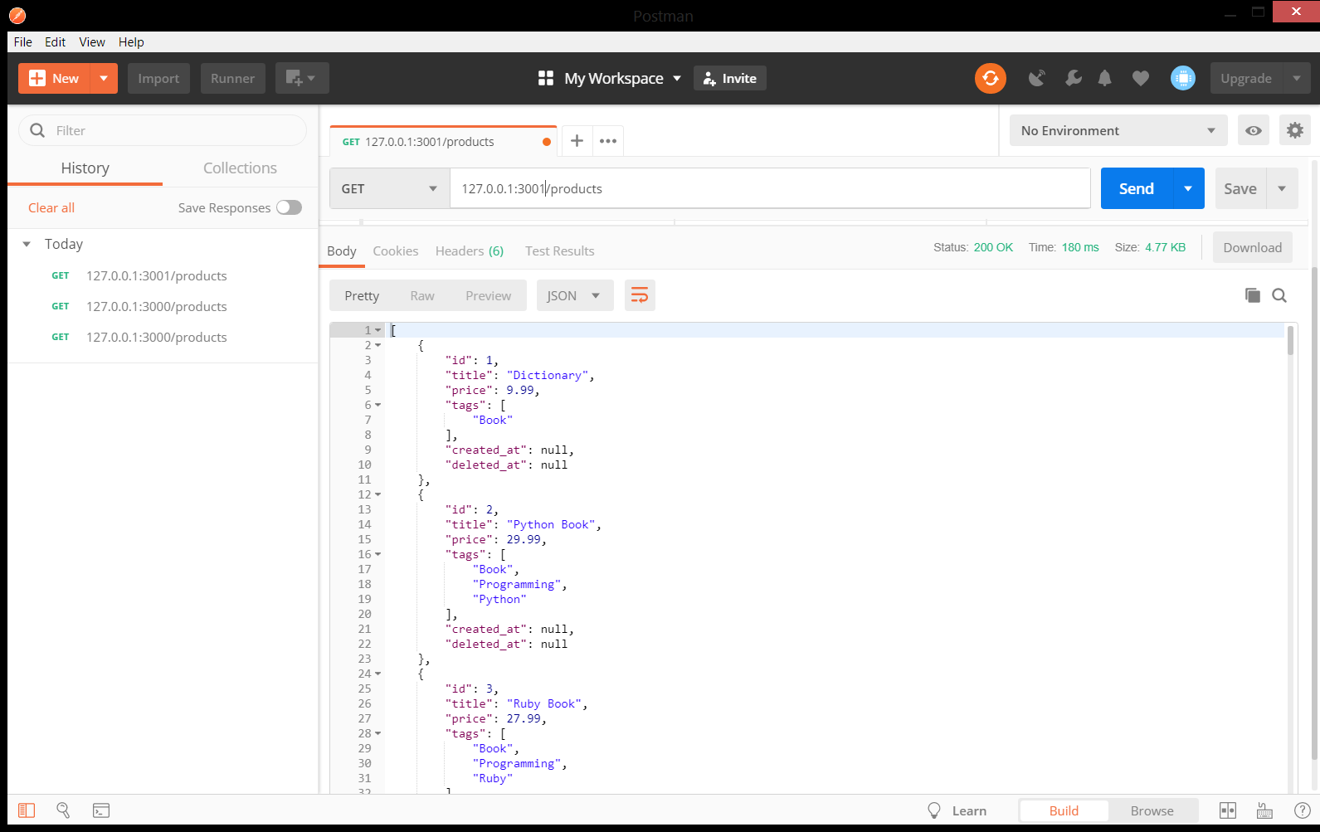

## GET /products/:id

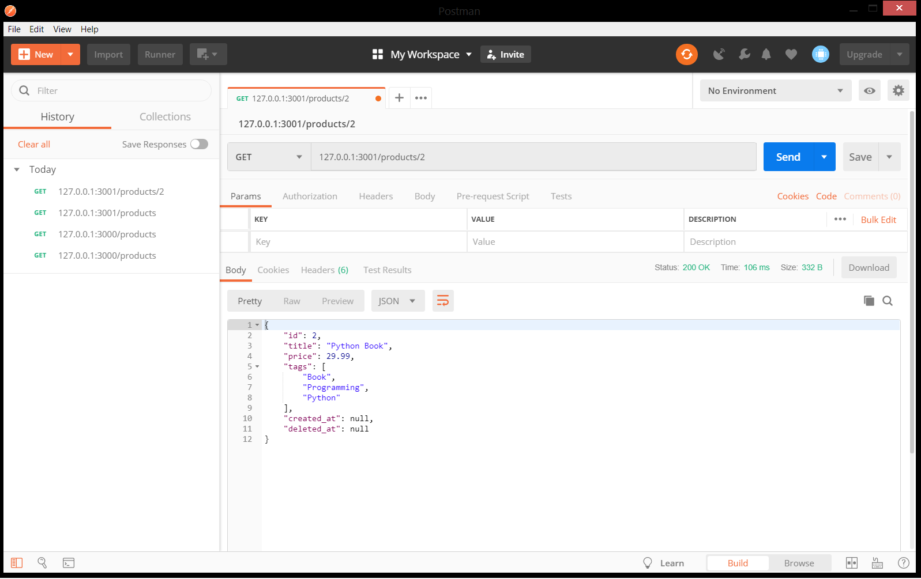

## POST /products

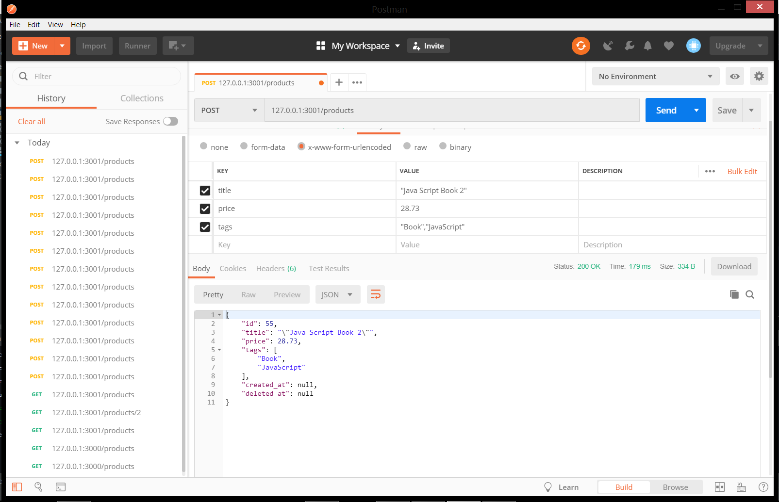

# PUT /products

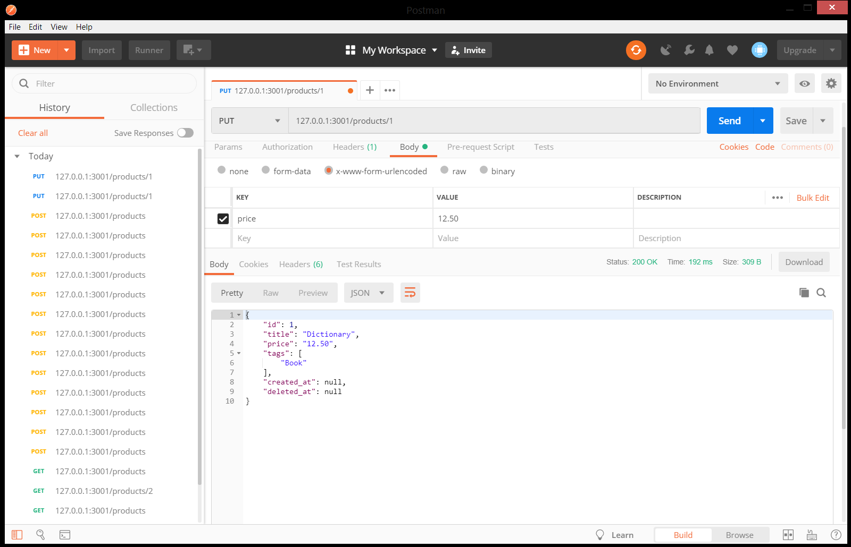

## DELETE /products/:id

### 