<https://www.prisma.io/docs/get-started/01-setting-up-prisma-new-database-JAVASCRIPT-a002/>

1. Install prisma: NPM install-g prisma

2. Create a folder: mkdir helloworld

3. Go to folder: CD hello-world

4. Create the file: touch docker-compose. Yml

Open the file and copy the following code into the docker-compose. yml file

version: '2'

services:

prisma:

image: prismagraphql/prisma:1.28

restart: always

ports:

- "4466:4466"

environment:

PRISMA_CONFIG: |

port: 4466

databases:

default:

connector: postgres

host: postgres

port: 5432

user: prisma

password: prisma

migrations: true

postgres:

image: postgres:10.3

restart: always

environment:

POSTGRES_USER: prisma

POSTGRES_PASSWORD: prisma

volumes:

- postgres:/var/lib/postgresql/data

volumes:

postgres:

5．docker-compose up -d

6．prisma init --endpoint <http://localhost:4466>

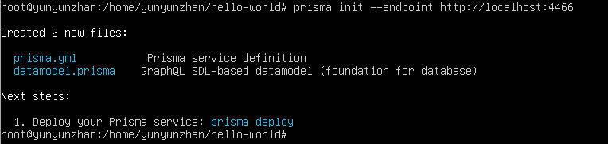

7．prisma deploy

8. Open the file prisma.yml and append the following code to the end

The generate:

- the generator: javascript - client

Output: / generated/prisma - client /

9. Prisma generate

10. Touch the index. Js

11. NPM init - y

12. NPM install - save prisma - the client - lib

13. Open index.js and copy the following code in

const { prisma } = require('./generated/prisma-client')

// A `main` function so that we can use async/await

async function main() {

// Create a new user called `Alice`

const newUser = await prisma.createUser({ name: 'Alice' })

console.log(`Created new user: ${newUser.name} (ID: ${newUser.id})`)

// Read all users from the database and print them to the console

const allUsers = await prisma.users()

console.log(allUsers)

}

main().catch(e => console.error(e))

14. Run: node index.js, and the result is as follows: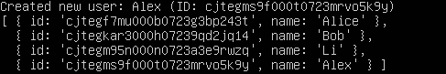

Fetch single user

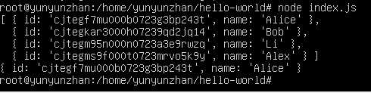

Filter user list

