Brendan Hawk
24 April 2024
BU MET ██ ███ Spring 2 2022
Term Project

Building A Data Warehouse
Sea Around Us Reconstructed Catch Data

Background
“Nowadays, as fisheries need to be managed in the context of the ecosystems in which they are embedded (Pikitch et al. 2004), less than full accounting for all withdrawals from marine ecosystems is insufficient. Therefore, the Sea Around Us strives to provide time-series of all marine fisheries catches since 1950, the first year that the Food and Agriculture Organization of the United Nations (FAO) produced its annual compendium of global fisheries statistics.”[1]
The Sea Around Us catch data is a reconstructed dataset that presents the total catches both in volume of biomass and as a standardized dollar amount for all years since the origination of the FAO’s annual reporting[1]. This dataset is extensively dimensioned, is available for several different kinds of distinct geographical areas, and is thoroughly and methodically prepared. As accessed for this project, there are 68 years of annual data covering 281 Exclusive Economic Zones. These EEZs are a marine area extending from the coast outward 200 nautical miles where nations are given exclusive use and access rights. There are, of course, multiple overlapping EEZs as well as many EEZs that belong to countries that hold political power over an area such as the many island territories governed by the United States or United Kingdom. Additionally, countries can make agreements with other entities to allow for fishing in their waters.

Technical Overview
From the source, there are seven important dimensions for this data:
- Commercial Group, a grouping of species based on commercial productions and catch methods
- EEZ
- End Use Type, eg Human consumption or fish meal and oil production, etc.
- Fishing Sector, eg Industrial or recreational, etc.
- Functional Group, another broad grouping taking into consideration feeding habits, sizes, etc.
- Gear, the type of fishing equipment used for the catch
- Taxon, the scientific taxonomy of the type of fish caught
There is also, of course, the time dimension. This data is published as annual values, so that is the only part of a time dimension we have. A ninth dimension has been added to enrich the dataset, pulling in the last 30 years of the Human Development Index values from the United Nations Development Programme. This metric is provided alongside the catch data in its original publication as a sort of economic indicator for the nation that controls the area being reported on. Here, instead of only providing one current value, historical data has been provided to view these values “then and now” with the historical catch data.

Assumptions and Realities
The original intentions of this project, which will be discussed in more depth later, did not come to fruition. The documented sources[2] of the data were unfortunately abandoned without posted notice, so the upfront assumptions about the availability and formats of the raw data were almost entirely wrong. The dimensional data design was thankfully rescued by focusing on a few manual extraction efforts, using undocumented API calls, and going to the source’s sources.
The best example of this is the dimension of taxonomic classifications. In the documentation the original project proposal was based off of it is listed as a dimension cube that could be accessed (alongside all the other dimensions and facts) using AWS services. Since none of those services are supported at this time, I was forced to try to find or reverse engineer all the taxa and their respective attributes myself. This was first attempted by going to straight to its original source, FishBase[3]. However, this was arduous, slow, and didn’t provide me a meaningful way to access the data in any automated fashion. There are over two thousand taxa to record, and having to do each one by hand was an impossible task. Searching for further sources of similar information, I then attempted to use the Integrated Taxonomic Information System[4], however it was not thorough enough in the realm of sea life. Finally, I landed on the World Register of Marine Species[5], and mercifully there is a python package[6] created by a community member to help automate the API access.
This is a very long-historied dataset, and it is being matched with a much younger dataset in the HDI. This naturally means that historic associations don’t exist in the years where the catch data is available but the HDI did not yet exist.
There can be much discussion and analysis of data in the EEZs that overlap. This project does not attempt to approach that subject. For any further information on how the catch data reconstruction may have addressed this, the original source has lengthy documentation on their methodology[1].

Warehouse Design and Processing

Design and Schema
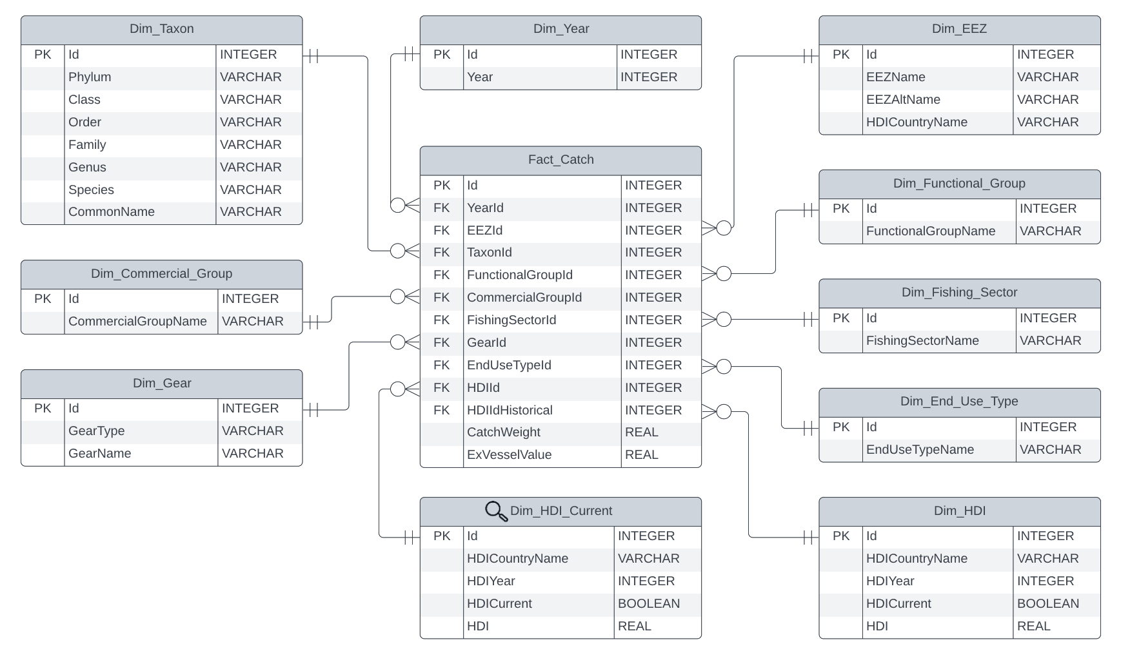Figure 1: Final Warehouse ERD

This warehouse design was truthfully a very straightforward exercise in Dimensional Modeling. Each fact attribute is separated into its own dimension. Dimensions and Facts are both keyed using surrogate primary keys created in the ETL pipeline. The run of this pipeline is treated as an historic load, so there would be a few changes to the scripts in the future if the need arose to make this an ongoing loading process.
Of note, there is one Slowly Changing Dimension: the HDI. Thankfully, the entire warehouse is over the same temporal grain, so matching values both historic and current is easier than usual. In lieu of using two columns to mark temporal validity for the SCD values, we can use just one to mark the year. Type 7 was chosen for ease of implementation and the ability to provide ongoing “then and now” analysis. A view was created for the “current” values to act as a second table and both it and the original HDI table are separately linked to the fact table with their primary key values.

ETL: Extraction
As mentioned above, the original design intention relied on (outdated) documentation detailing access to the original datasource in full through AWS services. It was unfortunately well past the design and planning phase when the actual extraction was begun and it was discovered that this access was no longer supported. I reached out directly to the Sea Around Us project in hopes that I could get even a subset of an image of their systems, but unfortunately they were unable to accommodate the request.
Instead, a large and unplanned amount of time was spent trying to figure out how to get the data from the source while avoiding being a bad actor to their systems. The only access I had to begin with was the same download button on their web-based exploration tool, which would require me to manually acquire separate data for each of the 281 EEZs. Before beginning what might have amounted to an entire day of work, I used the tools and experience I have as a web software engineer and found that their website access is built on top of an API layer. I do not generally condone the “abuse” of such APIs – if it is not built for public consumption then it is probably not built to handle open usage, and I do not condone harming the functionality of a project even for good reasons – however in this case I would only be automating the same calls that this website already uses to download this data. As a measure of good faith, the script written to perform this task uses timed pauses to minimize its impact and to mimic the same amount of time and load that I would have caused by manually downloading each set of data.
With non-standard geography comes a need to have data detailing the geography in a system that can then be used to draw these shapes on map. Another set of undocumented API calls retrieved this information from SAU as well as some metadata for each EEZ. This geographic data in “geojson” format would later be fed to our BI layer for the desired mapping functionality, and the metadata would later be used to populate the naming information for the EEZs.
HDI data was downloaded directly from the source website.
Lastly, one of the dimensions was detailed in the now-outdated SAU data access documentation. This was pulled directly from their project documentation on GitHub[2] and saved as a CSV for later processing. Before load, some exploration confirmed that the values still matched the values in the fact data.
With the EEZ attribute data, some dimensional data, the fact catch data, and the taxa acquired as detailed in the section above, I decided not to continue digging up the other dimensional attributes, and simply to use what was present in the raw fact data and press on.

ETL: Transformation and Load
First and foremost, the database was created with its entire structure. This included all the dimension table schema and both the raw and final fact table schema. A single PostgreSQL file was the most efficient way to accomplish this.
Transformation took a few different approaches, since the data was now in a few varied formats. First, the EEZ attribute data was pulled out of the json values from the SAU API using a tool called “jq”: a command-line tool used for parsing and query json structures[7].
The fact data was downloaded in zip files that contained the data and some citation and documentation. Unzipping was also automated using scripted command line tools for efficiency’s sake.
The rest of transformation and load took place in python scripts as Jupyter notebooks. These are a great tool for both large and small data processing and warehousing projects because they are interactive, but also automatable. First, the raw fact data was loaded from the unzipped csv files. Out of an abundance of caution for memory limitations, this was done on each file separately, rather than reading the entire dataset together and bulk inserting at once. From this raw source, the year, functional group, commercial group, fishing sector, and end use type dimensions were all loaded into their respective table as the set of unique values from the raw data. Since this is a one-time historical data load with no new data expected, I opted not to include an “unknown” record in these dimension tables. I would strongly recommend doing so if this were an ongoing warehousing effort.
The EEZ dimension required one step of manual processing. This data needed a correlation between it and the official names of countries so that later steps could match our fact records with the HDI values. Unfortunately, this was impossible to do in any automated fashion. I suppose in a proper long-lived data warehouse a single manual step might be taken to generate a crosswalk that could then be used. I opted to manually do this once knowing it did not have to be repeated on new data in the future.
The gear and EEZ data each have their own loading scripts, as these data are coming from separate source flat files. The gear data has only minor processing; the second column is a list of gear names and the first is a type for each row. These lists were split into individual rows with the type repeated for all values in the original list. The HDI data is also loaded in its own script, and similarly processed from “wide” to “long” having each column (representing a year of values) become a separate year attribute column and a value column. Rows for the most recently available year are marked as “current”, thus also populating the view portion of the Type 7 SCD it represents.
With all the data transformed and loaded, the final fact table can be built. For each chunk of data processed, the matching dimension keys are looked up and added to the dataframe. Some minor transformation is called for, such as standardizing the capitalization of gear name to make matching the gear dimensional values possible or converting the dollar amounts to dollars-and-cents instead of decimal values in millions of dollars. The data is finally loaded into the fact table and the warehouse data is complete.
The database is originally created with no indexes. The fact table has foreign keys, but no other restrictions. As a final step to make the BI layer more usable, indexing is done on the dimension key columns in the fact table and the primary key column of every dimension table. No unique constraint was created on the dimension keys either, so that the load phase could be as performant as possible. This is also added when running the indexing SQL file.

Bibliography
- Pauly D., Zeller D., Palomares M.L.D. (Editors), 2020. Sea Around Us Concepts, Design and Data (seaaroundus.org).
- Sea Around Us. Sau-ubc-cic-catchdata. 2022. Project Repository accessed online, https://github.com/SeaAroundUs/sau-ubc-cic-catchdata
- Froese, R. and D. Pauly. Editors. 2022. FishBase. World Wide Web electronic publication. www.fishbase.org, version (02/2022).
- Integrated Taxonomic Information System (ITIS), www.itis.gov,
https://doi.org/10.5066/F7KH0KBK
- WoRMS Editorial Board (2022). World Register of Marine Species. Available from https://www.marinespecies.org at VLIZ. Accessed 2022-04-21. doi:10.14284/170
- Rosas-Puchuri, Ulises., wormstools. 2020. Project Repository accessed online, https://github.com/Ulises-Rosas/WoRMStools
- Dolan, Stephen. jq. 2022. Project accessed online, https://stedolan.github.io/jq

