**Domain Model**: Betty Jo Booth (CS 414)

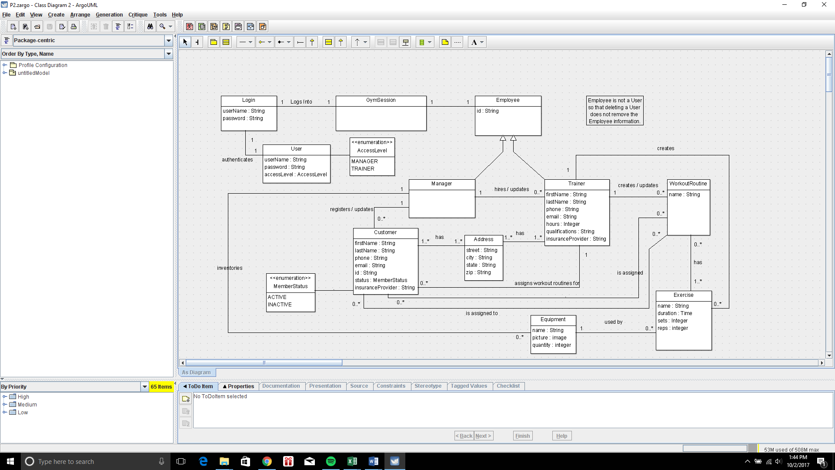

**GLOSSARY:**

|  |  |  |  |
| --- | --- | --- | --- |
| Term | Description | Format | Validation |
| Address | Composite of street, city, state, and zip. |  | Addresses do not need to be unique (i.e., two employees can share an address). |
| Address street | Street name and number | String (50) |  |
| Address city | City of address | String (25) |  |
| Address state | State of address | String (26) |  |
| Address zip | Zip code of address | String (9) |  |
| Customer | Not a direct Actor on the system. However, Customers (their information) are entered into the system by Managers and their WorkoutRountines created and modified by their Trainer. |  | Must be ACTIVE to be assigned WorkoutRoutines. |
| Customer address | Type Address. |  | Required |
| Customer email | Contact email for Customer. | String (50) |  |
| Customer firstName | First name of Customer. | String (25) | Required. |
| Customer id | Customer ID. | String (15) | Required / Unique |
| Customer insuranceProvider | Name of the insurance provider for the Customer | String (50) | Required |
| Customer lastName | Last name of Customer | String (25) | Required |
| Customer phone | Contact number for Customer. | String (10) |  |
| Customer status | The current status of the Customer based according to a predefined MemberStatus.type. If INACTIVE, workout routines cannot be assigned to the Customer. | ACTIVE or INACTIVE | Required |
| Employee | All Actors on the system (i.e., Manager and Trainer) are Employees. Has an ID. |  |  |
| Employee id | ID of the employee. | String (15) | Required / Unique  May be generated. |
| Equipment | Equipment kept by the gym. Equipment is created and updated by Users who are Managers. In turn, Equipment can be incorporated into Exercises to be included in Workout Routines.  Equipment is a composite of name, picture, and quantity. |  |  |
| Equipment name | Name of the equipment. | String (50) | Required / Unique. |
| Equip0ment picture | An image (likely jpg or something) of the equipment. | jpg. - ? | Required |
| Equipment quantity | The number of this equipment owned by the gym. | Integer | Required |
| Exercise | A specific exercise that can be done by a Customer. One or more exercises can be assigned to a single WorkoutRoutine.  A composite of name, machine, and duration OR sets/reps. |  |  |
| Exercise machine | Optionally, a machine (Equipment) can be assigned to an Exercise. | Equipment | One max / Optional |
| Exercise name | Name of the exercise. | String (50) | Required / unique |
| Exercise duration | An exercise may define a duration in lieu of a number of sets and corresponding reps. | Time | One of duration or sets and reps must be provided (not both). |
| Exercise sets/ reps | An exercise may define a number of sets and corresponding reps per set | Integer / Integer | One of duration or sets and reps must be provided (not both). |
| GymSession | Represents the current gym management system session. It has knowledge of the currently logged in User and corresponding Employee and their valid options (based on access level). Based on this, the GymSession determines the appropriate set of actions to be made available / displayed to the User. |  |  |
| is assigned | Association between Customer and WorkoutRoutine. A Customer can be assigned 0 or more WorkoutRoutines. | association | Customer is assigned zero or more WorkoutRoutines. |
| is assigned to | Association between WorkoutRoutine and Customer. A WorkoutRoutine can be assigned to 0 or more Customers. | association | A WorkoutRoutine is assigned to zero or more Customers. |
| Login | Authentication of Users of the system based on username and password validation. Also provides a means of creating new Users. |  | A new User can be created only for Employees. |
| Manager | An Employee who is a User on the system. Will interact directly with the system as an Actor to Hire / Update Trainers (0 or more), Register / Update Customers (0 or more), and Inventory / Update Equipment (0 or more). |  |  |
| Trainer | An Employee who is a User of the system. Managed by a single Manager. Will interact directly with the system as an Actor to Create Workout Routines (0 or more), Assign Workout Routines to Customers, Search on Workout Routines by Customer, and Search on Customers by their workout routine.  A composite of firstName, lastName, Address, phone, email, ID, and insuranceProvider, as well as hours and qualifications. |  |  |
| Trainer address | Type Address. | Address | Required |
| Trainer email | Contact email for Trainer. | String (50) |  |
| Trainer firstName | First name of Trainer. | String (25) | Required. |
| Trainer hours | Number of work hours of Trainer. | Integer | Required |
| Trainer insuranceProvider | Name of the insurance provider for the Trainer | String (50) | Required |
| Trainer lastName | Last name of Trainer | String (25) | Required |
| Trainer phone | Contact number for Trainer. | String (10) |  |
| Trainer qualifications | Trainer’s qualifications | String (100) | Required |
| User | User of the Gym Management System. Used in authenticating access to the system with user id and password. Will have associated access levels to allow system to determine valid actions.  This was not included as a base class (i.e., for Manager and Trainer) so that deleting a User would not delete the corresponding Employee. |  | Must be an employee. |
| User Username | Username of User through which user authenticates themselves to the system. | String (15) | Required / Unique. |
| User Password | Password of User through which user authenticates themselves to the system. | String (15) | Required. |
| WorkoutRoutine | Created by a Trainer to later be assigned to Customers.  A WorkoutRoutine is a composite of name and series of 1 or more Exercises. |  | Can only be assigned to an ACTIVE Customer. |
| WorkoutRoutine name | Name of the workout routine. | String (50) | Required / Unique |
| WorkoutRoutine exercise | A series of one or more Exercises that define the WorkoutRoutine. |  | A WorkoutRoutine must have 1 or more Exercises. |