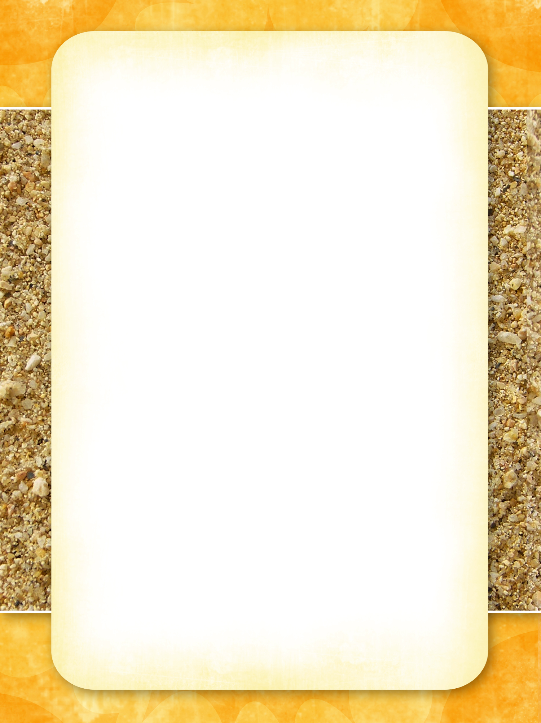

# Menú

VINOS Y COCTELES

**COCTELS**

GUARO SOUR………………………………………………………………$7

MARGARITA………………………………………………………………..$9

PINA COLADA……………………………………………………………..$8

VODKA MARTINA………………………………………………………… $9

CHOCOLATE MARTINI……………………………………………………$11

DRY OR DURTY MARTIN………………………………………………..$ 11

DAIQUIRIS………………………………………………………………..$8

NEGRONI………………………………………………………………….$11

GIN TONIC………………………………………………………………...$10

COSMOPOLITAN…………………………………………………………$8

PUNTO G………………………………………………………………….$12

MOJITO………………………………………………………………….$8

TEQUILA SUNRISE………………………………………………………$8

**WINES**

**SANGRIA BY GLASS……………………………………………………..$7**

**WHITE/RED BY GLASS…………………………………………………..$6**

**BY BOTTLE**

**CHARDONAY,SAUVINONG BLANC,PINOT GRIGIO, AND MORE**

**CARMERNERE, CHANTI, CABERNET SAUVINONG, MERLOT, PINOT NOIR, SIRAZ,**

**CHAMPAGNE, SPARKLING WINE. ….**