Machine Learning.xlsm

Instruction Manual

Created by OPER 544 Su19 Group 3

Capt Brandon Hufstetler

Capt Adam Brakeville

Capt Aaron Salazar

Lt Trey Pujats

Mr. Zachary Shannon

Contents

Getting Started 2

Developer Ribbon 2

Excel Add-Ins 3

Importing Data 3

Choose a Data File 4

Data Summary 5

Principal Component Analysis (PCA) 6

Naïve Bayes (NB) 7

Support Vector Machines (SVM) 8

# Getting Started

**\*Note:** Macros must be enabled for this program to work.

## Developer Ribbon

A few add-ins need to be enabled before the program will become fully functional.

Right-click anywhere in the ribbon and select “Customize the Ribbon…”, as seen in Figure 1.

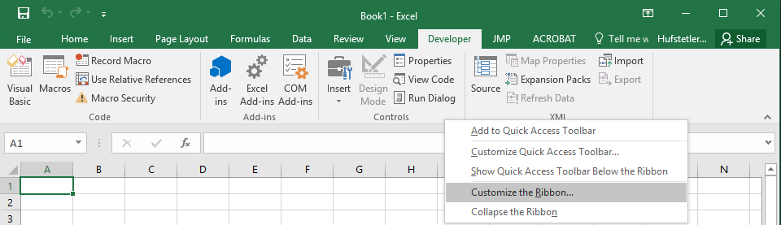

Figure Customize the Ribbon

In the Excel Options window, in the “Main Tabs” pane, check the box to enable “Developer”, as seen in Figure 2. Click “OK” to close the window.

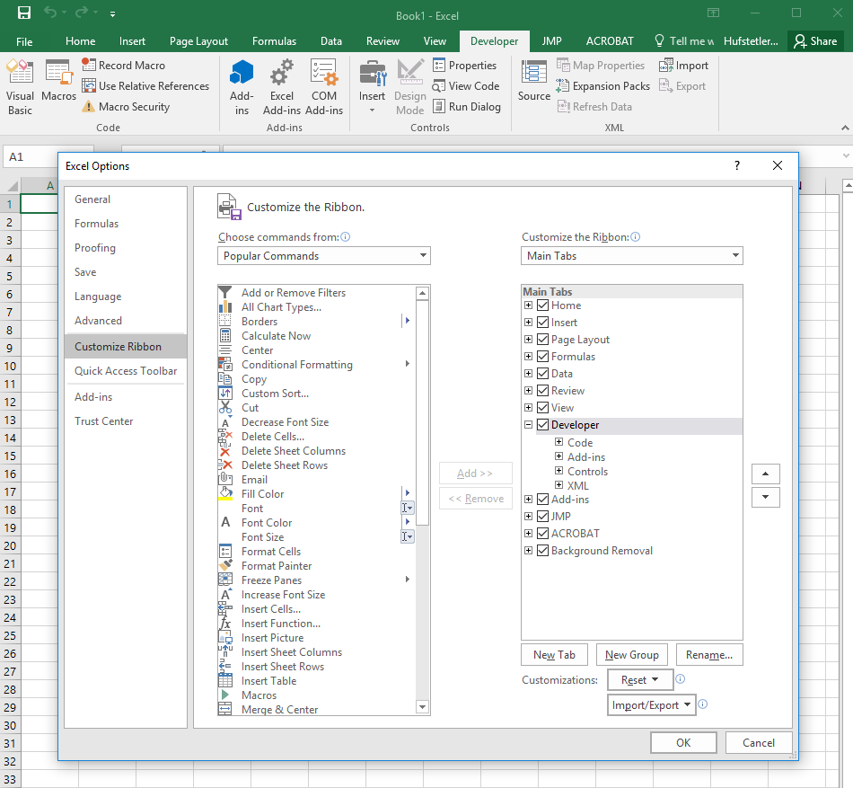

Figure Load the Developer Ribbon

## Excel Add-Ins

Open the “Developer Ribbon”. Click the icon with the two gears labelled “Excel Add-ins”. In the Add-ins window, check the boxes to enable “Analysis ToolPak”, “Analysis ToolPak – VBA”, and “Solver Add-In” as seen in Figure 3. Click “OK” to close the window.

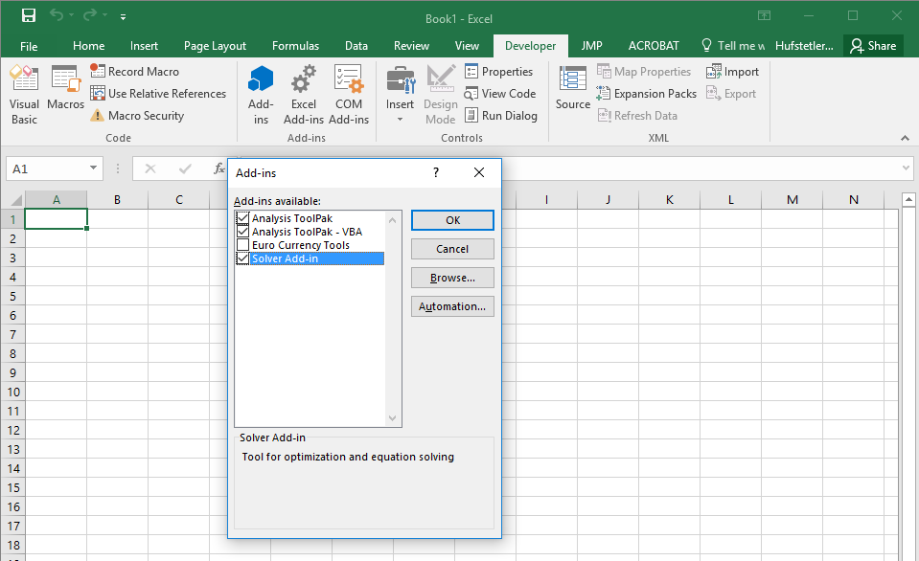

Figure Excel Add-Ins

# Importing Data

Importing data is accomplished by clicking the “Import Data” button on the “Input” page. Notice the “?” button in the top left. Clicking that button will open this document.

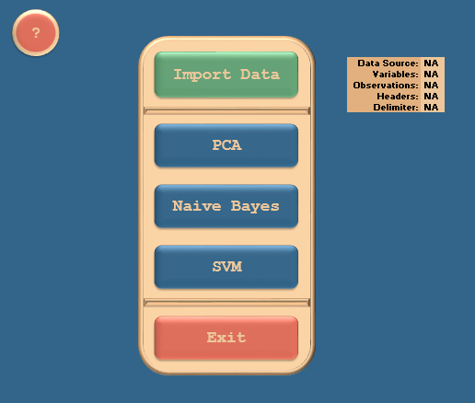

Figure Input Page

## Choose a Data File

Upon clicking the “Import Data” button. You’ll be prompted to select a data file. Current formats supported are:

* .xls
* .csv
* .txt (tab delimited)

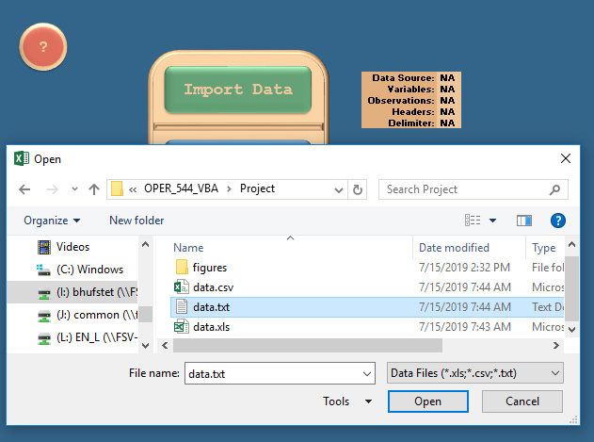

Figure Data File Selection Window

Next, a “Data Input Information” window will appear. If your data has headers, check the “Data has headers” box. Then select the Delimiter Type in the drop down menu. Press “OK” when you’re finished. If you are using a .txt file that is not tab delimited, a warning message will be displayed informing you that your data may not work with the program.

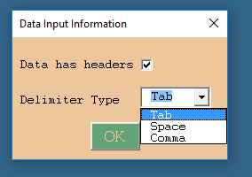

Figure Data Input Information Window

## Data Summary

Your data should now be populated in a new sheet called “data”. You can open that sheet to verify that the data is loaded correctly and separated into columns appropriately. If you used an incompatible delimiter, you may need to highlight the “A” column and click “Text to Columns” in the “Data” ribbon. If everything was loaded correctly, on the “Input” page you’ll see the file path chosen for you data, the number of variables and observations in you data, and your selections on whether or not headers are present and the delimiter type.



Figure Data Summary

# Principal Component Analysis (PCA)

# Naïve Bayes (NB)

# Support Vector Machines (SVM)