Screenshots from SAP DATAhub on SUSE CaasP v3 POC
doc created with help from customer‘s admin and Bo Jin from SUSE.

Overall architecture of the POC.
Some more details are written and documented on github.
https://github.com/bjin01/caasp-sapdatahub/blob/master/caasp-sap-datahub.md

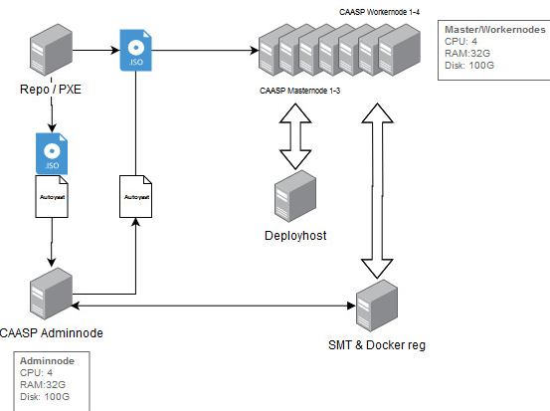

Below is a list of ‚kubectl get pod -n sap-datahub‘
