Shell Script

20221794 변진영

ex3-0.sh

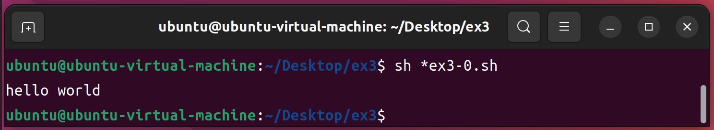

ex3-1.sh

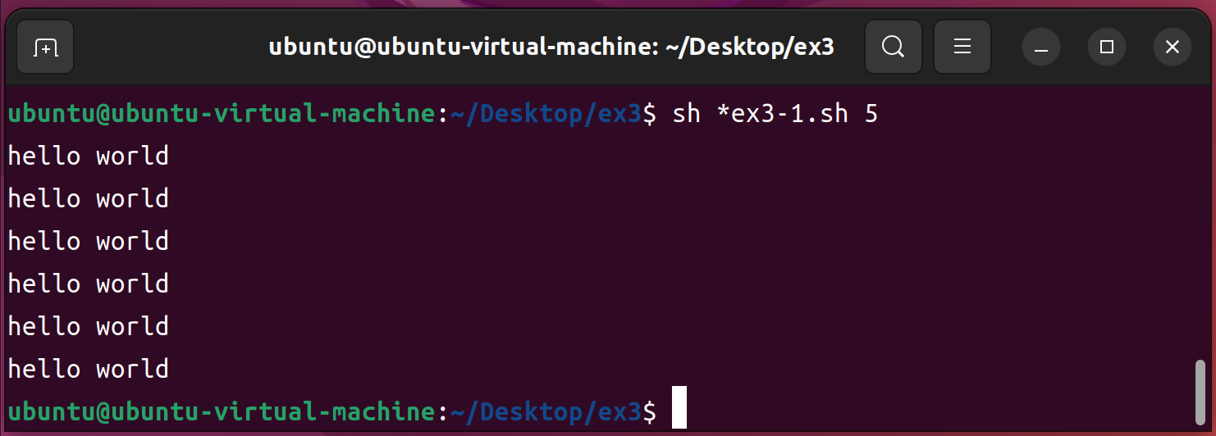

ex3-2.sh

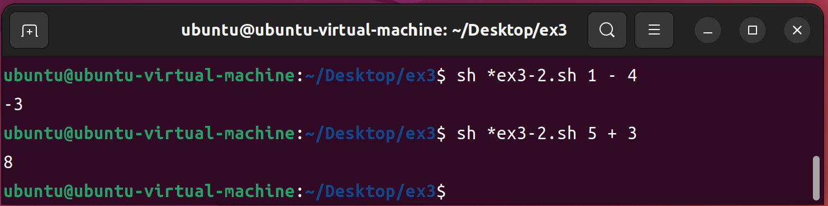

ex3-3.sh

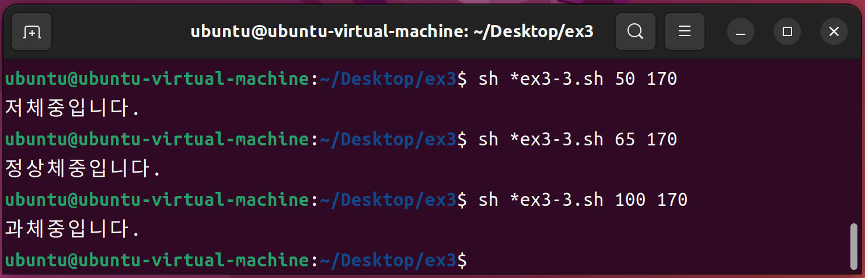

ex3-4.sh

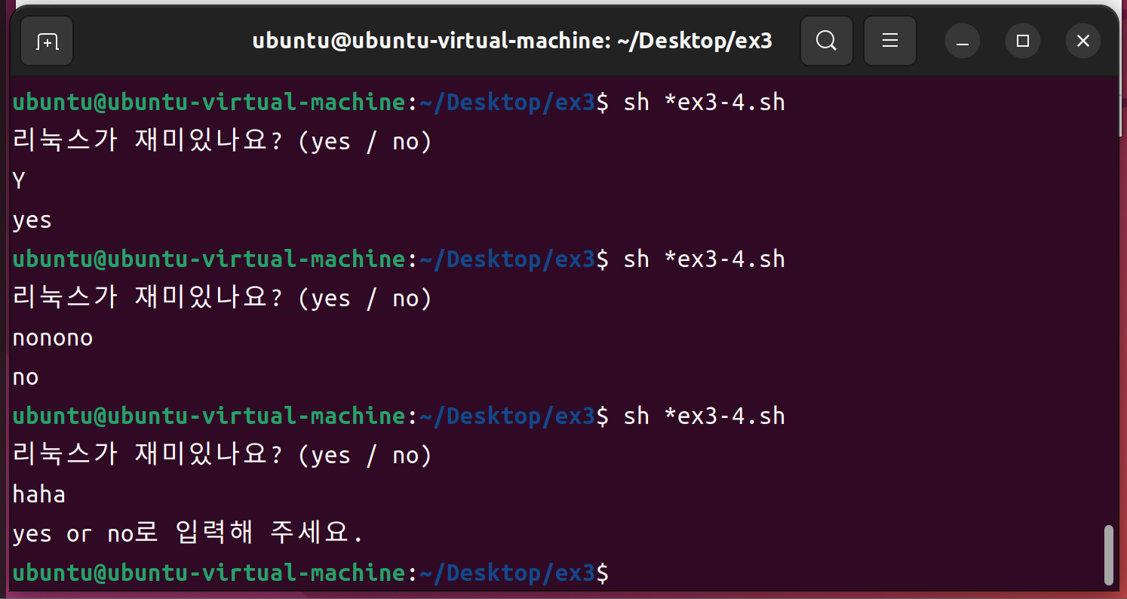

ex3-5.sh

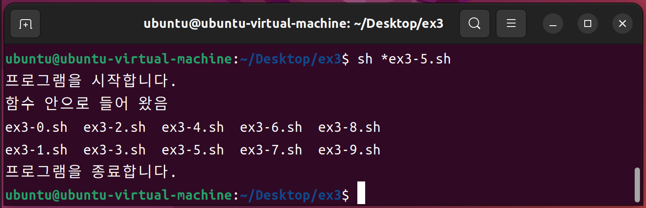

ex3-6.sh

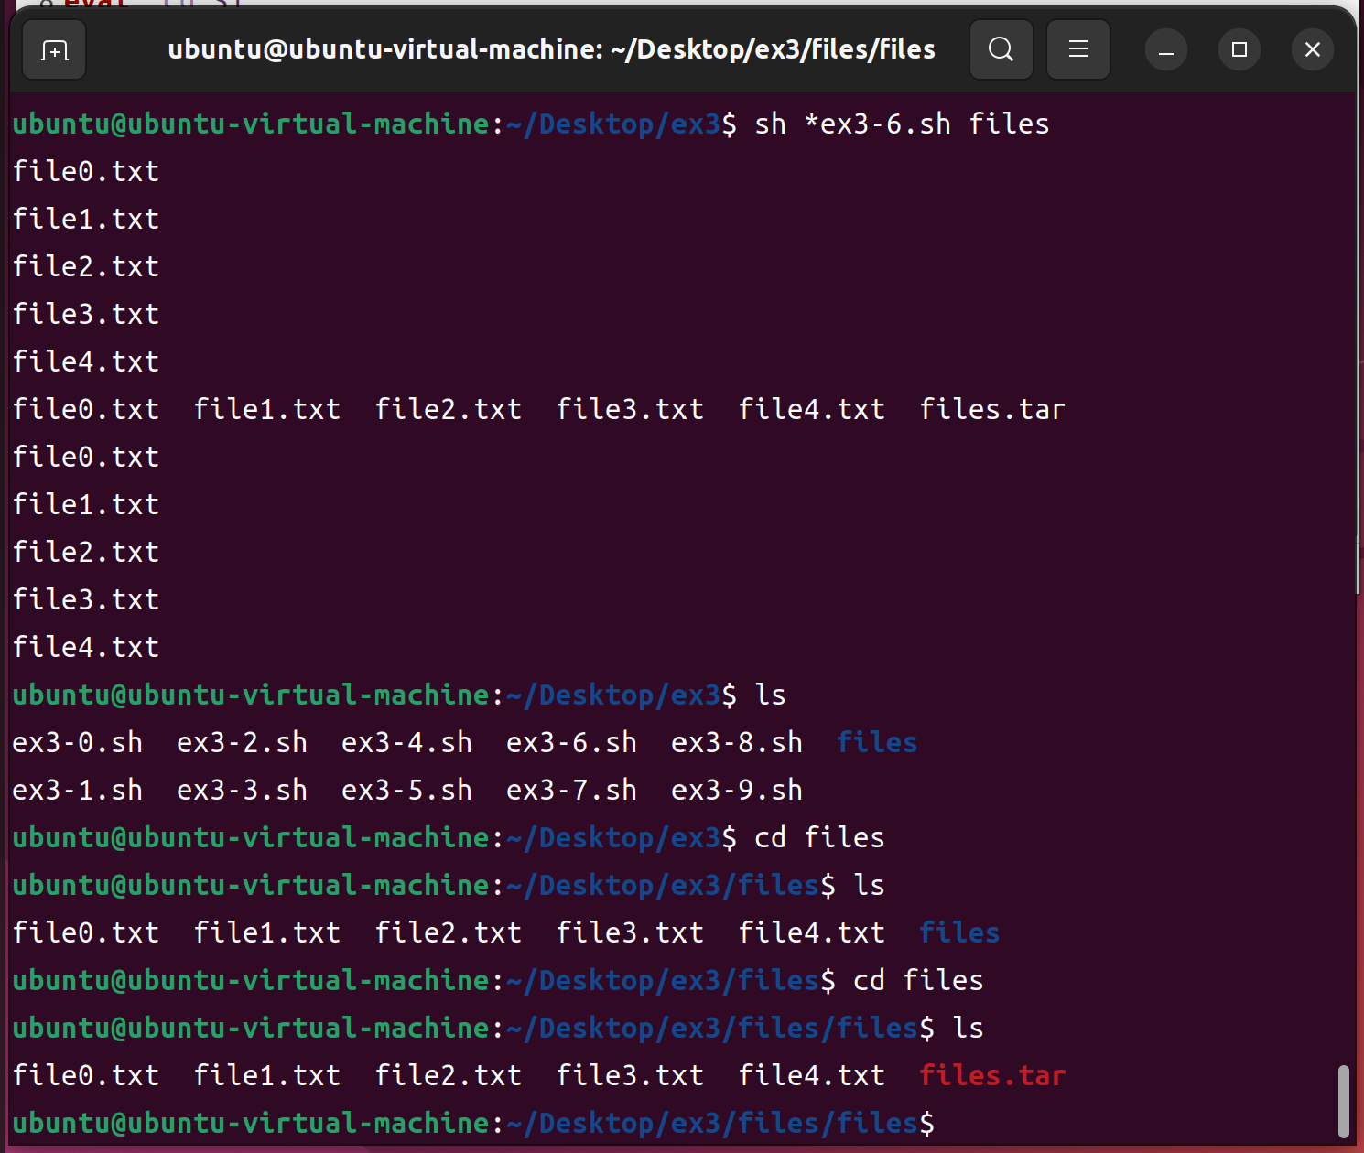

ex3-7.sh

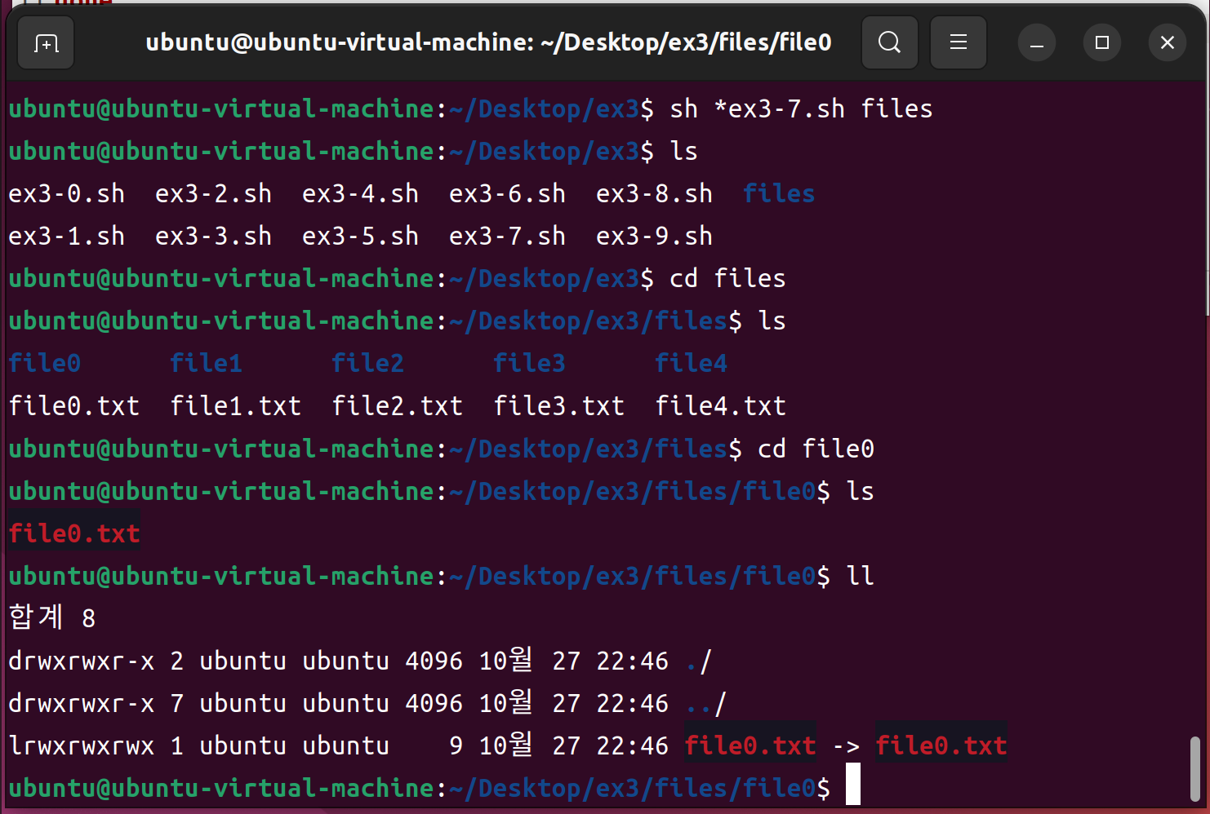

ex3-8.sh

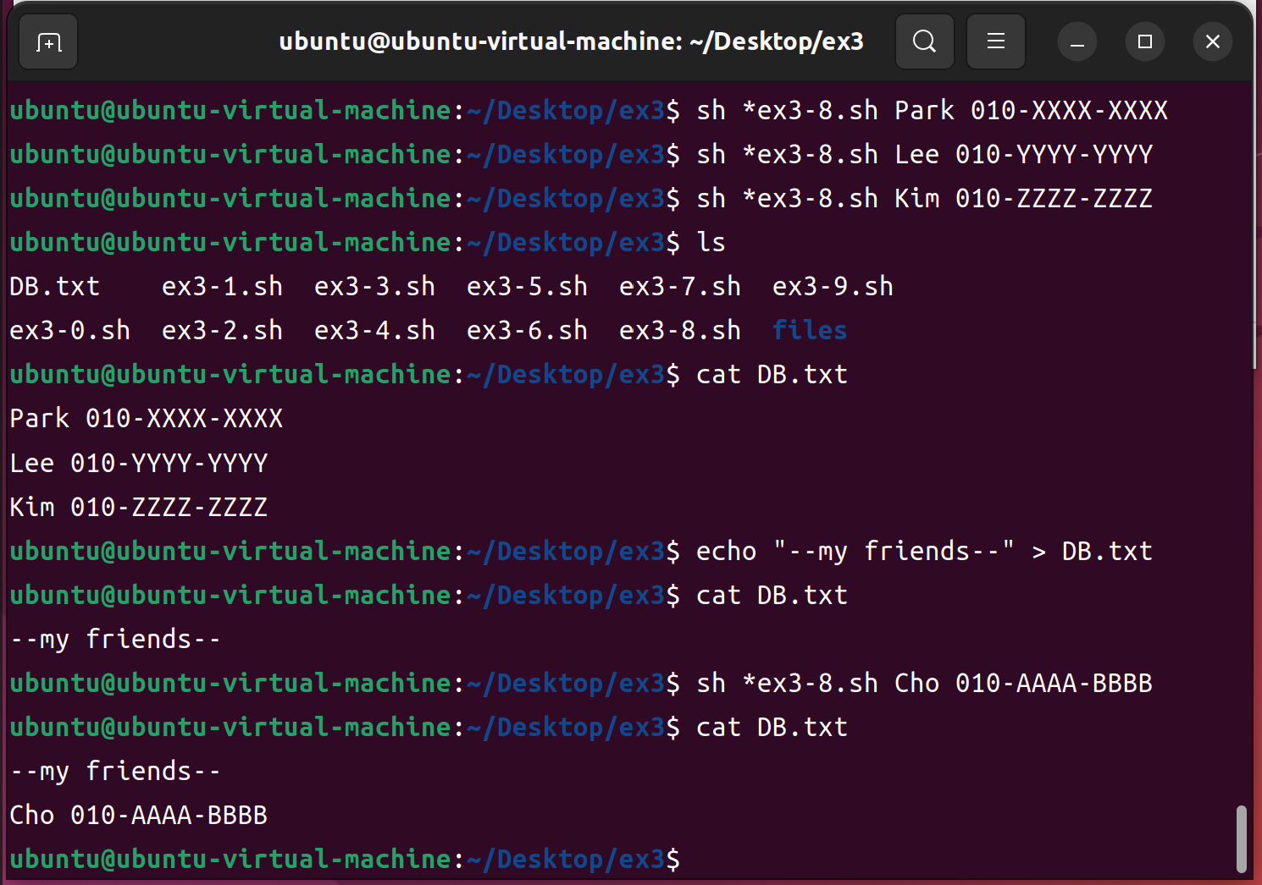

ex3-9.sh

