Software Specifications & Design Document
Assignment 1, EMBSYS110 , Spring 2015
Chad Bartlett, cbartlet@uw.edu

- Introduction
  - Project Overview
The purpose of this project is to implement a thread queue with three serialized threads (including one additional idle thread) and a shared variable. The application created for this project takes no inputs, but does output serial debug information. In addition, LEDs are toggled to indicate the state of the running application. Threads are executed forever using a round-robin schedule. The first two threads manipulate the globally shared variable and the third thread monitors the shared variable for errors. If an error occurs, a message is output through the serial-port and the LEDs enter an error pattern state.
  - Project Scope
The project scope is limited to the assigned tasks listed in Reference 1.4.1.

  - Document Preview
Section 2 describes the system architecture and requirements. Section 3 explains the detailed design. Section 3.4 describes the test plan. Finally, Sections 3.7 and 3.8 elaborates on the serial output and LED illumination patterns.
  - References
    - UW Tiny Kernel – Assignment 1, A1/CP110

- Architectural Design
  - Section Overview
The purpose of the section is to provide a high-level description of the application created for this project.

  - Block Diagram
The system is composed of the components listed in Figure 1.
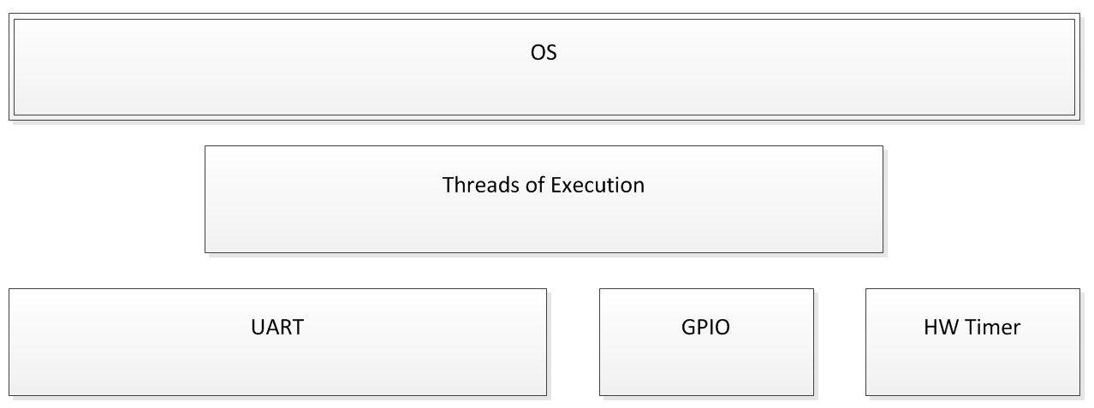
Figure 1: System block diagram.
  - System Requirements
The system requirements are listed in the following Tables. These requirements are specifically called out in Reference 1.4.1 with the exception of Table 6: Testing Requirements. The key words "MUST", "MUST NOT", "REQUIRED", "SHALL", "SHALL NOT", "SHOULD", "SHOULD NOT", "RECOMMENDED", "MAY", and "OPTIONAL" in this document are to be interpreted as described in RFC 2119.

Table 1: Thread Requirements
SRS_THD_001 | The thread queue must hold a minimum of four threads.
SRS_THD_002 | One thread must be called idle.
SRS_THD_003 | The idle thread should be the first thread in the thread queue.
SRS_THD_004 | The threads must be executed forever using a round-robin schedule.
SRS_THD_005 | Each thread must support data sharing.
SRS_THD_006 | Each thread must respond to events generated by other threads.
SRS_THD_007 | Each thread must contain an entry function. The entry function is the function called from the scheduler.
SRS_THD_008 | Each thread entry function should have a unique name.
SRS_THD_009 | The idle thread entry function should be called idleEntry().
SRS_THD_010 | Each thread entry function must have the following signature:  uint32_t functionName(void* data)  (Where a return code of 0 means success otherwise an error code.)

Table 2: Data Requirements
SRS_DAT_001 | A structure, thread_t, must be defined with the following fields:  {  UID // unique identification number  NAME // fixed 12-character string  PRIORITY // thread priority level  STATE // thread state; Ex. INITIAL, ACTIVE, READY, BLOCKED  PTR // function pointer to thread entry  }
SRS_DAT_002 | A method must be defined to output the fields from the structure defined in SRS_DAT_001.
SRS_DAT_003 | A structure, globalData_t, must be defined with the following fields:  {  GUARD // An access guard for this structure  INC // A counter incremented within the guard in each thread  T1 // The number of times thread 1 has been entered  T2 // The number of times thread 1 has been entered  }
SRS_DAT_004 | A structure should be created that contains, for example, the ID of the currently running thread. This structure would be used by the kernel as opposed to other threads.
SRS_DAT_005 | All structures and variables should be defined globally.

Table 3: Communication Requirements
SRS_COM_001 | Serial output must be enabled to provide feedback during run-time.

Table 4: Run-time Requirements
SRS_RUN_001 | An application running 3 threads must be created as described in Reference 1.4.1, under Section Design Requirements.
SRS_RUN_002 | If an error occurs, the error should be recorded and reported.
SRS_RUN_003 | Serial output should be generated throughout the board initialization code to indicate progress.
SRS_RUN_004 | A hardware timer should be implemented to provide a system tick for the application running at 1000 Hz.
SRS_RUN_005 | All thread state changes must be printed.
SRS_RUN_006 | At the completion of the ‘idle’ thread, the state of the shared variable described in SRS_DAT_003 must be printed.

Table 5: Documentation Requirements
SRS_DOC_001 | All source code should be documented using Doxygen with the following keywords where appropriate:  - File comment block: @file, @brief, @author, @date  - Function comment block: @brief, @param, @return  - Inline code using: ‘/**< description */’ or ‘//!< description’
Table 6: Testing Requirements
SRS_TST_001 | All APIs must be verified for conformity to the specifications.
SRS_TST_002 | The state of the shared variable defined in SRS_DAT_003 must be monitored during run-time to verify the counter variable remains < 3.
SRS_TST_003 | The system tick frequency defined in SRS_RUN_004 must be verified using an external tool (e.g. oscilloscope, DMM, logic analyzer, etc).
SRS_TST_004 | The board initialization execution time must be measured and recorded.
SRS_TST_005 | The execution time of all threads must be measured and recorded.

- Detailed Design
  - Section Overview
This section describes the build environment, scheduler, test plan, thread queue, error handling, serial output and LED illumination patterns. Refer to Appendix Section 4.1 for class diagrams of this application.
  - Build Environment
A virtual machine (VM) has been created using VirtualBox for use as the build environment for this project. The VM guest OS is Lubuntu 14.04. The target application is built using the GNU ARM Embedded Toolchain. A STMicroelectronics STM32VLDiscovery discovery kit with the STM32F100RB MCU is used as the target hardware. The project is under version control using Git with a repository on GitHub. The source code can be viewed on GitHub here or the repository cloned from the following address:

- https://github.com/bartsblues/EmbSys110_cbartlett.git

The project directory structure is as follows.

App/ -
|- OS.cpp
|- OS.h
|- Threads.cpp
|- Threads.h
|- main.cpp
|- mini_cpp.cpp
|- no_heap.cpp
Bin/ -
|- Assignment1_cbartlett.hex
|- Assignment1_cbartlett.bin
Bsp/ -
|- Bsp.cpp
|- Bsp.h
|- Interrupts.cpp
|- startup_stm32f10x.cpp
|- stm32f100.ld
|- stm32f10x_conf.h
Doc/ -
|- Assignment1_Design_cbartlett.doc
|- Assignment1_Design_cbartlett.pdf
Lib/ -
|- CriticalSection.cpp
|- CriticalSection.h
|- DUart.cpp
|- DUart.h
|- IDUart.cpp
|- IDUart.h
Tests/ -
|- stubs/ -
|- StubBsp.cpp
|- StubDUart.cpp
|- Makefile
|- RunAllTests.cpp
|- TestCriticalSectionAPI.cpp
|- TestIUart.cpp
|- TestOS.cpp
|- TestTemplate.cpp
./ -
|- .ddd_gdb
|- .nemiver_gdb
|- README
|- Makefile
|- Makefile.Includes
|- Makefile.Common

  - Scheduler
The scheduler executes a non-preemptive, round-robin pattern. Execution begins with the idle thread. Three additional threads execute sequentially. Once the last thread in the thread queue completes its tasks, the queue index wraps around to once again execute the idle thread, and so on. A visualization of this execution pattern is shown in Figure 2. Threads can be in one of four states: INITIAL, READY, ACTIVE and BLOCKED. However, in this implementation each thread runs to completion and therefore never enters the BLOCKED state. Also, all threads share a single stack. All OS procedures are handled with the OS class. See the class diagrams in Figure 3, Figure 5 and Figure 6 of Section 7.

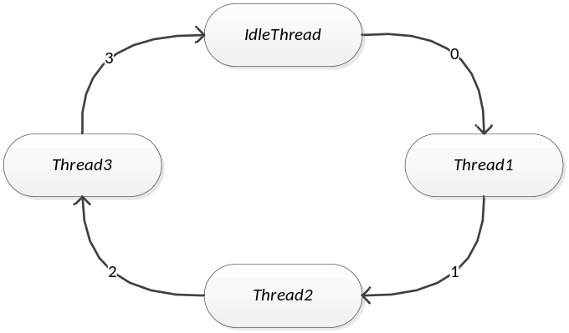
Figure 2 - Round-robin thread execution pattern.

  - Test Plan
The testing framework CppUTest is utilized to create tests that exercise the APIs of this application. These tests are executed within the VM in the guest environment after a successful build for the target.

In addition, the three threads form a run-time test of the round-robin scheduler. The first two threads manipulate a globally shared variable and the third thread monitors the shared variable for errors. If an error occurs, a message is output through the serial-port and the LEDs enter an error pattern state. See Section 3.8.

  - Thread Queue
The thread queue is a statically allocated array consisting of pointers to 4 thread_t objects described in Table 2. The idle thread is contained at the first index, followed by thread1, thread2 and thread3. See the Thread diagram in Figure 7 of Section 7.

  - Error Handling
Assert statements are used to maintain preconditions within the application. If an assertion fails the file and line number where the failure occurred are printed to serial output and the application enters a while(1) loop. The application must be manually reset to continue. All other run-time errors are printed to the serial output. See Section 3.8 as well.

  - Serial Output
A minimal UART driver has been created to provide serial output to the application. Three public functions allow for printing either strings or numeric values (in the form of unsigned integer decimal or hexadecimal output). The connection uses a bit rate of 115200 and 8-N-1. Sample Output is shown below. See the class diagram in Figure 4 of Section 7.

> Chad Bartlett's Assignment 1.

> Hardware initialization took: 5-milliseconds
(01) Name: Idle
(02) State: 0x2
Name: Producer
State: 0x2
Name: Consumer
State: 0x2
Name: Monitor
State: 0x2
(03) Inc: 0
(04) nT1: 0
(05) nT2: 0
(06) > Idle exec time: 10001-ms
Name: Producer
State: 0x2
(07) > Thread1 exec time: 1003-ms
Name: Producer
(08) State: 0x1
Name: Consumer
State: 0x2
(09) > Thread2 exec time: 1002-ms
Name: Consumer
State: 0x1
Name: Monitor
State: 0x2
(10) > Thread3 exec time: 1002-ms
Name: Monitor
State: 0x1
(11) Inc: 0
nT1: 1
nT2: 1
> Idle exec time: 10001-ms
Name: Idle
State: 0x1

- The name of the current thread
- The state of the current thread. State 0x2 corresponds to STATE_READY.
- Shared counter = 0. (Printed at the end of the Idle thread.)
- Times thread 1 has executed = 0. Shared counter = 0. (Printed at the end of the Idle thread.)
- Times thread 2 has executed = 0. Shared counter = 0. (Printed at the end of the Idle thread.)
- Execution time of the Idle thread.
- Execution time of the Thread1.
- State 0x1 corresponds to STATE_ACTIVE.
- Execution time of the Thread2.
- Execution time of the Thread3.
- State of shared data printed at the end of Idle.

  - LED Patterns
During normal operation, the blue LED flashes at a rate of 10 Hz while the green LED is cleared upon entry to the Idle thread and set upon exit. If the third thread detects an error with the shared data, the green LED flashes at a rate of 4 Hz. If an assertion has occurred both LEDs are steady on.

- Appendices
  - Object Diagrams
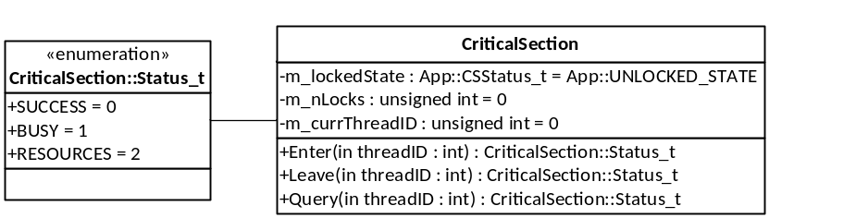
Figure 3 - Critical Section Class Diagram
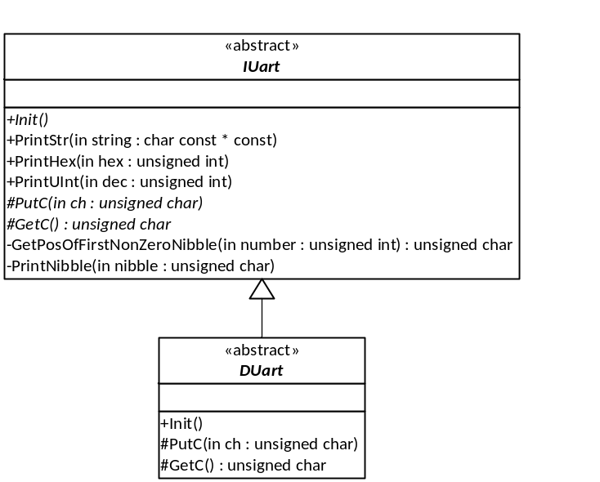
Figure 4- DUart Class Diagram

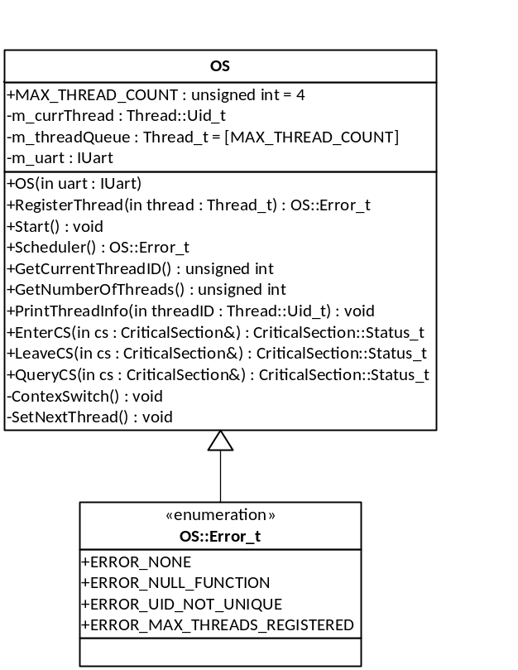
Figure 5- OS Class Diagram

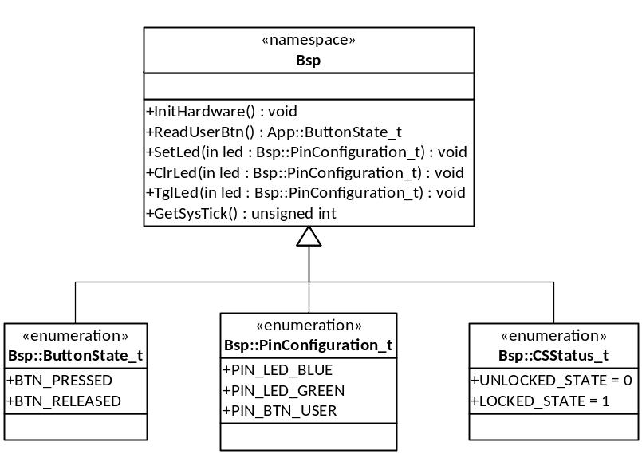
Figure 6 - Bsp namespace Diagram

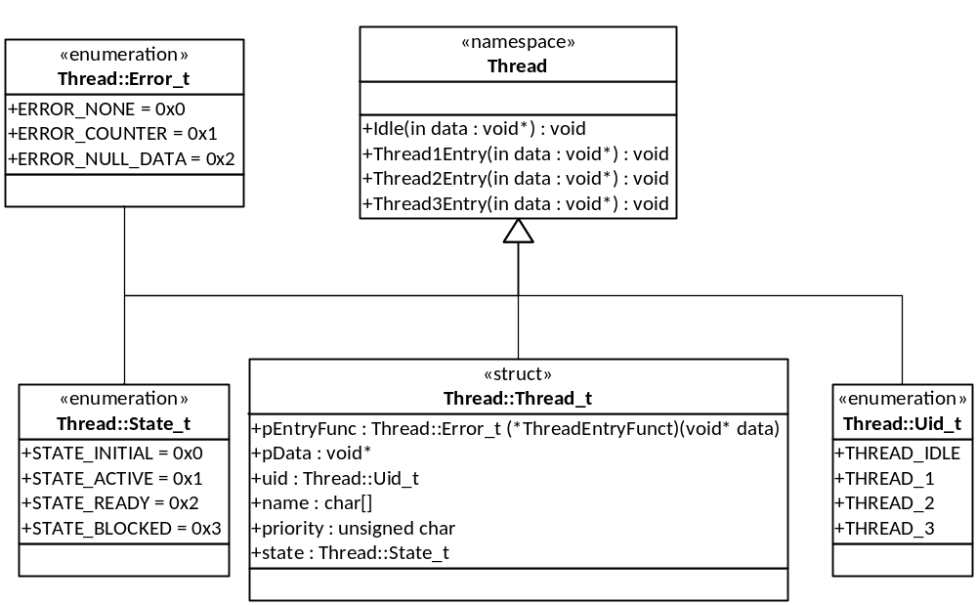
Figure 7- Thread namespace Diagram

