**BJJD - Use Case**

# Project Architecture

# Use Case Diagram

Basic Concepts

**Use Case Diagram:** A use case diagram is a representation of user’s interaction with the system that shows the relationship between the user and the different use cases in which user is involved. Example of Ticket Selling System:

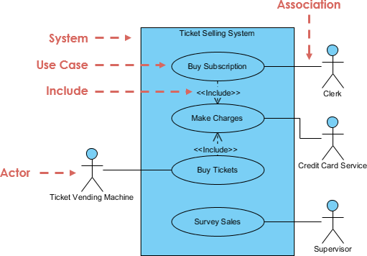

Use Case I: Authorization Service

# Use Case II: User Management Service

# Use Case II: People Management Service